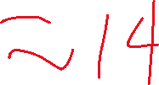

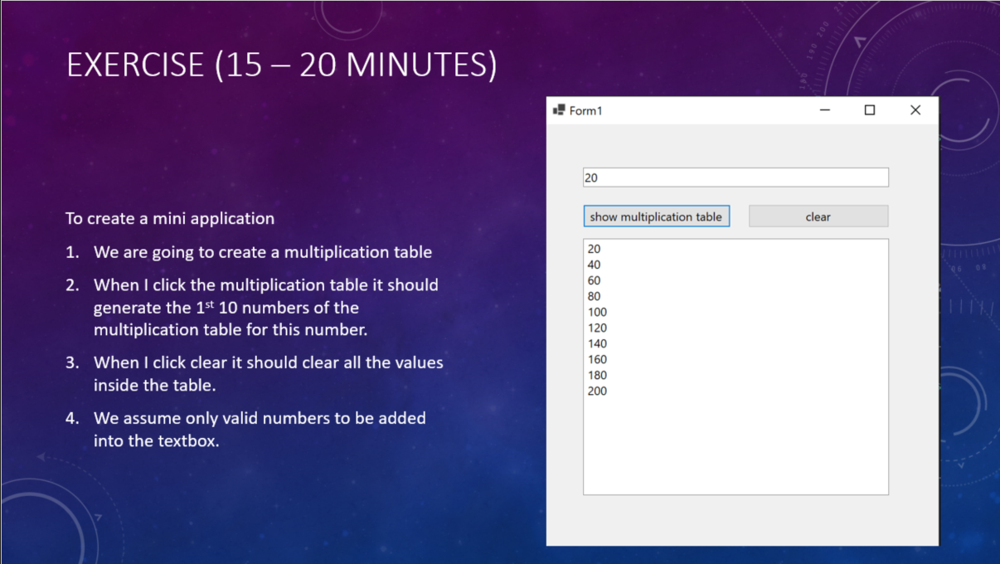2 Sub () Handles [].Click

**Sub btnShow.Click**

* intInput = txt.Text
* For Loop
* vbCrLf

**Sub bntClear.Click**

txt.Text = *Empty String*

txtDisplayResult

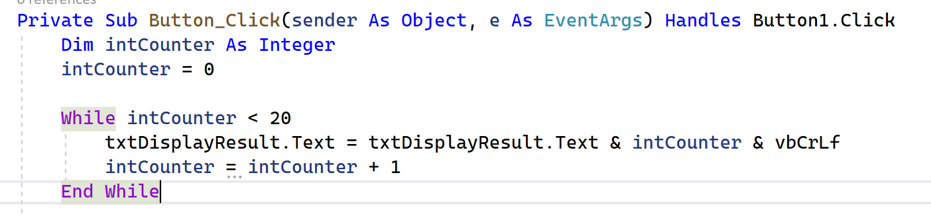

txt = “”

intCounter = 0

1st Loop

txt = txt(“”) & intCounter(0) & vbCrLf (\n)

intCounter = intCounter(0) + 1

txt = “0\n”

intCounter = 1

2nd Loop

txt = txt(“0\n”) & intCounter(1) & vbCrLf(\n)

intCounter = intCounter(1) + 1

intCounter = 2

3rd Loop

txt = txt(“0\n1\n”) & intCounter(2) & vbCrLf(\n)

intCounter = intCounter(2) + 1

intCounter = 3

4th Loop

txt = “0\n1\n2\n…19\n”

txt:

0

1

2

3

4

…

19