Multi-agent Simulation of Complex Economic Systems Driven by Deep Reinforcement Learning

Bo Chen*
College of Computer and Data Science, Fuzhou University
Fuzhou, China
bo.chen@fzu.edu.cn
*Corresponding author
Shiqi Ding
College of Computer and Data Science, Fuzhou University
Fuzhou, China
221020003@fzu.edu.cn
Yukun Lin
College of Computer and Data Science, Fuzhou University
Fuzhou, China
308006378@qq.com
Guohong Chen
School of Economics and Management, Fuzhou University
Fuzhou, China
cgh@fzu.edu.cn

Abstract—In economics, the study of macroeconomic laws often encounters challenges such as difficulties in data collection and low data quality. A complex economic system (CES) simulation model based on Multi-agent Simulation (MAS) was designed and proposed to provide reliable, high-quality virtual data support for economic research to address these issues. To enhance the intelligence of agent behaviors in the simulation model, an economic agent decision-making model based on the Twin Delayed Deep Deterministic Policy Gradient (TD3) algorithm was developed, and experimental results demonstrate the effectiveness of the TD3 algorithm in CES simulations. Additionally, the model's decision-making capability in complex economic environments was further improved by incorporating Long Short-term Memory (LSTM) networks to handle temporal relationships. The research presented herein explores the application effects of deep reinforcement learning in economic research, providing a reliable source of virtual economic data for theoretical economic research and offering new perspectives and methods for economic system simulation research.
Keywords—deep reinforcement learning; TD3; LSTM; Complex economic system simulation; Multi-agent reinforcement learning

Introduction
In theoretical economics, deriving formalized universal laws from macroeconomic phenomena is crucial. For example, the Fisher equation[1], quantifies the relationship between national income, price levels, and the money supply. Such research often faces a "data dilemma," where real-world economic data is difficult to obtain and often of low quality. Accurately quantifying certain macroeconomic variables under ideal conditions is even more challenging. As a result, simulation methods have become a common approach for modeling economic systems and developing models that reflect actual economic laws.
The real-world economic system is a nonlinear complex system characterized by numerous emergent problems[2]. In 1994, Holland[3] proposed the Complex Adaptive System (CAS) theory, providing a new direction for the study of economic systems. Based on CAS, Multi-Agent Simulation (MAS) methods[4] have gradually become mainstream in economic system research.
Due to its outstanding performance in learning human behavior in dynamic tasks[5], reinforcement learning has been widely recognized. As the theory of CAS and MAS technology develops and improves, many researchers have employed reinforcement learning to construct MAS models. These models generate virtual data to study the micro behaviors and macro phenomena that exist in the economic market. Researchers have applied reinforcement learning algorithms to build MAS models in various economic fields, including, tax policy[6], currency risk and return[7], and resource allocation strategies[8], variable speed limit control[9][10], offloading framework for Computation Service[11]. While deep reinforcement learning has been widely used and has achieved considerable results in the study of complex economic systems (CES) based on MAS, the behavioral strategies of economic agents in current multi-agent economic market simulations remain fixed or limited, and the support for CES research is still insufficient.
Considering this, this paper designs and implements an abstract MAS model of a CES. The model includes macroeconomic variables essential for research, allowing for data-driven analysis. The study applies the Twin Delayed Deep Deterministic Policy Gradient (TD3) algorithm[12] to enhance the intelligence of agents within the simulation. Additionally, the TD3 network is improved with Long Short-Term Memory[13] (LSTM) to better align agent behavior with real-world economic dynamics.

Simulation Model of Complex Economic Systems

Simulation Model
The simulation environment includes two types of abstract microeconomic agents: "firms" and "banks." The environment has one bank agent and two firm agents—Firm A, producing capital goods, and Firm B, producing consumer goods (representing labor). These goods are collectively referred to as products, and when these products are placed on the market, they are referred to as commodities.
These agents form a CES with multiple interactions. The bank issues loans to firms, recovering principal and interest over time. Firms use their capital and consumer goods to produce and sell commodities, then purchase more for the next production cycle. As shown in Fig 1, virtual agents interact within the environment, driving changes until a "termination condition" is met. This cycle is called a "round." At the start of each round, firms have an initial inventory, but no capital, as all market money originates from bank loans.
Fig.1 Complex System Operations Process
In each round, the system operates in a small cycle consisting of 6 stages, referred to here as a "day." The 6 stages of a "day" are as follows:
P1: Firm Decision-Making Phase
Each firm determines its daily actions based on its attributes (e.g., cash, debt, and product inventories) and the system's environmental state (e.g., inter-firm transaction records and market commodity prices). These decisions include the willingness to take loans, purchase commodities (capital and consumer goods), and set prices for the next day. On day 0 of each round (the initial stage), firms do not engage in decision-making. Instead, there are predefined initial demands for consumer and capital goods, along with initial pricing. Firms begin the round with this setup and make incremental decisions on subsequent days.
P2: Bank Decision-Making Phase
The bank observes various types of environmental and agent information, including the current state of each firm, the state of the bank itself, and the state of the entire system environment. Based on these observations, the bank determines the actual amount of loan to be granted to each firm, which cannot exceed the firm’s willingness to borrow. On day 0 of each round, the bank does not engage in decision-making but instead defaults to lending a fixed amount to each firm.
P3: Loan Phase
Following the bank's decision-making, loans are disbursed to the firms according to the decisions generated. Firms are required to pay interest daily and to repay the principal amount of the loan after a certain period (t days), with this paper setting the repayment cycle at 5 days. It is important to note that for policy reasons, the aggregate borrowing volume is constrained by the bank’s cash and reserves:
$$\begin{aligned}d≤γ(G_{b}+M_{b})\#(1)\end{aligned}$$
where $d=d_{A}+d_{B}$, $d_{A}$, $d_{B}$ represent the debts owed to the bank by Firm A and Firm B, respectively, $G_{b}$ is the bank's reserve, $M_{b}$ is the bank's cash, and γ is the bank's borrowing rate, indicating that the bank can lend out cash that is up to γ times its reserves.
If the total amount of new loans issued by the bank exceeds this ceiling, the legally disbursable loans must be allocated in proportion to the loan amounts requested by the two firms. $\begin{aligned}Δm_{i}=\left\{\begin{aligned}w_{i}, δ≥W \\ \frac{w_{i}}{W}*δ, &δ<W\end{aligned}\right.\#\left(2\right)\end{aligned}$where $Δm_{i}$ represents the actual loan received by the firm, $w_{i}$ represents the loan willingness of Firm i as decided in the P1 phase, $δ=γ\left(G_{b}+M_{b}\right)-\sum_{i=0}^{N}{d_{i}}$ represents the amount of new loans that can still be issued, and $W=\sum_{i=0}^{N}{w_{i}}$ represents the total loan willingness of both parties for the current day.
P4: Trading Phase
Firms place their production and inventory from the previous day on the market for sale at the prices decided on the previous day. Additionally, we set up two "third-party market" instances, represented by Firm α and Firm β. Firm A and Firm α jointly place capital goods on the market, while Firm B and Firm β jointly place consumer goods on the market. Firm α and Firm β introduce an unlimited amount of goods (capital/consumer goods) into the market at fixed prices. The theoretical implications and economic foundations for introducing the third-party market instances are detailed in Section Ⅱ.B. The process of launching products into the market is illustrated in Fig 2.
Fig. 2. Product Release into Market
As shown in Fig 3, the products from Firm A are labeled Capital Goods-A, and those from Firm α are labeled Capital Goods-α. Similarly, products from Firm B are identified as Consumer Goods-B, and those from Firm β as Consumer Goods-β. All market goods possess two key attributes: price and quantity.
Once all the goods have been placed in the market, each firm proceeds to purchase from the market according to the purchasing intentions decided in the P1 phase. For goods of the same type, firms will prioritize purchasing the lower-priced items. The market transaction process involves the following two scenarios:

If the third-party market firms (Firm α/Firm β) price their goods lower than the local firms (Firm A/Firm B):
In this case, the local firms will directly purchase the goods released by the third-party market firms. Since the third-party market firms supply an unlimited quantity of goods to the market, they can fully satisfy the demand of all firms.

If the third-party market firms price their goods higher than or equal to the local firms' pricing:
In this scenario, local firms first buy goods from local sources. If supply is insufficient, goods are allocated proportionally based on demand. For Firm $i$ (where $i=A,B$) with demand $R_{i}$ and total available goods C, the allocation to Firm i is calculated as:
$$\begin{aligned}S_{i}=\frac{C}{R_{A}+R_{B}}*R_{i}\#\left(3\right)\end{aligned}$$
After all the goods released by the local firms are sold, any unmet demand from the firms will be fulfilled by purchasing from the third-party market firms.
Fig. 3. Product Transaction Process
P5: Commodity Production Phase
Each firm produces its products based on the capital goods and consumer goods (an equivalent representation of labor) it obtained that day. The products produced will be placed on the corresponding market for trading the next day. Let the quantity of capital goods obtained on that day be denoted as K, and the quantity of consumer goods obtained as L; then the quantity of production Y is determined by the following equation:
$$\begin{aligned}Y=C*K_{a}*L_{b}\#\left(4\right)\end{aligned}$$
where C is a constant indicating the ratio of inputs to outputs, and a and b are coefficients indicating the share of capital goods and consumer goods in production. In the experiments conducted in this paper, both a and b are set to 0.5.
P6: Liquidation Phase
Firms must daily repay interest and the principal on bank debt due from five days prior. Insufficient cash leads to bankruptcy. The repaid interest increases the bank's reserves, $M_{b}$, for future loans. Reflecting real-world practices, these reserves grow each settlement, proportional to the volume of the goods all firms purchase during the P4 phase as market activity intensifies.
After the liquidation phase (P6), if any of the following conditions occur:

A firm goes bankrupt.

The number of days of system operation reaches a preset number of days T.
Once the termination condition is met, the round concludes. At the end of each round, both the overall environment and the individual attributes of the three economic entities are reset, initiating a new round.

Third-Party Markets
In this simulation, each firm holds an oligopolistic position as the sole producer/consumer, aiming to maximize revenue by minimizing costs, leading to reduced purchases and production but higher prices. This results in lower market dynamics and resource wastage, impacting economic functionality negatively.
In contrast, real economies use macroeconomic regulations to counter oligopolies by stabilizing prices and promoting employment. However, this simulation models a free market without such interventions, introducing a "third-party market" with Firm α and Firm β. These firms supply goods at fixed prices and unlimited quantities, diversifying the market and preventing oligopolistic cycles, without engaging in purchasing behavior.
Local firms, prioritizing lower prices, choose to purchase from these third-party firms when their prices are competitive, leading to no sales and no revenue for the local firms if they price higher. Anticipating this, local firms are expected to adapt by setting prices just below those of third-party firms to secure sales and maximize revenue. This adjustment aims to create a stable price environment that encourages more strategic purchasing by firms, enhancing overall market dynamics.

Decision-Making Problem of Economic Agents
The previous section introduced the model, where multiple economic agents are set up, and the macroeconomic system environment is formed through the micro-interactions between the agents. In this section, we will describe in detail the composition and specific application scenarios of these decision-making models.

Decision Inputs and Outputs
An intelligent agent interacts with the environment by outputting an action based on the state of the environment in which it is located. The state of the environment needs to be described comprehensively so that the agent can fully utilize the environmental information and make accurate judgments.
The firm agent’s state input is a 33-dimensional vector, detailed in TABLE I. , consisting of the firm's current state, last round's decisions, transaction records, and market prices. In the P1 phase, using these inputs, the firm formulates its daily production and procurement plans and sets the next day’s prices. These decisions are represented by a 4-dimensional action vector in TABLE III., indicating the firm's willingness to take loans (WNDF), purchase capital (K) and consumer goods (L), and set future pricing (P).
It is worth noting that when making decisions, the firm needs to observe environmental attributes, including the current pricing of all products. The firm will decide the quantity of goods to purchase based on this pricing. The pricing must be fixed before making the decision; therefore, the decision here is for the pricing of the next day’s products, not for the pricing of today’s products.
The state input of the bank agent is a 48-dimensional vector, as shown in TABLE II. Its state is divided into three types of data: the bank’s state, the operating state of the Firms, and the market observation data. Denote the state of Firm $i$ (where $i=A,B$) as $e_state_{i}$, and $e_state_{i}^{k}$ as the k-th type of data for firm $i$, where $k∈\left[1,4\right]$, corresponding to the four types of data for the firm. Since each firm’s state contains the complete market transaction records and product prices, the bank’s market observation data only needs to include part of the state of Firm A.
The action output of the bank agent is a 2-dimensional vector, as shown in TABLE III. Among them, $WNDB_{A}$ is the bank’s willingness to lend to Firm A, and $WNDB_{B}$ is the bank’s willingness to lend to Firm B. In the P2 phase, the bank agent needs to comprehensively consider the financial status of the firms and market risks to determine the amount of loans to be issued to the firms.
- State Space of Firms
State Category | Input Vector | Dimension
Firm Own State | [Cash, Inventory, Total Debt, Sales Volume Last Round, Production Volume Last Round, Pricing This Round, Principal Repayment This Round, Interest Repayment This Round] | 1-8
Decision and Execution State of Last Round | [Pricing Last Round, Loan Amount Decided Last Round, Loan Amount Actually Received Last Round, Capital Goods Purchase Volume Last Round, Consumer Goods Purchase Volume Last Round] | 9-13
Inter-Firm Transaction Records of Last Round | [Quantity and Price of Goods Purchased by Firm A from Firm A, Quantity and Price of Goods Purchased by Firm A from Firm B, Quantity and Price of Goods Purchased by Firm A from Firm α, Quantity and Price of Goods Purchased by Firm A from Firm β, Quantity and Price of Goods Purchased by Firm B from Firm A, Quantity and Price of Goods Purchased by Firm B from Firm B, Quantity and Price of Goods Purchased by Firm B from Firm α, Quantity and Price of Goods Purchased by Firm B from Firm β] | 14-29
Market Commodity Prices | [Price of Firm A’s Goods, Price of Firm B’s Goods, Price of α’s Goods, Price of β’s Goods] | 30-33
- State Space of Bank
State Category | Input Vector | Dimension
Bank Own State | [Cash, Remaining Available Reserves] | 1-2
Firm Operation State | [$e_state_{A}^{1,2}$, $e_state_{B}^{1,2}$] | 3-29
Market Observation Data | [$e_state_{A}^{3,4}$] | 30-48
- Action Space of Economic Agents
Agent’s Type | Output Vector | Vector Dimension
Firm | [WNDF, K, L, P] | 4
Bank | [$WNDB_{A}$, $WNDB_{B}$] | 2

Evaluation indicators

Cumulative returns
When assessing the decision-making model, we focus on the cumulative returns of firms and banks, which gauge economic performance and decision-making effectiveness in the simulation. Higher profits, a crucial indicator of profitability, are the primary objective of economic entities.
When the agent operates on the t-th day, let the operating income of Firm $i$ ($i = A, B$) on that day be denoted as $R_{t}^{i}$ , the expenditure on purchasing goods as $C_{t}^{i}$ , and the interest paid as $D_{t}^{i}$. Generally, the profit $p_{t}^{i}$ of firm i at the end of all stages on the t-th day is given by:
$$\begin{aligned}p_{t}^{i}=R_{t}^{i}-C_{t}^{i}-D_{t}^{i}\#\left(5\right)\end{aligned}$$
In Section II.A, covering phases P1, P4, and P5, pricing decisions made by agents today affect the market and income realization tomorrow. Similarly, today's loan decisions impact interest expenditures starting the next day. To better reflect the value of decisions, this paper calculates profit using the revenue and interest expenditure of the next day, such that the profit $p_{t}^{i}$ of firm i on day t is:
$$\begin{aligned}p_{t}^{i}=R_{t+1}^{i}-C_{t}^{i}-D_{t+1}^{i}\#\left(6\right)\end{aligned}$$
Beyond profit, real markets frequently use operating income as an independent metric to evaluate a firm's development. It signifies the primary business outcome and a crucial foundation for generating profit. Therefore, a firm's comprehensive return, combining both profit and operating income, provides a more accurate assessment of the model's decision-making effectiveness. The comprehensive return $r_{t}^{i}$ of Firm $i$ on day t is:
$\begin{aligned}r_{t}^{i}=p_{t}^{i}+R_{t+1}^{i}=2R_{t+1}^{i}-C_{t}^{i}-D_{t+1}^{i}\#\left(7\right)\end{aligned}$
Finally, by accumulating the firm's returns, we obtain its cumulative returns, allowing for a comprehensive evaluation of the firm's operational performance and reflecting its overall market performance. Specifically, the cumulative return $S_{i}$ of Firm $i$ is the sum of the returns from day 0 to day t in a round, given by:
$$\begin{aligned}S_{i}=\sum_{d=0}^{t}{r_{t}^{i}}\#\left(8\right)\end{aligned}$$
Higher cumulative returns indicate that the firm can achieve profitability through effective production and sales strategies, demonstrating the agent's learning ability and adaptability to market environments.
The bank's returns come from the interest paid by firms to the bank. The bank's return $r_{t}^{b}$ on the t-th day is given by:
$$\begin{aligned}r_{t}^{b}=\sum_{i=A,B}{D_{t}^{i}}\#\left(9\right)\end{aligned}$$
Thus, the cumulative return $S_{i}^{b}$ of the bank in a round is the sum of the returns from day 0 to day t:
$$\begin{aligned}S_{i}^{b}=\sum_{t=0}^{T}{r_{t}^{b}}\#\left(10\right)\end{aligned}$$
The bank's cumulative returns, which represent the interest income from lending, indicate effective risk management, sound loan strategies, and profitability. These returns reflect not only numerical growth but also the bank's ability to optimize its interests in a complex economic environment.

Survival days
Survival days are not only a temporal metric but also a validation of the agent’s survival strategies and adaptability in volatile market conditions.

Decision Model with Twin Delayed Deep Deterministic Policy Gradient Algorithm
This section will apply the TD3 algorithm to the decision-making problem. The design and implementation of a decision model based on the TD3 algorithm will be covered. Finally, this model will be applied in a simulation environment to validate the effectiveness of the algorithm.

Decision Model
The decision model is based on the TD3[12] algorithm, which is a reinforcement learning algorithm as an improvement over the Deep Deterministic Policy Gradient[14] (DDPG) algorithm.
The network architecture of the TD3 decision models is shown in Fig 4. Since the architecture of the target network and the current network are identical, only the architecture of the target network is presented here. The input vector for the Actor network is the state, and the output vector is the action. The input vector for the Critic network is the state-action pair, and the output vector is the Q-value corresponding to the current state-action pair. Fig 4 also shows the dimensions of the input and output vectors as well as the sizes of the hidden layers (H1, H2) in the target network of the TD3 decision model.
Fig. 4. Network Architecture of TD3 Decision Models
Identical hyperparameters are applied for both firm and bank agents, as detailed in TABLE IV. The exploration noise's standard deviation gradually decreases, stabilizing at 0.01 after 80,000 iterations. Despite the deterministic policy and fixed initial values, some exploration noise is retained post-training to prevent agents from following a single fixed trajectory.
- Hyperparameters of the Decision Models
Hyperparameters | Initial Value
Experience Buffer Size | 80000
Actor Learning Rate | 0.001
Critic Learning Rate | 0.002
Exploration Noise | Gaussian Noise with Mean 0
Noise Standard Deviation | 0.5
Delay Update Rounds | 3
Policy Variance | Gaussian Noise with Mean 0, Standard Deviation 0.01

Reward Function Definition
In reinforcement learning, the direction of training and optimizing the economic agents' strategies is controlled by the design of the reward function. According to real-world logic, the fundamental goal of economic entities is to achieve higher profitability. Therefore, in this paper, the reward function for the agents is set based on the returns discussed in Section Ⅲ.B.
Specifically, the reward function for the firm agents is defined as the previous day's profit plus the current day's revenue. The reward $r_{t}^{i}$ for Firm i (where $i=A, B$) on day t is calculated using the same formula as in (7) of Section Ⅲ.B. This reward structure helps firms to more comprehensively evaluate the effectiveness of their decisions, thereby incentivizing them to adopt more proactive production and sales strategies. The reward function for the bank is set as the interest collected from the firms. The reward $r_{t}^{b}$ for the bank on day t is calculated using the same formula as in (9) of Section Ⅲ.B. This setup reflects the core objective of the bank, which is to maximize interest income through reasonable loan strategies while controlling risk. Through this reward function, the bank agent can balance risk and return in its loan decisions, optimizing its lending strategy to support the economic activities of firms and achieve its own profit goals.
In addition to the basic rewards mentioned above, this paper also implements penalties for the economic agents. The premise for real-world economic entities in pursuing profits is that they must avoid bankruptcy. Therefore, after the P6 liquidation phase on day t, if Firm $i$ goes bankrupt, a penalty is applied to both the firm and the bank's basic rewards. Specifically, on day t, the final reward $r_{t}^{i}$ for Firm $i$ is:
$$\begin{aligned}r_{t}^{i}=r_{t}^{i}-10\#（11）\end{aligned}$$
The final reward $r_{t}^{b}$ for bank is:
$$\begin{aligned}r_{t}^{b}=r_{t}^{b}-10\#（12）\end{aligned}$$

Experimental Results
We conducted 10,000 simulation rounds using both the TD3 and a random decision-making method. Fig 5 compares agent performance across these scenarios. Fig 5(a) shows survival days, uniform across agents as a round end when any firm goes bankrupt. Fig 5(b) and (c) display the average cumulative returns for firms and the bank, respectively.
It is important to note that, to clearly and intuitively reflect changes in the agents' returns and survival capabilities, and to make the trends in the figures more apparent and easier to understand. This paper uses a sliding window with a step size of 100 to smooth the numerical values of the experimental results. Specifically, for round i, the average of the statistic $M_{i}$ is calculated as:
$$\begin{aligned}{ M}_{i}=\frac{S_{i+100}-S_{i}}{100}\#（13）\end{aligned}$$
where $S_{i}$ is the cumulative value of the statistic from round 0 to round i.
Fig 5(a) illustrates that under a random strategy, firms quickly go bankrupt by the preset repayment days, while adoption of the TD3 decision model significantly increases survival days, stabilizing at 100 days. Fig 5(b) shows that the average cumulative returns of the firms stabilize within a similar range, indicating a Nash equilibrium[15] state where the decision model achieves an optimal strategy sequence.
Figs 5(b) and(c) reveal that agents using the random decision model have low average cumulative returns, whereas those using the TD3 model achieve much higher returns. This suggests that firms are effectively strategizing production and sales for profitability, and banks are managing risks and loans profitably. Further observations confirm that agent behaviors align with economic principles and mirror real-world economic activities.

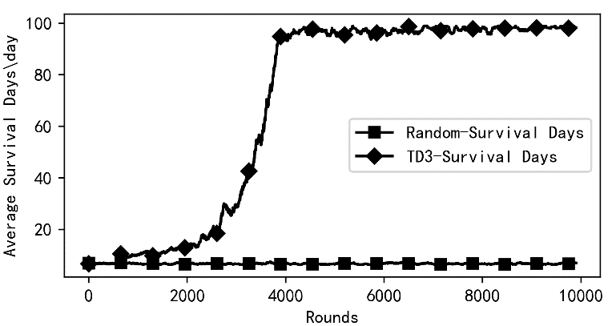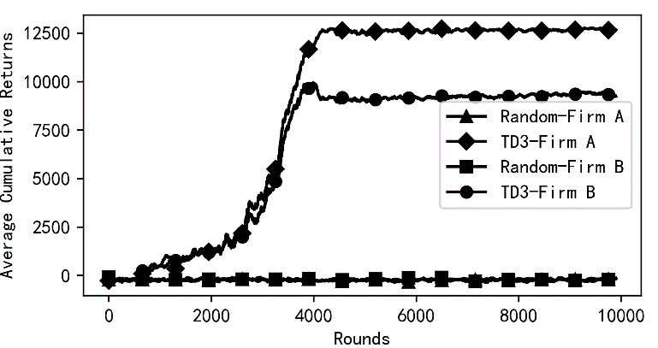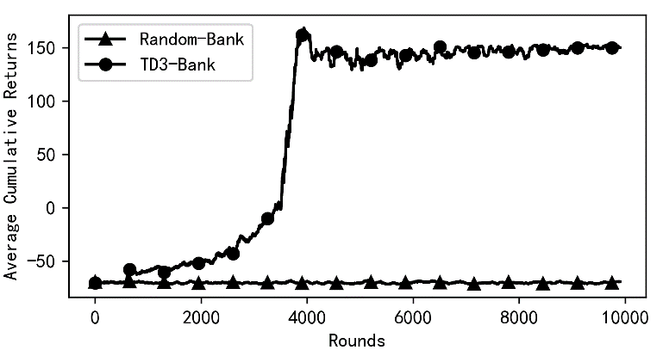 Fig. 5. Operational Comparison between TD3 Decision Models and Random Decision-making
(a) Survival Days
(b) Average Cumulative Returns of Firms

(c) Average Cumulative Returns of Banks

Decision Model Using Twin Delayed Deep Deterministic Policy Gradient with Long Short-Term Memory Algorithm
The TD3 algorithm has issues with decreased stability and excessive bias in CES. To improve the robustness of the TD3 algorithm and address the problem of long-term dependencies, this paper introduces LSTM networks to optimize the TD3 network structure, resulting in the design and implementation of the Twin Delayed Deep Deterministic Policy Gradient with Long Short-Term Memory (TD3_LSTM) algorithm decision model.

Model Principles and Structure Design
LSTM[13] is a special variant of Recurrent Neural Networks (RNN) that can effectively remember long-term dependencies when processing sequential data. Referring to the network architecture design by Lingheng [16], the TD3_LSTM network architecture designed in this paper is shown in Fig 6.
In this experiment, the basic settings, hyperparameters, and reward structures for the TD3_LSTM decision model are identical to those of the TD3 model. Fig 6 details the dimensions of the input and output vectors and the sizes of the hidden layers in the TD3_LSTM model, tailored to address the decision problem. Here, l is the historical sequence length, set to 6.
Fig. 6. Network Architecture of TD3_LSTM
It is important to note that the time length of the samples (sample duration) drawn from the experience pool when updating a network that includes an LSTM has significant importance. By setting a fixed sample duration, the LSTM can learn the local patterns and short-term dependencies of the input sequence within this time window. Specifically, in this paper, when updating the network, 500 samples are drawn from the experience pool, each with a duration of 6, consistent with the previously set l.
Under the TD3_LSTM network framework, N mini-batches of experiences${{\left({h_{t}}^{l},s_{t},a_{t},r_{t},s_{t+1}\right)}_{i}}_{i=1}^{N}$ are sampled from the experience pool $D$, where at time t, $s_{t}$is the state, $a_{t}$ is the action, $r_{t}$ is the reward, and$s_{t+1}$ is the next state. The historical state-action pair $h_{t}^{l}$ of length l is defined as follows:
$$h_{t}^{l}=\{\begin{matrix}s_{t-l},a_{t-l},⋯,s_{t-1},a_{t-1} & \text{ if }l,t≥1, \\ s^{0},a^{0} & \text{ Otherwise}\text{,} \end{matrix} （14）$$
where $s^0$ and $a^0$ are zero-value dummy state and action vectors, with dimensions identical to those of the normal state and action vectors. When $t<1$or $l<1$, no historical state-action pair is used, and the zero-value dummy state and action vectors are stored in the experience pool $D$ as experience. The pseudo-code for the TD3_LSTM algorithm is as follows:
Algorithm TD3_LSTM
Initialize critic networks$Q_{ω_{i}}\left(s,a\right)$, and actor network $μ_{θ}\left(s\right)$with random parameters $ω_{1},ω_{2},θ$
Initialize target networks $θ^{-}←θ,ω_{1}^{-}←ω_{1},ω_{2}^{-}←ω_{2}$
Initialize replay buffer $D$ and past history $h_{1}^{l}←0$
for t = 1 to T do
Select action with exploration noise $a_{t}=μ_{θ}\left(s_{t},h_{t}^{l}\right)+N\left(0,σ\right)$ and observe reward $r_{t}$ and new state $s_{t+1}$ Store transition tuple $\left(s_{t},a_{t},r_{t},s_{t+1}\right)$ in $D$
if done then: $h_{t+1}^{l}←0$
else: $h_{t+1}^{l}=\left(h_{t}^{l}-\left(s_{t-l},a_{t-l}\right)\right)∪\left(s_{t},a_{t}\right)$
end if
Sample mini-batch of N transitions ${{\left({h_{t}}^{l},s_{t},a_{t},r_{t},s_{t+1}\right)}_{i}}_{i=1}^{N}$ from $D$
$\tilde{a_{i}}=μ_{θ}^{-}\left(s_{i+1}\right)+clip\left(N\left(0,σ\right),-c,c\right)$
$y_{i}=r_{i}+γmin_{k=1,2}Q_{ω_{k}^{-}}\left(s_{i+1},\tilde{a}\right)$
Update critics $ω_{1},ω_{2}←L\left(ω_{i}\right)=E{\left[y_{i}-Q_{ω_{i}}\left(s_{i},\tilde{a_{i}}\right)\right]}^{2}$
if t mod c then
Update $θ$ by the deterministic policy gradient:
$θ←L\left(θ\right)=E\left[-Q_{ω_{1}}\left(s_{i},μ_{θ}\left(s_{i+1}\right)\right)\right]$
Update target networks:
$θ^{-}←\left(1-τ\right)θ^{-}+τ$ , $ω^{-}←\left(1-τ\right)ω_{i}^{-}+τω_{i}$
end if
end for

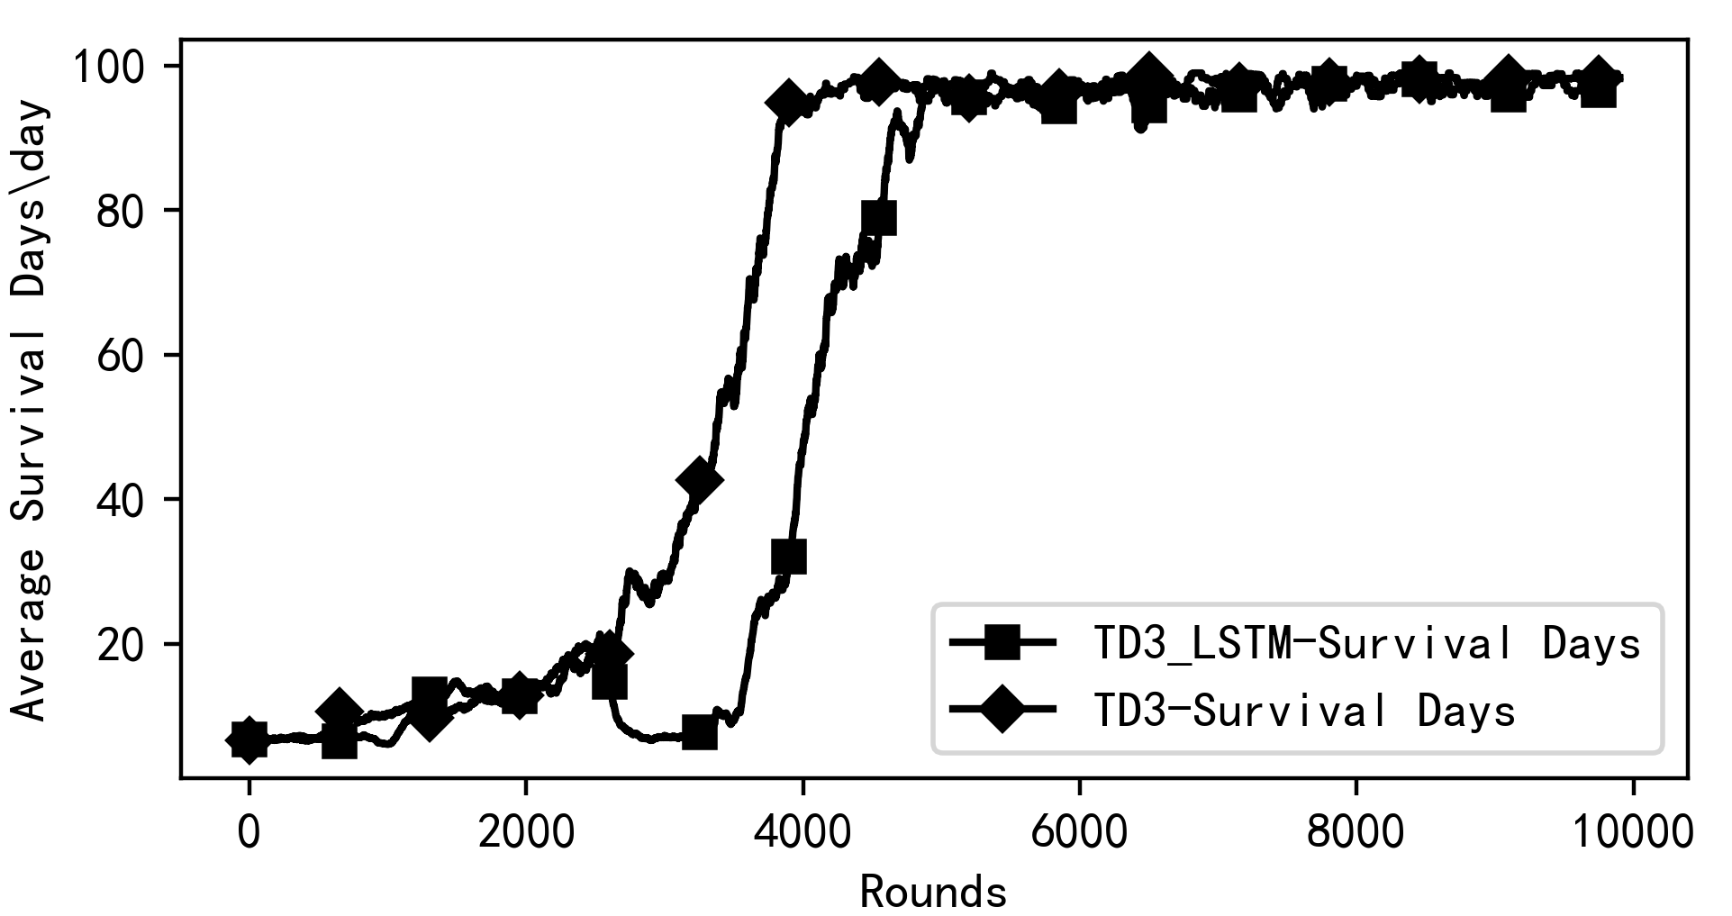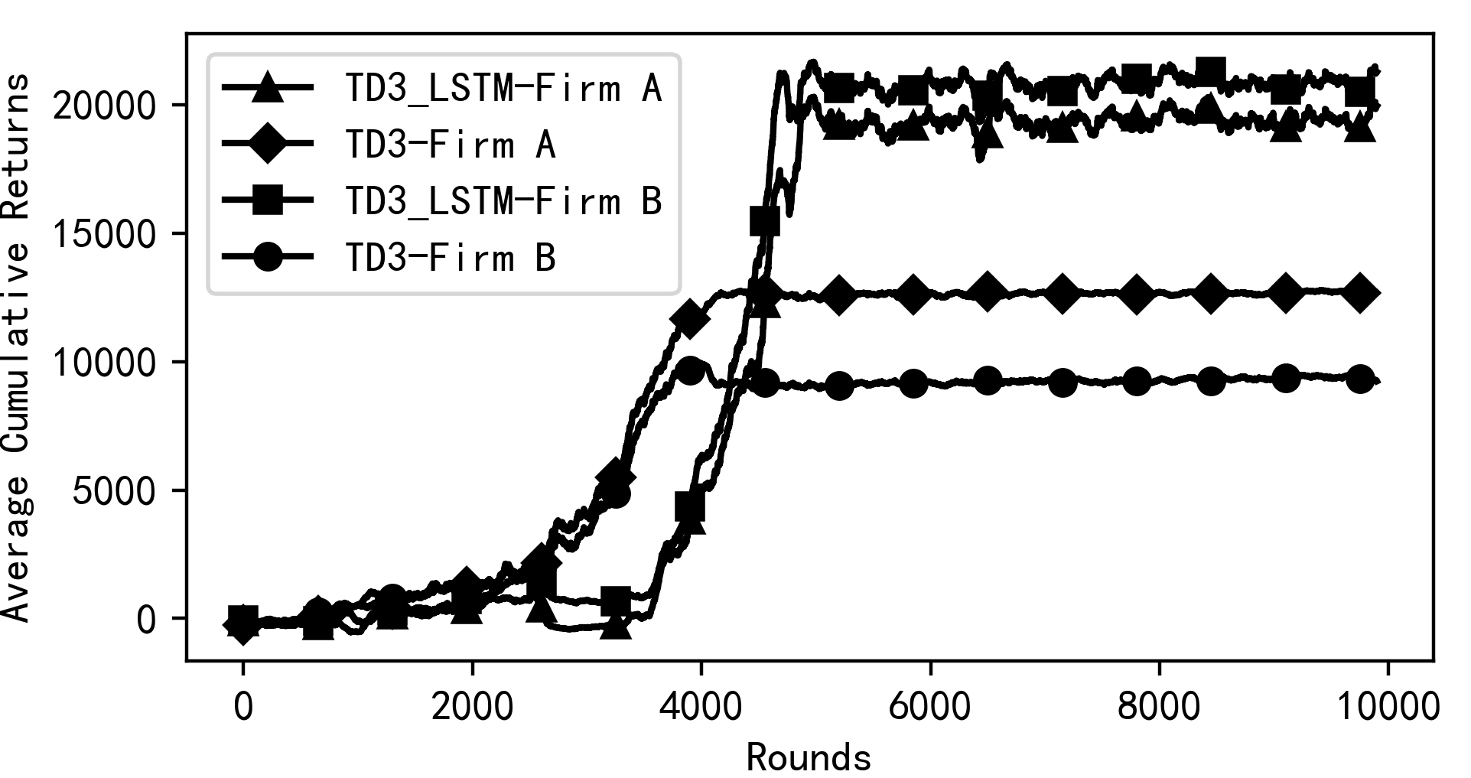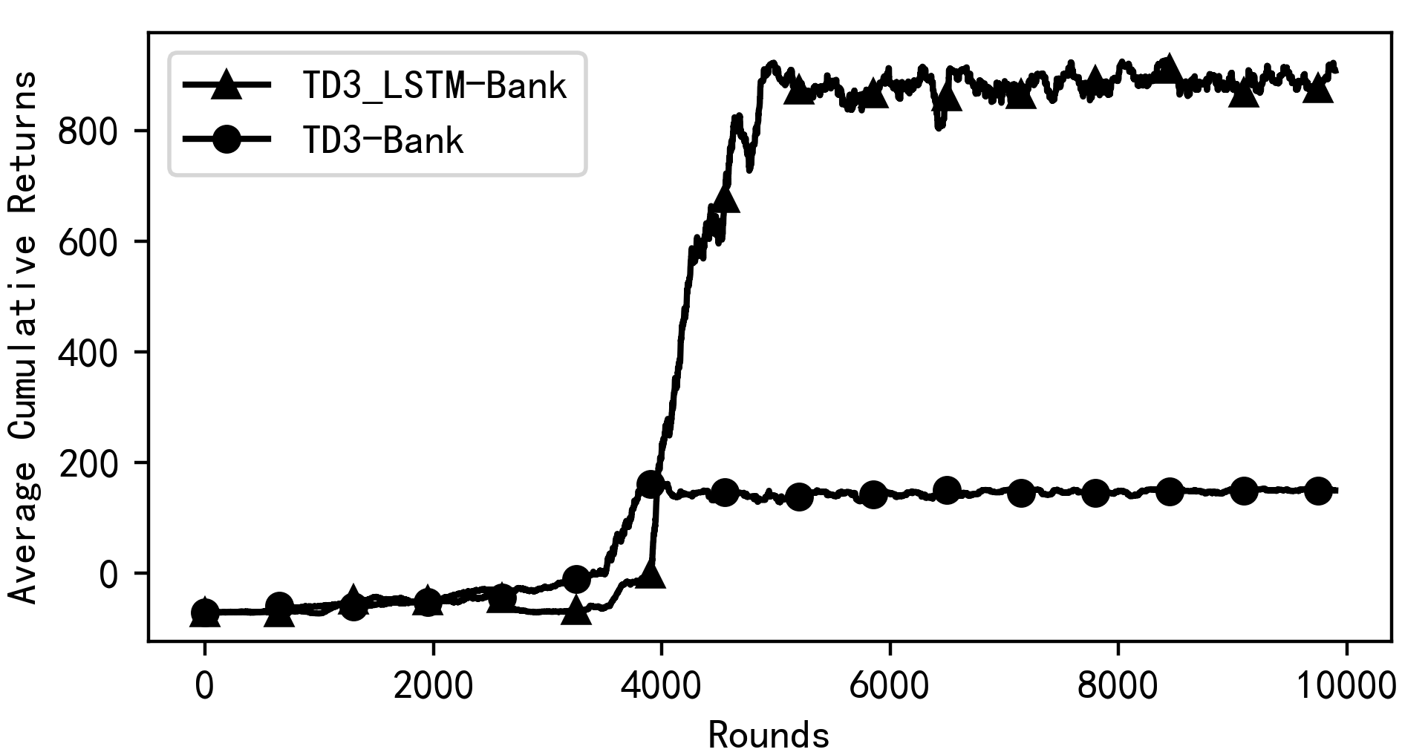Fig. 7. Operational Comparison between LSTM_TD3 Decision Models and TD3 Decision Models
(a) Survival Days
(b) Average Cumulative Returns of Firms
(c) Average Cumulative Returns of Banks

Experimental Results
This section compares the TD3_LSTM decision-making method with the traditional TD3 method through simulation experiments, with findings presented in Fig 7. Both methods stabilize at a 100-day survival limit, as depicted in Fig 7(a). The average cumulative returns of both methods stabilize within a similar range, indicating a Nash equilibrium, as shown in Fig 7(b). Further analysis from Fig 7(b) and (c) shows that the TD3_LSTM model significantly outperforms the TD3 model in average cumulative returns for both firms and banks. The TD3_LSTM model adopts higher pricing and more aggressive purchasing strategies, which enables firms to increase production and optimize pricing for maximum returns. Banks using this model issue loans at levels that maximize interest income while mitigating excessive risk. The LSTM component enhances firms' ability to quickly adjust pricing at the start of a round, leading to increased borrowing and income for both firms and banks.
Overall, the TD3_LSTM model shows more intelligent agent behavior, higher efficiency, and accuracy in managing time-series data, leading to superior returns and closer alignment with real-world market dynamics.

Conclusion
This paper develops a Multi-agent Simulation (MAS) model of a complex economic system (CES) and integrates a TD3-based economic agent decision model to enhance agent intelligence. The operation of the TD3 algorithm is thoroughly explained, and its effectiveness is validated through comparative experiments with a random decision approach. These experiments demonstrate that economic agents can sustain themselves, increase their benefits, and perform in ways that mirror real-world market behaviors.
Building on this, the study incorporates an LSTM network into the TD3 algorithm, forming the TD3_LSTM decision model. The enhanced model is experimentally shown to surpass the traditional TD3 model in simulation performance. By applying LSTM, the TD3_LSTM model boosts predictive capabilities, improves efficiency and accuracy with time-series data, and enables agents to make more proactive decisions that yield greater benefits and align more closely with actual market dynamics.

acknowledgment
This project was supported by the National Natural Science Foundation of China (Grant no.70973022), the National Social Science Foundation of China Youth Project (Grant no.15CJL003), and Fujian Key Laboratory of Network Computing and Intelligent Information Processing (Fuzhou University).

references
- W. Eichhorn and J. Voeller, Theory of the Price Index: Fisher’s Test Approach and Generalizations. Berlin, Germany: Springer-Verlag, 1976.
- G. Q. Hua, “Research on simulation of complex economic systems based on agents,” M.S. thesis, Taiyuan University of Science and Technology, Taiyuan, China, 2011.
- J. H. Holland, Hidden Order: How Adaptation Builds Complexity. Reading, MA: Addison-Wesley, 1995.
- P.-O. Siebers and U. Aickelin, “Introduction to multi-agent simulation,” in Encyclopedia of Decision Making and Decision Support Technologies, IGI Global, 2008, pp. 554-564.
- V. Dutt, “Explaining human behavior in dynamic tasks through reinforcement learning,” J. Adv. Inf. Technol., vol. 2, pp. 177–188, 2011.
- S. Zheng, A. Trott, S. Srinivasa, and C. Wu, “The AI economist: Improving equality and productivity with AI-driven tax policies,” arXiv:2004.13332 [econ.GN], 2020.
- A. Shavandi and M. Khedmati, “A multi-agent deep reinforcement learning framework for algorithmic trading in financial markets,” Expert Syst. Appl., vol. 208, p. 13, 2022.
- D. Wang, W. Zhang, B. Song, and Y. Liu, “Market-based model in CR-IoT: A Q-probabilistic multi-agent reinforcement learning approach,” IEEE Trans. Cogn. Commun. Netw., vol. 6, no. 1, pp. 179-188, 2020.
- Y. Zhang, et al., “Field deployment of multi-agent reinforcement learning based variable speed limit controllers,” arXiv preprint arXiv:2407.08021, 2024.
- Y. Zhang, et al., “Marvel: multi-agent reinforcement-learning for large-scale variable speed limits,” arXiv preprint arXiv:2310.12359, 2023.
- N. Muslim, S. Islam, and J.-C. Grégoire, “Reinforcement learning based offloading framework for computation service in the edge cloud and core cloud,” J. Adv. Inf. Technol., vol. 13, no. 2, pp. 139–146, Apr. 2022.
- S. Fujimoto, H. van Hoof, and D. Meger, “Addressing function approximation error in actor-critic methods,” arXiv:1802.09477 [cs.LG], 2018.
- S. Hochreiter and J. Schmidhuber, “Long short-term memory,” Neural Comput., vol. 9, no. 8, pp. 1735-1780, 1997.
- T. P. Lillicrap, J. J. Hunt, A. Pritzel, and N. Heess, “Continuous control with deep reinforcement learning,” arXiv:1509.02971 [cs.LG], 2015.
- J. F. Nash Jr., “Equilibrium points in n-person games,” Proc. Natl. Acad. Sci., vol. 36, no. 1, pp. 48-49, 1950.
- L. Mnih, R. Goroshin, and D. Krueger, “Memory-based deep reinforcement learning for POMDPs,” in Proc. 2021 IEEE/RSJ Int. Conf. Intell. Robot. Syst. (IROS 2021), Prague, Czech Republic, 2021, pp. 5619-5626.

