**实验二 布局的使用**

**一、实验目的**

**掌握安卓布局之线性布局，约束布局，表格布局**

**二、实验环境（实验的软件、硬件环境）**

硬件：PC机 软件：Android Studio

**三、实验步骤**

线性布局：

代码：

<?xml version="1.0" encoding="utf-8"?>  
<LinearLayout xmlns:android="http://schemas.android.com/apk/res/android"  
 android:layout_width="match_parent"  
 android:layout_height="match_parent"  
 android:orientation="vertical">  
 <LinearLayout  
 android:layout_width="match_parent"  
 android:layout_height="60dp"  
 android:orientation="horizontal">  
  
 <Button  
 android:layout_width="0dp"  
 android:layout_weight="2"  
 android:hint="请输入账户名"  
 android:layout_height="match_parent" />  
 <Button  
 android:layout_width="0dp"  
 android:layout_height="match_parent"  
 android:hint="222"  
 android:layout_weight="3"/>  
 <Button  
 android:layout_width="0dp"  
 android:layout_weight="2"  
 android:hint="请输入账户名"  
 android:layout_height="match_parent" />  
 <Button  
 android:layout_width="0dp"  
 android:layout_weight="2"  
 android:hint="请输入账户名"  
 android:layout_height="match_parent" />  
 </LinearLayout>  
 <LinearLayout  
 android:layout_width="match_parent"  
 android:layout_height="60dp"  
 android:orientation="horizontal">  
 <Button  
 android:layout_width="0dp"  
 android:layout_weight="2"  
 android:hint="请输入账户名"  
 android:layout_height="match_parent" />  
 <Button  
 android:layout_width="0dp"  
 android:layout_height="match_parent"  
 android:hint="222"  
 android:layout_weight="3"/>  
 <Button  
 android:layout_width="0dp"  
 android:layout_weight="2"  
 android:hint="请输入账户名"  
 android:layout_height="match_parent" />  
 <Button  
 android:layout_width="0dp"  
 android:layout_weight="2"  
 android:hint="请输入账户名"  
 android:layout_height="match_parent" />  
 </LinearLayout>  
 <LinearLayout  
 android:layout_width="match_parent"  
 android:layout_height="60dp"  
 android:orientation="horizontal">  
 <Button  
 android:layout_width="0dp"  
 android:layout_weight="1"  
 android:hint="请输入账户名"  
 android:layout_height="match_parent" />  
 <Button  
 android:layout_width="0dp"  
 android:layout_height="match_parent"  
 android:hint="222"  
 android:layout_weight="1"/>  
 <Button  
 android:layout_width="0dp"  
 android:layout_weight="1"  
 android:hint="请输入账户名"  
 android:layout_height="match_parent" />  
 <Button  
 android:layout_width="0dp"  
 android:layout_weight="1"  
 android:hint="请输入账户名"  
 android:layout_height="match_parent" />  
 </LinearLayout>  
  
 <LinearLayout  
 android:layout_width="match_parent"  
 android:layout_height="60dp"  
 android:orientation="horizontal">  
 <Button  
 android:layout_width="0dp"  
 android:layout_weight="3"  
 android:hint="请输入账户名"  
 android:layout_height="match_parent" />   
 <Button  
 android:layout_width="0dp"  
 android:layout_height="match_parent"  
 android:hint="222"  
 android:layout_weight="4"/>  
 <Button  
 android:layout_width="0dp"  
 android:layout_weight="3"  
 android:hint="请输入账户名"  
 android:layout_height="match_parent" />  
 <Button  
 android:layout_width="0dp"  
 android:layout_weight="3"  
 android:hint="请输入账户名"  
 android:layout_height="match_parent" />  
 </LinearLayout>  
</LinearLayout>

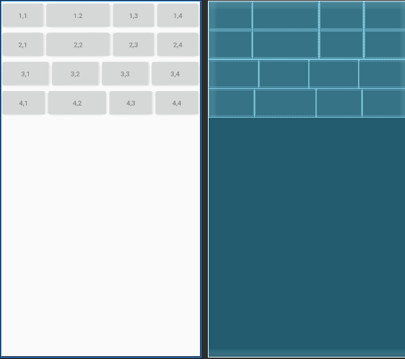

约束布局

<androidx.constraintlayout.widget.ConstraintLayout  
 xmlns:android="http://schemas.android.com/apk/res/android"  
 xmlns:app="http://schemas.android.com/apk/res-auto"  
 android:layout_width="match_parent"  
 android:layout_height="match_parent">>  
 <Button  
 android:id="@+id/one"  
 android:layout_width="wrap_content"  
 android:layout_height="wrap_content"  
 android:text="左对齐"  
 app:layout_constraintLeft_toLeftOf="parent"  
 app:layout_constraintTop_toTopOf="parent"  
 />  
 <Button  
 android:id="@+id/two"  
 android:layout_width="wrap_content"  
 android:layout_height="wrap_content"  
 android:text="水平居中"  
 app:layout_constraintLeft_toLeftOf="parent"  
 app:layout_constraintRight_toRightOf="parent"  
 app:layout_constraintTop_toTopOf="parent"/>  
 <Button  
 android:id="@+id/three"  
 android:layout_width="wrap_content"  
 android:layout_height="wrap_content"  
 android:text="右对齐"  
 app:layout_constraintRight_toRightOf="parent"  
 app:layout_constraintTop_toTopOf="parent"  
 />  
 <Button  
 android:layout_width="wrap_content"  
 android:layout_height="wrap_content"  
 android:id="@+id/four"  
 app:layout_constraintRight_toLeftOf="@+id/five"  
 app:layout_constraintTop_toBottomOf="@+id/two"/>  
  
 <Button  
 android:layout_width="wrap_content"  
 android:layout_height="wrap_content"  
 android:id="@+id/five"  
 app:layout_constraintTop_toBottomOf="@+id/two"  
 app:layout_constraintLeft_toLeftOf="parent"  
 app:layout_constraintRight_toRightOf="parent"/>  
 <Button  
 android:layout_width="wrap_content"  
 android:layout_height="wrap_content"  
 android:id="@+id/six"  
 app:layout_constraintLeft_toRightOf="@+id/five"  
 app:layout_constraintTop_toBottomOf="@+id/two"/>  
 <Button  
 android:layout_width="match_parent"  
 android:layout_height="wrap_content"  
 android:layout_marginBottom="556dp"  
 app:layout_constraintBottom_toBottomOf="parent"  
 app:layout_constraintLeft_toLeftOf="parent" />  
</androidx.constraintlayout.widget.ConstraintLayout>

效果图

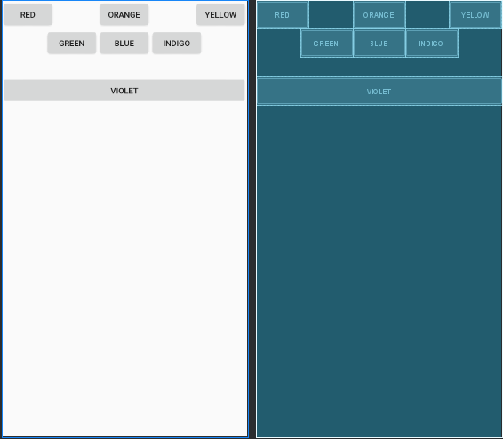

表格布局：代码

<TableLayout xmlns:android="http://schemas.android.com/apk/res/android"  
 android:layout_width="match_parent"  
 android:layout_height="match_parent"  
 android:stretchColumns="0">  
  
 <TableRow>  
 <Button  
 android:layout_width="match_parent"  
 android:layout_height="wrap_content"  
 android:text="open... ctrl-o"  
 ></Button>  
 </TableRow>  
 <TableRow>  
 <Button  
 android:layout_width="match_parent"  
 android:layout_height="wrap_content"  
 android:text="save... ctrl-s"  
 ></Button>  
 </TableRow>  
 <TableRow>  
 <Button  
 android:layout_width="match_parent"  
 android:layout_height="wrap_content"  
 android:text="save as... ctrl-shift-s"  
 ></Button>  
 </TableRow>  
  
 <TableRow>  
 <View  
 android:layout_width="match_parent"  
 android:layout_height="1dp"  
 android:background="#FF2300"/>  
 </TableRow>  
  
 <TableRow>  
 <Button  
 android:layout_width="match_parent"  
 android:layout_height="wrap_content"  
 android:text="import... "  
 ></Button>  
 </TableRow>  
 <TableRow>  
 <Button  
 android:layout_width="match_parent"  
 android:layout_height="wrap_content"  
 android:text="export... ctrl-E"  
 ></Button>  
 </TableRow>  
 <TableRow>  
 <View  
 android:layout_width="match_parent"  
 android:layout_height="1dp"  
 android:background="#FF2300"/>  
 </TableRow>  
 <TableRow>  
 <Button  
 android:layout_width="match_parent"  
 android:layout_height="wrap_content"  
 android:text="Quit... "></Button>  
 </TableRow>  
</TableLayout>

效果图

