


Informatics Institute of Technology

Department of Computing

BSc (Hons) Artificial Intelligence and Data Science

Module: CM2604 Machine Learning

Module Coordinator: Sahan Priyanayana

Coursework Report

Abstract

This report documents a machine learning solution that predicts customer churn for a telecommunications provider using the public Telco Customer Churn dataset of 7,043 customers. The corpus was cleaned, explored and transformed through a leakage-free scikit-learn pipeline that scales numeric attributes and one-hot encodes categorical attributes. Engineered features were also tested but did not improve cross-validated performance.
Three supervised classifiers, K-Nearest Neighbours, Logistic Regression and Random Forest, were trained under two experimental settings: default hyperparameters and hyperparameters tuned with 5-fold stratified grid search optimising F1. The tuned Random Forest achieved the best result on the held-out test set, with an F1-score of 0.631, recall of 0.791 and ROC-AUC of 0.844, identifying 296 of the 374 customers who actually churned.
The report also presents a fairness audit across gender and age groups, the ethical strategies followed during development, post-deployment strategies, and the limitations and possible enhancements of the work.

Acknowledgement

I would like to thank the module coordinator, Sahan Priyanayana, for the lectures and guidance that provided the foundation for this coursework. This project challenged me to think critically about how data preparation, model selection and evaluation choices affect the conclusions drawn from a machine learning experiment.

Table of Contents

I. Abstract i
II. Acknowledgement ii
III. Table of Contents iii
IV. List of Figures iv
V. List of Tables v
VI. List of Abbreviations vi
1. Introduction 1
2. Corpus Preparation 2
2.1. Dataset Overview 2
2.2. Data Cleaning 2
2.3. Exploratory Data Analysis 2
2.4. Preprocessing 5
2.5. Feature Engineering 6
3. Solution Methodology 7
3.1. Classification Models 7
3.2. Experimental Settings and Hyperparameter Tuning 7
4. Evaluation 8
4.1. Evaluation Criteria 8
4.2. Experimental Results 8
4.3. Feature Importance 9
5. AI Ethics 11
5.1. Strategies Followed During Development 11
5.2. Post-Deployment Strategies 11
6. Limitations and Future Enhancements 13
6.1. Limitations 13
6.2. Future Enhancements 13
7. Conclusion 14
8. References 15
Appendix A: Source Code 16

List of Figures

Figure 1 Class balance of the target variable 3
Figure 2 Churn rate by categorical attribute 4
Figure 3 Distribution of numeric attributes by churn status 5
Figure 4 Correlation between numeric attributes and churn 5
Figure 5 Churn rate by number of subscribed services 6
Figure 6 ROC curves of the tuned models 9
Figure 7 Confusion matrices of the tuned models 9
Figure 8 Top 15 feature importances of the tuned Random Forest 10

List of Tables

Table 1 Cross-validated F1 with and without engineered features 6
Table 2 Best hyperparameters found by grid search 7
Table 3 Test set results for both experimental settings 8
Table 4 Fairness audit of the tuned Random Forest on the test set 11

List of Abbreviations

AUC – Area Under the Curve
CV – Cross-Validation
DSL – Digital Subscriber Line
EDA – Exploratory Data Analysis
GDPR – General Data Protection Regulation
KNN – K-Nearest Neighbours
ML – Machine Learning
ROC – Receiver Operating Characteristic

1. Introduction

Customer churn occurs when a subscriber cancels a service, taking their recurring revenue with them. If customers who are likely to leave can be identified early, a provider can intervene with a targeted retention offer. This report documents a binary classification solution that predicts whether a telecommunications customer will churn, using the Telco Customer Churn dataset (BlastChar, 2018).
Three supervised algorithms, K-Nearest Neighbours (KNN), Logistic Regression and Random Forest, were implemented with scikit-learn (Pedregosa et al., 2011) and compared under two experimental settings: default and tuned hyperparameters. The report covers corpus preparation, solution methodology, evaluation, AI ethics, limitations and future enhancements. The implementation is governed through Git and is publicly available at https://github.com/YJaruban/CW. The full source code is included in Appendix A.

2. Corpus Preparation

2.1. Dataset Overview

The dataset contains 7,043 customers and 21 attributes. These describe demographics (gender, senior citizen, partner, dependents), the account (tenure, contract, billing and payment method, monthly and total charges) and the subscribed services (phone, internet and six add-ons such as online security and tech support). The target attribute, Churn, records whether the customer left.

2.2. Data Cleaning

An initial inspection reported no missing values and no duplicate rows. However, TotalCharges was stored as text rather than as a number. Converting it revealed 11 blank entries, all belonging to customers with a tenure of zero months.
Justification: These are new customers who have not yet been billed, so the blanks were replaced with 0 instead of deleting the rows, which would have removed genuine information. The customerID column was dropped because a unique identifier has no predictive value. Churn was mapped to 1/0, and SeniorCitizen was converted from 1/0 to Yes/No so that every categorical attribute is handled consistently by the encoder.

2.3. Exploratory Data Analysis

Class balance: Only 1,869 customers (26.5%) churned, while 5,174 (73.5%) stayed. A model that always predicts “stayed” would therefore reach 73.5% accuracy while being useless, so accuracy alone is misleading on imbalanced data (He and Garcia, 2009). This insight motivated the stratified split and the choice of F1 as the tuning metric.
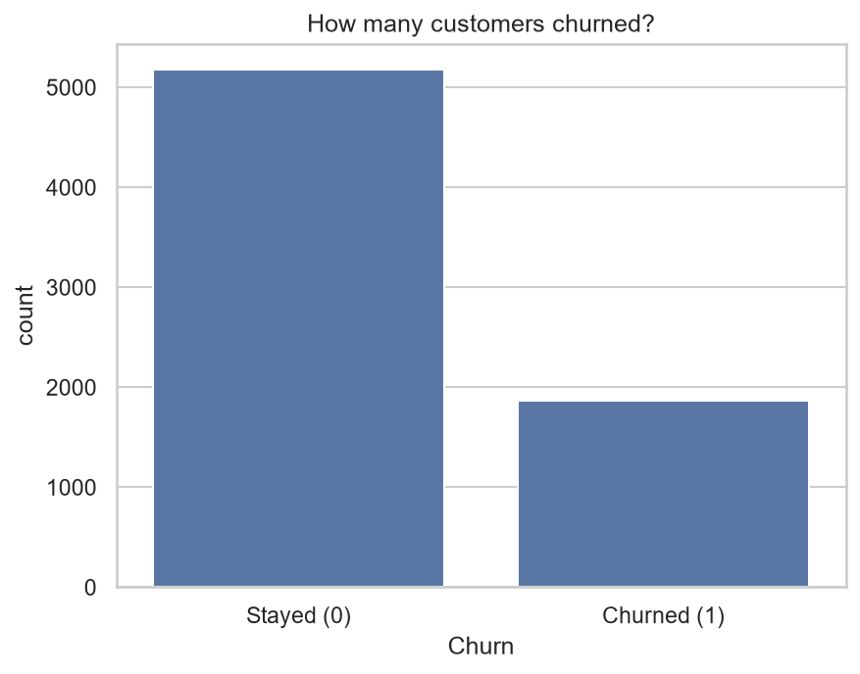
Figure 1 Class balance of the target variable
Categorical attributes: Contract type is the strongest signal: 42.7% of month-to-month customers churned, compared with 11.3% on one-year and 2.8% on two-year contracts. Churn is also high for fibre optic internet (41.9% against 19.0% for DSL), electronic check payment (45.3%), and customers without tech support (41.6%) or online security (41.8%). Senior citizens churn more (41.7% against 23.6%), whereas gender shows almost no difference (26.9% against 26.2%).
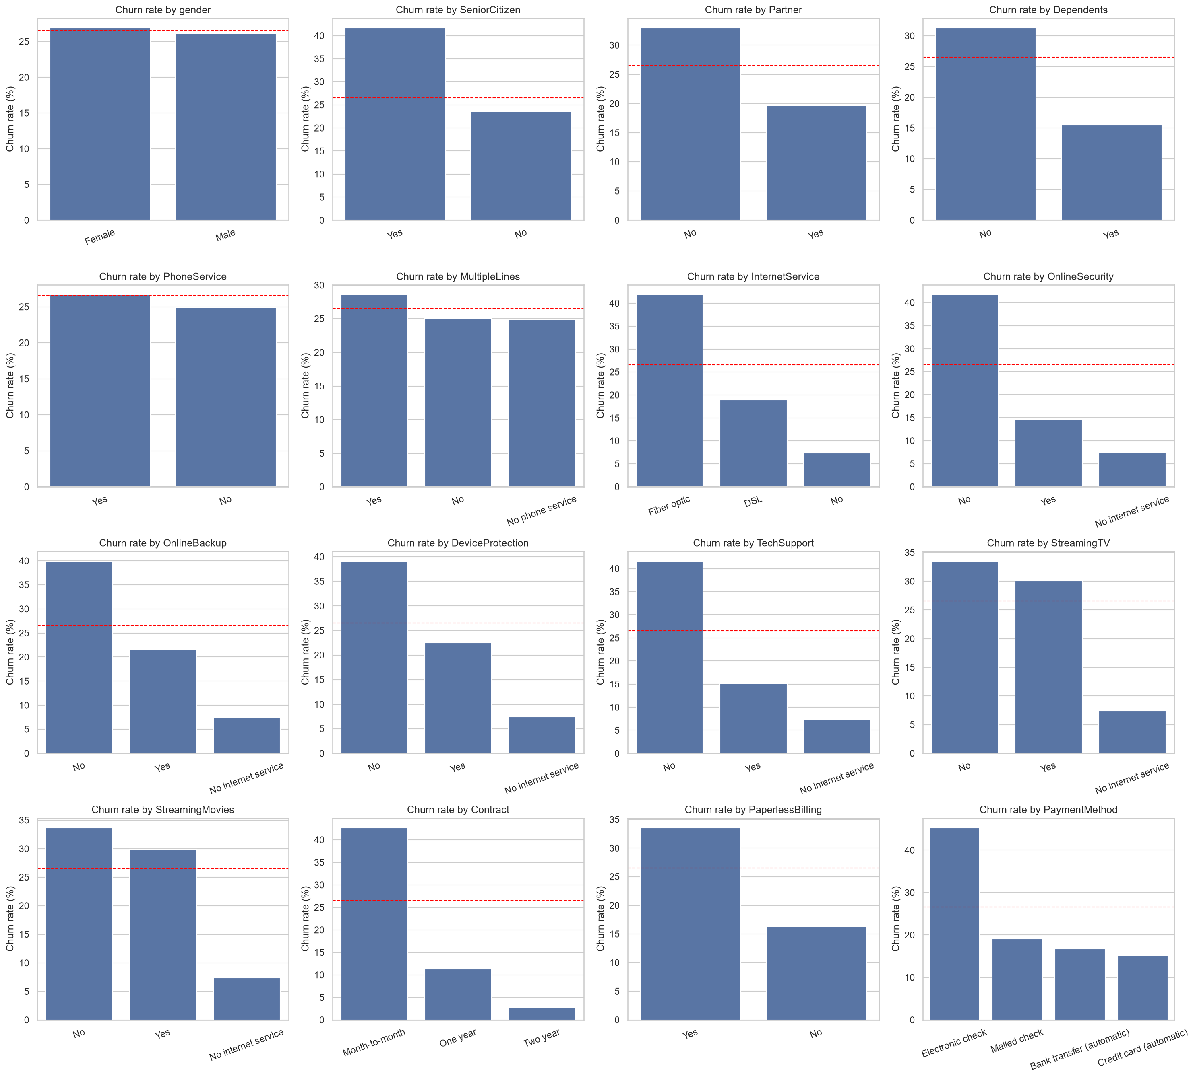
Figure 2 Churn rate by categorical attribute
Numeric attributes: Churned customers have a median tenure of 10 months against 38 months for those who stayed, and a higher median monthly charge (79.65 against 64.43). Churn is therefore concentrated among new customers with expensive plans. The IQR rule found no outliers in any numeric attribute, so no records were removed.
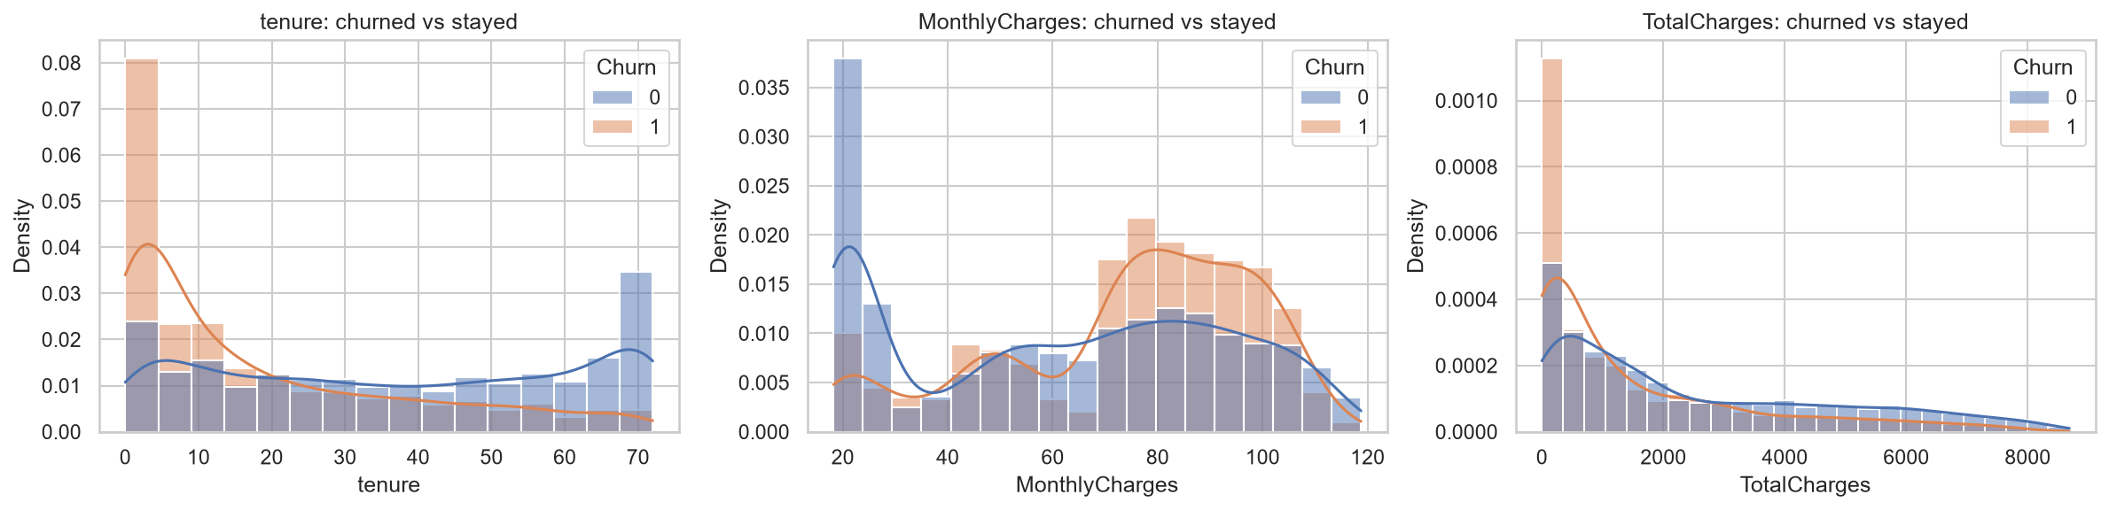
Figure 3 Distribution of numeric attributes by churn status
Correlation: Tenure has the strongest linear relationship with churn (−0.35), followed by TotalCharges (−0.20) and MonthlyCharges (0.19). Tenure and TotalCharges are highly correlated (0.83); in fact TotalCharges is almost exactly tenure multiplied by MonthlyCharges (r ≈ 1.00). The attribute was kept because regularisation handles this multicollinearity.
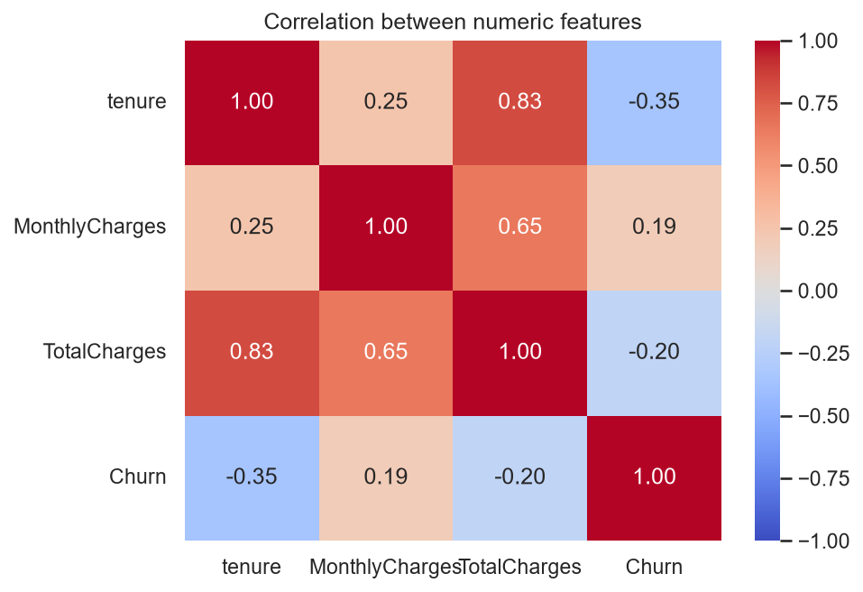
Figure 4 Correlation between numeric attributes and churn

2.4. Preprocessing

The data was split 80/20 into 5,634 training and 1,409 test customers, stratified on the target so both sets keep the 26.5% churn rate. A ColumnTransformer then applies two transformations:
- StandardScaler on tenure, MonthlyCharges and TotalCharges, giving each a mean of zero and unit variance.
- OneHotEncoder on the 16 categorical attributes, converting each category into a binary column.
Justification: KNN is distance-based, so without scaling TotalCharges (ranging into the thousands) would dominate every distance calculation. Scaling also makes the regularisation in Logistic Regression treat all coefficients equally. One-hot encoding avoids imposing a false order on nominal categories such as payment method. The transformer and classifier were combined in a single Pipeline, so the scaler and encoder are fitted only on training data within each cross-validation fold, which prevents data leakage from the validation and test sets.

2.5. Feature Engineering

Three engineered features were tested. The redundant “No internet service” and “No phone service” levels were merged into “No”, NumServices counts the services a customer subscribes to, and TenureGroup bands tenure into four ranges. Churn peaks at three services (about 44%) and falls to about 5% for customers with nine.
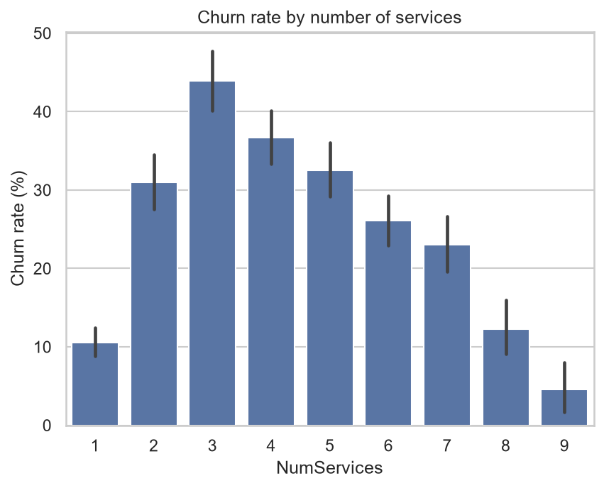
Figure 5 Churn rate by number of subscribed services
However, when the tuned models from Section 3.2 were re-evaluated with 5-fold cross-validation, the engineered features did not improve F1 for any model (Table 1); every difference is within one standard deviation. They mostly re-express information already present in tenure and the service attributes, so the original feature set was kept.
Table 1 Cross-validated F1 with and without engineered features
Model | Original features (CV F1) | Engineered features (CV F1)
KNN | 0.610 ± 0.023 | 0.600 ± 0.016
Logistic Regression | 0.629 ± 0.021 | 0.626 ± 0.020
Random Forest | 0.634 ± 0.020 | 0.631 ± 0.019

3. Solution Methodology

3.1. Classification Models

K-Nearest Neighbours: KNN classifies a customer by a majority vote of the k most similar training customers (Cover and Hart, 1967). It makes no assumption about the shape of the data but is sensitive to feature scale and to the choice of k.
Logistic Regression: This linear model estimates the probability of churn by passing a weighted sum of the features through the sigmoid function (Hosmer, Lemeshow and Sturdivant, 2013). It is fast and interpretable, but assumes a linear relationship with the log-odds.
Random Forest: An ensemble of decision trees, each trained on a bootstrap sample with a random subset of features, whose votes are averaged (Breiman, 2001). Averaging reduces the variance of individual trees and captures non-linear interactions.

3.2. Experimental Settings and Hyperparameter Tuning

Experiment 1 (Default): Each model was trained with scikit-learn’s default hyperparameters on the preprocessing pipeline, providing a baseline.
Experiment 2 (Tuned): GridSearchCV was used with 5-fold stratified cross-validation on the training set only, optimising F1. The grids covered 100 combinations for KNN (odd k from 3 to 51, weighting scheme and distance metric), 24 for Logistic Regression (regularisation strength C, L1 or L2 penalty and class weighting) and 80 for Random Forest (number of trees, maximum depth, minimum samples per leaf and class weighting).
Justification: The class_weight=“balanced” option was included to address the imbalance found in the EDA. It penalises errors on the minority churn class more heavily without creating synthetic records. The best configurations are shown in Table 2.
Table 2 Best hyperparameters found by grid search
Model | Best hyperparameters | CV F1
KNN | n_neighbors = 47, weights = uniform, metric = euclidean | 0.610 ± 0.023
Logistic Regression | C = 0.1, penalty = L2, class_weight = balanced | 0.629 ± 0.021
Random Forest | n_estimators = 100, max_depth = None, min_samples_leaf = 10, class_weight = balanced | 0.634 ± 0.020

4. Evaluation

4.1. Evaluation Criteria

All models were evaluated on the untouched test set using accuracy, precision, recall, F1-score and ROC-AUC. Missing a customer who is about to leave (a false negative) loses that customer, whereas a false alarm only costs a retention offer. Recall and F1 on the churn class are therefore treated as the optimal metrics, supported by ROC-AUC, which measures ranking quality independently of the decision threshold. Accuracy is reported for completeness only.

4.2. Experimental Results

Table 3 Test set results for both experimental settings
Model | Setting | Accuracy | Precision | Recall | F1 | ROC-AUC
KNN | Default | 0.757 | 0.542 | 0.553 | 0.548 | 0.788
Logistic Regression | Default | 0.806 | 0.657 | 0.559 | 0.604 | 0.842
Random Forest | Default | 0.782 | 0.613 | 0.487 | 0.542 | 0.818
KNN | Tuned | 0.783 | 0.591 | 0.588 | 0.590 | 0.832
Logistic Regression | Tuned | 0.741 | 0.508 | 0.786 | 0.617 | 0.841
Random Forest | Tuned | 0.754 | 0.525 | 0.791 | 0.631 | 0.844

Default setting: Logistic Regression was the strongest baseline (F1 0.604, ROC-AUC 0.842). The default Random Forest grows unrestricted trees and found fewer than half of the churners (recall 0.487). All three baselines missed between 44% and 51% of churners.
Tuned setting: Increasing k from 5 to 47 smoothed KNN’s noisy neighbourhoods, raising ROC-AUC from 0.788 to 0.832. For Random Forest, limiting leaves to at least 10 samples and balancing the class weights raised recall from 0.487 to 0.791 and F1 from 0.542 to 0.631, the best result overall. Logistic Regression’s recall rose from 0.559 to 0.786, but its ROC-AUC was unchanged (0.842 to 0.841), showing that tuning shifted its decision boundary rather than improving how well it ranks customers.
Trade-off: Accuracy fell for the two class-weighted models because they now accept more false alarms in exchange for catching more churners, which is a deliberate trade-off given the evaluation criteria. The cross-validation F1 scores in Table 2 closely match the test scores, indicating that the tuned models generalise. However, their standard deviations (about 0.02) exceed the gap between Random Forest and Logistic Regression, so that difference is not conclusive.
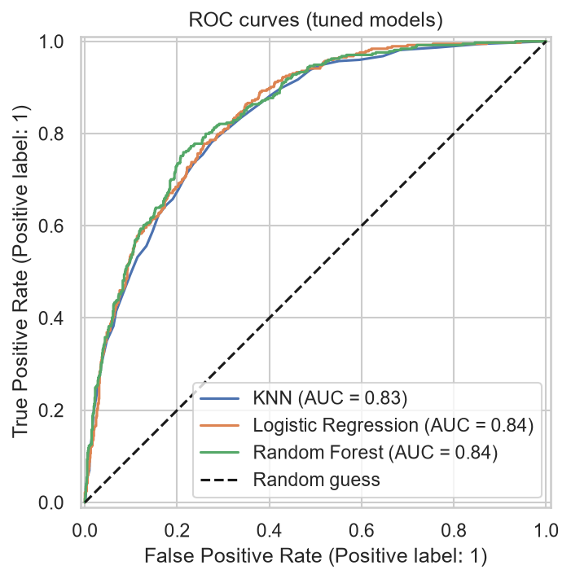
Figure 6 ROC curves of the tuned models
The confusion matrices show that the tuned Random Forest identified 296 of the 374 actual churners with 268 false alarms. Logistic Regression identified 294 with 285 false alarms, while KNN identified only 220. Random Forest was therefore selected as the final model.
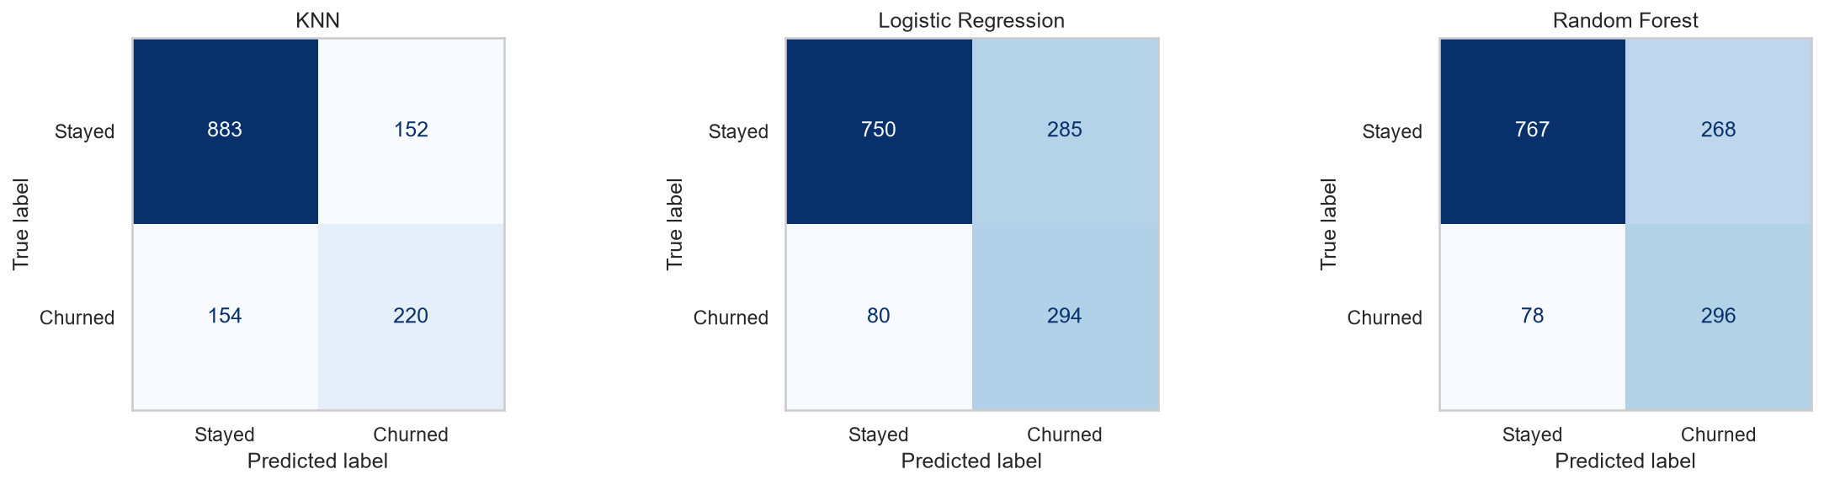
Figure 7 Confusion matrices of the tuned models

4.3. Feature Importance

The most important features of the tuned Random Forest are a month-to-month contract, tenure, total charges, a two-year contract and the absence of online security. This agrees with the EDA insights, which gives confidence that the model has learned genuine patterns.
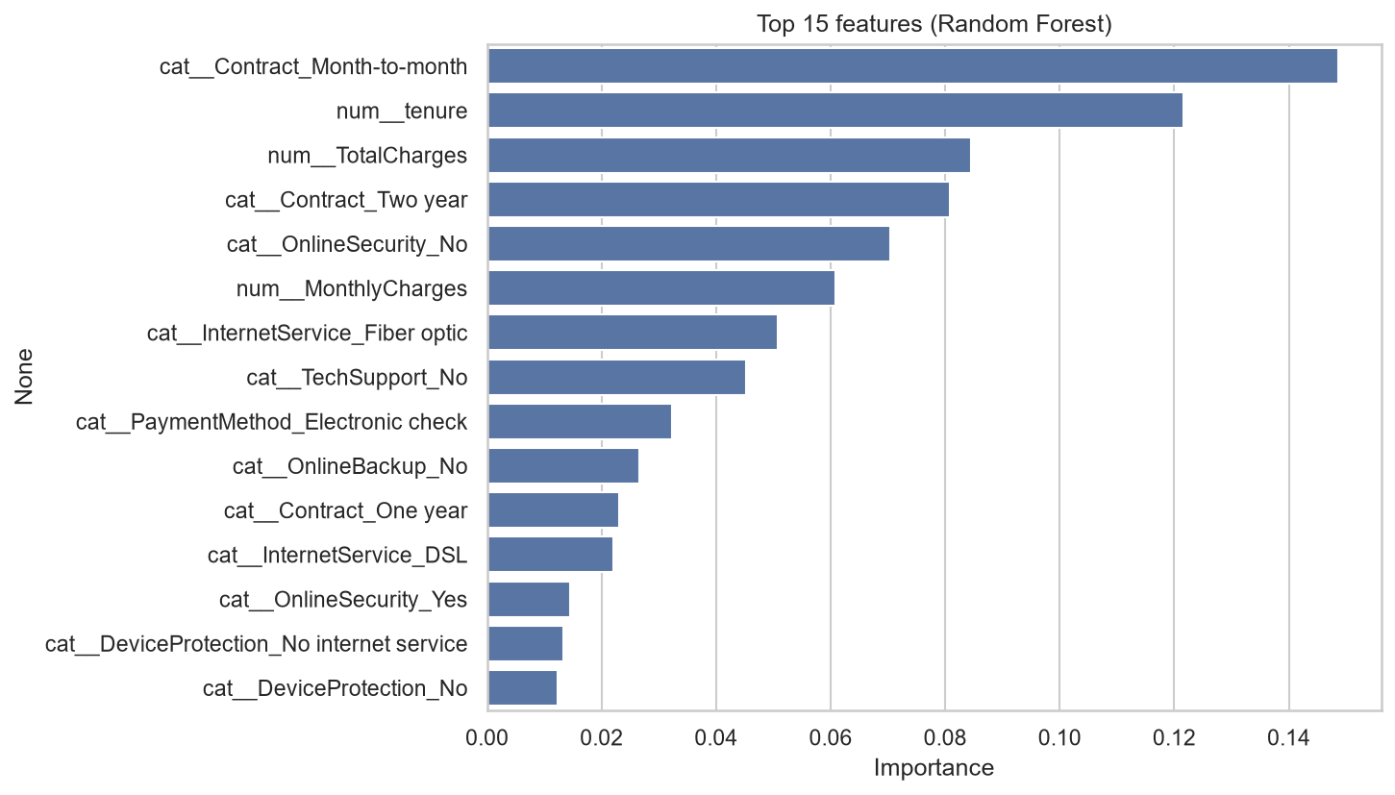
Figure 8 Top 15 feature importances of the tuned Random Forest

5. AI Ethics

5.1. Strategies Followed During Development

Privacy and data minimisation: The dataset is public and anonymised, and the customerID was removed before modelling so that no prediction can be traced to an individual from the features.
Honest evaluation and reproducibility: The test set was held out from all fitting and tuning, random seeds were fixed, and every change is recorded in Git, so the reported results can be reproduced and audited.
Fairness audit: The selected model was evaluated separately for gender and senior citizen groups (Table 4), since unequal error rates between groups are a recognised source of harm (Mehrabi et al., 2021).
Table 4 Fairness audit of the tuned Random Forest on the test set
Group | Customers | Actual churn % | Flagged % | Recall | Precision
Female | 687 | 28.1 | 39.2 | 0.772 | 0.554
Male | 722 | 25.1 | 40.9 | 0.812 | 0.498
Non-senior | 1187 | 23.3 | 35.5 | 0.754 | 0.494
Senior | 222 | 44.1 | 64.4 | 0.898 | 0.615

Performance across gender is similar, with recall of 0.772 for female and 0.812 for male customers. Senior citizens are flagged far more often (64.4% against 35.5%), which largely reflects their higher actual churn rate, and churners in this group are detected more reliably (recall 0.898 against 0.754). This gap must be monitored so that retention offers are not distributed unequally.
Protected attributes: The model was retrained without gender and performance was unchanged (F1 0.634 against 0.631, ROC-AUC 0.843 against 0.844). Gender adds no predictive value, so it should be excluded from any deployed model.

5.2. Post-Deployment Strategies

- Performance and drift monitoring: Prices, plans and customer behaviour change over time, causing concept drift (Gama et al., 2014). Recall, precision and input distributions should be tracked regularly and the model retrained when they degrade.
- Recurring fairness audits: The audit in Table 4 should be repeated on live data, because bias can emerge after deployment.
- Human oversight: Predictions should support retention staff, not trigger automatic decisions. The model must never be used to deny service or to raise prices for customers predicted to stay.
- Privacy and legal compliance: Customer data must be processed under applicable data protection law such as GDPR, with access control, limited retention and clear communication to customers about how their data is used.
- Feedback loops: Retention offers change customer behaviour, which contaminates future training labels. A small control group should be kept to measure the true effect.

6. Limitations and Future Enhancements

6.1. Limitations

- The dataset is a single snapshot from one provider with no time dimension, so the results may not generalise to other markets or periods.
- Results are based on a single train/test split, and the differences between the tuned models are small, so the ranking may change with a different split.
- Precision is approximately 0.52, meaning almost half of the flagged customers would not have churned.
- The default decision threshold of 0.5 was used and was not optimised against business costs.
- The engineered features tested were simple; richer interaction features were not explored.
- Fairness was audited for two attributes only.

6.2. Future Enhancements

- Tune the decision threshold using the real cost of a lost customer and of a retention offer.
- Explore interaction features and remove the redundant TotalCharges attribute.
- Compare resampling techniques such as SMOTE against class weighting.
- Evaluate gradient boosting models and use repeated cross-validation to report confidence intervals.
- Add SHAP explanations to justify individual predictions to retention staff.

7. Conclusion

This coursework delivered a complete churn prediction workflow on the Telco Customer Churn dataset. The EDA showed that churn is driven mainly by short tenure, month-to-month contracts and high monthly charges, and that the classes are imbalanced. KNN, Logistic Regression and Random Forest were compared with default and tuned hyperparameters on a leakage-free pipeline. Tuning with class weighting substantially improved the detection of churners, and the tuned Random Forest performed best with an F1-score of 0.631, recall of 0.791 and ROC-AUC of 0.844. The fairness audit found no need for the gender attribute, and monitoring, human oversight and regular audits are recommended after deployment.

8. References

BlastChar, 2018. Telco Customer Churn. [online] Kaggle. Available at: https://www.kaggle.com/datasets/blastchar/telco-customer-churn [Accessed 30 September 2026].
Breiman, L., 2001. Random forests. Machine Learning, 45(1), pp.5–32.
Cover, T. and Hart, P., 1967. Nearest neighbor pattern classification. IEEE Transactions on Information Theory, 13(1), pp.21–27.
Gama, J., Žliobaitė, I., Bifet, A., Pechenizkiy, M. and Bouchachia, A., 2014. A survey on concept drift adaptation. ACM Computing Surveys, 46(4), pp.1–37.
He, H. and Garcia, E.A., 2009. Learning from imbalanced data. IEEE Transactions on Knowledge and Data Engineering, 21(9), pp.1263–1284.
Hosmer, D.W., Lemeshow, S. and Sturdivant, R.X., 2013. Applied Logistic Regression. 3rd ed. Hoboken, NJ: John Wiley & Sons.
Mehrabi, N., Morstatter, F., Saxena, N., Lerman, K. and Galstyan, A., 2021. A survey on bias and fairness in machine learning. ACM Computing Surveys, 54(6), pp.1–35.
Pedregosa, F. et al., 2011. Scikit-learn: Machine learning in Python. Journal of Machine Learning Research, 12, pp.2825–2830.

Appendix A: Source Code

Git repository (public): https://github.com/YJaruban/CW
The complete notebook (churn.ipynb) is reproduced below as text.
Cell 1
# Import and load the dataset
import os
import pandas as pd
import numpy as np
import matplotlib.pyplot as plt
import seaborn as sns

sns.set_theme(style="whitegrid")
os.makedirs("figures", exist_ok=True)

df = pd.read_csv("WA_Fn-UseC_-Telco-Customer-Churn.csv")
print(df.shape)
df.head()
Cell 2
# check the data
df.info()
print(df.isna().sum().sum(),"missing values")
print(df.duplicated().sum(),"duplicate rows")
Cell 3
# finding the problem in TotalCharges
print((df["TotalCharges"].str.strip() == "").sum(),"empty values in TotalCharges")
df["TotalCharges"] = pd.to_numeric(df["TotalCharges"], errors="coerce")
df[df["TotalCharges"].isna()][["tenure","MonthlyCharges","TotalCharges"]]
Cell 4
# clean the data
df["TotalCharges"] = df["TotalCharges"].fillna(0) # new customers → 0 charges
df = df.drop(columns="customerID") # ID is useless for prediction
df["Churn"] = df["Churn"].map({"Yes": 1, "No": 0}) # target → 1/0
df["SeniorCitizen"] = df["SeniorCitizen"].map({1: "Yes", 0: "No"}) # match other Yes/No columns
df.dtypes
Cell 5
# class balance
ax = sns.countplot(x="Churn", data=df)
ax.set_xticks([0, 1], ["Stayed (0)", "Churned (1)"])
ax.set_title("How many customers churned?")
plt.savefig("figures/01_class_balance.png", dpi=150, bbox_inches="tight")
plt.show()
df["Churn"].value_counts(normalize=True)
Cell 6
# churn rate for every categorical column
cat_eda = df.select_dtypes(exclude="number").columns

fig, axes = plt.subplots(4, 4, figsize=(20, 18))
for ax, col in zip(axes.flat, cat_eda):
rate = df.groupby(col)["Churn"].mean().sort_values(ascending=False) * 100
sns.barplot(x=rate.index, y=rate.values, ax=ax)
ax.axhline(df["Churn"].mean() * 100, color="red", linestyle="--", linewidth=1)
ax.set_title(f"Churn rate by {col}")
ax.set_ylabel("Churn rate (%)")
ax.set_xlabel("")
ax.tick_params(axis="x", rotation=20)
plt.tight_layout()
plt.savefig("figures/02_churn_by_category.png", dpi=150, bbox_inches="tight")
plt.show()

# churn rate per category, highest first
summary = pd.concat(
[df.groupby(c)["Churn"].agg(["mean", "size"]).assign(feature=c) for c in cat_eda])
summary["mean"] = (summary["mean"] * 100).round(1)
summary.rename(columns={"mean": "Churn %", "size": "Customers"}).sort_values("Churn %", ascending=False).head(12)
Cell 7
# tenure and charges, churned vs stayed
num_cols = ["tenure", "MonthlyCharges", "TotalCharges"]

fig, axes = plt.subplots(1, 3, figsize=(16, 4))
for ax, col in zip(axes, num_cols):
sns.histplot(data=df, x=col, hue="Churn", kde=True,
stat="density", common_norm=False, ax=ax)
ax.set_title(f"{col}: churned vs stayed")
plt.tight_layout()
plt.savefig("figures/03_numeric_distributions.png", dpi=150, bbox_inches="tight")
plt.show()
df.groupby("Churn")[num_cols].median()
Cell 8
# outlier check (IQR rule)
fig, axes = plt.subplots(1, 3, figsize=(16, 4))
for ax, col in zip(axes, num_cols):
sns.boxplot(data=df, x="Churn", y=col, ax=ax)
ax.set_xticks([0, 1], ["Stayed", "Churned"])
ax.set_title(f"{col} by churn")
plt.tight_layout()
plt.savefig("figures/03b_boxplots.png", dpi=150, bbox_inches="tight")
plt.show()

for col in num_cols:
q1, q3 = df[col].quantile([0.25, 0.75])
iqr = q3 - q1
n_out = ((df[col] < q1 - 1.5 * iqr) | (df[col] > q3 + 1.5 * iqr)).sum()
print(f"{col}: {n_out} outliers")
Cell 9
# correlation heatmap
corr = df[num_cols + ["Churn"]].corr()
sns.heatmap(corr, annot=True, fmt=".2f", cmap="coolwarm", vmin=-1, vmax=1)
plt.title("Correlation between numeric features")
plt.savefig("figures/04_correlation.png", dpi=150, bbox_inches="tight")
plt.show()
Cell 10
# is TotalCharges just tenure x MonthlyCharges?
estimate = df["tenure"] * df["MonthlyCharges"]
print("Correlation of TotalCharges with tenure x MonthlyCharges:",
round(df["TotalCharges"].corr(estimate), 3))
Cell 11
# split into train and test sets
from sklearn.model_selection import train_test_split

X = df.drop(columns="Churn")
y = df["Churn"]

X_train, X_test, y_train, y_test = train_test_split(
X, y, test_size=0.2, stratify=y, random_state=42)

print("Train:", X_train.shape, " Test:", X_test.shape)
Cell 12
# preprocessing
from sklearn.compose import ColumnTransformer
from sklearn.preprocessing import OneHotEncoder, StandardScaler

num_cols = ["tenure", "MonthlyCharges", "TotalCharges"]
cat_cols = [c for c in X.columns if c not in num_cols]

preprocess = ColumnTransformer([
("num", StandardScaler(), num_cols),
("cat", OneHotEncoder(handle_unknown="ignore"), cat_cols),
])
Cell 13
# A helper function that scores each model
from sklearn.metrics import (accuracy_score, precision_score, recall_score,
f1_score, roc_auc_score)

results = []

def evaluate(name, setting, model):
pred = model.predict(X_test)
prob = model.predict_proba(X_test)[:, 1]
row = {"Model": name, "Setting": setting,
"Accuracy": accuracy_score(y_test, pred),
"Precision": precision_score(y_test, pred),
"Recall": recall_score(y_test, pred),
"F1": f1_score(y_test, pred),
"ROC-AUC": roc_auc_score(y_test, prob)}
results.append(row)
return row
Cell 14
# Experiment 1, default hyperparameters (same preprocessing pipeline)
from sklearn.pipeline import Pipeline
from sklearn.neighbors import KNeighborsClassifier
from sklearn.linear_model import LogisticRegression
from sklearn.ensemble import RandomForestClassifier

default_models = {
"KNN": KNeighborsClassifier(),
"Logistic Regression": LogisticRegression(max_iter=1000),
"Random Forest": RandomForestClassifier(random_state=42),
}

for name, clf in default_models.items():
pipe = Pipeline([("prep", preprocess), ("model", clf)])
pipe.fit(X_train, y_train) # ← this is the "training"
print(evaluate(name, "Default", pipe))
Cell 15
# Experiment 2, hyperparameter tuning
from sklearn.model_selection import GridSearchCV, StratifiedKFold

cv = StratifiedKFold(n_splits=5, shuffle=True, random_state=42)

search_spaces = {
"KNN": (KNeighborsClassifier(), {
"model__n_neighbors": list(range(3, 52, 2)),
"model__weights": ["uniform", "distance"],
"model__metric": ["euclidean", "manhattan"],
}),
"Logistic Regression": (LogisticRegression(solver="liblinear", max_iter=1000), {
"model__C": [0.001, 0.01, 0.1, 1, 10, 100],
"model__l1_ratio": [0, 1], # 0 = L2 (ridge), 1 = L1 (lasso)
"model__class_weight": [None, "balanced"],
}),
"Random Forest": (RandomForestClassifier(random_state=42), {
"model__n_estimators": [100, 300],
"model__max_depth": [None, 5, 10, 15],
"model__min_samples_leaf": [1, 5, 10, 20, 30],
"model__class_weight": [None, "balanced"],
}),
}

best_models = {}
for name, (clf, grid) in search_spaces.items():
pipe = Pipeline([("prep", preprocess), ("model", clf)])
search = GridSearchCV(pipe, grid, cv=cv, scoring="f1", n_jobs=-1)
search.fit(X_train, y_train)
best_models[name] = search.best_estimator_
print(f"\n{name} best params: {search.best_params_}")
std = search.cv_results_["std_test_score"][search.best_index_]
print(f"{name} best CV F1: {search.best_score_:.3f} ± {std:.3f}")
print(evaluate(name, "Tuned", search.best_estimator_))
Cell 16
# Comparison Table
results_df = pd.DataFrame(results).round(3)
results_df.to_csv("figures/results_table.csv", index=False)
results_df
Cell 17
# ROC curves and confusion matrices
from sklearn.metrics import RocCurveDisplay, ConfusionMatrixDisplay

fig, ax = plt.subplots(figsize=(6, 5))
for name, model in best_models.items():
RocCurveDisplay.from_estimator(model, X_test, y_test, name=name, ax=ax)
ax.plot([0, 1], [0, 1], "k--", label="Random guess")
ax.set_title("ROC curves (tuned models)")
ax.legend()
plt.savefig("figures/05_roc_curves.png", dpi=150, bbox_inches="tight")
plt.show()

fig, axes = plt.subplots(1, 3, figsize=(16, 4))
for ax, (name, model) in zip(axes, best_models.items()):
ConfusionMatrixDisplay.from_estimator(model, X_test, y_test, ax=ax, cmap="Blues",
display_labels=["Stayed", "Churned"], colorbar=False)
ax.set_title(name)
ax.grid(False)
plt.tight_layout()
plt.savefig("figures/06_confusion_matrices.png", dpi=150, bbox_inches="tight")
plt.show()
Cell 18
# which feature matter most?
rf = best_models["Random Forest"]
feature_names = rf.named_steps["prep"].get_feature_names_out()
importances = pd.Series(rf.named_steps["model"].feature_importances_, index=feature_names)
top = importances.sort_values(ascending=False).head(15)

plt.figure(figsize=(8, 6))
sns.barplot(x=top.values, y=top.index)
plt.title("Top 15 features (Random Forest)")
plt.xlabel("Importance")
plt.savefig("figures/07_feature_importance.png", dpi=150, bbox_inches="tight")
plt.show()
Cell 19
# feature engineering
service_cols = ["PhoneService", "MultipleLines", "OnlineSecurity", "OnlineBackup",
"DeviceProtection", "TechSupport", "StreamingTV", "StreamingMovies"]

def engineer(data):
data = data.copy()
# "No internet service" / "No phone service" repeat what InternetService / PhoneService already say
for col in service_cols:
data[col] = data[col].replace({"No internet service": "No", "No phone service": "No"})
# how many services the customer has signed up for
data["NumServices"] = (data[service_cols] == "Yes").sum(axis=1) + (data["InternetService"] != "No")
# tenure bands (churn falls sharply in the first year)
data["TenureGroup"] = pd.cut(data["tenure"], bins=[-1, 12, 24, 48, 72],
labels=["0-12", "13-24", "25-48", "49-72"]).astype(str)
return data

X_train_fe = engineer(X_train)
X_test_fe = engineer(X_test)

# churn rate by number of services (training data only)
sns.barplot(x=X_train_fe["NumServices"], y=y_train * 100)
plt.title("Churn rate by number of services")
plt.ylabel("Churn rate (%)")
plt.savefig("figures/08_num_services.png", dpi=150, bbox_inches="tight")
plt.show()
X_train_fe.head()
Cell 20
# Experiment 3, do the engineered features help? (5-fold CV on the training set)
from sklearn.model_selection import cross_val_score
from sklearn.base import clone

fe_num = ["tenure", "MonthlyCharges", "TotalCharges", "NumServices"]
fe_cat = [c for c in X_train_fe.columns if c not in fe_num]
preprocess_fe = ColumnTransformer([
("num", StandardScaler(), fe_num),
("cat", OneHotEncoder(handle_unknown="ignore"), fe_cat),
])

fe_rows = []
for name, model in best_models.items():
clf = model.named_steps["model"]
base = cross_val_score(Pipeline([("prep", preprocess), ("model", clone(clf))]),
X_train, y_train, cv=cv, scoring="f1", n_jobs=-1)
eng = cross_val_score(Pipeline([("prep", preprocess_fe), ("model", clone(clf))]),
X_train_fe, y_train, cv=cv, scoring="f1", n_jobs=-1)
fe_rows.append({"Model": name,
"Base F1": f"{base.mean():.3f} ± {base.std():.3f}",
"Engineered F1": f"{eng.mean():.3f} ± {eng.std():.3f}"})
pd.DataFrame(fe_rows)
Cell 21
# Does the model treat groups fairly?
from sklearn.metrics import recall_score, precision_score

best = best_models["Random Forest"]
check = X_test.copy()
check["actual"] = y_test
check["predicted"] = best.predict(X_test)

def fairness_report(col):
rows = []
for group, g in check.groupby(col):
rows.append({
col: group,
"Customers": len(g),
"Actual churn %": round(g["actual"].mean() * 100, 1),
"Flagged as churn %": round(g["predicted"].mean() * 100, 1),
"Recall": round(recall_score(g["actual"], g["predicted"]), 3),
"Precision": round(precision_score(g["actual"], g["predicted"]), 3),
})
return pd.DataFrame(rows)

for col in ["gender", "SeniorCitizen"]:
display(fairness_report(col))
Cell 22
# Is gender needed at all?
from sklearn.base import clone

X_train_ng = X_train.drop(columns="gender")
X_test_ng = X_test.drop(columns="gender")

prep_ng = ColumnTransformer([
("num", StandardScaler(), num_cols),
("cat", OneHotEncoder(handle_unknown="ignore"), [c for c in cat_cols if c != "gender"]),
])
rf_ng = Pipeline([("prep", prep_ng), ("model", clone(best.named_steps["model"]))])
rf_ng.fit(X_train_ng, y_train)

print("With gender F1:", round(f1_score(y_test, best.predict(X_test)), 3),
" ROC-AUC:", round(roc_auc_score(y_test, best.predict_proba(X_test)[:, 1]), 3))
print("Without gender F1:", round(f1_score(y_test, rf_ng.predict(X_test_ng)), 3),
" ROC-AUC:", round(roc_auc_score(y_test, rf_ng.predict_proba(X_test_ng)[:, 1]), 3))

