project1_Q1_Q2.R
yveszhang
2026-05-18
# Project 1 - Bayesian Weibull regression on the Veteran lung cancer data
# Questions 1 and 2
library(survival) # contains the 'veteran' dataset
library(rjags) # interface to JAGS
## Loading required package: coda
## Linked to JAGS 4.3.2
## Loaded modules: basemod,bugs
library(coda) # MCMC diagnostics
set.seed(20260518)
data(cancer, package = "survival")
# Use only patients with observed event (status == 1), as instructed
vet <- veteran[veteran$status == 1, ]
# trt: 1 = standard, 2 = test chemotherapy
# We recode as 0/1 so that beta_trt is the contrast (test vs standard)
trt01 <- vet$trt - 1
# celltype has 4 levels: squamous, smallcell, adenocarcinoma, large
# We use 'squamous' as the reference category and create 3 dummy variables
vet$celltype <- relevel(factor(vet$celltype), ref = "squamous")
X_cell <- model.matrix(~ celltype, data = vet)[, -1]
# columns: celltypesmallcell, celltypeadeno, celltypelarge
# JAGS data list
jags_data <- list(
N = nrow(vet),
time = vet$time,
trt = trt01,
karno = vet$karno - mean(vet$karno),
smallcell = X_cell[, "celltypesmallcell"],
adeno = X_cell[, "celltypeadeno"],
large = X_cell[, "celltypelarge"]
)
# --- Model (BUGS code) --------------------------------------------------------
# Likelihood: T_i ~ Weibull(k, lambda_i)
# - k : shape parameter (>0); k>1 -> increasing hazard, k<1 -> decreasing
# - lambda_i: scale-related parameter linked to covariates via log(lambda_i) = -eta_i
#
# Linear predictor:
# eta_i = b0 + b_trt*trt + b_karno*karno + b_sc*smallcell + b_ad*adeno + b_lg*large
#
# Priors (uninformative / vague):
# - All regression coefficients: N(0, 1e4) (precision 1e-4 in JAGS notation)
# - Shape k: Gamma(0.01, 0.01), a standard vague prior on a positive parameter
model_string <- "
model {
for (i in 1:N) {
time[i] ~ dweib(k, lambda[i])
log(lambda[i]) <- -eta[i]
eta[i] <- beta0
+ beta_trt * trt[i]
+ beta_karno * karno[i]
+ beta_smallcell * smallcell[i]
+ beta_adeno * adeno[i]
+ beta_large * large[i]
}
# Vague priors on regression coefficients
beta0 ~ dnorm(0, 0.0001)
beta_trt ~ dnorm(0, 0.0001)
beta_karno ~ dnorm(0, 0.0001)
beta_smallcell ~ dnorm(0, 0.0001)
beta_adeno ~ dnorm(0, 0.0001)
beta_large ~ dnorm(0, 0.0001)
# Vague prior on the Weibull shape (k > 0)
k ~ dgamma(0.01, 0.01)
}
"
writeLines(model_string, "weibull_model.txt")
# --- MCMC settings ------------------------------------------------------------
# Three independent chains with overdispersed starting values, so that the
# Gelman-Rubin diagnostic is meaningful.
inits <- list(
list(beta0 = -5, beta_trt = -1, beta_karno = -0.1,
beta_smallcell = 1, beta_adeno = 1, beta_large = 1, k = 0.5),
list(beta0 = 0, beta_trt = 0, beta_karno = 0,
beta_smallcell = 0, beta_adeno = 0, beta_large = 0, k = 1.0),
list(beta0 = 5, beta_trt = 1, beta_karno = 0.1,
beta_smallcell = -1, beta_adeno = -1, beta_large = -1, k = 2.0)
)
n.chains <- 3
n.adapt <- 2000 # JAGS adaptation phase
n.burn <- 5000 # burn-in to discard
n.iter <- 50000 # iterations kept (per chain)
n.thin <- 10 # increase if autocorrelation is high
params <- c("beta0", "beta_trt", "beta_karno",
"beta_smallcell", "beta_adeno", "beta_large", "k")
# --- Run JAGS -----------------------------------------------------------------
jmod <- jags.model("weibull_model.txt",
data = jags_data,
inits = inits,
n.chains = n.chains,
n.adapt = n.adapt)
## Compiling model graph
## Resolving undeclared variables
## Allocating nodes
## Graph information:
## Observed stochastic nodes: 128
## Unobserved stochastic nodes: 7
## Total graph size: 960
##
## Initializing model
# Burn-in
update(jmod, n.iter = n.burn)
# Sampling
samples <- coda.samples(jmod,
variable.names = params,
n.iter = n.iter,
thin = n.thin)
# --- Convergence diagnostics --------------------------------------------------
# Numerical summary
summary(samples)
##
## Iterations = 7010:57000
## Thinning interval = 10
## Number of chains = 3
## Sample size per chain = 5000
##
## 1. Empirical mean and standard deviation for each variable,
## plus standard error of the mean:
##
## Mean SD Naive SE Time-series SE
## beta0 5.59695 0.471101 3.847e-03 1.030e-02
## beta_adeno -1.10285 0.289515 2.364e-03 3.732e-03
## beta_karno 0.03051 0.005183 4.232e-05 4.881e-05
## beta_large -0.34630 0.278338 2.273e-03 3.265e-03
## beta_smallcell -0.88651 0.265888 2.171e-03 3.693e-03
## beta_trt -0.22186 0.196075 1.601e-03 2.014e-03
## k 1.06460 0.070150 5.728e-04 1.441e-03
##
## 2. Quantiles for each variable:
##
## 2.5% 25% 50% 75% 97.5%
## beta0 4.69984 5.26936 5.59157 5.91560 6.53043
## beta_adeno -1.66024 -1.30019 -1.10780 -0.90524 -0.53011
## beta_karno 0.02041 0.02706 0.03049 0.03405 0.04059
## beta_large -0.89738 -0.53448 -0.34443 -0.16227 0.20119
## beta_smallcell -1.41563 -1.06390 -0.88261 -0.70448 -0.36907
## beta_trt -0.60370 -0.35552 -0.22168 -0.08951 0.16104
## k 0.93027 1.01676 1.06364 1.11162 1.20419
# 1. Trace and density plots
plot(samples)
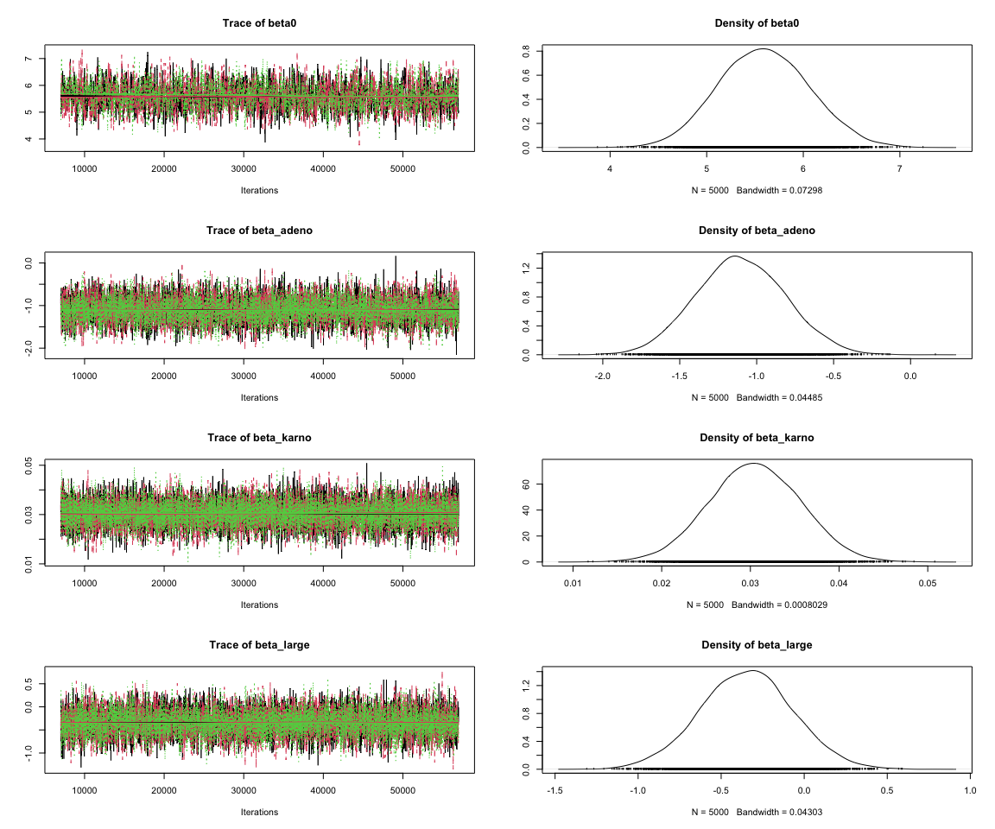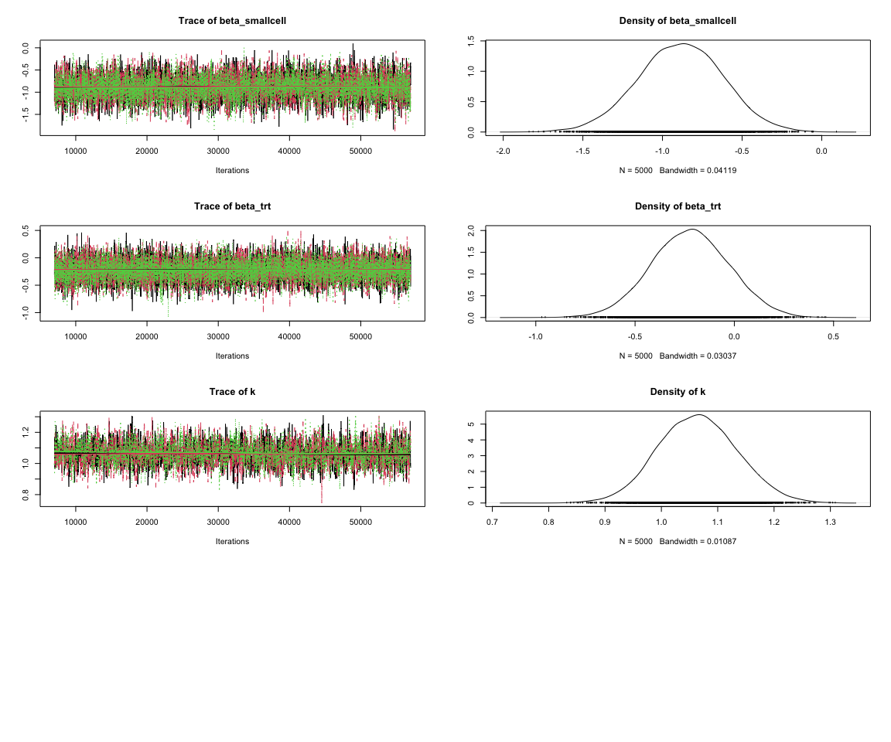
# 2. Gelman-Rubin (potential scale reduction factor)
# Rule of thumb: point estimate and upper CI < 1.1 (ideally < 1.05) -> converged
gelman.diag(samples, multivariate = FALSE)
## Potential scale reduction factors:
##
## Point est. Upper C.I.
## beta0 1 1.01
## beta_adeno 1 1.00
## beta_karno 1 1.00
## beta_large 1 1.00
## beta_smallcell 1 1.00
## beta_trt 1 1.00
## k 1 1.00
gelman.plot(samples)
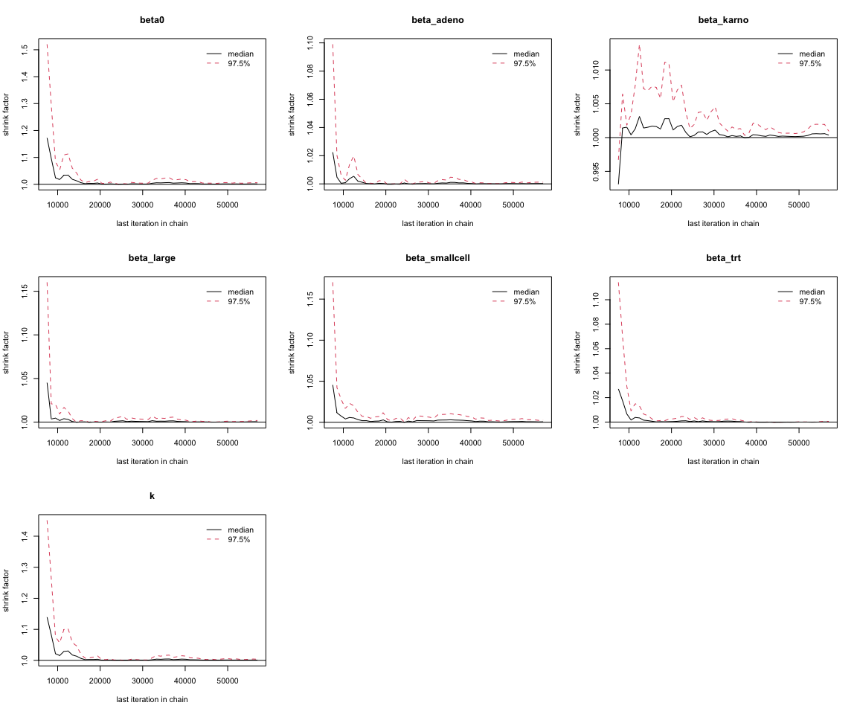
# 3. Autocorrelation
autocorr.plot(samples)
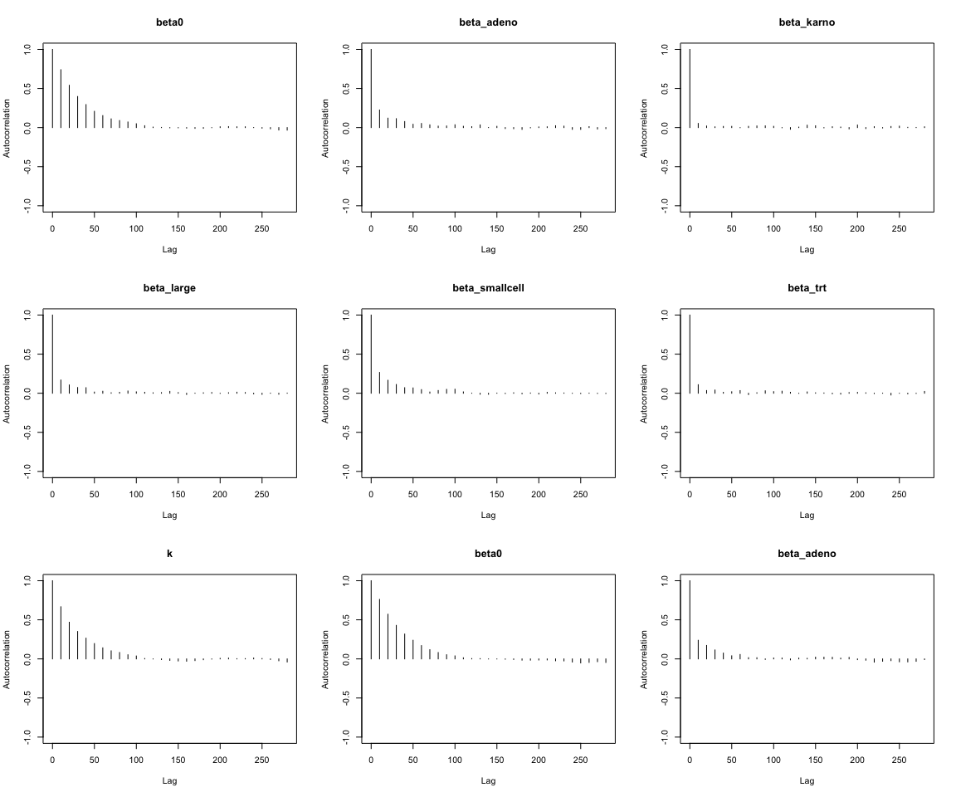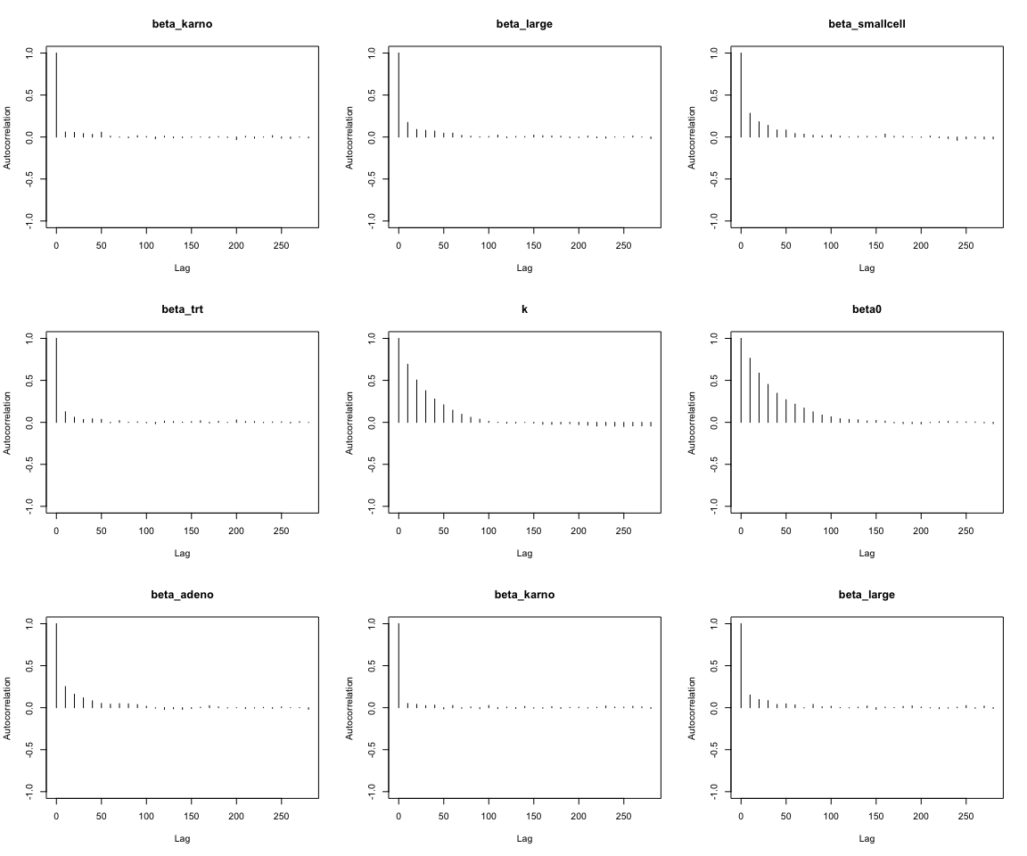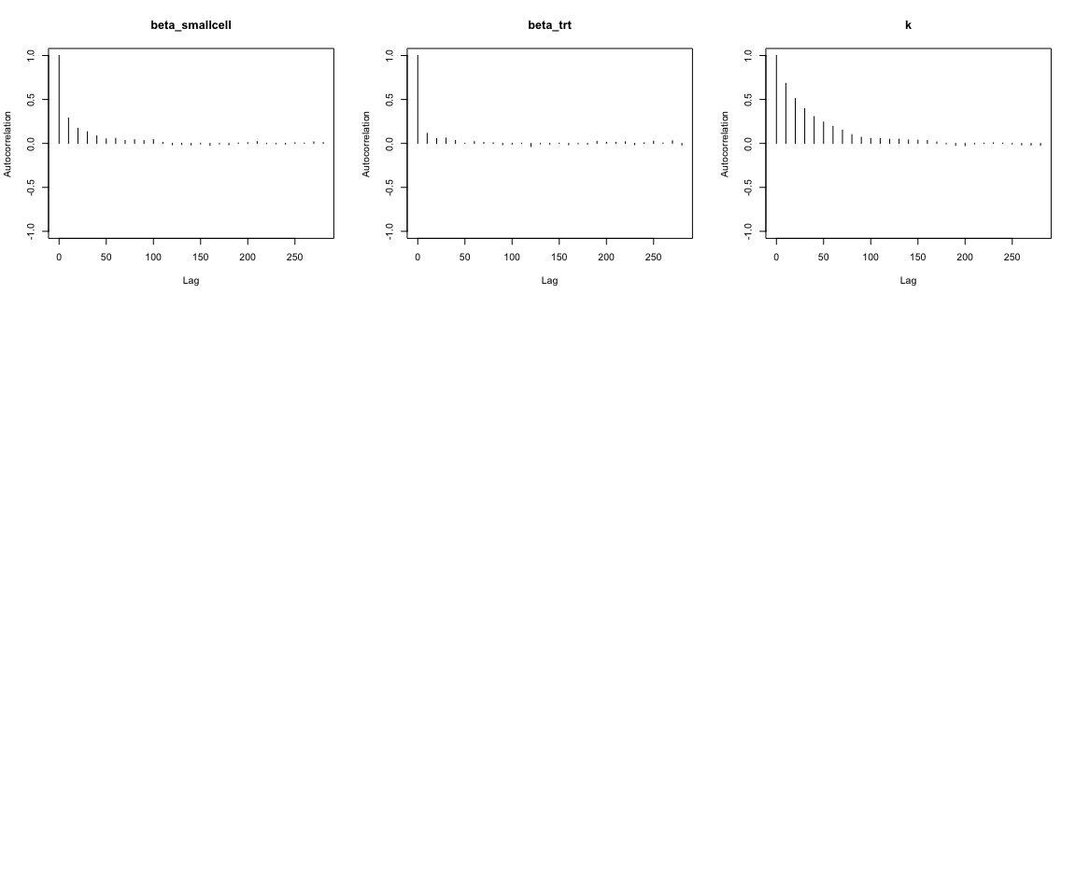
autocorr.diag(samples) # numerical autocorrelations at lags 0, 1, 5, 10, 50
## beta0 beta_adeno beta_karno beta_large beta_smallcell
## Lag 0 1.000000000 1.000000000 1.000000000 1.000000000 1.000000000
## Lag 10 0.754689888 0.238282291 0.053886836 0.164484453 0.279434957
## Lag 50 0.238568926 0.044310933 0.019490408 0.035262679 0.067745058
## Lag 100 0.050934379 0.021585765 0.015753703 0.013404458 0.039884043
## Lag 500 -0.008380821 0.008615494 -0.003909092 -0.001585111 0.001574564
## beta_trt k
## Lag 0 1.000000000 1.000000000
## Lag 10 0.116747700 0.680709111
## Lag 50 0.018168213 0.216108476
## Lag 100 0.002372311 0.035585869
## Lag 500 0.009067013 -0.008587431
# 4. Effective sample size
effectiveSize(samples)
## beta0 beta_adeno beta_karno beta_large beta_smallcell
## 2097.204 6022.977 11482.864 7279.168 5184.037
## beta_trt k
## 9485.803 2374.372
# 5. Geweke diagnostic (z-scores; |z| < 2 indicates no evidence of non-stationarity)
geweke.diag(samples)
## [[1]]
##
## Fraction in 1st window = 0.1
## Fraction in 2nd window = 0.5
##
## beta0 beta_adeno beta_karno beta_large beta_smallcell
## 0.25595 0.08560 0.50261 -0.30652 -0.42150
## beta_trt k
## -0.02961 0.29349
##
##
## [[2]]
##
## Fraction in 1st window = 0.1
## Fraction in 2nd window = 0.5
##
## beta0 beta_adeno beta_karno beta_large beta_smallcell
## -0.3629 0.3963 -1.7970 0.2142 0.1253
## beta_trt k
## 0.2404 -0.4224
##
##
## [[3]]
##
## Fraction in 1st window = 0.1
## Fraction in 2nd window = 0.5
##
## beta0 beta_adeno beta_karno beta_large beta_smallcell
## 2.281 -0.901 1.552 -1.311 -1.411
## beta_trt k
## -1.721 2.548
# 6. Heidelberger-Welch stationarity / halfwidth tests (optional, complementary)
heidel.diag(samples)
## [[1]]
##
## Stationarity start p-value
## test iteration
## beta0 passed 1 0.483
## beta_adeno passed 1 0.941
## beta_karno passed 1 0.219
## beta_large passed 1 0.956
## beta_smallcell passed 1 0.561
## beta_trt passed 1 0.584
## k passed 1 0.338
##
## Halfwidth Mean Halfwidth
## test
## beta0 passed 5.5813 0.032878
## beta_adeno passed -1.0984 0.012420
## beta_karno passed 0.0305 0.000153
## beta_large passed -0.3421 0.010810
## beta_smallcell passed -0.8841 0.012753
## beta_trt passed -0.2209 0.006812
## k passed 1.0625 0.004634
##
## [[2]]
##
## Stationarity start p-value
## test iteration
## beta0 passed 1 0.8363
## beta_adeno passed 1 0.9385
## beta_karno passed 1 0.0525
## beta_large passed 1 0.4646
## beta_smallcell passed 1 0.6560
## beta_trt passed 1 0.3479
## k passed 1 0.9468
##
## Halfwidth Mean Halfwidth
## test
## beta0 passed 5.5815 0.03644
## beta_adeno passed -1.1001 0.01306
## beta_karno passed 0.0305 0.00018
## beta_large passed -0.3444 0.01142
## beta_smallcell passed -0.8784 0.01251
## beta_trt passed -0.2187 0.00703
## k passed 1.0627 0.00496
##
## [[3]]
##
## Stationarity start p-value
## test iteration
## beta0 passed 1 0.156
## beta_adeno passed 1 0.667
## beta_karno passed 1 0.430
## beta_large passed 1 0.587
## beta_smallcell passed 1 0.203
## beta_trt passed 1 0.133
## k passed 1 0.164
##
## Halfwidth Mean Halfwidth
## test
## beta0 passed 5.6280 0.035444
## beta_adeno passed -1.1100 0.012523
## beta_karno passed 0.0306 0.000163
## beta_large passed -0.3524 0.011010
## beta_smallcell passed -0.8970 0.012348
## beta_trt passed -0.2260 0.006675
## k passed 1.0686 0.005076
# If high autocorrelation / low ESS:
# - increase n.iter and/or n.thin (e.g. thin = 5 or 10),
# - or re-parameterise / centre covariates (karno could be centred to help mixing).

