Web design

<https://www.yugioh-card.com/en/>

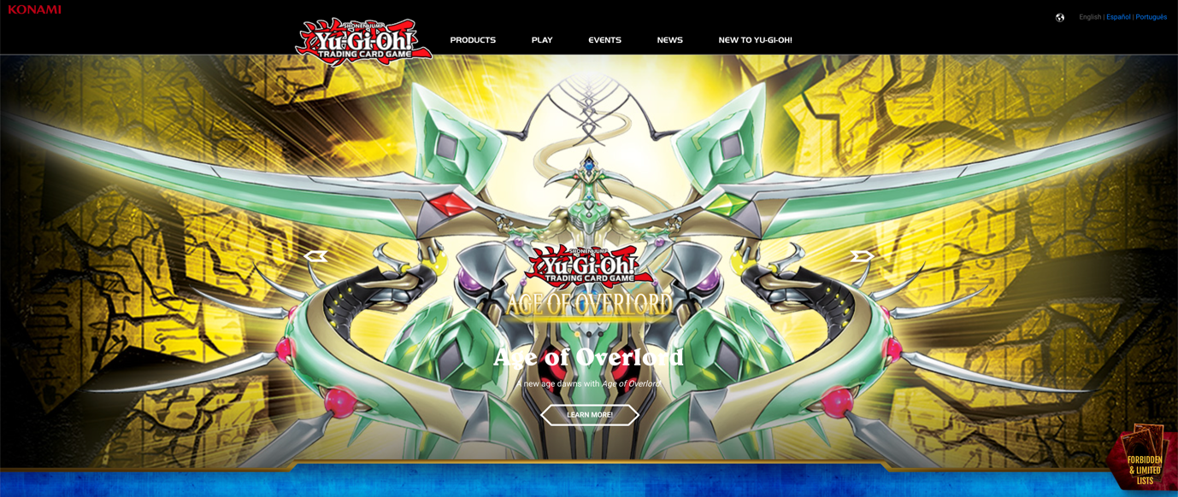

Description:

Start by introducing your design purpose and the inspiration behind it.

"For my web design project, I chose to go from Yu-Gi-Oh! Websites, particularly yugioh-card.com, draw inspiration. The goal is to create a visually appealing and user-friendly website for Yu-Gi-Oh! Fans."

Location:

Explain why I chose yugioh-card.com.

"I chose yugioh-card.com for its comprehensive and user-centric design. The website provides information about Yu-Gi-Oh! The rich information on cards and related content effectively meets the needs of fans."

Attractive elements:

Discuss the specific elements of yugioh-card.com that appeal to you.

"The navigation bar on yugioh-card.com stands out for its ease of use. It conforms to modern web design principles by providing intuitive access to the various parts of the website. In addition, the bold title immediately grabs people's attention and sets the tone for an immersive user experience."

Color scheme:

Describe the color scheme I chose and its rationale.

"In my design, I chose a classic black and white color scheme. Black provides a stylish background, while white ensures readability and highlights key elements. This high-contrast combination adds a touch of sophistication and modernity to the overall aesthetic."

Specific elements of the merger:

Detail how I plan to incorporate elements into your own design.

"To reflect yugioh-card.com's stylish navigation, I will create a clean and intuitive navigation bar. The black background will contain white text, ICONS, and accent colors to maintain a modern look. The title will have visually arresting elements that capture the essence of Yu-Gi-Oh, instantly appealing to visitors."

Implement in my assignments:

The navigation in my homework is a little bit different than this page that I chose because it's a whole big expansion and I only need one expansion.

<https://www.yugioh.com/>

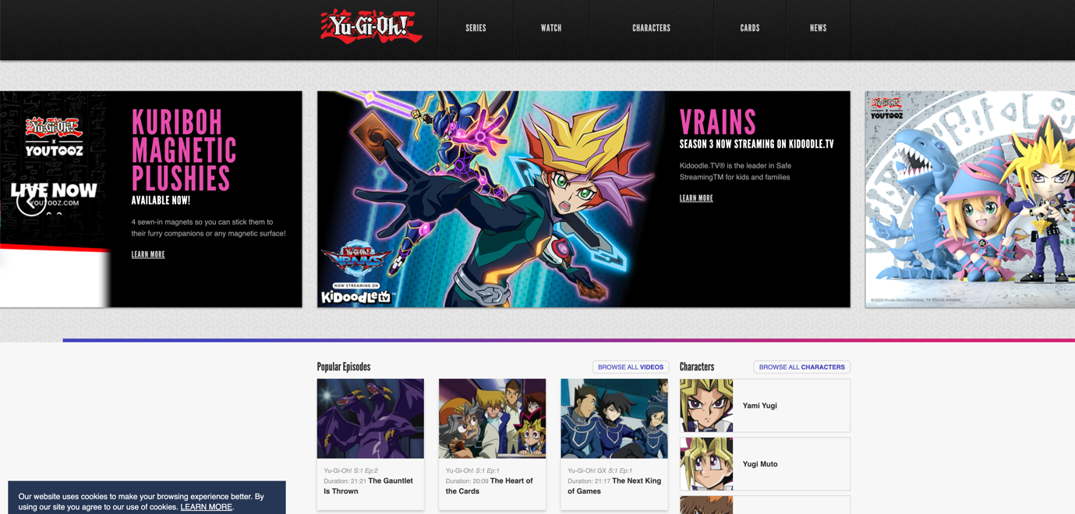

Description:

Why did you choose yugioh.com and yugioh-card.com?

"I chose yugioh.com and yugioh-card.com as the official Yu-Gi-Oh sites to ensure a comprehensive resource for fans. Each site offers unique elements that help inspire overall design."

What elements of these sites caught your attention, and why?

"On yugioh.com, dynamic image changes immediately stand out. This interactive feature adds a layer of engagement that keeps visitors visually interested. It conforms to modern web design principles that prioritize user interaction and experience. As for yugioh-card.com, the clean navigation bar and bold title create a relaxed and impactful user experience with an emphasis on simplicity and aesthetics."

How do you plan to incorporate these elements into your own designs?

"My goal was to incorporate dynamic graphic changes inspired by yugioh.com to add an interactive style to my site. This will be implemented strategically, perhaps in headings or other key sections. From yugioh-card.com, I will adopt a clean navigation bar and bold title design, ensuring a user-friendly and visually striking layout."

<https://www.yugioh-card.com/eu/>

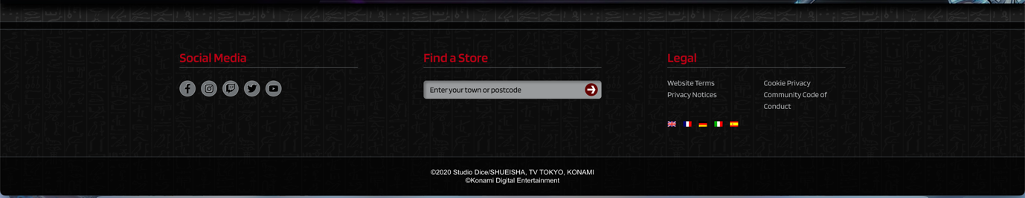

Why did you choose yugioh-card.com/eu?

"I chose yugioh-card.com/eu because it is the official European hub for Yu-Gi-Oh cards. The site's comprehensive content and regional focus make it a valuable reference for European fans."

What elements of yugioh-card.com/eu appeal to you, and why?

"The footer for yugioh-card.com/eu caught my eye. Its clean layout contains the necessary links and information to help achieve a well-organized and easily accessible design. This is in line with modern web design principles that provide a seamless user experience and easy navigation of the experience."

How do you plan to incorporate footers into your own design?

"Inspired by yugioh-card.com/eu, I will incorporate a similarly clean and organized footer into my design. This will include the necessary links, contact information and other relevant details to enhance user navigation and accessibility."

Where can I see this element in your homework?

"Throughout my assignment, you will find the influence of yugioh-card.com/eu's footer design.