
MCA PROJECT REPORT
ON
SysInsight: AI-Powered System Monitoring and Resource Prediction Platform
Submitted in Partial Fulfillment of the Requirements for the Degree of
MASTER OF COMPUTER APPLICATIONS (MCA)
ONLINE MODE - 3rd SEMESTER
Submitted By
Yashwanth Kumar BL
Registration No: 2536100046
Academic Session: 2025-2026
Kurukshetra University, Kurukshetra

ACKNOWLEDGEMENT

I express my sincere gratitude to all those who have directly or indirectly contributed to the successful completion of my MCA Project titled "SysInsight: AI-Powered System Monitoring and Resource Prediction Platform."
I would like to thank Kurukshetra University, Kurukshetra, for providing me the opportunity to undertake this project as a part of the Master of Computer Applications (MCA) curriculum.
I am highly grateful to my project guide, Mr. Harshavardhana BN, for providing valuable guidance, encouragement, and constructive suggestions throughout the development of this project. Their support and expertise helped me successfully complete this work.
I would also like to express my gratitude to all the faculty members of the MCA Department for their continuous support, motivation, and valuable knowledge imparted during the course of study.
I extend my heartfelt thanks to my family and friends for their constant encouragement, cooperation, and moral support during the project work.
Finally, I would like to thank everyone who directly or indirectly contributed to the successful completion of this project.

Submitted By

Yashwanth Kumar BL
Registration No.: 2536100046
MCA (Online Mode) – 3rd Semester
Academic Session: 2025–2026
Kurukshetra University, Kurukshetra

CERTIFICATE FROM GUIDE

This is to certify that this project entitled “SysInsight: AI-Powered System Monitoring and Resource Prediction Platform” submitted in partial fulfillment of the degree of Master of Computer Applications (MCA) to Kurukshetra University, Kurukshetra by Mr. Yashwanth Kumar BL, Registration No. 2536100046 (Roll No. 11187539), is an authentic work carried out by him under my guidance.
The matter embodied in this project work has not been submitted earlier for the award of any degree or diploma to the best of my knowledge and belief.

Signature of the Student Signature of the Guide

Date: ___________________

SYNOPSIS OF THE PROJECT
Project Title
SysInsight: AI-Powered System Monitoring and Resource Prediction Platform
Statement of the Problem
Modern computer systems run multiple applications simultaneously, resulting in continuous consumption of system resources such as CPU, RAM, Disk, and Network bandwidth. Existing monitoring tools provide resource usage information but often lack historical analysis, centralized visualization, and predictive capabilities.
Users find it difficult to continuously monitor system performance, identify resource bottlenecks, and anticipate future resource requirements. The absence of an integrated monitoring and prediction platform can lead to reduced system efficiency and delayed decision-making.
The proposed system, SysInsight, addresses these challenges by providing real-time monitoring, health score evaluation, historical data storage, graphical trend analysis, and machine learning-based prediction of future resource utilization.
Why the Topic was Chosen
System performance monitoring is an essential aspect of modern computing environments. With increasing application complexity and resource demands, users require intelligent tools capable of providing detailed insights into system performance.
The topic was chosen because it combines several important areas of computer science, including:
- System Monitoring
- Database Management
- Data Visualization
- Graphical User Interface Development
- Machine Learning
- Predictive Analytics
The project provides practical exposure to these technologies while solving a real-world problem.

Objective of the Project
The primary objectives of the project are:
- To monitor CPU utilization in real time.
- To monitor RAM utilization in real time.
- To monitor Disk utilization in real time.
- To monitor Network activity.
- To calculate an overall system health score.
- To store historical monitoring records in a database.
- To generate graphical performance trends.
- To identify top resource-consuming processes.
- To predict future resource utilization using Machine Learning.
- To provide a user-friendly dashboard for performance analysis.
Scope of the Project
The scope of SysInsight includes:
- Real-time monitoring of system resources.
- Historical data collection and storage.
- Trend analysis using graphical representations.
- Health assessment of the monitored system.
- Machine learning-based prediction of future resource utilization.
- Performance evaluation through an interactive dashboard.
The system is designed primarily for personal computers and educational environments and can be extended for enterprise monitoring applications.
Methodology
The project follows a structured software development approach based on the Software Development Life Cycle (SDLC).

The implementation process consists of the following phases:
- Requirement Analysis
- System Design
- Development
- Database Integration
- Graph Generation
- Machine Learning Integration
- Testing and Validation
- Documentation
The monitoring functionality was implemented using Python and the Psutil library. Historical records were stored using SQLite. Graphical visualization was implemented using Matplotlib, while Linear Regression from Scikit-Learn was used for prediction.
Hardware and Software Used
Hardware Requirements
- Processor: Intel Core i5 or Higher
- RAM: 8 GB or Higher
- Storage: 20 GB Free Space
- Display Resolution: 1366 × 768 or Higher
Software Requirements
- Windows 11
- Python 3.x
- SQLite Database
- CustomTkinter
- Psutil
- Pandas
- NumPy
- Matplotlib
- Scikit-Learn
Testing Technologies Used
The following testing methods were used:
- Unit Testing
- Integration Testing
- System Testing
- Validation Testing
- Functional Testing
Testing was performed to ensure correct operation of monitoring, database storage, graph generation, and prediction modules.
Contribution of the Project
The project contributes an integrated solution for system monitoring and predictive analytics. Unlike traditional monitoring tools, SysInsight combines real-time monitoring, historical data storage, trend visualization, and machine learning-based forecasting within a single platform.
The developed system assists users in understanding system behavior, identifying resource-intensive processes, and anticipating future resource requirements. The project demonstrates the practical application of software engineering, database management, data visualization, and machine learning concepts.

Conclusion
SysInsight successfully integrates system monitoring, database logging, graphical trend analysis, and machine learning-based prediction into a single user-friendly application. The project provides an effective solution for monitoring system health and supports proactive resource management through intelligent prediction capabilities.

5. MAIN REPORT
1. OBJECTIVE & SCOPE OF THE PROJECT
1.1 Introduction
In today's computing environment, computer systems execute multiple applications and services simultaneously, resulting in continuous utilization of system resources such as CPU, memory, disk storage, and network bandwidth. Monitoring these resources is essential to ensure efficient system performance, detect bottlenecks, and maintain overall system stability.
Traditional monitoring tools generally provide only real-time information and often lack advanced analytical capabilities such as historical trend analysis and future resource prediction. To address these limitations, the project “SysInsight: AI-Powered System Monitoring and Resource Prediction Platform” has been developed. The system integrates real-time monitoring, database storage, graphical analysis, and machine learning-based prediction into a single user-friendly platform.
The project aims to provide users with a comprehensive view of system performance while enabling proactive decision-making through intelligent resource forecasting.
1.2 Objective of the Project
The primary objective of SysInsight is to develop an intelligent system monitoring platform capable of analyzing and predicting system resource utilization.
The specific objectives of the project are:
- To monitor CPU utilization in real time.
- To monitor RAM utilization in real time.
- To monitor Disk utilization in real time.
- To monitor Network activity and usage statistics.
- To calculate an overall System Health Score.
- To identify top resource-consuming processes.
- To store historical monitoring records in an SQLite database.
- To generate graphical trends for performance analysis.
- To predict future resource utilization using Machine Learning techniques.
- To provide a modern and user-friendly dashboard interface for system monitoring.
1.3 Scope of the Project
The scope of the project includes monitoring, analyzing, and predicting system resource utilization on personal computer systems.
The major areas covered within the scope are:
- Real-time CPU monitoring.
- Real-time RAM monitoring.
- Real-time Disk monitoring.
- Network statistics monitoring.
- Health score calculation and status evaluation.
- Historical data collection and storage.
- Performance trend visualization through graphs.
- Resource prediction using Linear Regression.
- Process analysis and identification of high-resource-consuming applications.
- Interactive graphical dashboard for users.
The system is primarily designed for educational, personal, and small-scale organizational environments. However, the architecture can be extended in future to support enterprise-level monitoring and cloud-based infrastructure management.
1.4 Benefits of the Project
The implementation of SysInsight provides several advantages:
- Continuous monitoring of system resources.
- Improved understanding of system performance.
- Early identification of performance bottlenecks.
- Historical performance tracking.
- Visual analysis through graphs and charts.
- Machine learning-based prediction of future resource usage.
- Better resource management and planning.
- User-friendly interface for easy monitoring.

1.5 Conclusion
The objective and scope of SysInsight clearly define the purpose and boundaries of the project. The system provides an integrated platform for real-time monitoring, performance analysis, historical data storage, and predictive analytics. The project combines concepts from system monitoring, database management, graphical visualization, and machine learning to deliver an effective and intelligent monitoring solution.

2. THEORETICAL BACKGROUND
2.1 Introduction
Theoretical background provides the conceptual foundation required for understanding the technologies, methodologies, and principles used in the development of the SysInsight system. The project integrates concepts from system monitoring, database management, graphical visualization, and machine learning to create an intelligent platform for performance analysis and resource prediction.
Understanding these concepts is essential for designing and implementing an efficient monitoring system capable of analyzing system behavior and predicting future resource utilization.
2.2 System Monitoring
System monitoring is the process of continuously observing and collecting information about the performance and health of a computer system. Monitoring enables users and administrators to understand how system resources are utilized and helps identify performance bottlenecks before they impact productivity.
System monitoring typically includes:
- CPU utilization monitoring
- Memory utilization monitoring
- Disk activity monitoring
- Network activity monitoring
- Process monitoring
Effective monitoring improves system reliability, performance optimization, and resource management.
2.3 CPU Monitoring
The Central Processing Unit (CPU) is one of the most critical components of a computer system. CPU monitoring involves measuring processor utilization to determine how effectively computing resources are being used.
High CPU utilization may indicate:
- Heavy application workloads
- Background processing
- Insufficient system resources
- Potential performance bottlenecks
Monitoring CPU usage helps users optimize system performance and identify resource-intensive applications.
2.4 RAM Monitoring
Random Access Memory (RAM) is used by the operating system and applications for temporary data storage. RAM monitoring measures the percentage of memory currently in use.
Excessive memory utilization can result in:
- Reduced system responsiveness
- Increased disk swapping
- Performance degradation
Monitoring RAM usage enables efficient memory management and helps users identify memory-intensive applications.
2.5 Disk Monitoring
Disk monitoring involves tracking storage utilization and disk activity. It provides information regarding available storage capacity and resource consumption.
Disk monitoring is important because:
- Storage shortages can affect application performance.
- Excessive disk usage may slow down system operations.
- Historical trends help predict future storage requirements.
Regular monitoring ensures efficient storage management and prevents capacity-related issues.
2.6 Network Monitoring
Network monitoring involves observing data transmission and reception within a computer system. It helps users understand network activity and bandwidth utilization.
Network monitoring provides:
- Data transmission statistics
- Data reception statistics
- Bandwidth utilization information
- Network performance analysis
Network monitoring is useful for identifying unusual traffic patterns and understanding communication behavior.
2.7 Database Management System
A Database Management System (DBMS) is software that stores, organizes, and manages data efficiently. In the SysInsight project, SQLite is used as the database management system.
SQLite offers several advantages:
- Lightweight architecture
- No separate server requirement
- Fast performance
- Easy integration with Python
- Portable database files
The database stores historical monitoring information that is later used for graph generation and machine learning prediction.
2.8 Data Visualization
Data visualization refers to the graphical representation of information and data. Visualization techniques help users understand trends, patterns, and relationships within collected data.
The SysInsight project uses graphical visualization to display:
- CPU utilization trends
- RAM utilization trends
- Health score trends
Data visualization improves decision-making by presenting information in an intuitive and understandable manner.
2.9 Machine Learning
Machine Learning is a branch of Artificial Intelligence that enables systems to learn from historical data and make predictions without explicit programming for every scenario.

Machine learning applications include:
- Prediction
- Classification
- Pattern recognition
- Decision support
In SysInsight, machine learning is used to forecast future resource utilization based on historical monitoring records.
2.10 Linear Regression
Linear Regression is one of the simplest and most widely used supervised machine learning algorithms. It establishes a relationship between dependent and independent variables and predicts future values based on historical observations.
The algorithm is suitable for:
- Trend forecasting
- Resource utilization prediction
- Performance analysis
SysInsight utilizes Linear Regression to predict future CPU usage, RAM utilization, and Health Score values.
2.11 Python Programming Language
Python is a high-level, interpreted programming language known for its simplicity and extensive library support. It is widely used for software development, data analysis, automation, and machine learning applications.
Python was selected for this project because of:
- Easy syntax
- Rich library ecosystem
- Cross-platform compatibility
- Strong support for data analysis and machine learning

2.12 Python Libraries Used
The following libraries were utilized during development:
Psutil
Used for collecting CPU, RAM, Disk, Network, and Process information.
SQLite3
Used for storing historical monitoring records.
Matplotlib
Used for generating graphical performance trends.
Pandas
Used for data manipulation and analysis.
NumPy
Used for numerical computations.
Scikit-Learn
Used for implementing the Linear Regression prediction model.
CustomTkinter
Used for developing the modern graphical dashboard interface.

2.13 Conclusion
The theoretical concepts discussed in this chapter form the foundation of the SysInsight project. System monitoring, database management, data visualization, and machine learning collectively contribute to the development of an intelligent platform capable of monitoring system performance and predicting future resource utilization. These concepts provide the necessary framework for implementing the proposed solution.

3. DEFINITION OF PROBLEM
3.1 Introduction
In modern computing environments, computers execute multiple applications and background services simultaneously. These applications continuously consume system resources such as CPU, memory, disk space, and network bandwidth. Efficient utilization of these resources is essential to ensure smooth system operation and maintain overall performance.
Most operating systems provide basic monitoring tools that display current resource utilization. However, these tools often provide only real-time information and lack advanced analytical capabilities such as historical trend analysis, centralized monitoring, health assessment, and future resource prediction. As a result, users face difficulties in understanding long-term system behavior and identifying potential performance issues before they occur.
3.2 Problem Statement
The primary problem addressed by this project is the lack of an integrated platform that combines real-time monitoring, historical data analysis, and predictive analytics for system resource management.
Existing monitoring solutions generally suffer from the following limitations:
- Limited real-time monitoring capabilities.
- Absence of historical performance tracking.
- Lack of centralized health assessment.
- No graphical trend analysis for long-term evaluation.
- Inability to predict future resource utilization.
- Difficulty in identifying resource-intensive processes.
- Limited support for intelligent decision-making.
Due to these limitations, users often react to system performance issues only after they occur rather than preventing them proactively.

3.3 Need for the Proposed System
There is a growing need for an intelligent monitoring solution capable of providing both current and future insights into system performance.
The proposed system is required to:
- Continuously monitor system resources.
- Store historical monitoring information.
- Analyze system behavior over time.
- Identify performance bottlenecks.
- Calculate an overall system health score.
- Provide graphical performance visualization.
- Predict future resource utilization using Machine Learning techniques.
- Assist users in proactive resource management.
Such a solution enables users to make informed decisions regarding system performance and resource optimization.
3.4 Existing System Limitations
The existing monitoring tools available in operating systems provide only basic monitoring functionality.
Some major limitations include:
Lack of Historical Data Storage
Most monitoring tools display only current utilization values and do not maintain long-term historical records.
Absence of Predictive Analysis
Traditional monitoring tools cannot forecast future system resource consumption.
Limited Visualization
Users often receive numerical values without detailed graphical trend analysis.
No Health Score Evaluation
Existing tools do not provide a consolidated health score that represents overall system condition.

Inadequate Process Analysis
Users may find it difficult to identify which processes are consuming the highest amount of resources.
These limitations reduce the effectiveness of performance monitoring and system management.
3.5 Proposed Solution
To overcome the limitations of existing systems, the proposed solution, SysInsight: AI-Powered System Monitoring and Resource Prediction Platform, has been developed.
The system provides:
- Real-time CPU monitoring.
- Real-time RAM monitoring.
- Real-time Disk monitoring.
- Network utilization monitoring.
- Health score calculation.
- Historical data storage using SQLite.
- Trend graph generation.
- Top process analysis.
- Machine Learning-based prediction of future resource utilization.
- Interactive graphical dashboard.
The integration of these features within a single platform makes the system more effective and user-friendly than traditional monitoring solutions.
3.6 Objectives of the Solution
The proposed solution aims to achieve the following:
- Improve system monitoring efficiency.
- Provide centralized performance information.
- Enable historical trend analysis.
- Facilitate proactive performance management.
- Improve resource utilization awareness.
- Provide future performance predictions.
- Support better decision-making through data analysis.

3.7 Conclusion
The analysis of existing monitoring approaches revealed several limitations related to historical analysis, visualization, and prediction capabilities. The proposed SysInsight system addresses these challenges by integrating monitoring, database management, graphical visualization, and machine learning-based prediction within a unified platform. The solution enhances system performance analysis and supports proactive resource management.

4. SYSTEM ANALYSIS & DESIGN vis-à-vis USER REQUIREMENTS
4.1 Introduction
System Analysis and Design is an important phase in software development that focuses on understanding user requirements and designing an effective solution to satisfy those requirements. The objective of this phase is to analyze the existing problem, identify user needs, evaluate feasibility, and design a structured system architecture.
The SysInsight system was designed to provide a comprehensive platform for monitoring system resources, storing historical data, generating performance graphs, and predicting future resource utilization using Machine Learning techniques.

4.2 User Requirements Analysis
User requirements define the functionalities and services expected from the proposed system.
Functional Requirements
The system shall:
- Monitor CPU utilization in real time.
- Monitor RAM utilization in real time.
- Monitor Disk utilization in real time.
- Monitor Network activity.
- Display top resource-consuming processes.
- Calculate System Health Score.
- Store monitoring data in SQLite database.
- Generate graphical performance trends.
- Predict future resource utilization.
- Display all information through a graphical dashboard.

Non-Functional Requirements
The system shall:
- Be user-friendly.
- Provide accurate monitoring information.
- Be reliable and efficient.
- Support future enhancements.
- Operate with minimal system overhead.
- Provide quick response time.

4.3 Feasibility Study
A feasibility study was conducted to determine whether the proposed system could be developed successfully.
Technical Feasibility
The project utilizes Python, SQLite, Psutil, Matplotlib, CustomTkinter, Pandas, NumPy, and Scikit-Learn. These technologies are readily available and provide all required functionalities.
Therefore, the project is technically feasible.
Economic Feasibility
The software libraries and development tools used in the project are open-source and freely available. No additional hardware investment is required.
Therefore, the project is economically feasible.
Operational Feasibility
The developed system provides a simple graphical interface and requires minimal user training. Users can easily monitor and analyze system performance.
Therefore, the project is operationally feasible.

4.4 System Architecture
The architecture of SysInsight consists of the following major modules:
- Dashboard Module
- Monitoring Module
- Health Calculation Module
- Database Module
- Graph Generation Module
- AI Prediction Module
The Monitoring Module collects resource utilization data and forwards it to the Health Calculator and Database Module. Historical data stored in the database is used by the Graph Module and AI Prediction Module. The Dashboard displays the results to the user.
Figure 4.1: System Architecture of SysInsight
┌────────────────────────────┐
│ USER │
└─────────────┬──────────────┘
│
▼
┌────────────────────────────┐
│ DASHBOARD GUI │
└─────────────┬──────────────┘
│
▼
┌────────────────────────────┐
│ MONITORING ENGINE │
│ (CPU/RAM/DISK/NETWORK) │
└─────────────┬──────────────┘
│
▼
┌────────────────────────────┐
│ HEALTH CALCULATOR │
└─────────────┬──────────────┘
│
▼
┌────────────────────────────┐
│ SQLITE DATABASE │
└───────┬─────────┬──────────┘
│ │
▼ ▼
┌────────────┐ ┌──────────────┐
│ GRAPHS │ │ AI PREDICTION│
└──────┬─────┘ └──────┬───────┘
│ │
└──────┬───────┘
▼
┌────────────────────────────┐
│ RESULT DISPLAY │
└────────────────────────────┘

4.5 Data Flow Diagram (DFD Level 0)
The Level 0 Data Flow Diagram represents the overall interaction between the user, SysInsight system, and database.

Figure 4.2: DFD Level 0 of SysInsight
+----------------+
| USER |
+--------+-------+
|
v
+-----------------------------+
| SYSINSIGHT |
+-----------------------------+
|
v
+-----------------------------+
| SQLITE DATABASE |
+-----------------------------+
4.6 Data Flow Diagram (DFD Level 1)
The Level 1 Data Flow Diagram provides a detailed representation of the major modules within the system and the flow of information between them.
Figure 4.3: DFD Level 1 of SysInsight
+---------+
| USER |
+----+----+
|
v
+------------------+
| Dashboard Module |
+--------+---------+
|
v
+------------------+
| Monitoring Module|
+--------+---------+
|
v
+------------------+
| Health Module |
+--------+---------+
|
v
+------------------+
| Database Module |
+--------+---------+
/ \
/ \
v v
+---------------+ +---------------+
| Graph Module | | AI Prediction |
+-------+-------+ +-------+-------+
\ /
\ /
\ /
v v
+---------------+
| Result Display|
+---------------+
4.7 Entity Relationship Diagram (ER Diagram)
The system uses an SQLite database for storing historical monitoring records. The primary entity used is the Metrics table, which stores CPU usage, RAM usage, Disk usage, Health Score, and Timestamp information.
Figure 4.4: Entity Relationship Diagram of SysInsight
+------------------------------------------------+
| METRICS |
+------------------------------------------------+
| id (Primary Key) |
| timestamp |
| cpu |
| ram |
| disk |
| health |
+------------------------------------------------+

4.8 Process Flowchart
The process flowchart represents the sequence of operations performed by the system.
The workflow consists of:
- Collecting system metrics.
- Calculating health score.
- Storing monitoring records.
- Generating trend graphs.
- Performing AI prediction.
- Displaying results to the user.

Figure 4.5: Process Flowchart of SysInsight
+-----------+
| START |
+-----+-----+
|
v
+----------------------------+
| Collect System Metrics |
| CPU, RAM, Disk, Network |
+-------------+--------------+
|
v
+----------------------------+
| Calculate Health Score |
+-------------+--------------+
|
v
+----------------------------+
| Store Data in Database |
+-------------+--------------+
|
v
+----------------------------+
| Generate Trend Graphs |
+-------------+--------------+
|
v
+----------------------------+
| Predict Future Usage |
+-------------+--------------+
|
v
+----------------------------+
| Display Results |
+-------------+--------------+
|
v
+-----------+
| END |
+-----------+

4.9 Design Considerations
The following factors were considered during system design:
- Simplicity of user interface.
- Efficient resource utilization.
- Scalability and maintainability.
- Accurate monitoring and prediction.
- Secure local database storage.
- Modular architecture for future enhancement.
These considerations helped ensure that the developed system remains efficient, reliable, and user-friendly.

4.10 Conclusion
System Analysis and Design played a crucial role in defining the structure and functionality of the SysInsight platform. User requirements were analyzed, feasibility was evaluated, and the architecture, data flow, database structure, and process flow were designed accordingly. The resulting design provides a solid foundation for implementing an efficient and intelligent system monitoring and prediction platform.

5. SYSTEM PLANNING (PERT CHART)
5.1 Introduction
System Planning is an important activity in software development that involves scheduling, organizing, and managing project activities to ensure successful completion within the available time and resources. Proper planning helps in identifying project milestones, allocating resources efficiently, and monitoring project progress.
For the development of SysInsight, project activities were organized into different phases including requirement analysis, system design, coding, database integration, graph generation, machine learning implementation, testing, and documentation.

5.2 Project Planning
The development of SysInsight followed a structured Software Development Life Cycle (SDLC) approach. Each phase was completed sequentially to ensure systematic development and testing of the system.
The major project activities included:
- Requirement Gathering and Analysis
- System Design
- Development of Monitoring Module
- Database Integration
- Graph Generation Module Development
- AI Prediction Module Development
- Testing and Validation
- Documentation

5.3 Activity Schedule
Activity | Duration
Requirement Analysis | 2 Days
System Design | 3 Days
Monitoring Module Development | 4 Days
Database Integration | 2 Days
Graph Generation Module | 2 Days
AI Prediction Module | 3 Days
Testing & Validation | 3 Days
Documentation | 5 Days
Table 5.1: Project Activity Schedule

5.4 PERT Chart
The Program Evaluation and Review Technique (PERT) chart illustrates the sequence of activities involved in the development of SysInsight.
Start
|
v
Requirement Analysis
|
v
System Design
|
v
Monitoring Module Development
|
v
Database Integration
|
v
Graph Generation Module
|
v
AI Prediction Module
|
v
Testing & Validation
|
v
Documentation
|
v
End
Figure 5.1: PERT Chart of SysInsight Project

5.5 Milestones Achieved
The following milestones were achieved during project development:
- Completion of requirement analysis.
- Successful design of system architecture.
- Development of real-time monitoring dashboard.
- Implementation of SQLite database storage.
- Generation of performance trend graphs.
- Integration of machine learning prediction module.
- Successful testing and validation.
- Preparation of project documentation.

5.6 Benefits of Project Planning
Project planning provided the following benefits:
- Improved resource allocation.
- Better project management.
- Reduced development risks.
- Timely completion of project activities.
- Efficient monitoring of progress.
- Improved quality of implementation.

5.7 Conclusion
System planning played a significant role in the successful completion of the SysInsight project. The planned sequence of activities ensured systematic development, effective resource utilization, and timely achievement of project objectives. The PERT chart provides a clear representation of the workflow followed during project implementation.

6. PROCESS LOGIC OF EACH MODULE
6.1 Introduction
The SysInsight system is divided into several independent modules that work together to provide real-time monitoring, data storage, visualization, and resource prediction. Each module performs a specific function and contributes to the overall operation of the system. The modular architecture improves maintainability, scalability, and ease of development.
The major modules of the system are:
- Monitoring Module
- Health Calculation Module
- Database Module
- Graph Generation Module
- AI Prediction Module
- Dashboard GUI Module

6.2 Monitoring Module
Purpose
The Monitoring Module is responsible for collecting real-time system resource information from the operating system.
Inputs
- CPU Utilization
- RAM Utilization
- Disk Utilization
- Network Statistics
Processing
The module uses the Psutil library to continuously retrieve system metrics. The collected data is updated at regular intervals and forwarded to other modules for analysis and storage.

Outputs
- CPU Usage Percentage
- RAM Usage Percentage
- Disk Usage Percentage
- Network Statistics
Process Logic
Start
↓
Collect CPU Usage
↓
Collect RAM Usage
↓
Collect Disk Usage
↓
Collect Network Data
↓
Send Data to Health Calculator
↓
Store Data in Database
↓
Display on Dashboard
↓
End
Figure 6.1: Monitoring Module Logic

6.3 Health Calculation Module
Purpose
The Health Calculation Module evaluates the overall condition of the system based on collected resource utilization values.
Inputs
- CPU Usage
- RAM Usage
- Disk Usage
Processing
The module applies a predefined health calculation formula to generate a health score ranging from 0 to 100.
Outputs
- Health Score
- Health Status (Healthy, Warning, Critical)
Process Logic
Receive CPU, RAM, Disk Data
↓
Apply Health Formula
↓
Calculate Health Score
↓
Determine Status
↓
Display Result
Figure 6.2: Health Calculation Module Logic

6.4 Database Module
Purpose
The Database Module stores historical monitoring information for future analysis and prediction.
Inputs
- Timestamp
- CPU Usage
- RAM Usage
- Disk Usage
- Health Score
Processing
The module inserts monitoring records into an SQLite database.
Outputs
- Historical Monitoring Records
Process Logic
Receive Monitoring Data
↓
Create Database Connection
↓
Insert Record
↓
Commit Transaction
↓
Close Connection
Figure 6.3: Database Module Logic

6.5 Graph Generation Module
Purpose
The Graph Generation Module visualizes historical monitoring information using graphical charts.
Inputs
- Historical Database Records
Processing
The module retrieves stored records and generates trend graphs using Matplotlib.
Outputs
- CPU Trend Graph
- RAM Trend Graph
- Health Score Trend Graph
Process Logic
Read Database Records
↓
Extract Resource Data
↓
Generate Graphs
↓
Display Charts
Figure 6.4: Graph Generation Module Logic

6.6 AI Prediction Module
Purpose
The AI Prediction Module predicts future resource utilization based on historical monitoring records.
Inputs
- Historical CPU Records
- Historical RAM Records
- Historical Health Score Records
Processing
The module uses Linear Regression from Scikit-Learn to train a prediction model and forecast future values.
Outputs
- Predicted CPU Usage
- Predicted RAM Usage
- Predicted Health Score
Process Logic
Load Historical Data
↓
Prepare Dataset
↓
Train Linear Regression Model
↓
Generate Predictions
↓
Display Results
Figure 6.5: AI Prediction Module Logic

6.7 Dashboard GUI Module
Purpose
The Dashboard GUI Module serves as the user interface of the system and displays all monitoring information.
Inputs
- Monitoring Data
- Health Score
- Process Information
- AI Predictions
Processing
The module organizes collected information into a user-friendly graphical dashboard.
Outputs
- Interactive Dashboard Display
Process Logic
Receive Data
↓
Update Labels
↓
Update Progress Bars
↓
Display Health Status
↓
Display Process Information
↓
Refresh Dashboard
Figure 6.6: Dashboard GUI Module Logic

6.8 Module Interaction
The modules interact with one another in a sequential manner.
Monitoring Module
↓
Health Calculation Module
↓
Database Module
↓
Graph Generation Module
↓
AI Prediction Module
↓
Dashboard GUI
Figure 6.7: Module Interaction Diagram

6.9 Conclusion
The modular architecture of SysInsight simplifies system development and maintenance. Each module performs a well-defined function and contributes to the overall objective of monitoring, analyzing, storing, visualizing, and predicting system performance. The interaction among these modules ensures smooth operation and efficient resource management.

7. METHODOLOGY ADOPTED, SYSTEM IMPLEMENTATION & DETAILS OF HARDWARE & SOFTWARE USED
7.1 Introduction
The development of SysInsight followed a structured methodology to ensure systematic implementation, testing, and deployment of the system. The project integrates system monitoring, database management, graphical visualization, and machine learning techniques to provide an intelligent resource monitoring platform.
The methodology adopted during development ensured proper planning, implementation, testing, and maintenance of the software system.

7.2 Methodology Adopted
The Waterfall Model was adopted for the development of SysInsight.
The Waterfall Model is a sequential software development methodology in which each phase is completed before the next phase begins. This approach provides better project management and documentation.
The phases followed during development are:
1. Requirement Analysis
System requirements were identified and analyzed. Functional and non-functional requirements were documented.
2. System Design
System architecture, database design, module design, and user interface design were prepared.
3. Development
Individual modules such as monitoring, health calculation, database storage, graph generation, and prediction were implemented using Python.
4. Testing
The developed modules were tested individually and collectively to ensure proper functionality.

5. Deployment
The completed application was executed and validated on a Windows environment.
6. Maintenance
Future updates and enhancements can be incorporated based on user requirements.

Figure 7.1: Waterfall Model
Requirement Analysis
↓
System Design
↓
Development
↓
Testing
↓
Deployment
↓
Maintenance

7.3 Hardware Requirements
The hardware configuration used for development and testing is shown below.
Minimum Hardware Requirements
Component | Specification
Processor | Intel Core i3 or Higher
RAM | 4 GB Minimum
Storage | 10 GB Free Space
Display | 1366 × 768 Resolution
Hardware Used During Development
Component | Specification
Processor | Intel Core i5
RAM | 8 GB
Storage | SSD Storage
Operating System | Windows 11

7.4 Software Requirements
The software components used during development are listed below.
Software | Purpose
Python 3.13 | Core Development
SQLite | Database Storage
Psutil | System Monitoring
Matplotlib | Graph Generation
Pandas | Data Processing
NumPy | Numerical Computation
Scikit-Learn | Machine Learning
CustomTkinter | Dashboard GUI
Visual Studio Code | Development Environment

7.5 System Implementation
The implementation phase involved developing multiple modules and integrating them into a single application.
The implementation process included:
- Development of real-time monitoring module.
- Development of health calculation module.
- Integration of SQLite database.
- Development of graph generation module.
- Development of machine learning prediction module.
- Development of graphical dashboard interface.
- Testing and validation of all modules.

7.6 Dashboard Implementation
The dashboard serves as the central interface of the application.
Major features displayed include:
- CPU Utilization
- RAM Utilization
- Disk Utilization
- Network Statistics
- Health Score
- System Status
- System Information
- Top Processes

Figure 7.2: SysInsight Dashboard
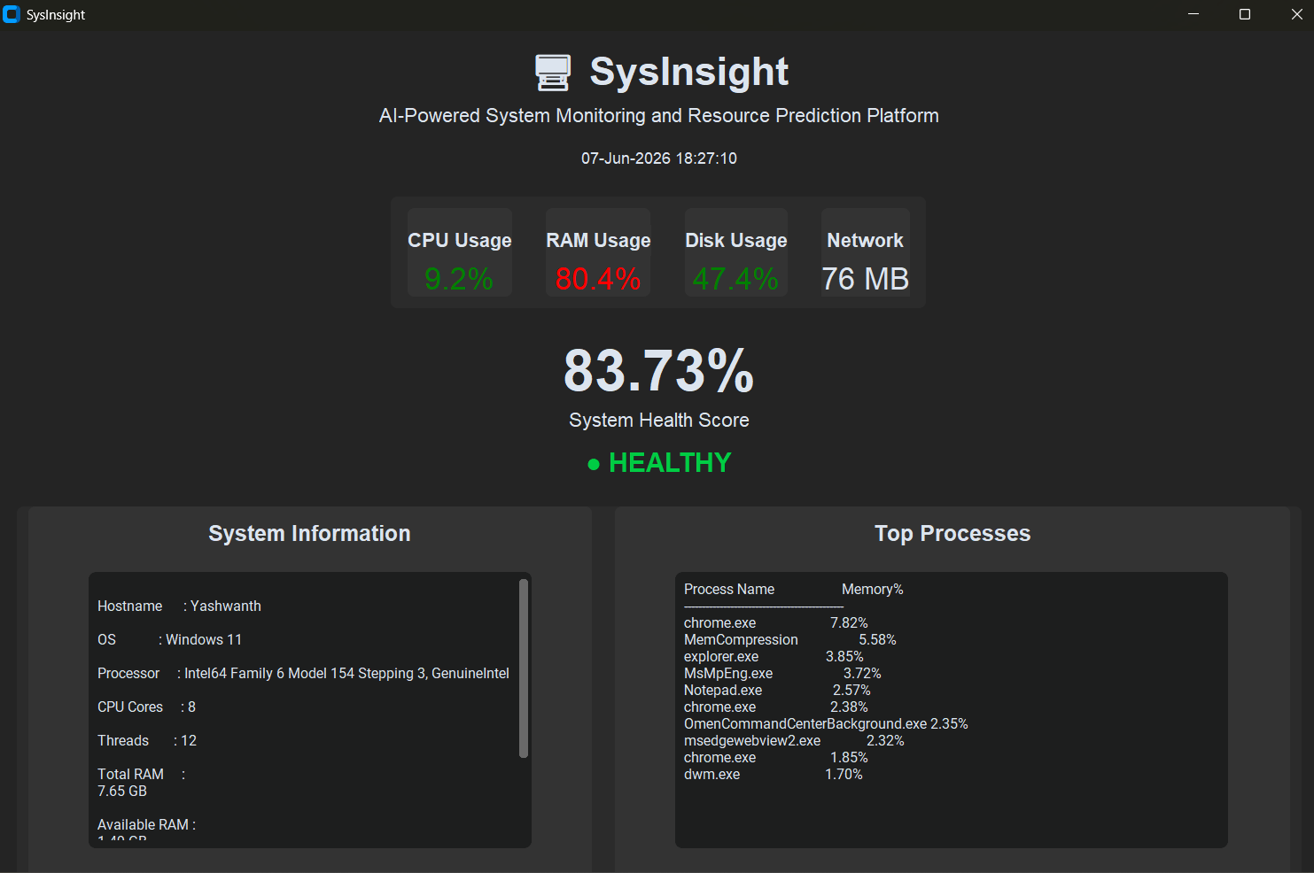
The dashboard provides a real-time view of system performance and allows users to monitor resource utilization efficiently.

7.7 System Information Module Implementation
The System Information module displays detailed hardware and operating system information.
Displayed information includes:
- Hostname
- Operating System
- Processor Information
- CPU Cores
- Threads
- Total RAM
- Available RAM

Figure 7.3: System Information Module
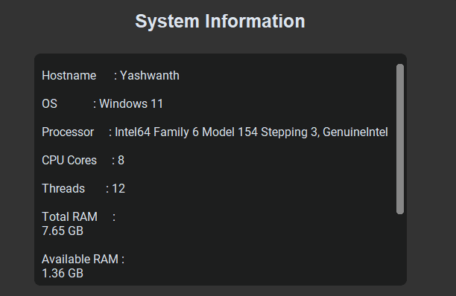
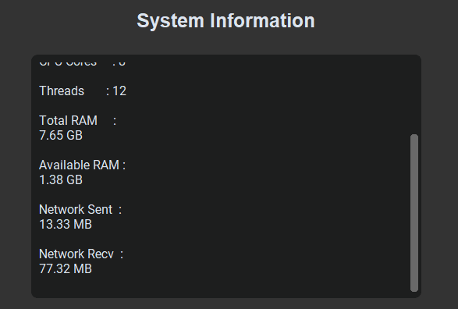
This module helps users understand the current hardware configuration and resource availability.

7.8 Top Processes Module Implementation
The Top Processes module identifies processes consuming the highest amount of memory.

Figure 7.4: Top Processes Module
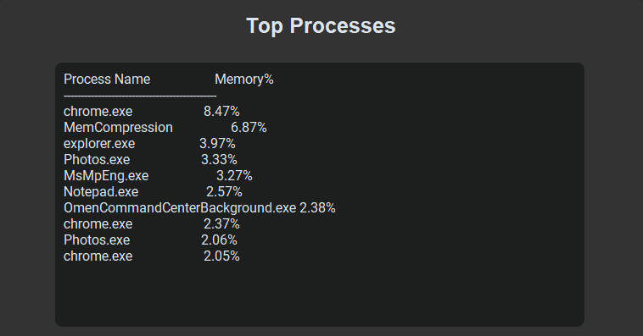
The module assists users in identifying resource-intensive applications and understanding system workload distribution.

7.9 Database Implementation
SQLite was selected as the database management system because of its lightweight architecture and easy integration with Python.
The database stores:
- Timestamp
- CPU Usage
- RAM Usage
- Disk Usage
- Health Score

Figure 7.5: Database Records
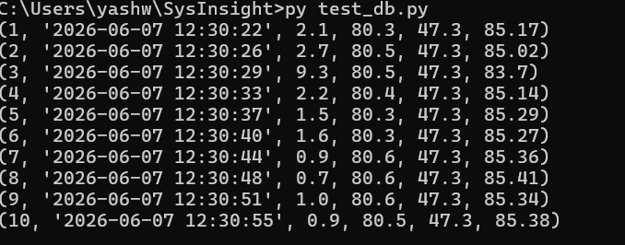
The database enables historical analysis and serves as the data source for graphs and prediction.

7.10 Graph Generation Implementation
Matplotlib was used to generate graphical representations of system performance.
Generated graphs include:
- CPU Usage Trend
- RAM Usage Trend
- Health Score Trend
Figure 7.6: CPU Trend Graph
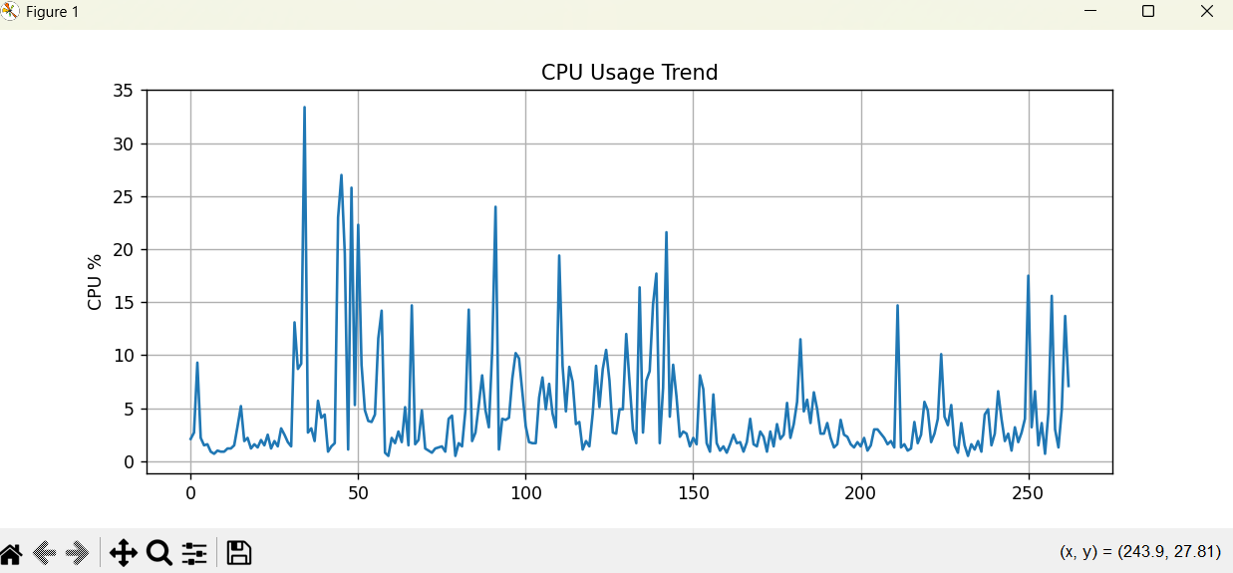
Figure 7.7: RAM Trend Graph
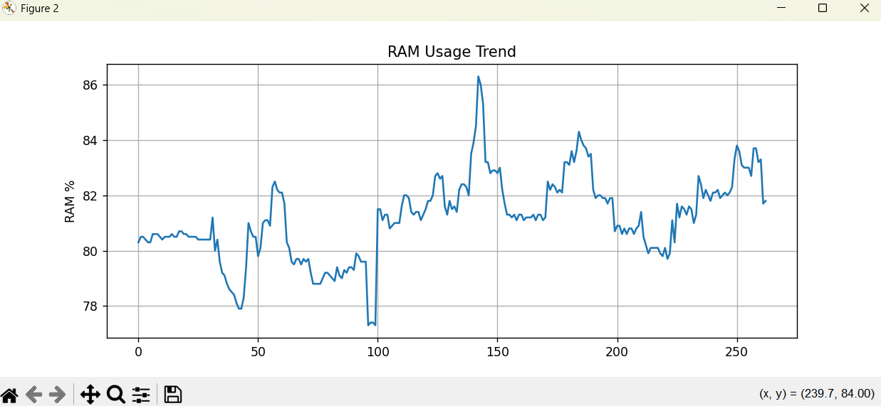
Figure 7.8: Health Score Trend Graph
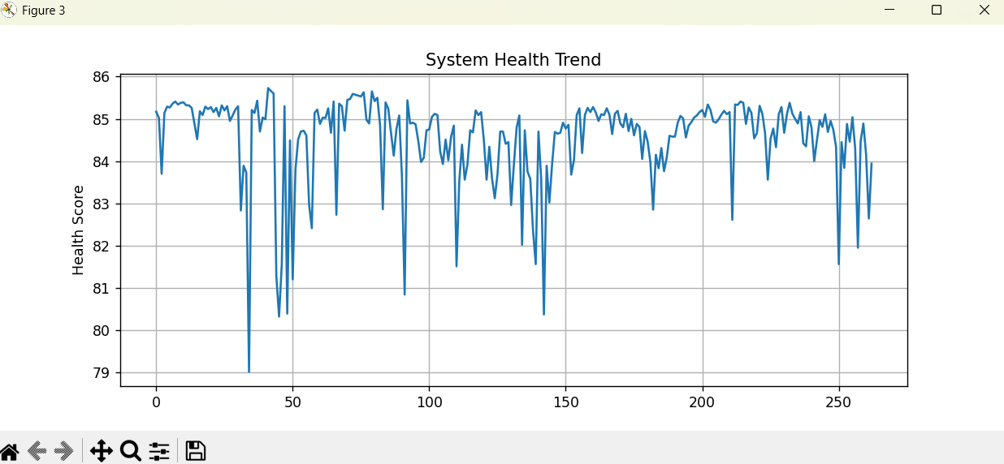
These graphs help users visualize performance trends over time.

7.11 AI Prediction Module Implementation
The AI Prediction Module was developed using Linear Regression from the Scikit-Learn library.

The model analyzes historical monitoring records and predicts future:
- CPU Usage
- RAM Usage
- Health Score
Figure 7.9: AI Prediction Results
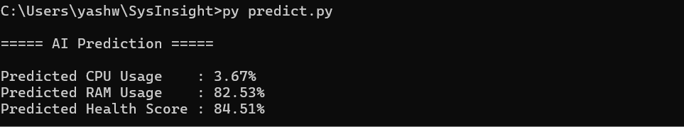
Sample Prediction:
Predicted CPU Usage : 3.21%
Predicted RAM Usage : 80.60%
Predicted Health Score : 84.90%
The prediction module provides insights into future resource consumption and supports proactive decision-making.

7.12 Conclusion
The implementation of SysInsight successfully integrated monitoring, database management, graphical visualization, and machine learning into a single platform. The hardware and software resources used were sufficient for development and testing. The resulting system provides an efficient, user-friendly, and intelligent solution for monitoring and predicting system resource utilization.

8. SYSTEM MAINTENANCE & EVALUATION
8.1 Introduction
System Maintenance and Evaluation are important activities that ensure the long-term effectiveness, reliability, and performance of a software system. Maintenance involves updating and improving the system after deployment, while evaluation assesses whether the developed system meets the intended objectives and user requirements.
The SysInsight system was evaluated based on functionality, performance, usability, reliability, and prediction accuracy. Maintenance considerations were also identified to support future enhancements and continuous operation.

8.2 System Maintenance
System maintenance refers to modifications and improvements made to a software system after its deployment. Proper maintenance ensures that the system continues to operate efficiently and remains compatible with evolving technologies.
The maintenance activities applicable to SysInsight include:
Corrective Maintenance
Corrective maintenance involves identifying and fixing errors or bugs discovered after deployment. Any issues related to monitoring, database operations, graph generation, or prediction functionality can be resolved through corrective maintenance.
Adaptive Maintenance
Adaptive maintenance ensures compatibility with future operating system updates, Python versions, and third-party libraries.
Examples include:
- Supporting future Windows versions.
- Supporting Linux and macOS platforms.
- Updating Python libraries.
Perfective Maintenance
Perfective maintenance focuses on improving performance and adding new features.

Possible improvements include:
- Cloud-based monitoring.
- Email and SMS alerts.
- Multi-system monitoring.
- Advanced prediction algorithms.
- Mobile application integration.
Preventive Maintenance
Preventive maintenance aims to reduce future system failures by regularly updating software components, optimizing database performance, and improving code quality.

8.3 System Evaluation
The developed system was evaluated to determine whether it satisfies the requirements identified during the analysis phase.
The evaluation criteria included:
Functional Evaluation
The system successfully performed:
- Real-time monitoring.
- Health score calculation.
- Database storage.
- Graph generation.
- Process analysis.
- AI prediction.
Performance Evaluation
The system demonstrated:
- Fast response time.
- Low resource consumption.
- Efficient database operations.
- Smooth dashboard updates.
Usability Evaluation
The graphical dashboard provides a user-friendly interface that enables users to understand system performance easily.
Reliability Evaluation
The system consistently monitored system resources and generated accurate outputs without significant errors during testing.

8.4 Module Evaluation
Module | Function | Status
Monitoring Module | Resource Monitoring | Successful
Health Module | Health Score Calculation | Successful
Database Module | Data Storage | Successful
Graph Module | Trend Visualization | Successful
AI Prediction Module | Resource Forecasting | Successful
Dashboard Module | User Interface | Successful
Table 8.1: Module Evaluation Results

8.5 Performance Evaluation Results
The system was tested under normal operating conditions.
Parameter | Result
CPU Monitoring | Accurate
RAM Monitoring | Accurate
Disk Monitoring | Accurate
Network Monitoring | Accurate
Database Storage | Successful
Graph Generation | Successful
AI Prediction | Successful
Dashboard Performance | Smooth
Table 8.2: System Performance Evaluation
The evaluation results indicate that all modules performed according to the specified requirements.
8.6 Advantages of the Developed System
The developed SysInsight platform provides several advantages:
- Real-time monitoring of system resources.
- Easy-to-use graphical dashboard.
- Historical data storage and retrieval.
- Graphical performance trend analysis.
- Identification of resource-intensive processes.
- Machine learning-based prediction capabilities.
- Lightweight and efficient implementation.
- Low development and operational cost.
8.7 Limitations of the System
Although the system performs effectively, certain limitations exist:
- Supports only local system monitoring.
- Uses a basic Linear Regression prediction model.
- Does not provide cloud-based monitoring.
- Does not generate automatic alerts.
- Limited support for enterprise-scale environments.
These limitations provide opportunities for future enhancement.
8.8 Future Enhancement Possibilities
The following enhancements can be incorporated in future versions:
- Cross-platform support for Linux and macOS.
- Cloud-based centralized monitoring.
- Mobile application support.
- Email and SMS alert notifications.
- Advanced machine learning models.
- Remote monitoring of multiple systems.
- PDF and Excel report generation.
- Security and intrusion monitoring features.

8.9 Conclusion
The evaluation results demonstrate that the SysInsight system successfully meets its objectives and user requirements. The system provides accurate monitoring, efficient database storage, graphical visualization, and machine learning-based prediction within a single integrated platform. Maintenance strategies and future enhancement opportunities have also been identified to ensure long-term usability and scalability of the system.

9. COST AND BENEFIT ANALYSIS
9.1 Introduction
Cost and Benefit Analysis is an important aspect of software project evaluation. It helps determine whether the benefits gained from a system justify the resources invested in its development and implementation. The analysis considers both the costs incurred during development and the advantages obtained from the system.
The SysInsight project was developed using open-source technologies, making it a cost-effective solution for system monitoring and resource prediction.

9.2 Cost Analysis
The development of SysInsight required hardware and software resources. Most of the software tools used were freely available, which significantly reduced development costs.
Hardware Cost
Component | Description | Cost (₹)
Computer/Laptop | Existing System Used for Development | Existing
Processor | Intel Core i5 | Existing
RAM | 8 GB | Existing
Storage | SSD Storage | Existing
Table 9.1: Hardware Cost Analysis
Since an existing personal computer was used, no additional hardware expenditure was required.

Software Cost
Software | Purpose | Cost
Python 3.13 | Programming Language | Free
SQLite | Database Management | Free
Psutil | System Monitoring | Free
Matplotlib | Graph Generation | Free
Pandas | Data Processing | Free
NumPy | Numerical Computation | Free
Scikit-Learn | Machine Learning | Free
CustomTkinter | GUI Development | Free
Visual Studio Code | Development Environment | Free
Table 9.2: Software Cost Analysis
All software components used in the project are open-source and freely available.

Development Cost
Resource | Cost
Software Licenses | Nil
Database Server | Nil
Cloud Infrastructure | Nil
Third-Party Services | Nil
Table 9.3: Development Cost Analysis
The overall development cost of the project is minimal because no commercial software licenses or paid services were required.

9.3 Benefit Analysis
The implementation of SysInsight provides several benefits to users and organizations.
Operational Benefits
- Real-time monitoring of system resources.
- Improved visibility into system performance.
- Identification of resource-intensive processes.
- Better understanding of system health.
Technical Benefits
- Historical performance tracking.
- Database-based storage and retrieval.
- Graphical trend visualization.
- Machine learning-based prediction.
- Modular and scalable architecture.
User Benefits
- User-friendly dashboard interface.
- Easy interpretation of system status.
- Reduced effort in manual monitoring.
- Improved decision-making through data analysis.
Organizational Benefits
- Better resource utilization.
- Improved productivity.
- Reduced performance-related issues.
- Support for proactive system management.

9.4 Cost-Benefit Comparison
Factor | Cost | Benefit
Hardware | Minimal | Continuous Monitoring
Software | Free | Data Analysis
Development | Low | Performance Optimization
Maintenance | Low | Resource Prediction
Training | Minimal | Easy-to-Use Interface
Table 9.4: Cost-Benefit Comparison
The benefits provided by the system significantly outweigh the development and maintenance costs.

9.5 Return on Investment (ROI)
Although SysInsight is an academic project, it demonstrates a positive return on investment because:
- Development costs are extremely low.
- Open-source technologies eliminate licensing expenses.
- The system improves monitoring efficiency.
- Resource prediction can help prevent future performance issues.
Therefore, the project is economically beneficial and practical for real-world applications.

9.6 Conclusion
The Cost and Benefit Analysis indicates that SysInsight is a highly cost-effective solution for system monitoring and resource prediction. The project was developed using freely available technologies and existing hardware resources, resulting in minimal development costs. The benefits obtained through real-time monitoring, historical analysis, graphical visualization, and predictive analytics greatly exceed the resources invested in the project. Consequently, the system is economically feasible and provides significant value to users.

10. DETAILED LIFE CYCLE OF THE PROJECT
10.1 Introduction
The Software Development Life Cycle (SDLC) is a structured methodology used for planning, designing, developing, testing, deploying, and maintaining software systems. The SysInsight project was developed following the Waterfall Model, which provides a systematic and sequential approach to software development.
The project life cycle consisted of requirement analysis, system design, implementation, testing, deployment, and maintenance activities. Each phase was completed successfully before proceeding to the next phase, ensuring proper documentation and quality assurance.
Figure 10.1: Software Development Life Cycle
Requirement Analysis
↓
System Design
↓
Implementation
↓
Testing
↓
Deployment
↓
Maintenance

10.2 ERD and DFD
Entity Relationship Diagram (ERD) and Data Flow Diagrams (DFD) were used to represent the database structure and data movement within the system.
Figure 10.2: Entity Relationship Diagram (ERD)
(Insert ER Diagram Here)
The ER Diagram represents the Metrics table containing:
- ID
- Timestamp
- CPU Usage
- RAM Usage
- Disk Usage
- Health Score
Figure 10.3: DFD Level 0
(Insert DFD Level 0 Here)
The Level 0 DFD illustrates the interaction between the user, SysInsight system, and database.
Figure 10.4: DFD Level 1
(Insert DFD Level 1 Here)
The Level 1 DFD provides a detailed view of the monitoring, database, graph generation, and AI prediction modules.

10.3 Input and Output Screen Design
The graphical user interface was designed using CustomTkinter to provide a modern and user-friendly dashboard.
Input Design
The system automatically collects:
- CPU Usage
- RAM Usage
- Disk Usage
- Network Statistics
- Process Information
No manual user input is required for monitoring operations.

Output Design
The following outputs are generated by the system:
Figure 10.5: SysInsight Dashboard

Figure 10.6: System Information Module


Figure 10.7: Top Processes Module


Figure 10.8: Database Output

Figure 10.9: CPU Usage Trend Graph

Figure 10.10: RAM Usage Trend Graph

Figure 10.11: Health Score Trend Graph

Figure 10.12: AI Prediction Output

The output screens provide real-time monitoring information, historical trend analysis, and future resource prediction.

10.4 Process Involved
The overall process flow of the SysInsight system is shown below.
Figure 10.13: Overall Process Flow
System Metrics Collection
↓
Monitoring Engine
↓
Health Calculation
↓
Database Storage
↓
Graph Generation
↓
AI Prediction
↓
Dashboard Display
The system continuously collects monitoring data, stores it in the database, generates performance graphs, predicts future resource utilization, and displays the results through the dashboard.

10.5 Methodology Used for Testing
Testing was performed to ensure the reliability and correctness of the developed system.
The following testing methodologies were used:
Unit Testing
Each module was tested independently to verify its functionality.
Integration Testing
Interaction between modules was tested to ensure proper communication and data flow.
System Testing
The complete application was tested as a single integrated system.
Validation Testing
Outputs generated by the system were compared with expected results to verify accuracy.

10.6 Test Report
The results of testing are summarized below.
Test Case | Description | Result
TC-01 | CPU Monitoring | PASS
TC-02 | RAM Monitoring | PASS
TC-03 | Disk Monitoring | PASS
TC-04 | Health Calculation | PASS
TC-05 | Database Storage | PASS
TC-06 | Graph Generation | PASS
TC-07 | AI Prediction | PASS
TC-08 | Dashboard Interface | PASS
Table 10.1: Test Report Summary
The testing results confirmed that all modules functioned correctly and met the specified requirements.

10.7 Printout of the Reports
The system generated several reports and outputs that were used for analysis.
The following outputs were produced:
- Historical Monitoring Records
- CPU Usage Trend Graph
- RAM Usage Trend Graph
- Health Score Trend Graph
- AI Prediction Results
These reports assist users in understanding system performance and future resource requirements.

10.8 Printout of the Code Sheet
Important source code modules developed for the project include:
- health.py
- database.py
- process_analyzer.py
- graph.py
- predict.py
- dashboard.py

10.8.1 Health Calculation Module (health.py)
Figure 10.13: Source Code of Health Calculation Module

def calculate_health(cpu, ram, disk):
health = 100 - (
(cpu * 0.4) +
(ram * 0.4) +
(disk * 0.2)
)

if health < 0:
health = 0

return round(health, 2)
Description
The Health Calculation Module calculates the overall health score of the system based on CPU, RAM, and Disk utilization percentages.

10.8.2 Database Module (database.py)
Figure 10.14: Source Code of Database Module

import sqlite3

conn = sqlite3.connect(
"sysinsight.db"
)

cursor = conn.cursor()

cursor.execute(
"""
CREATE TABLE IF NOT EXISTS metrics
(
id INTEGER PRIMARY KEY AUTOINCREMENT,
timestamp TEXT,
cpu REAL,
ram REAL,
disk REAL,
health REAL
)
"""
)
conn.commit()
conn.close()
Description
The Database Module creates and manages the SQLite database used for storing historical monitoring records.

10.8.3 Process Analyzer Module (process_analyzer.py)
Figure 10.15: Source Code of Process Analyzer Module
import psutil

def get_top_processes():

process_list = []

for proc in psutil.process_iter(
['name', 'memory_percent']
):

try:

process_list.append(
(
proc.info['name'],
proc.info['memory_percent']
)
)

except:
pass

process_list.sort(
key=lambda x: x[1],
reverse=True
)

return process_list[:10]
Description
The Process Analyzer Module identifies the top memory-consuming processes running on the system.

10.8.4 Graph Generation Module (graph.py)
Figure 10.16: Source Code of Graph Generation Module
import sqlite3
import pandas as pd
import matplotlib.pyplot as plt

conn = sqlite3.connect(
"sysinsight.db"
)

df = pd.read_sql_query(
"SELECT * FROM metrics",
conn
)

plt.plot(df["cpu"])

plt.title(
"CPU Usage Trend"
)

plt.xlabel("Records")
plt.ylabel("CPU Usage (%)")

plt.show()

Description
The Graph Generation Module retrieves historical monitoring records from the database and generates performance trend graphs.

10.8.5 AI Prediction Module (predict.py)
Figure 10.17: Source Code of AI Prediction Module
from sklearn.linear_model import LinearRegression
import numpy as np

X = np.array(
[1,2,3,4,5]
).reshape(-1,1)

y = np.array(
[20,25,30,35,40]
)

model = LinearRegression()

model.fit(X,y)

prediction = model.predict([[6]])

print(
prediction[0]
)
Description
The AI Prediction Module uses Linear Regression to analyze historical monitoring data and predict future resource utilization.

10.8.6 Dashboard Module (dashboard.py)
Figure 10.18: Dashboard Initialization Code
app = ctk.CTk()

app.title(
"SysInsight"
)

app.geometry(
"1200x850"
)

Figure 10.19: Resource Monitoring Logic
cpu = psutil.cpu_percent()

ram = psutil.virtual_memory().percent

disk = psutil.disk_usage(
"C:\\"
).percent

health = calculate_health(
cpu,
ram,
disk
)

Figure 10.20: Dashboard Update Function
cpu_value.configure(
text=f"{cpu:.1f}%"
)

ram_value.configure(
text=f"{ram:.1f}%"
)

disk_value.configure(
text=f"{disk:.1f}%"
)

health_label.configure(
text=f"{health:.2f}%"
)
Description
The Dashboard Module provides a graphical user interface that displays system monitoring information, health score, process statistics, trend graphs, and AI prediction results.
Relevant portions of source code have been included in the annexure. The complete source code has also been submitted in soft copy along with the project report.

10.9 Conclusion
The Detailed Life Cycle of the Project describes the development process, design artifacts, testing methodology, system outputs, and implementation details of SysInsight. The successful completion of all phases demonstrates the effectiveness of the adopted development methodology and confirms that the system satisfies the intended objectives.

11. USER / OPERATIONAL MANUAL
11.1 Introduction
The User / Operational Manual provides guidelines for installation, operation, maintenance, security, and backup procedures of the SysInsight system. It serves as a reference document for users and administrators who wish to monitor system performance and analyze resource utilization using the application.
The manual explains the operational procedures, system controls, access rights, and security measures implemented within the system.

11.2 System Requirements
Hardware Requirements
Component | Requirement
Processor | Intel Core i3 or Higher
RAM | 4 GB Minimum
Storage | 10 GB Free Space
Display | 1366 × 768 Resolution
Software Requirements
Software | Version
Windows | Windows 10/11
Python | Python 3.x
SQLite | Latest Version
CustomTkinter | Latest Version
Psutil | Latest Version
Pandas | Latest Version
NumPy | Latest Version
Matplotlib | Latest Version
Scikit-Learn | Latest Version

11.3 Installation Procedure
The following steps should be followed to install and execute the SysInsight application.
Step 1
Install Python 3.x on the system.
Step 2
Install the required Python libraries using the command:
pip install customtkinter
pip install psutil
pip install pandas
pip install numpy
pip install matplotlib
pip install scikit-learn
Step 3
Place all project files in the SysInsight project directory.
Step 4
Create the SQLite database by executing:
python database.py
Step 5
Run the dashboard application:
python dashboard.py
The dashboard window will open and start monitoring system resources automatically.

11.4 Operating Procedure
The operation of SysInsight is straightforward and requires minimal user interaction.
Monitoring System Resources
- Launch the dashboard application.
- Observe CPU, RAM, Disk, and Network utilization.
- Monitor the health score displayed on the dashboard.
- Review system information and top processes.
Viewing Historical Data
- Execute the database viewer script.
- Review stored monitoring records.
- Analyze historical resource utilization.
Generating Graphs
- Execute the graph generation module.
- View CPU, RAM, and Health Score trend graphs.
- Analyze performance patterns.
Running AI Prediction
- Execute the prediction module.
- View predicted CPU usage.
- View predicted RAM usage.
- View predicted Health Score.

11.5 Security Aspects
The SysInsight system incorporates several security measures to ensure data integrity and safe operation.
Local Data Storage
All monitoring records are stored locally within an SQLite database. No information is transmitted to external servers.
Read-Only Monitoring
The application only collects monitoring information and does not modify operating system settings.
Restricted Access
Only users with access to the local system can execute the application and view monitoring data.
Data Integrity
Database transactions are committed properly to prevent accidental data corruption.

11.6 Access Rights
The following access rights apply to the system:
User Type | Access Rights
Administrator | Full Access
Local User | Dashboard Access
Guest User | No Access
Administrator Privileges
Administrators can:
- Execute all modules.
- View monitoring data.
- Generate reports.
- Access database records.
- Perform maintenance activities.
Standard User Privileges
Standard users can:
- Run the dashboard.
- View monitoring information.
- Generate graphs.

11.7 Backup Procedure
Regular backups help protect historical monitoring records from accidental loss.
Database Backup
The SQLite database file:
sysinsight.db
should be copied periodically to a secure storage location.
Backup Steps
- Close the application.
- Locate the database file.
- Copy the database file to an external storage device or backup folder.
- Verify successful backup completion.
Backup Frequency
Weekly backups are recommended for regular system usage.

11.8 System Controls
The following controls are implemented within the application.
Input Controls
- Automatic metric collection.
- Data validation before storage.
- Exception handling for resource collection failures.
Processing Controls
- Health score verification.
- Database transaction management.
- Prediction model validation.
Output Controls
- Real-time dashboard updates.
- Accurate graph generation.
- Consistent prediction reporting.

11.9 Error Handling
The system includes basic error-handling mechanisms.
Examples include:
- Handling unavailable process information.
- Database connection error handling.
- Missing data validation.
- Prediction model exception handling.
These mechanisms improve system stability and reliability.

11.10 Maintenance Guidelines
The following maintenance practices are recommended:
- Update Python libraries regularly.
- Monitor database size.
- Verify backup completion.
- Test prediction modules periodically.
- Maintain system documentation.

11.11 Conclusion
The User / Operational Manual provides complete guidance regarding installation, operation, security, access rights, backup procedures, and system controls of the SysInsight platform. Following these guidelines ensures efficient and secure operation of the system while maintaining data integrity and application reliability.

