1. **项目**
   1. vue项目，需按开发、测试等环境来分离配置文件，通过打包命令引用对应的配置
   2. java项目，配置文件安环境区分，或者应用配置中心，通过启动命令传入所属环境的变量
   3. maven对包的引用，必须发布到maven私服，不能通过本地install再引用
2. **流程**
   1. **vue项目（例：backstage-admin）**

2.1.1 创建、配置作业

参数化构建过程配置git parameter

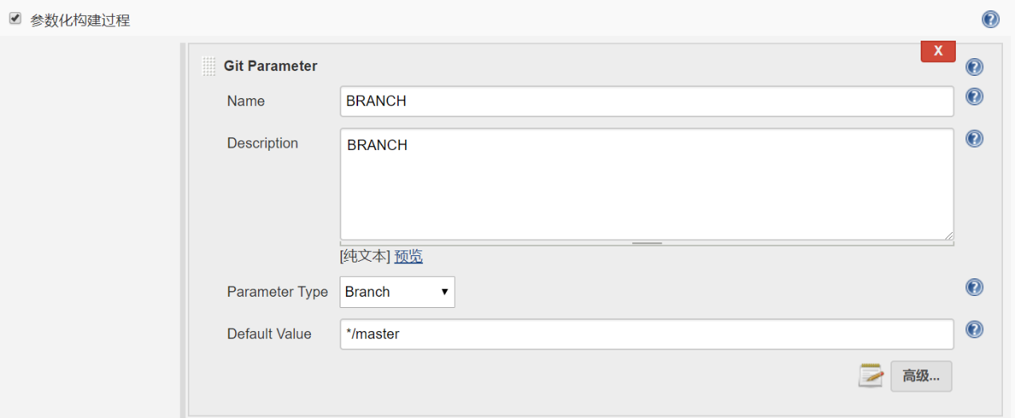

配置源码管理

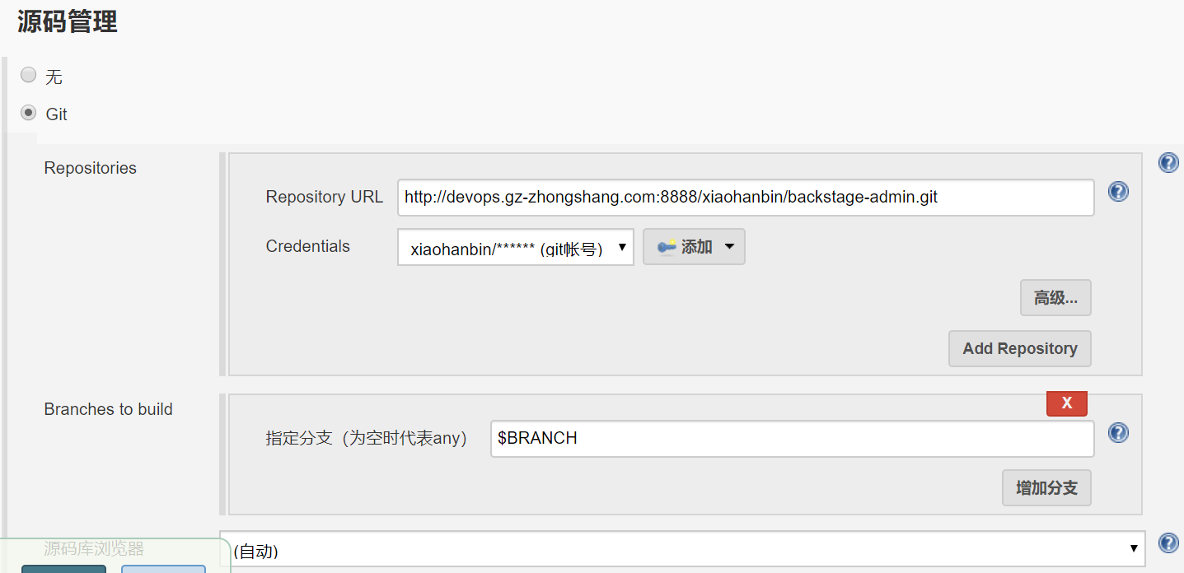

构建-执行shell

DATE=$(date +%Y%m%d%H%M)

projectdir=$JENKINS_HOME/workspace/backstage-admin/dist

destdir="/data/gf/gf-backstage/manager"

cnpm install

cnpm run build

cd $projectdir

ansible -i /etc/ansible/host/gateway_hosts gateway01 -m synchronize -a 'src='$projectdir' dest='$destdir''

2.1.2 增加ansible host配置

在/etc/ansible/host下面增加gateway_hosts，内容如下

[gateway01]

192.168.0.225

* 1. **运行jar（例：escenter）**
     1. 创建、配置作业

参数化构建过程配置git parameter



配置选项参数

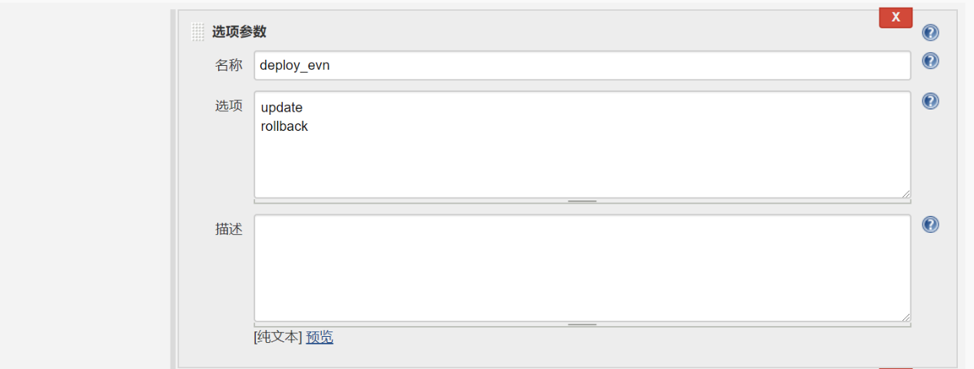

配置文本参数

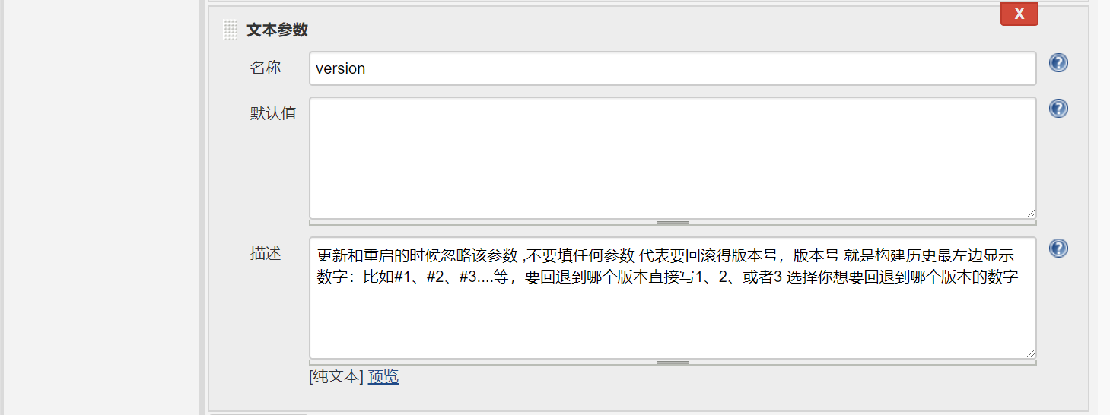

配置源码管理

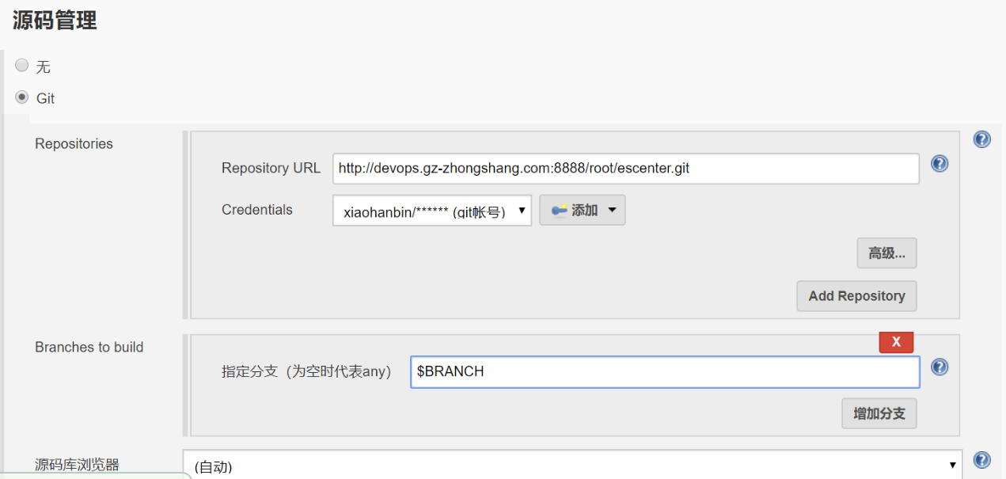

构建-执行shell

project="test-git-build"

app="escenter"

versionwar=1.2.3

srcdir="$JENKINS_HOME/workspace/$project/target"

destdir=/data/zs/app

shdir="/etc/ansible/script"

script=escenter.sh

host=test

case $deploy_evn in

update)

mvn clean package -U -Dmaven.test.skip=true

cd $JENKINS_HOME/workspace/$project/target

rm -f $app-$versionwar-SNAPSHOT.tar.gz

tar -czf $app-$versionwar-SNAPSHOT.tar.gz $app-$versionwar-SNAPSHOT.jar

cp -f $app-$versionwar-SNAPSHOT.tar.gz $JENKINS_HOME/jobs/$JOB_NAME/builds/$BUILD_ID

ansible $host -m copy -a 'src='$srcdir/$app-$versionwar-SNAPSHOT.tar.gz' backup=yes dest='$destdir''

ansible $host -m script -a ''$shdir/$script' update'

;;

rollback)

echo "version: ${version}"

echo rollback

ansible $host -m copy -a 'src='$JENKINS_HOME/jobs/$JOB_NAME/builds/${version}/$app-$versionwar-SNAPSHOT.tar.gz' backup=yes dest='$destdir''

ansible $host -m script -a ''$shdir/$script' update'

;;

*)

exit

;;

esac

* + 1. 增加ansible host配置

/etc/ansible/hosts增加如下内容

[test]

192.168.0.225

* + 1. 增加shell脚本

/etc/ansible/script目录下增加escenter.sh脚本，内容如下

#!/bin/bash

source /etc/profile

export JAVA_HOME="/data/jdk1.8.0_171/"

versionwar=1.2.3

shdir="/data/zs"

projectname="escenter-$versionwar-SNAPSHOT"

update (){

cd $shdir

rm -fr ./*.jar

kill -9 `ps -ef | grep escenter-$versionwar-SNAPSHOT |grep -v grep |awk '{print $2}'`

tar -xf /data/zs/app/$projectname.tar.gz -C /data/zs

cd $shdir

nohup java -jar /data/zs/$projectname.jar >> /data/zs/es.log 2>&1 &

};

stop (){

kill -9 `ps -ef | grep escenter-$versionwar-SNAPSHOT |grep -v grep |awk '{print $2}'`

};

case $1 in

update)

update

;;

stop)

stop

;;

*)

echo $"Usage: $0 {update|stop}"

exit

esac

* 1. **Wrapper（例：gf-article-service）**
     1. 创建、配置作业

参数化构建过程，配置git parameter

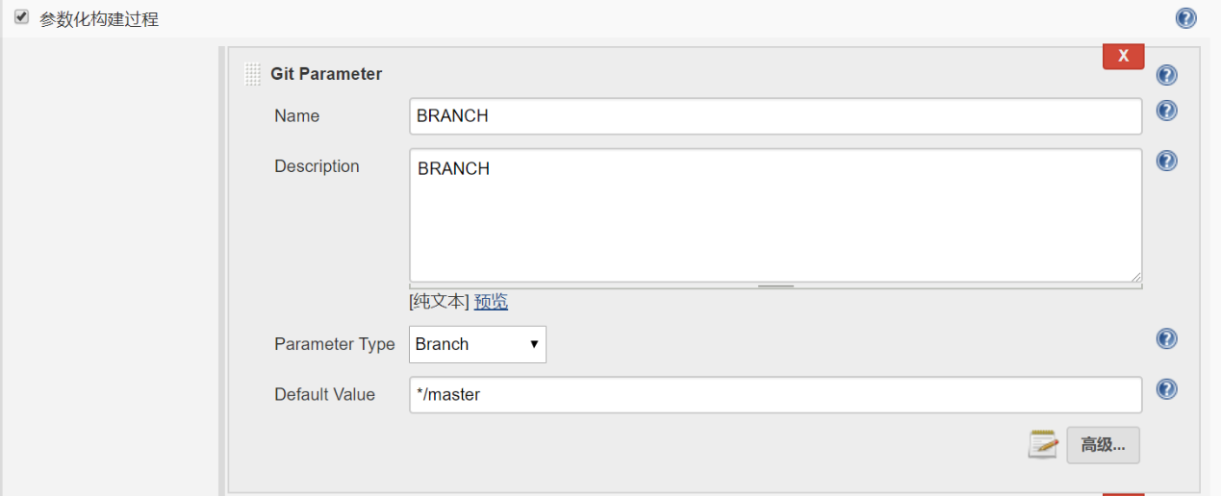

配置选项参数

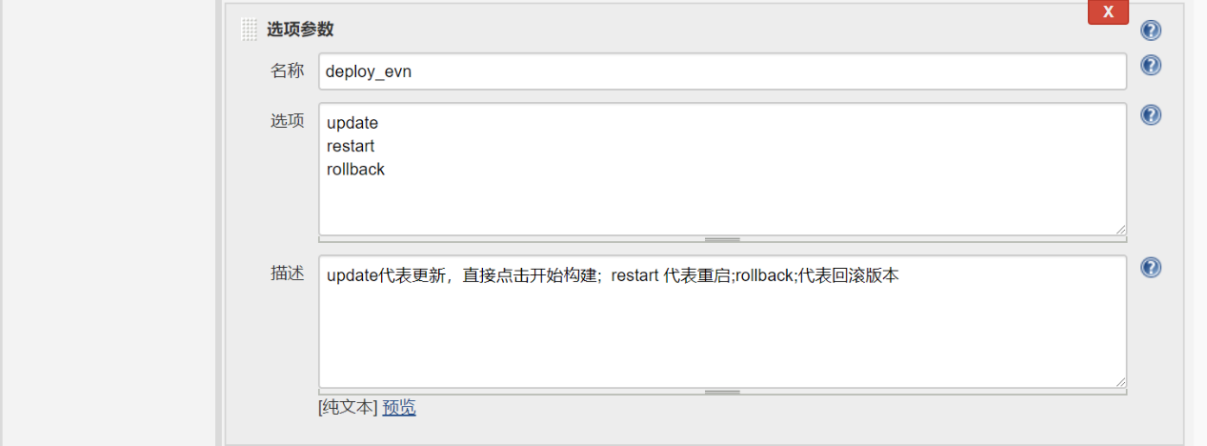

配置文本参数

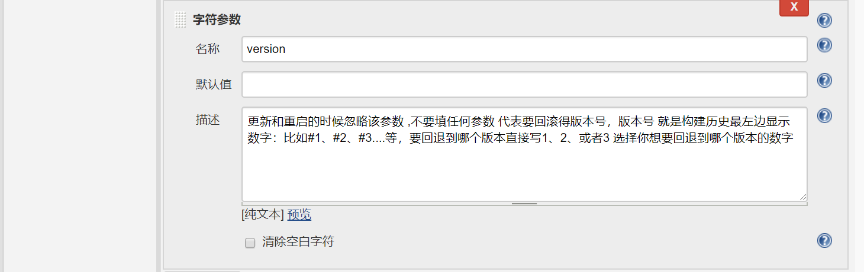

配置源码管理

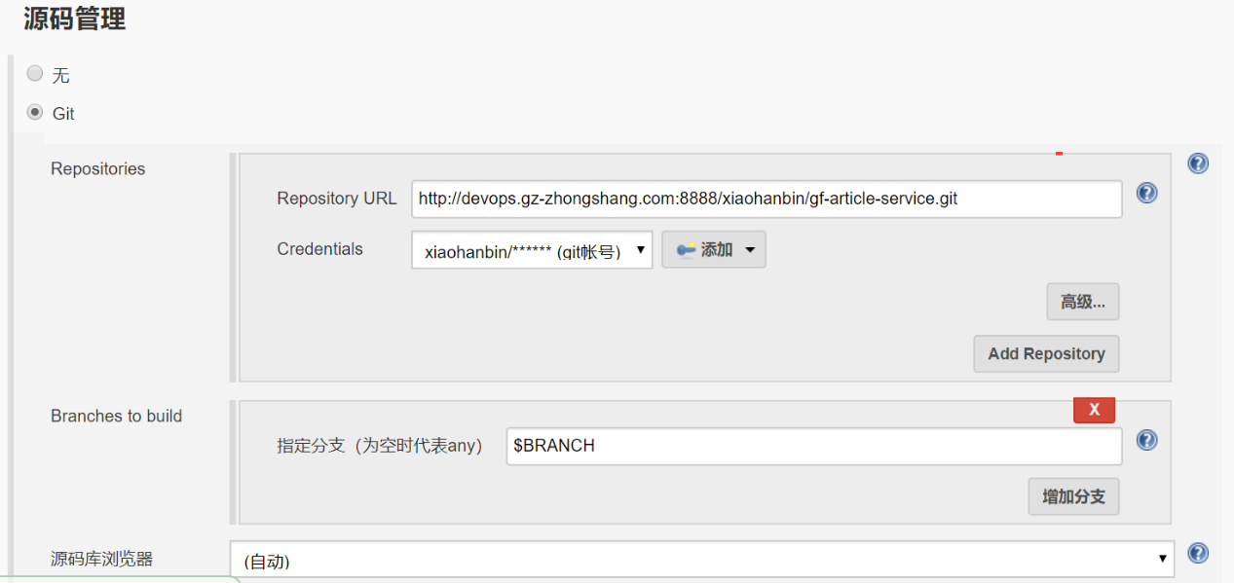

构建-执行shell

project="gf-article-service"

versionwar=0.0.2

script=article.sh

port=9001

host=article

host1=article01

host2=article02

hostconfig="/etc/ansible/host/article_hosts"

item="$project-$versionwar-SNAPSHOT-bin"

srcdir="$JENKINS_HOME/workspace/$project/target/$item/"

destdir=/data/gf/app

shdir="/etc/ansible/script/"

case $deploy_evn in

update)

mvn clean install -U -Dmaven.test.skip=true

cd $JENKINS_HOME/workspace/$project/target/$item

rm -f $project-$versionwar-SNAPSHOT.tar.gz

tar -czf $project-$versionwar-SNAPSHOT.tar.gz $project-$versionwar-SNAPSHOT

cp -f $project-$versionwar-SNAPSHOT.tar.gz $JENKINS_HOME/jobs/$JOB_NAME/builds/$BUILD_ID

ansible $host -m copy -a 'src='$srcdir/$project-$versionwar-SNAPSHOT.tar.gz' backup=yes dest='$destdir''

ansible -i $hostconfig $host1 -m script -a ''$shdir/$script' update'

sleep 60

ansible -i $hostconfig $host1 -m shell -a 'echo "" |telnet 127.0.0.1 '$port' 2>/dev/null'| grep \'^]

if [ $? -eq 0 ];then

#ansible -i $hostconfig $host2 -m script -a ''$shdir/$script' update'

echo "run second service"

fi

;;

restart)

ansible -i $hostconfig $host1 -m script -a ''$shdir/$script' update'

sleep 60

ansible -i $hostconfig $host1 -m shell -a 'echo "" |telnet 127.0.0.1 '$port' 2>/dev/null' | grep \'^]

if [ $? -eq 0 ];then

#ansible -i $hostconfig $host2 -m script -a ''$shdir/$script' update'

echo "run second service"

fi

;;

rollback)

echo "version: ${version}"

echo rollback

ansible $host -m copy -a 'src='$JENKINS_HOME/jobs/$JOB_NAME/builds/${version}/$project-$versionwar-SNAPSHOT.tar.gz' backup=yes dest='$destdir''

ansible -i $hostconfig $host1 -m script -a ''$shdir/$script' update'

sleep 60

ansible -i $hostconfig $host1 -m shell -a 'echo "" |telnet 127.0.0.1 '$port' 2>/dev/null'| grep \'^]

if [ $? -eq 0 ];then

#ansible -i $hostconfig $host2 -m script -a ''$shdir/$script' update'

echo "run second service"

fi

;;

*)

exit

;;

esac

* + 1. 增加ansible host配置

/etc/ansible/hosts增加如下内容

[article]

192.168.0.225

/etc/ansible/host下增加article_hosts文件，内容如下

[article01]

192.168.0.225

[article02]

192.168.0.226

* + 1. 增加shell脚本

/etc/ansible/script下增加article.sh

#!/bin/bash

source /etc/profile

export JAVA_HOME="/data/jdk1.8.0_171/"

version=0.0.2

shdir="/data/gf/gf-article-service-$version-SNAPSHOT"

ipaddr=`ifconfig eth2 | grep " inet addr" | awk '{print $2}'|awk -F ':' '{print $NF}'`

projectname="gf-article-service-$version-SNAPSHOT"

update (){

cd $shdir

if [ ! -d $shdir/logs ];then

mkdir $shdir/logs

fi

rm -fr ./lib

kill -9 ` ps -ef | grep gf-article-service-$version-SNAPSHOT |grep -v grep |awk '{print $2}'`

tar -xf /data/gf/app/$projectname.tar.gz -C /data/gf

cd $shdir/bin

./service.sh restart wrapper.java.additional.1=-Denv=test wrapper.java.initmemory=256 wrapper.java.maxmemory=256 wrapper.java.additional.2=-server wrapper.java.additional.3=-Xmn256M wrapper.java.additional.4=-Xss256K wrapper.java.additional.5=-XX:+CMSClassUnloadingEnabled wrapper.java.additional.6=-XX:+ScavengeBeforeFullGC wrapper.java.additional.7=-XX:+UseParNewGC wrapper.java.additional.8=-XX:+CMSParallelRemarkEnabled wrapper.java.additional.9=-XX:SoftRefLRUPolicyMSPerMB=0 wrapper.java.additional.10=-XX:+UseFastAccessorMethods wrapper.java.additional.11=-XX:+UseConcMarkSweepGC wrapper.java.additional.12=-XX:ParallelGCThreads=2 wrapper.java.additional.13=-XX:CMSFullGCsBeforeCompaction=5 wrapper.java.additional.14=-XX:+UseCMSCompactAtFullCollection wrapper.java.additional.15=-XX:SurvivorRatio=4 wrapper.java.additional.16=-XX:LargePageSizeInBytes=128m wrapper.java.additional.17=-XX:+UseCMSInitiatingOccupancyOnly wrapper.java.additional.18=-XX:CMSInitiatingOccupancyFraction=80 wrapper.java.additional.19=-XX:+UseCompressedOops wrapper.java.additional.20=-XX:+CMSScavengeBeforeRemark wrapper.java.additional.21=-XX:TargetSurvivorRatio=80 wrapper.java.additional.22=-XX:+ParallelRefProcEnabled wrapper.java.additional.23=-XX:+UseBiasedLocking wrapper.java.additional.24=-XX:-OmitStackTraceInFastThrow wrapper.java.additional.25=-XX:AutoBoxCacheMax=20000 wrapper.java.additional.26=-XX:+AggressiveOpts wrapper.java.additional.27=-XX:PretenureSizeThreshold=5242880 wrapper.java.additional.28=-XX:InitialCodeCacheSize=20971520 wrapper.java.additional.29=-XX:ReservedCodeCacheSize=268435456 wrapper.java.additional.30=-XX:+UseCodeCacheFlushing wrapper.java.additional.31=-XX:+TieredCompilation wrapper.java.additional.32=-XX:+DisableExplicitGC wrapper.java.additional.33=-XX:+ExplicitGCInvokesConcurrent wrapper.java.additional.34=-XX:+ExplicitGCInvokesConcurrentAndUnloadsClasses wrapper.java.additional.35=-XX:StringTableSize=800024 wrapper.java.additional.36=-XX:TLABWasteTargetPercent=2 wrapper.java.additional.37=-XX:ConcGCThreads=8 wrapper.java.additional.38=-Dcom.sun.management.jmxremote wrapper.java.additional.39=-Dcom.sun.management.jmxremote.authenticate=false wrapper.java.additional.40=-Dcom.sun.management.jmxremote.ssl=falsewrapper.java.additional.41=-Dcom.sun.management.jmxremote.port=12346 wrapper.java.additional.42=-Djava.rmi.server.hostname=$ipaddr

};

stop (){

cd $shdir/bin

./service.sh stop

};

case $1 in

update)

update

;;

stop)

stop

;;

*)

echo $"Usage: $0 {update|stop}"

exit

esac