1. Hyperparameter Settings and Training-Test Isolation
All model choices, fusion weights, and the classification threshold were determined by ten-fold cross-validation using the training set only. The independent test set was reserved exclusively for final evaluation and was not used for feature selection, sampling-strategy selection, classifier selection, weight tuning, or threshold optimization. The final settings used for the reported experiments are listed in Supplementary Table S1.
Table S1.Hyperparameter settings of SMILES-BioDTIPre.
Model or component | Parameter | Value
XGBoost | Number of trees | 7000
XGBoost | Max depth | 12
XGBoost | Learning rate | 0.02
LightGBM | Number of trees | 5000
LightGBM | Learning rate | 0.03
LightGBM | Number of leaves | 95
Both classifiers | n_jobs | 4
Both classifiers | random_state | 42
Probability fusion | XGBoost weight | 0.62
Probability fusion | LightGBM weight | 0.38
Decision rule | Classification threshold | 0.39

2. Local Web-based Predictor
To facilitate local deployment and practical use, we developed a Flask-based web predictor for SMILES-BioDTIPre. After starting the application, users can access the browser-based interface locally at http://127.0.0.1:5000. The predictor supports both single-sample and batch drug-target interaction screening.
In single-sample mode, users enter one drug SMILES sequence and one target protein amino-acid sequence. SMILES-T5 and BioT5+ generate the corresponding drug and target representations, which are concatenated into a 1536-dimensional joint feature and passed to the trained XGBoost-LightGBM ensemble. The predictor then returns the XGBoost probability, LightGBM probability, weighted fusion probability, and final binary prediction.
In batch mode, users upload a CSV file containing the SMILES and Protein columns. The application processes each drug-target pair and returns a downloadable CSV file containing the original inputs, model-specific probabilities, fused probabilities, predicted labels, and processing status. The input interface and an example of the batch-prediction output are shown in Supplementary Figure S1.
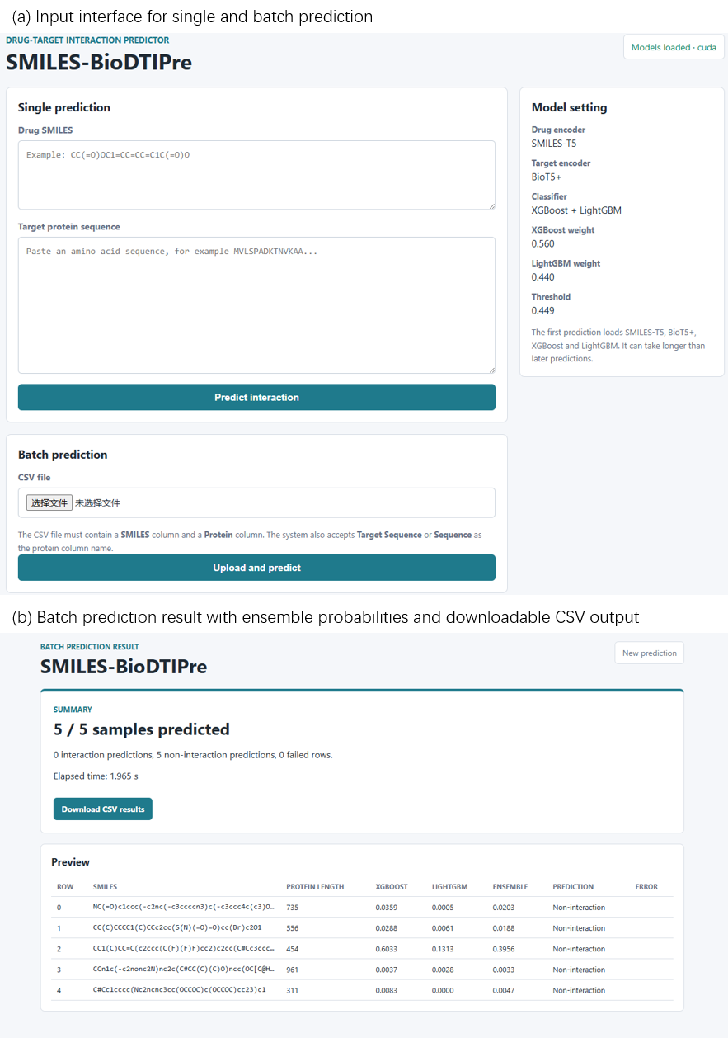
Figure S1. Local Flask-based web predictor of SMILES-BioDTIPre. (a) Input interface supporting single-sample and batch drug-target interaction prediction. (b) Batch-prediction results showing the XGBoost probability, LightGBM probability, weighted fusion probability, predicted label, processing status, and downloadable CSV output.

