**Research Paper**

**Evaluating Sustainable Manufacturing Practices Using Data Envelopment Analysis (DEA): A Multi- Criteria Approach**

By

Likhith Raj Yesala

**Table of Contents**

**Abstract** 3

**Introduction & Motivation** 4

**Literature Review** 6

**Research Design** 8

**Methodology: A Two-Phase DEA-Based Framework for Subjective and Objective Efficiency Assessment** 11

**Results & Discussions** 15

**Future Research** 18

**Conclusion** 18

**References** 19

# **Abstract**

In the research, the relations between the manufacturing performance and sustainability are investigated, and the focus is made on Nestle, Henkel, P&G and Unilever. The authors start with the now familiar definition of sustainability as articulated by the World Commission on Environment and Development when it was first used in 1987. It prescribes the need for today’s progress that sustains the future generations’ ability to meet their own needs without compromising present demands. Another issue that arises in sustainable manufacturing practices is how to measure the relative performance of decision-making units where there may be a lot of conflict between the criteria that have to be used. The authors of this paper are aware of this challenge and present DEA as a useful method for the assessment of sustainability. DEA is a very effective tool which can be used to overcome these challenges.

The company’s commitment to sustainability and the use of DEA to assess the environmental and social impact of manufacturing activities are examined in the paper. The proposed strategy combines the conjoint analysis of subjective efficiency assessments that take into consideration stakeholders’ preferences with the DEA-based assessments of efficiency. The approach proposed by the authors includes a two-stage assessment tool for the evaluation of the organizational unit’s performance, which also combines the subjective and objective efficiency indicators, thus offering a more accurate assessment of the sustainability performance. The importance of the study’s findings in highlighting the effectiveness of strategies in technical efficiency for the long-term sustainability is underlined. These findings were obtained with the help of Technical Efficiency values and observed an upward trend which is in correlation with sustainable manufacturing processes which involve water use, capital, waste, and workforce.

# **Introduction & Motivation**

The idea of sustainability has received much attention in recent years, especially the idea put forward by the World Commission on Environment and Development in 1987: sustainable development is the development that fulfills the current need without endangering the future generations’ ability to fulfill their needs. Sustainable development is the process of ensuring that the resource base remains intact to support the future generation’s financial, social, and other requirements [1].

**Research Problem**

Sustainability evaluation has a major issue, which is the need to combine dissimilar and sometimes opposite criteria into various dimensions. Experts have proposed evaluation frameworks to track the evolution of sustainability in the future [2]. Thus, despite the progress in the theories and practices of sustainability, the topic of organizational sustainability is still under researched. Much emphasis has been placed on the development of indicators that can be used to measure, as well as to categorize and avoid sustainability. However, these indicators alone may not be sufficient to measure sustainable growth efficiently [3] [4].

The problem of organizational sustainability is still far from developing, although the theoretical and practical bases for this problem have been strengthened [5]. Sustainable management practices have become compulsory for manufacturing industries mainly because of the growing awareness of the environment across the globe. These sustainable manufacturing practices should be evaluated to determine their effectiveness towards the achievement of the environmental objectives and constant enhancement. Thus, DEA serves as a powerful tool when comparing the efficiency of decision-making units (DMUs) with reference to various inputs and/or outputs. For this reason, it is a suitable technique for analyzing sustainable manufacturing practices.

Over the last few years, the global community has recorded a massive shift towards the production of sustainable goods. This trend has been encouraged by the rising incidents of environmental degradation, consumers’ preference for green products, and legislation. Sustainability manufacturers are keen on achieving sustainable goals in their business by effectively and efficiently developing evaluation procedures. Bench marking techniques that are normally used in performance evaluation are mostly financial and quantitative and therefore lack the capacity to address the various dimensions of sustainability in manufacturing.

Since DEA presents a logical and non-subjective methodology for comparing the performance of DMUs in terms of sustainable manufacturing, the application of Data Envelopment Analysis is a promising solution for this problem. Environmental consciousness is now rising, and the manufacturing sector is among the leading culprits for influencing climate change and other environmental triggers. Sustainable manufacturing practices can be implemented to ensure that the sector does not harm the environment in the future and even minimizes the amount of harm caused to the environment.

This paper focuses on the significance of efficiency appraisal of the Unilever company across the world. Efficient firms are aware of the shareholders’ needs, utilize resources, and implement changes that are beneficial. The application of DEA is highlighted as one of the most necessary ways to determine efficiency in terms of multiple inputs and outputs. DEA is shown to offer more accurate efficiency measurements than other methods. Efficiency refers to the ability of a business organization to operate with minimum input to produce maximum output over time, thus remaining competitive. Additionally, the article introduces a study on China’s environmental efficiency that suggests a cross-efficiency assessment considering negative outputs for assessing environmental efficiencies under different policy targets. To meet diverse policy requirements, this model combines economic growth, environmental conservation, and a win-win approach in line with decision-makers’ preferences. In many developing countries such as Nigeria, where companies face economic challenges, it has become necessary for managers to evaluate their levels of effectiveness.

**Research Questions**

* How can sustainable manufacturing practices be effectively assessed?
* What role does Data Envelopment Analysis (DEA) play in evaluating the ecological and societal impacts of manufacturing operations?
* Can DEA provide a comprehensive framework for assessing both subjective and objective efficiency evaluations in sustainable manufacturing?

**Research Hypothesis**

DEA is a suitable and impartial approach to measure the comparative efficiency of DMUs concerning sustainable manufacturing performance.

**Motivation**

The motivation behind this study is driven by several factors:

* **Environmental Concerns**: The manufacturing sector is one of the biggest culprits when it comes to climate change and other effects on the environment. The use of green practices in the manufacturing processes can greatly help in minimizing the contribution of the sector to greenhouse gases, hence preserving the environment for the generations to come.
* **Consumer Demand**: Consumers’ awareness of environmental issues pushes them to prefer environmentally friendly products, which forces manufacturers to embrace sustainability.
* **Regulatory Requirements**: The rising standards of the environment require efficient methods of evaluating sustainable manufacturing practices.

It is important to have sustainable manufacturing which will ensure the long-term survival of the manufacturing industry and mitigate some of the adverse effects of human actions on the environment. However, evaluating the effectiveness of sustainable manufacturing practices is challenging due to their multi-dimensional nature. These practices aim to reduce environmental impacts, minimize resource utilization, endorse social responsibility, and maintain economic viability, which makes assessment complex.

DEA is an effective tool to address this challenge, supporting informed decisions for benchmarking business performance improvement and stakeholder involvement. As a nonparametric method that handles multiple inputs and outputs, DEA offers flexibility to include different perspectives, making it well-suited for this type of assessment.

# **Literature Review**

On a global scale sustainable development has come to be more widely recognized as a significant problem. The appetite for natural resources (such as water, metals, and fossil fuels) has shot up over the last decade or so owing to the world economy's fast elongation, yet these resources' availability is finite.

The "black box" approach used to quantify activity efficiency prevents conventional DEA models from connecting the underlying reasons of process inefficiencies to the different stages of the process. This approach has limitations when assessing the efficacy of tasks involving two stages (or sub-processes) and when the inputs and outputs from a single step may be swapped out [6]. Applying a standard black-box technique to assess the efficacy of a two-stage process makes it challenging to pinpoint the root causes of inefficiencies.

In a publication [7], one of the first two-stage DEA models was introduced. It was used to evaluate the overall performance of the two marketability and profitability sub-processes in US commercial banks by determining how successful they were overall. However, because the efficacy of each stage was ascertained using a distinct DEA model, the potential conflict between the two phases was overlooked. Following this first approach, the focus shifted to evaluating both the overall efficiency of an integrated model and the efficiency of each stage separately. To do this, Liang et al. [8] employed a two-phase technique to assess the DMUs' efficiency using the concepts of cooperative and non-cooperative games from the game theory literature. When collaboration is lacking, the leader is evaluated and optimized based on the more important stage's efficiency score first. The follower's less important stage is only measured after that, if the leader stage's efficiency fails to change.

The debate was advanced by Chen et al. [9], who emphasized that the availability of intermediate measures makes it challenging to establish improvement objectives for the inefficient DMUs. These authors developed a method to identify the benchmark efficient DMUs for the inefficient DMUs inside a two-stage framework. Chen et al. noted that many of the two-stage DEA models in the literature can determine the position of the DEA efficiency frontier, but they are unable to evaluate the efficiency scores of the DMUs. Consequently, the inefficient DMUs cannot be projected into the efficiency frontier. Using the model developed, Chen et al. showed in two different trials that the projections provided by this model do not yield efficient target DMUs for the inefficient DMUs as an example.

Managing uncertainties in planning sustainable systems is an important task and Multi-criteria Decision Analysis (MCDA) is revealed as a promising approach to deal with the sustainability context. In this regard, MCDA is defined as a rational process of decision making that considers multiple criteria and the level of risk that is inherent in planning. The MCDA helps the decision-makers to consider the sustainability criteria that include the environmental, economic, and social impacts of the decision. The methodology’s advantage is in the fact that it can accommodate uncertainties by structuring the evaluation of trade-offs and decision-making processes, which in turn enables the development of a more resilient approach to the design of sustainable systems. By employing MCDA, the decision makers can more easily find their way through the complex web of uncertainties; and thus, help in achieving more sustainable solutions when striving for sustainability [2].

At the same time, data envelopment analysis (DEA) determines the relative effectiveness of a set of decision-making units (DMUs) in solving related problems [10]. DEA is a nonparametric method that employs many inputs to generate numerous outputs, whereby one can determine the level of efficiency of one DMU to the other [11]. Another paper advances the literature by applying a multi-stage DEA model to assess energy efficiency in sugar plants, addressing a gap in research on stage-specific efficiency in energy-saving measures [12]. While traditional DEA models offer a broad performance overview, they often miss the details required for multi-stage processes. This study integrates expert opinions and stage-by-stage efficiency analysis, providing a detailed performance benchmark and identifying areas for improvement. By applying DEA to complex, multi-stage contexts, the paper offers both methodological advancements and practical insights for enhancing energy efficiency in energy-intensive industries.

Another study presents a hybrid FA-DEA-AHP model for selecting low-carbon suppliers, integrating Factor Analysis, Data Envelopment Analysis, and Analytic Hierarchy Process [13]. It builds an evaluation index system and applies the model to rank suppliers based on product quality, qualifications, and environmental competitiveness. An empirical study with cement suppliers shows the model's effectiveness in selecting and ranking suppliers, advancing the methodology for low-carbon supply chain management. In another work, Izadikhah et al. [14] introduced a unique stochastic two-stage DEA model in the context of unwanted data to evaluate the sustainability of the SCs. Moreover, Fathi et al. [15] introduced a robust two-stage network DEA (RTNDEA) model to evaluate supply chain sustainability and efficiency in the transport industry, accounting for undesirable outputs and uncertain data.The authors [16] used a non-radial DEA model to evaluate the project's components. This methodology assesses the environmental performance of suppliers while accounting for undesired inputs and outputs. Lin et al. [17] proposed an inverse DEA model to evaluate the efficiency of container ports and investigate how much resource they use in relation to unwanted outcomes. Tavassoli et al. [18] proposed four alternative supplier selection models and a stochastic-fuzzy DEA model to evaluate a supplier's sustainability. The impact of operational and sustainable operations on the retail business's performance was assessed using a two-stage network DEA model-based performance assessment technique.

The authors [16] applied a non-radial DEA model to measure the project’s components. This methodology evaluates the environmental performance of suppliers with consideration of the undesired inputs and outputs. Lin et al. [17] have suggested the inverse DEA model to measure the efficiency of the container ports, and to explore to what extent the resource they use leads to undesirable effects. Tavassoli et al. [18] presented four different supplier selection strategies and a stochastic-fuzzy DEA model to measure a supplier’s sustainability. Based on the two-stage network DEA model-based performance assessment technique, operational and sustainable operations’ effects on the performance of the retail business were evaluated.

The study by Moghaddas et al. [19] put forward a network DEA-based assessment approach that shall be used to develop sustainable supply chains (SSC) by evaluating strategies at each stage to optimize economic, social, and environmental performance. It integrates sustainability-related inputs and outputs, considers competition, and addresses undesirable outputs and feedback to ensure real-world applicability. This approach helps decision-makers select the most efficient strategies for maximizing overall network efficiency.

These studies together illustrate how flexible DEA can be across different sectors looking at efficiency and sustainability concerns. All the above-presented research enhances an overall understanding of DEA through its interrelation with comprehensive study on efficiency improvement within various organizations for top management seeking to implement best practices in their divisions through objective identification of areas calling for change, thus influencing performance management and optimization strategies among other things.

**Previous approach**

Using mathematical programming techniques, DEA estimates an efficiency frontier by considering the highest-performing performance observations (extreme points), which "envelop" the remaining observations. The ratio of generated outputs to used inputs is one way to define efficiency:

**Efficiency = outputs/inputs**

An inefficient unit can become efficient by either increasing output (products) while keeping resource consumption at the same level, decreasing resource consumption while keeping production at the same level, or doing both at once [1] [2] [3].

If n firms (as DMU) convert similar m inputs to the same s outputs, then the optimal design problem is solved for n firms. The jth firm applies an m-dimension input vector (I = 1, 2; …, m) to generate an s-dimensional output vector (r = 1, 2, …, s), with subscript 0 designating the firm that is being evaluated. An inefficient unit can become efficient by either increasing output (products) while keeping resource consumption at the same level, decreasing resource consumption while keeping production at the same level, or doing both at once.

Every company is represented by:

Maximize ∑𝑈𝑟𝑌𝑟𝑐

Subject to the constraints

∑t=1​Vi​Xij​ ≤ 1 for j=1,2,…,n

for r = 1,2 …,s

for r = 1,2 …,m

Both the weighted output and input must be positive, as they represent key performance metrics. The sum j reflects the simulated (weighted) output. The goal is to maximize the ratio of weighted outputs to weighted inputs, known as the relative efficiency ratio. The highest possible value for this ratio is 1. A firm achieves DEA efficiency if its efficiency score is 1, meaning it meets the efficiency criteria; otherwise, it is deemed inefficient. Consequently, within any group of firms, at least one must be highly efficient (with an efficiency score of 1), while the others, with scores less than 1, are relatively less efficient. These efficiency scores are used to rank the firms accordingly.

# **Research Design**

This research evaluates the sustainability practices of manufacturing companies using a two-phase Data Envelopment Analysis (DEA) framework. The primary focus is on Nestle, Henkel, Procter & Gamble (P&G), and Unilever. The study integrates both subjective and objective measures of efficiency to provide a comprehensive analysis of sustainable manufacturing practices.

**Research Objectives**

* To assess the effectiveness of sustainable manufacturing practices in leading companies.
* To utilize DEA for evaluating the ecological and societal impacts of manufacturing operations.
* To develop a comprehensive framework combining subjective efficiency evaluations with DEA-based objective assessments.

**Type of Research Design**

This research adopts a correlational research design. This design is suitable for addressing the research problem because it allows for the examination of relationships between multiple variables, such as resource usage, production efficiency, and sustainability outcomes, without manipulating the study environment. By using DEA, a powerful non-parametric method, the study effectively correlates input variables (e.g., energy consumption, water usage) with output variables (e.g., production volume, waste reduction), offering a robust framework for evaluating the relative efficiency of manufacturing practices.

**Justification for Correlational Design**

The correlational design is appropriate for this research for several reasons:

* **Complex Interdependencies:** Sustainable manufacturing involves complex interdependencies between various inputs and outputs. Correlational design helps in understanding these relationships without requiring experimental manipulation.
* **Real-world Applicability:** This design allows the study to be conducted in real-world settings, ensuring that the findings are applicable to actual manufacturing practices.
* **Efficiency Evaluation:** DEA, used in this study, is inherently correlational, focusing on the relative efficiency of decision-making units by comparing multiple inputs and outputs.

**Methodological Approach**

The research design used in the study involves the use of two-phase data collection technique to capture both quantitative and qualitative data on sustainability performance.

**Phase 1: Subjective Efficiency Assessment**

This phase involves identification of the stakeholders’ preference and attitude towards sustainable manufacturing practices. The methodology includes:

**Conjoint Analysis:**

* **Objective:** To identify the stakeholders’ attitudes toward the different aspects of sustainable manufacturing.
* **Procedure:** Surveys designed to gather data on stakeholders' preferences for different sustainability features, such as energy conservation, waste reduction, and water usage.
* **Analysis:** Data is analyzed to derive relative importance and utility scores for each attribute, providing insights into stakeholder priorities.

**Data envelopment analysis:** A nonparametric method employed to evaluate the relative efficiency of carbon emission reduction among a group of similar decision-making units (DMUs) by considering various input and output parameters.

**Phase 2: Objective Efficiency Assessment**

This phase involves measuring the actual performance of manufacturing operations using objective data. Key steps include:

**Selection of Inputs and Outputs:** Identifying relevant inputs (e.g., energy consumption, raw materials, water usage) and outputs (e.g., production volume, waste reduction) critical to sustainable manufacturing.

**Data Collection and Preprocessing:**

* **Sources:** Data collected from company sustainability reports, production records, and other relevant documents.
* **Processing:** Data is cleaned, normalized, and prepared for analysis to ensure accuracy and consistency.

**DEA Model Selection and Formulation:**

* **Model Choice:** A non-radial DEA model is selected, suitable for evaluating multiple inputs and outputs while accounting for inefficiencies.
* **Formulation:** The model is formulated based on the research objectives, defining the inputs and outputs to be analyzed.

**Model Implementation and Analysis:**

* **Tools:** Software tools such as DEAP and PyDEA are used to implement the DEA model.
* **Evaluation:** Analysis identifies the most efficient decision-making units (DMUs) and highlights areas for potential improvement.

**Data Sources**

The data used in this study come from various sources, including:

* **Company Sustainability Reports:** Annual reports detailing the sustainability initiatives and outcomes of the companies under study.
* **Production Records:** Data on production volumes, resource consumption, and waste generation.
* **Stakeholder Surveys:** Responses from stakeholders collected through conjoint analysis surveys.

**Variables and Measures**

The study uses the following variables:

**Input Variables:**

* Energy consumption
* Water usage
* Raw material usage

**Output Variables:**

* Production volume
* Waste reduction
* Emission levels

**Analytical Framework**

The proposed framework integrates subjective and objective efficiency assessments to provide a holistic view of sustainability performance. The subjective efficiency assessment captures stakeholder preferences, while the objective efficiency assessment evaluates actual performance using DEA.

* **Subjective Efficiency Scores:** Derived from conjoint analysis, these scores reflect stakeholder preferences for different sustainability attributes.
* **Objective Efficiency Scores:** Calculated using DEA, these scores measure the relative efficiency of manufacturing units in terms of resource usage and waste reduction.

**Interpretation and Implications**

The results of the DEA analysis are interpreted to identify best practices and areas for improvement in sustainable manufacturing. The findings are used to:

* **Benchmark Performance:** Compare the sustainability performance of different companies and identify leaders in the industry.
* **Inform Decision-Making:** Provide actionable insights for companies to enhance their sustainability practices.
* **Engage Stakeholders:** Communicate the efficiency and sustainability performance to stakeholders, fostering greater transparency and accountability.

**Expected Outcomes**

The study expects to achieve the following outcomes:

* **Enhanced Understanding of Sustainable Practices:** Providing a detailed analysis of how leading companies implement and benefit from sustainable manufacturing practices.
* **Identification of Efficiency Drivers:** Highlighting the key factors that drive efficiency in sustainable manufacturing.
* **Recommendations for Improvement:** Offering practical recommendations for companies to improve their sustainability performance.

# **Methodology: A Two-Phase DEA-Based Framework for Subjective and Objective Efficiency Assessment**

This paper presents a framework that applies DEA for evaluating social and environmental effects of corporate manufacturing processes. Among the most significant principles of sustainability strategy is the minimization of the manufacturing impact. This goal consists of measures associated with energy saving, water and waste management, and utilization. The framework can be adopted by a company to evaluate the vulnerabilities that exist regarding sustainability issues in the organization. Thus, we proposed a new two-phase model for assessing subjective as well as the objective efficiency of the organizational units (DMUs). The framework adopted DEA as an efficiency measure and conjoint analysis to incorporate stakeholders’ preference.

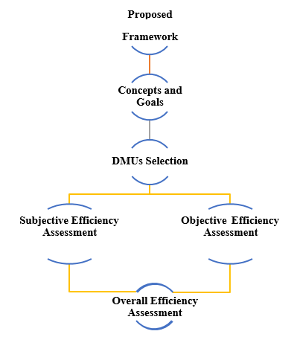

Some aspects examined in the project for evaluating sustainable manufacturing practices using DEA are as follows:

* **Selection of inputs and outputs:** The main inputs and outputs relevant to sustainable manufacturing performance should be identified. This can include a variety of things such as environmental impact, resource use, social responsibility, and economic viability.
* **Data collection and preprocessing:** Data required for DEA analysis should be collected and preprocessed. This could involve cleaning the data, removing outliers, and normalizing it.
* **Model selection and formulation:** Appropriate DEA model should be selected and formulated depending on the specific research objectives. This may include input-oriented, output-oriented, or non-radial DEA models.
* **Model implementation and analysis:** The appropriate manufacturing units that are most efficient can be determined through implementing as well as analyzing the DEA model for possible areas of improvement. Different software packages like DEAP and PyDEA can be used for this process.
* **Interpretation and implications:** Interpret the DEA results and draw implications for decision- making, benchmarking, performance improvement, and stakeholder engagement. Ultimately, the overall efficiency is computed as the sum of products of all partial efficiency scores, both subjective and objective, and their weights. AHP weights determine the importance of efficiency measures in the analysis.

**Subjective Efficiency Assessment**

The evaluation of respondents' subjective efficiency, which mostly relies on their preferences and views, is the first stage in our methodological approach. There are two phases to this examination, as shown in the picture below.

* **Conjoint analysis:** Conjoint analysis is a statistical method based on surveys that is employed in market research to ascertain consumers' values for several characteristics (such as features, functions, and advantages) that comprise a particular product or service. The five steps of conjoint preference analysis are depicted in the figure below.
* **Data envelopment analysis:** A nonparametric method called data envelopment analysis is used to assess the relative efficiency of reducing carbon emissions among a collection of homogeneous decision-making units (DMUs) that include a variety of input and output parameters.

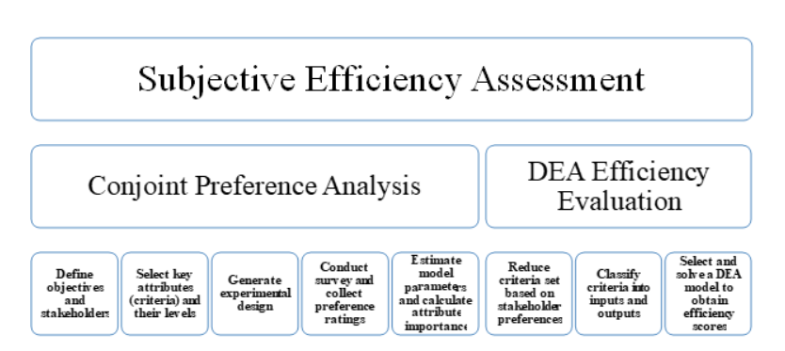

**Objective Efficiency Assessment**

Objective efficiency evaluation measures how well an actual process or system has performed using objective data. It can be said that objective efficiency evaluation uses numbers to measure performance. The sources of such data are numerous, including financial statements, production records, customer satisfaction surveys etc. This information is then used for the computation of efficiency scores. These scores could either be used in comparing different processes or systems as well as monitoring the progress over time of a single process or system. Key steps include input/output selection, data collection, DEA model selection, and efficiency score estimation.

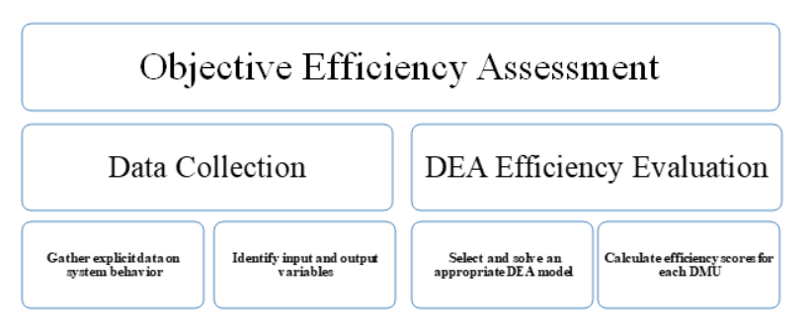

**Variables Description**

The input and output variables were applied in this study to establish the efficiency of sustainability manufacturing. There are several input variable sets that are used in empirical studies.

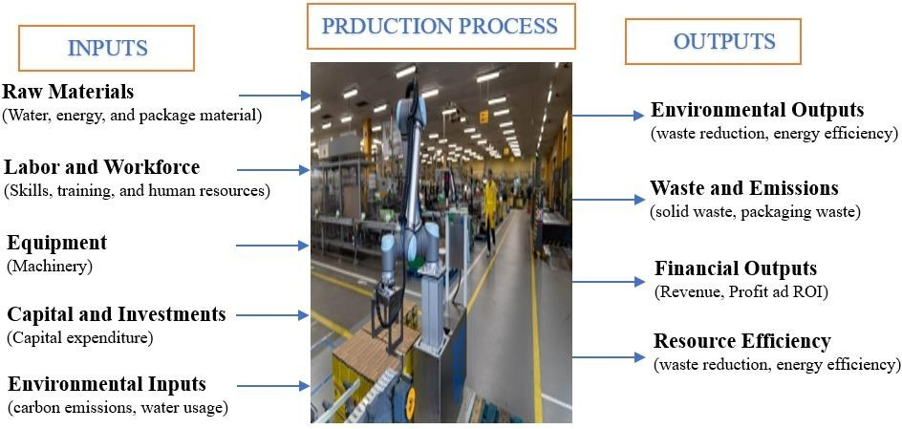

**Empirical study**

Among the mentioned strategies, the DEA methodology is one of the most effectively used by sustainability manufacturers. DEA also helps Unilever to compare its manufacturing facilities with other manufacturing plants around the world, hence identifying areas that need improvement. By identifying the most efficient facilities, they can replicate their best practices across its global network, resulting in overall efficiency gains.

The commitment to sustainability manufacturing extends beyond efficiency improvements. The company also proactively invests in innovative technologies and processes to further reduce its environmental impact. For example, Unilever has moved to the use of renewable energy, recycling of water and using circular economy to reduce wastage. The outcomes depict that waste produced by Unilever is reducing day by day.

**Progress and achievement**

The Unilever EOS data includes water, energy and greenhouse gas emissions, waste, and occupational safety. The assurance symbols for each reporting year are included in the dataset.

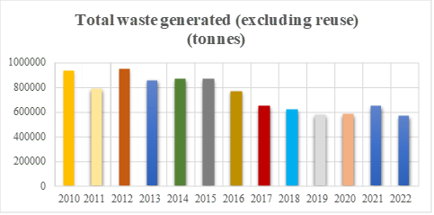

It contains Information about the makeup of our workforce, the diversity of genders within it, learning and growth, and recruiting and retention.

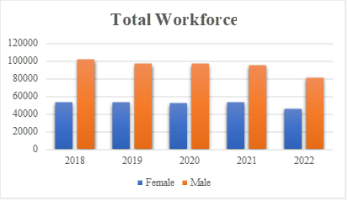

To determine the reason for the consistent decrease in water usage in Unilever's sustainability manufacturing over the years, a thorough analysis is needed. Several factors could contribute to this trend:

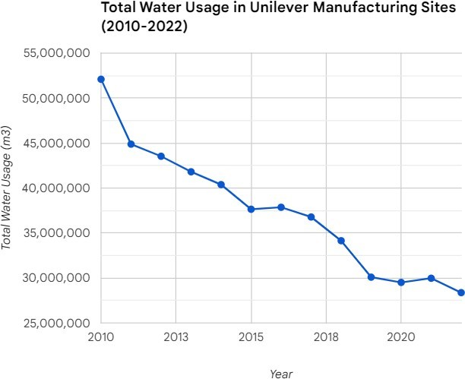

# **Results & Discussions**

After the detailed analysis, it is concluded that water usage, workforce management, waste reduction and capital investments are some of the factors that would affect the efficiency and sustainability of manufacturing processes. The Technical Efficiency values provided show an upward trend from 2010 to 2022. This may suggest that technical efficiency in sustainable manufacturing has improved over the years. Higher values generally indicate good efficiency.

It is hard to give a detailed analysis without knowing the scale or benchmark you used for your DEA model. However, when there is a consistent increase in Technical Efficiency these years, we can say that sustainability manufacturing processes have improved.

Regarding this statement, it is argued that over time Unilever, Nestle, Henkel and P&G have achieved success by using its Technical Efficiency optimization strategies related to lower water usage as well as improved staff management.

**Nestle** has the highest technical efficiency score among the four companies in each of the four years, which is 1. This implies that the company uses its input efficiently to produce outputs. The causes could be many, such as superior input material, more efficient operational processes, or better management.

**Henkel** also has a high technical efficiency score in all four years, ranging from 0.9443 to 1. This indicates that Henkel is also using its inputs efficiently to produce its outputs. However, Henkel's technical efficiency score is not as high as Nestle's in any year. This suggests that there may be some areas where Henkel could improve its efficiency.

**P&G** has the lowest technical efficiency score among the four companies in each of the four years, which is between 2.1628 and 2. 3832.This implies that P&G can significantly increase its output by reducing inputs or decreasing costs of production. On this note, low technical efficiency scores for P&G may be attributed to several factors like poor quality inputs, inefficient production process and bad management practices.

**Unilever’s** technical efficiency score fluctuates between 0.3775 and 0.6512 which means a lot can be done by reducing the input or increasing output to improve their level of technical efficiency.

Nevertheless, over time Unilever’s level of technical efficiency has been rising gradually, meaning they are in a process of increasing their effectiveness.

|  |
| --- |
| Nestle Data Envelopment Analysis |
| DMU | **Year** | **Phi** | **Technical Efficiency** |
| 1 | 2019 | 1 | 2 |
| 2 | 2020 | 1.039937 | 0.961596 |
| 3 | 2021 | 1 | 1 |
| 4 | 2022 | 1 | 1 |
| Henkel Data Envelopment Analysis |
| DMU | **Year** | **Phi** | **TE** |
| 1 | 2018 | 1 | 1 |
| 2 | 2019 | 1.024954 | 0.975654 |
| 3 | 2020 | 1.058979 | 0.944306 |
| 4 | 2021 | 1.036667 | 0.96463 |
| 5 | 2022 | 1 | 1 |
| P&G Data Envelopment Analysis |
| DMU | **Year** | **Phi** | **TE** |
| 1 | 2019 | 0.423017 | 2.363971 |
| 2 | 2020 | 0.419611 | 2.383161 |
| 3 | 2021 | 0.462355 | 2.16284 |
| 4 | 2022 | 0.459516 | 2.176204 |
| Unilever Data Envelopment Analysis |
| DMU | **Year** | **Phi** | **TE** |
| 1 | 2019 | 2.64928 | 0.37746 |
| 2 | 2020 | 1.59195 | 0.62816 |
| 3 | 2021 | 1.6301 | 0.61346 |
| 4 | 2022 | 1.53553 | 0.65124 |

**Discussion**

In general, Nestlé and Henkel are more technically efficient than Unilever and Procter & Gamble.

* Nestlé always has a technical efficiency index equal to one for every year which means she operates with minimal waste.
* Henkel is nearing a technical efficiency score of one for each year meaning it does likewise when it comes to production methods and techniques.
* Unilever’s technical efficiency scores are all significantly below one, meaning the company could improve its TE by either reducing input or expanding output.
* P&G has the least average technical efficiency score amongst the four companies every year. Thus, this shows that P&G can enhance its technical efficiency by lowering inputs and increasing outputs.

**Reasons for differences in technical efficiency**

There are several possible explanations for the wide range of different levels of technical efficiencies between these four firms. They include:

* **Differences in the quality of inputs:** Nestle and Henkel may be using higher quality inputs than P&G and Unilever. This would enable them to get more out of a given quantity of inputs, hence attaining higher technical efficiency.
* **Differences in production process:** Nestle and Henkel could be having better production techniques than P&G and Unilever. This would enable them to produce more output with less input, hence higher technical efficiency.
* **Differences in scale:** Nestle and Henkel are more extensive firms as compared to P&G and Unilever. This can give them economies of scale which would reduce their costs hence increasing their TE as a ratio.
* **Differences in management practices:** Nestle and Henkel may possess even better management practices than P&G and Unilever. This will assist in improving their efficiency and thus productivity as well as increase profitability.

The above companies can always apply the DEA results to realize the places they need to improve on to increase efficiency. For instance, P&G and Unilever may aim at increasing their technical efficiency by decreasing their input or by raising their outputs.

**Overall Comparison**

* **Technical Efficiency Consistency:** Nestle and Henkel have been consistently operating at high levels of technical efficiency, showing stability of operations. P&G and Unilever exhibit different trends, with efficiency increasing over time.
* **Change over time:** P&G and Unilever show high improvements in technical efficiency indicating adaptability and process optimization. Nestle and Henkel remain highly efficient but with slight variations.
* **Phi versus TE:** Total Efficiency (Phi) represents overall efficiency whilst Technical Efficiency (TE) considers variation of inputs and outputs. Nestle and Henkel have the highest Phi constantly representing that they are fully efficient given the inputs and outputs considered here.
* **Combination of Sustainability:** There is a need for further analysis to establish the relationship between sustainability practices and the company’s performance. Sustainability initiatives should be integrated into the operational efficiency measures made by organizations to ensure maximum positive environmental impacts.
* **Resilience in Operations:** Many enterprises exhibiting steady high scores for productivity are likely to be more resilient in operations.
* **Sustainability through Continuous Improvement:** Continuous improvement in efficacy builds long-term sustainability as well as competitiveness.

Additionally, using this data enables them to compare how they perform compared to other companies. An instance is Nestle comparing its performance with Henkel to determine which company is more effective.

The DEA results provide important information that can be used by companies to make them more efficient and profitable.

# **Future Research**

* **Improved Efficiency Measures:** This means that Unilever might have been able to adopt more efficient water management practices and technologies over time thus leading to a reduction in water consumption during their manufacturing processes.
* **Technological Innovations:** Advanced and sustainable technologies could have contributed to the reduced usage of water. For the same or even higher production output, it may be possible to use less water since the equipment may have been changed or the process optimized.
* **Investment in Sustainable Practices:** Also, the commitment that has been made towards the achievement of sustainable development has led to the investment in environmentally friendly activities such as water conservation programs. It could be in the form of using the water in a cyclic manner within the manufacturing processes.
* **Corporate Sustainability Goals:** For instance, Nestle corporate sustainability goals are aimed at the reduction of resource use in compliance with international initiatives to deal with environmental issues. This dedication may imply that in the future they will use water in the minimal way possible.
* **Regulatory Compliance:** Some changes in environmental regulations or higher attention paid to water conservation might have led to initiating proactive measures aimed at cutting down its use of water to conforming to industry standards and regulations.
* **Consumer and Stakeholder Pressure:** The sustainable manufacturers may have had its attention directed towards reducing its ecological footprints through water conservation, among other things; a possibility that is connected to increasing consumer and stakeholder consciousness on the need for environmentally responsible practices.
* **Continuous Improvement Initiatives:** It is likely that in response to its commitment to continuous improvement, Unilever may have been involved in resource optimization efforts on a day-to-day basis. This might result in less consumption of water.

# **Conclusion**

In conclusion, Unilever has undoubtedly shown its dedication to sustainable manufacturing practices with the implementation of several initiatives focused on optimizing resource usage. It's possible that companies have utilized the DEA model to enhance technical efficiency throughout its operation history. The comprehensive commitment to environmental and economic sustainability is embodied in water optimization, engagement, and health of its workforce, upholding circular economy ideals to minimize waste, and favorable investments in sustainable technology. Companies’ utilization of the DEA model is reflected in the upward trend of Technical Efficiency values, indicating a successful effort to improve their manufacturing processes. Adopting the principles of the model has allowed not only to save costs but also demonstrate their commitment to environmental conservation, proving that sustainability and business efficiency can coexist.

Nestle and Henkel demonstrate firmness in operations, which is shown by their consistently high scores of efficiencies. More research on this matter would give a comprehensive understanding of specific factors affecting sustainability practices as well as operational efficiency. The DEA results reveal that Nestle and Henkel are the most technically efficient of the four. Nevertheless, Unilever’s technical efficiency has been steadily increasing over the years, which indicates that they are taking steps to improve their efficiency. P&G could become much more technically efficient by decreasing its inputs or increasing its outputs.

# **References**

|  |  |
| --- | --- |
| [1] | P. Ahi and C. Searcy, "Assessing sustainability in the supply chain: A triple bottom line approach," 2015. |
| [2] | R. Vivas, Â. Sant’anna, K. Esquerre and F. Freires, "Measuring Sustainability Performance with Multi Criteria Model: A Case Study," *2019.* |
| [3] | B. Fahimnia and A. Jabbarzadeh, "Marrying supply chain sustainability and resilience: A match made in heaven," 2016. |
| [4] | A. Afful-Dadzie, E. Afful-Dadzie and C. Turkson, "A TOPSIS extension framework for re-conceptualizing sustainability measurement," 2016. |
| [5] | J. F. Kirchoff, A. Omar and B. S. Fugate, "A Behavioral Theory of Sustainable Supply Chain Management Decision Making in Non-exemplar Firms," 2016. |
| [6] | Y.-T. Chang, N. Zhang, D. Danao and N. Zhang, "Environmental efficiency analysis of transportation system in China: A non-radial DEA approach," 2013. |
| [7] | J. Zhu, "Quantitative Models for Performance Evaluation and Benchmarking," 2014. |
| [8] | L. Liang, W. D. Cook and J. Zhu, "DEA models for two-stage processes: Game approach and efficiency decomposition," 2008. |
| [9] | Y. Chen, W. D. Cook and J. Zhu, "Deriving the DEA frontier for two-stage processes," 2010. |
| [10] | M. J. Rezaee, S. Yousefi and J. Hayati, "A multi-objective model for closed-loop supply chain optimization and efficient supplier selection in a competitive environment considering quantity discount policy," 2017. |
| [11] | S. Yousefi, M. J. Rezaee and M. Solimanpur, "Supplier selection and order allocation using two-stage hybrid supply chain model and game-based order price," 2019. |
| [12] | H. Borgheipour, F. H. Lotfi and Z. Moghaddas, "Implementing energy efficiency for target setting in the sugar industry of Iran," 2017. |
| [13] | X. He and J. Zhang, "Supplier Selection Study under the Respective of Low-Carbon Supply Chain: A Hybrid Evaluation Model Based on FA-DEA-AHP," 2018. |
| [14] | M. Izadikhah, M. Azadi, M. Toloo and F. K. Hussain, "Sustainably resilient supply chains evaluation in public transport: A fuzzy chance-constrained two-stage DEA approach," 2021. |
| [15] | A. Fathi, B. Karimi and R. F. Saen, "Sustainability assessment of supply chains by a novel robust two-stage network DEA model: a case study in the transport industry," 2022. |
| [16] | B. Djordjević and E. Krmac, "Evaluation of Energy-Environment Efficiency of European Transport Sectors: Non-Radial DEA and TOPSIS Approach," 2019. |
| [17] | Y. Lin, L. Yan and Y.-M. Wang, "Performance Evaluation and Investment Analysis for Container Port Sustainable Development in China: An Inverse DEA Approach," 2019. |
| [18] | M. Tavassoli and M. Ghandehari, "Classification and forecasting of sustainable-resilience suppliers via developing a novel fuzzy MIP model and DEA in the presence of zero data," 2023. |
| [19] | Z. Moghaddas, B. M. Tosarkani and S. Yousefi, "A Developed Data Envelopment Analysis Model for Efficient Sustainable Supply Chain Network Design," 2021. |