实验九 实验报告

班级 网络152 学号 3150931035 姓名 陈奕林 其他组员 张越 何源

一、实验目的

理解三层架构的结构，熟练使用动软.net生成器

二、实验要求

1. 熟悉Visual Studio .Net 2010的基本操作方法。

2. 认真学习动软.net生成器的用法

3. 熟练掌握三层架构工程代码的配置方法

4 熟练掌握三层架构代码的调用方法以及修改方法

三、实验内容

采用 C/S结构，基于动软.net代码生成器编写程序。系统要求用户有学生、老师、管理员使用，学生可以在线查看可选课程信息、在线选课、个人信息修改、成绩查看，老师可以查询自己的课程人数，管理员可以对整个系统进行管理（包括系统管理、用户管理、课程管理）。

四、实验步骤

**1. 功能框图**

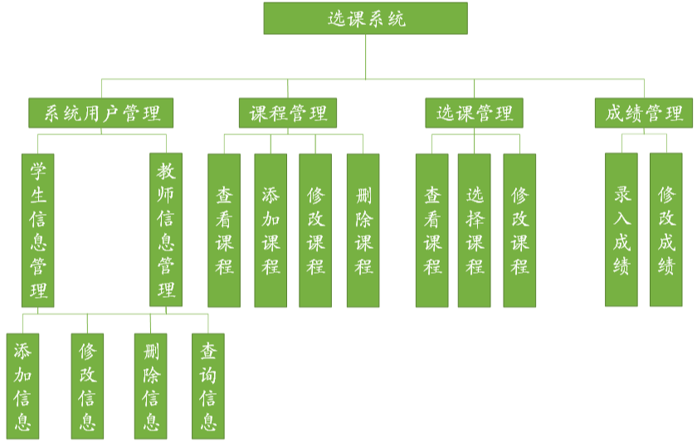

**2数据库分析与设计**

Administrators (ID, userName, passwd)

Courses (ID, couName, couTime, couPoint)

Teachers (ID, teaName, teaSex, teaTitle, passwd)

Students (ID, stuName, stuSex, stuCollege, stuMajor, stuClass, passwd)

TC (teaID, couID)

CS (couID, stuID, teaID, score)

**3. 权限说明**

▪ 管理员可以管理学生、教师、课程信息，对齐进行增、删、改、查操作

▪ 教师登录可以查看自己的课程和学自己课程的学生

▪ 教师可以录入成绩

▪ 学生可以浏览所有课程，并进行选课，可以查看自己所学的课程以及成绩

**4.自己负责的功能**

管理员增删查改，学生增删查改，教师增删查改，课程增删查改。

学生选课，教师录入成绩，课程增加任课老师

**5. 界面设计**

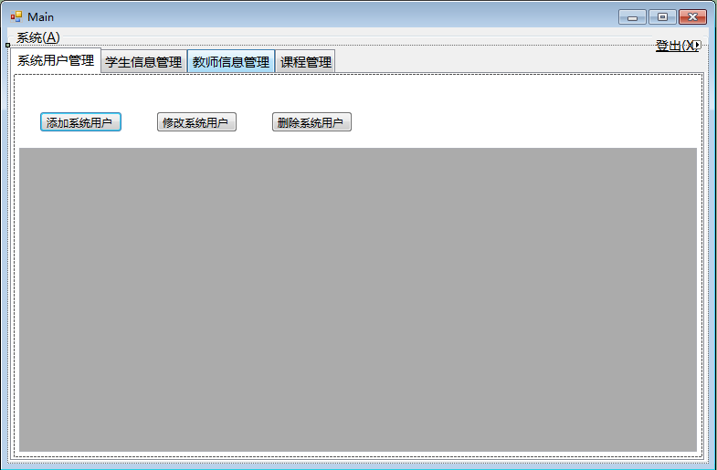

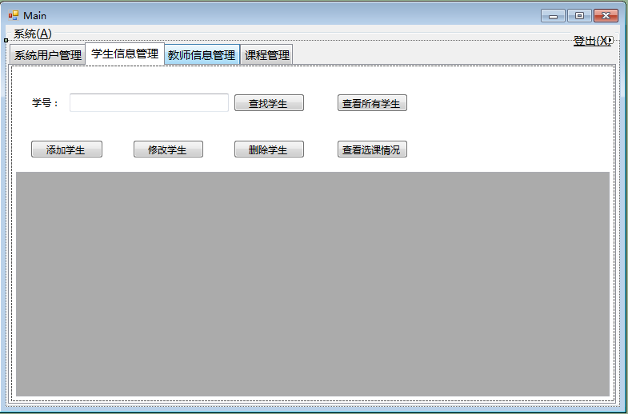

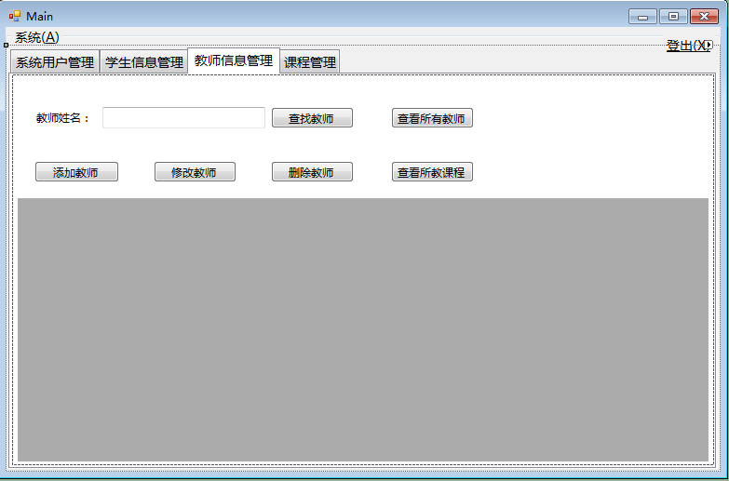

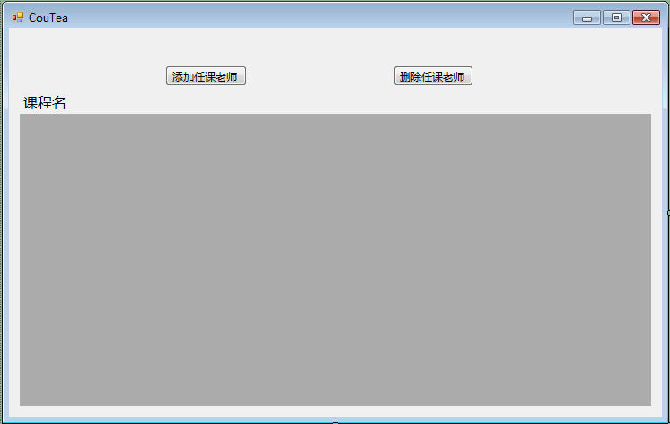

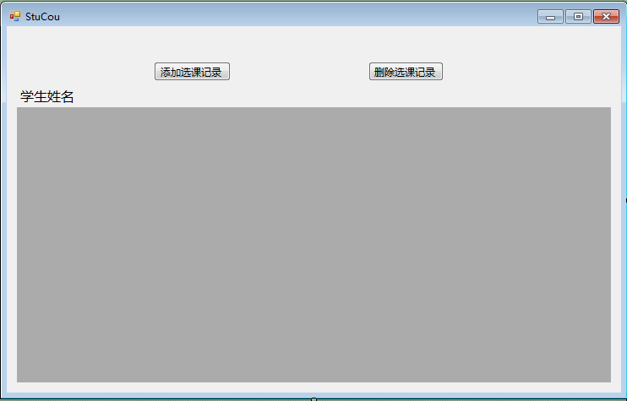

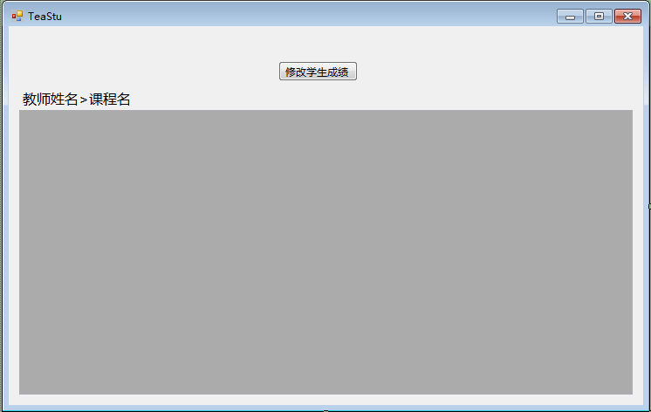

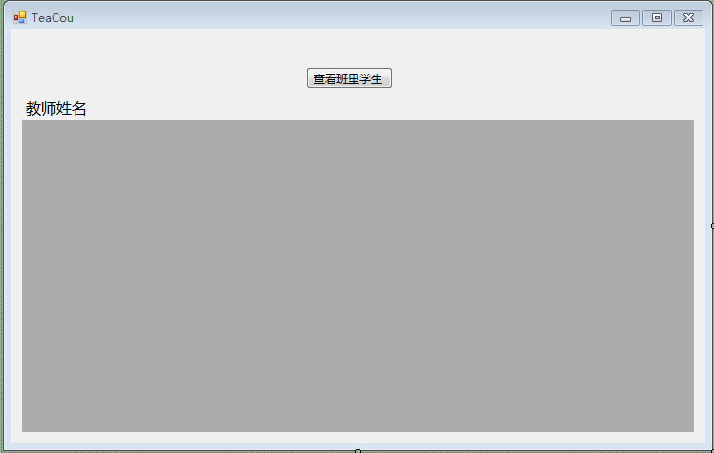

**6. 部分实验代码**

***Main.cs***

using System;

using System.Collections.Generic;

using System.ComponentModel;

using System.Data;

using System.Drawing;

using System.Linq;

using System.Text;

using System.Windows.Forms;

namespace Form_SC

{

public partial class Main : Form

{

#region 一些字段属性

private int sortOrder = 0;

private static DataSet _dsAdmin = new DataSet();

private static DataSet _dsStudent = new DataSet();

private static DataSet _dsTeacher = new DataSet();

private static DataSet _dsCourse = new DataSet();

public static DataSet dsAdmin

{

get

{

return _dsAdmin;

}

set

{

_dsAdmin = value;

}

}

public static DataSet dsStudent

{

get

{

return _dsStudent;

}

set

{

_dsStudent = value;

}

}

public static DataSet dsTeacher

{

get

{

return _dsTeacher;

}

set

{

_dsTeacher = value;

}

}

public static DataSet dsCourse

{

get

{

return _dsCourse;

}

set

{

_dsCourse = value;

}

}

#endregion

#region 控件加载，数据加载

public Main()

{

InitializeComponent();

Init();

LoadData();

}

private void Form_Main_FormClosed(object sender, FormClosedEventArgs e)

{

if (this.Tag.ToString() == "Out")

{

Login login = (Login)this.Owner;

login.Dispose();

login.Close();

}

}

private void Init()

{

this.Tag = "Out";

tabcMain.Visible = false;

tabcMain.Controls.Clear();

switch (Maticsoft.Common.StaticDataClass.userType)

{

case "管理员":

gbMain.Text = "系统(&A)";

tabcMain.Controls.Add(tabpAdmin);

tabcMain.Controls.Add(tabpStudent);

tabcMain.Controls.Add(tabpTeacher);

tabcMain.Controls.Add(tabpCourse);

tabcMain.SelectTab(tabpAdmin);

tabcMain.Visible = true;

break;

case "学生":

gbMain.Text = "学生(&S)";

tabcMain.Controls.Add(tabpStudent);

tabcMain.Controls.Add(tabpCourse);

tabcMain.SelectTab(tabpStudent);

labStuID.Visible = false;

tbStuID.Visible = false;

btSearchByStuID.Visible = false;

btSeeAllStudents.Visible = false;

btAddStudent.Visible = false;

btUpdateStudent.Location = new Point(50, 35);

btUpdateStudent.Text = "修改信息";

btDeleteStudent.Visible = false;

btSeeStuCou.Location = new Point(200, 35);

dgvStudent.Location = new Point(6, 93);

dgvStudent.Size = new System.Drawing.Size(742, 323);

CoursePageInit();

tabcMain.Visible = true;

break;

case "教师":

gbMain.Text = "教师(&T)";

tabcMain.Controls.Add(tabpTeacher);

tabcMain.Controls.Add(tabpCourse);

tabcMain.SelectTab(tabpTeacher);

labTeaName.Visible = false;

tbTeaName.Visible = false;

btSearchByTeaName.Visible = false;

btSeeAllTeachers.Visible = false;

btAddTeacher.Visible = false;

btUpdateTeacher.Location = new Point(50, 35);

btUpdateTeacher.Text = "修改信息";

btDeleteTeacher.Visible = false;

btSeeTeaCou.Location = new Point(200, 35);

dgvTeacher.Location = new Point(6, 93);

dgvTeacher.Size = new System.Drawing.Size(742, 323);

CoursePageInit();

tabcMain.Visible = true;

break;

}

}

private void CoursePageInit()

{

btAddCourse.Visible = false;

btUpdateCourse.Visible = false;

btDeleteCourse.Visible = false;

btSeeCouTea.Location = new Point(537, 35);

dgvCourse.Location = new Point(6, 93);

dgvCourse.Size = new System.Drawing.Size(742, 323);

}

private void LoadData()

{

switch (Maticsoft.Common.StaticDataClass.userType)

{

case "管理员":

LoadData_Admin();

bwMain.DoWork += new DoWorkEventHandler(bwMain_STC_DoWork);

bwMain.RunWorkerAsync();

break;

case "学生":

LoadData_Student();

bwMain.DoWork += new DoWorkEventHandler(bwMain_C_DoWork);

bwMain.RunWorkerAsync();

break;

case "教师":

LoadData_Teacher();

bwMain.DoWork += new DoWorkEventHandler(bwMain_C_DoWork);

bwMain.RunWorkerAsync();

break;

default:

MessageBox.Show("登录出错！", "提醒", MessageBoxButtons.OK, MessageBoxIcon.Warning);

this.Close();

break;

}

}

private void bwMain_STC_DoWork(object sender, DoWorkEventArgs e)

{

LoadData_Student();

LoadData_Teacher();

LoadData_Course();

}

private void bwMain_C_DoWork(object sender, DoWorkEventArgs e)

{

LoadData_Course();

}

private void dgv_CellClick(object sender, DataGridViewCellEventArgs e)

{

DataGridView dgv = sender as DataGridView;

if (e.RowIndex >= 0 && e.ColumnIndex >= 0)

{

switch (dgv.Name)

{

case "dgvAdmin":

Maticsoft.Common.StaticDataClass.admin.ID = int.Parse(dgv.Rows[e.RowIndex].Cells[0].Value.ToString());

Maticsoft.Common.StaticDataClass.admin.userName = dgv.Rows[e.RowIndex].Cells[1].Value.ToString();

break;

case "dgvStudent":

Maticsoft.Common.StaticDataClass.student.ID = dgv.Rows[e.RowIndex].Cells[0].Value.ToString();

Maticsoft.Common.StaticDataClass.student.stuName = dgv.Rows[e.RowIndex].Cells[1].Value.ToString();

Maticsoft.Common.StaticDataClass.student.stuSex = dgv.Rows[e.RowIndex].Cells[2].Value.ToString().Equals("男") ? 1 : 0;

Maticsoft.Common.StaticDataClass.student.stuCollege = dgv.Rows[e.RowIndex].Cells[3].Value.ToString();

Maticsoft.Common.StaticDataClass.student.stuMajor = dgv.Rows[e.RowIndex].Cells[4].Value.ToString();

Maticsoft.Common.StaticDataClass.student.stuClass = dgv.Rows[e.RowIndex].Cells[5].Value.ToString();

break;

case "dgvTeacher":

Maticsoft.Common.StaticDataClass.teacher.ID = dgv.Rows[e.RowIndex].Cells[0].Value.ToString();

Maticsoft.Common.StaticDataClass.teacher.teaName = dgv.Rows[e.RowIndex].Cells[1].Value.ToString();

Maticsoft.Common.StaticDataClass.teacher.teaSex = dgv.Rows[e.RowIndex].Cells[2].Value.ToString().Equals("男") ? 1 : 0;

Maticsoft.Common.StaticDataClass.teacher.teaTitle = dgv.Rows[e.RowIndex].Cells[3].Value.ToString();

break;

case "dgvCourse":

Maticsoft.Common.StaticDataClass.course.ID = dgv.Rows[e.RowIndex].Cells[0].Value.ToString();

Maticsoft.Common.StaticDataClass.course.couName = dgv.Rows[e.RowIndex].Cells[1].Value.ToString();

Maticsoft.Common.StaticDataClass.course.couTime = int.Parse(dgv.Rows[e.RowIndex].Cells[2].Value.ToString());

Maticsoft.Common.StaticDataClass.course.couPoint = decimal.Parse(dgv.Rows[e.RowIndex].Cells[3].Value.ToString());

break;

}

}

else

{

Maticsoft.Common.StaticDataClass.admin.userName = "";

Maticsoft.Common.StaticDataClass.student.ID = "";

Maticsoft.Common.StaticDataClass.teacher.ID = "";

Maticsoft.Common.StaticDataClass.course.ID = "";

if (sortOrder == 0)

{

dgv.Sort(dgv.Columns[e.ColumnIndex], ListSortDirection.Descending);

sortOrder++;

}

else

{

dgv.Sort(dgv.Columns[e.ColumnIndex], ListSortDirection.Ascending);

sortOrder--;

}

}

}

private void labLogout_Click(object sender, EventArgs e)

{

Login login = (Login)this.Owner;

login.Init();

login.Show();

this.Tag = "Logout";

this.Dispose();

this.Close();

}

#endregion

}

}

***Main_Administrator.cs***

using System;

using System.Collections.Generic;

using System.ComponentModel;

using System.Data;

using System.Drawing;

using System.Linq;

using System.Text;

using System.Windows.Forms;

namespace Form_SC

{

public partial class Main : Form

{

#region 系统用户数据加载

public void LoadData_Admin()

{

dsAdmin = new Maticsoft.BLL.Administrators().GetList("");

dsAdmin.Tables["ds"].Columns["ID"].ColumnName = "ID";

dsAdmin.Tables["ds"].Columns["userName"].ColumnName = "用户名";

dgvAdmin.DataSource = dsAdmin.Tables["ds"];

int columnNumber = dgvAdmin.ColumnCount;

foreach (DataGridViewColumn col in dgvAdmin.Columns)

{

col.DefaultCellStyle.Alignment = DataGridViewContentAlignment.MiddleCenter;

col.SortMode = DataGridViewColumnSortMode.NotSortable;

col.FillWeight = 100 / columnNumber;

}

dgvAdmin.ColumnHeadersDefaultCellStyle.Alignment = DataGridViewContentAlignment.MiddleCenter;

dgvAdmin.AllowUserToAddRows = false;

dgvAdmin.RowHeadersVisible = false;

dgvAdmin.ReadOnly = true;

}

#endregion

#region 系统用户信息相关操作

private void btAddAdmin_Click(object sender, EventArgs e)

{

new AddAdmin().ShowDialog(this);

}

public bool AddAdmin()

{

return new Maticsoft.BLL.Administrators().Add(Maticsoft.Common.StaticDataClass.admin);

}

private void btUpdateAdmin_Click(object sender, EventArgs e)

{

if (Maticsoft.Common.StaticDataClass.admin.userName == "" || Maticsoft.Common.StaticDataClass.admin.userName == null)

{

MessageBox.Show("请先选择一行记录！", "提醒", MessageBoxButtons.OK, MessageBoxIcon.Warning);

}

else

{

new UpdateAdmin().ShowDialog(this);

}

}

public bool UpdateAdmin()

{

return new Maticsoft.BLL.Administrators().Update(Maticsoft.Common.StaticDataClass.admin);

}

private void btDeleteAdmin_Click(object sender, EventArgs e)

{

if (Maticsoft.Common.StaticDataClass.admin.userName == "" || Maticsoft.Common.StaticDataClass.admin.userName == null)

{

MessageBox.Show("请先选择一行记录！", "提醒", MessageBoxButtons.OK, MessageBoxIcon.Warning);

}

else if (MessageBox.Show("确认删除 用户名为 " + Maticsoft.Common.StaticDataClass.admin.userName + " 的系统用户？", "信息", MessageBoxButtons.OKCancel, MessageBoxIcon.Information) == DialogResult.OK)

{

if (DeleteAdmin())

{

MessageBox.Show("删除成功！", "信息", MessageBoxButtons.OK, MessageBoxIcon.Information);

Maticsoft.Common.StaticDataClass.admin.userName = "";

LoadData_Admin();

}

else

{

MessageBox.Show("删除失败！", "错误", MessageBoxButtons.OK, MessageBoxIcon.Error);

}

}

}

public bool DeleteAdmin()

{

return new Maticsoft.BLL.Administrators().Delete(Maticsoft.Common.StaticDataClass.admin.ID);

}

#endregion

}

}

***Main_Course.cs***

using System;

using System.Collections.Generic;

using System.ComponentModel;

using System.Data;

using System.Drawing;

using System.Linq;

using System.Text;

using System.Windows.Forms;

namespace Form_SC

{

public partial class Main : Form

{

#region 课程数据加载

public void LoadData_Course()

{

dsCourse = new Maticsoft.BLL.Courses().GetList("");

dsCourse.Tables["ds"].Columns["ID"].ColumnName = "课程号";

dsCourse.Tables["ds"].Columns["couName"].ColumnName = "课程名称";

dsCourse.Tables["ds"].Columns["couTime"].ColumnName = "学时";

dsCourse.Tables["ds"].Columns["couPoint"].ColumnName = "学分";

dgvCourse.DataSource = dsCourse.Tables["ds"];

int columnNumber = dgvCourse.ColumnCount;

foreach (DataGridViewColumn col in dgvCourse.Columns)

{

col.DefaultCellStyle.Alignment = DataGridViewContentAlignment.MiddleCenter;

col.SortMode = DataGridViewColumnSortMode.NotSortable;

col.FillWeight = 100 / columnNumber;

}

dgvCourse.ColumnHeadersDefaultCellStyle.Alignment = DataGridViewContentAlignment.MiddleCenter;

dgvCourse.AllowUserToAddRows = false;

dgvCourse.RowHeadersVisible = false;

dgvCourse.ReadOnly = true;

}

#endregion

#region 课程信息相关操作

private void btAddCourse_Click(object sender, EventArgs e)

{

new AddCourse().ShowDialog(this);

}

public bool AddCourse()

{

return new Maticsoft.BLL.Courses().Add(Maticsoft.Common.StaticDataClass.course);

}

private void btUpdateCourse_Click(object sender, EventArgs e)

{

if (Maticsoft.Common.StaticDataClass.course.ID == "" || Maticsoft.Common.StaticDataClass.course.ID == null)

{

MessageBox.Show("请先选择一行记录！", "提醒", MessageBoxButtons.OK, MessageBoxIcon.Warning);

}

else

{

new UpdateCourse().ShowDialog(this);

}

}

public bool UpdateCourse()

{

return new Maticsoft.BLL.Courses().Update(Maticsoft.Common.StaticDataClass.course);

}

private void btDeleteCourse_Click(object sender, EventArgs e)

{

if (Maticsoft.Common.StaticDataClass.course.ID == "" || Maticsoft.Common.StaticDataClass.course.ID == null)

{

MessageBox.Show("请先选择一行记录！", "提醒", MessageBoxButtons.OK, MessageBoxIcon.Warning);

}

else if (MessageBox.Show("确认删除 课程号为 " + Maticsoft.Common.StaticDataClass.course.ID + " 的课程信息？", "信息", MessageBoxButtons.OKCancel, MessageBoxIcon.Information) == DialogResult.OK)

{

if (DeleteCourse())

{

MessageBox.Show("删除成功！", "信息", MessageBoxButtons.OK, MessageBoxIcon.Information);

Maticsoft.Common.StaticDataClass.course.ID = "";

LoadData_Course();

}

else

{

MessageBox.Show("删除失败！", "错误", MessageBoxButtons.OK, MessageBoxIcon.Error);

}

}

}

public bool DeleteCourse()

{

return new Maticsoft.BLL.Courses().Delete(Maticsoft.Common.StaticDataClass.course.ID);

}

private void btSearchByCouName_Click(object sender, EventArgs e)

{

Maticsoft.Common.StaticDataClass.course.ID = "";

string name = tbCouName.Text.Trim();

if (name == null || name == "")

{

MessageBox.Show("不能有空！", "提醒", MessageBoxButtons.OK, MessageBoxIcon.Warning);

}

else

{

DataSet ds = new Maticsoft.BLL.Courses().GetList(String.Format(" couName like '%{0}%' ", name));

if (ds.Tables.Count > 0 && ds.Tables["ds"].Rows.Count > 0)

{

ds.Tables["ds"].Columns["ID"].ColumnName = "课程号";

ds.Tables["ds"].Columns["couName"].ColumnName = "课程名称";

ds.Tables["ds"].Columns["couTime"].ColumnName = "学时";

ds.Tables["ds"].Columns["couPoint"].ColumnName = "学分";

dgvCourse.DataSource = ds.Tables["ds"];

int columnNumber = dgvCourse.ColumnCount;

foreach (DataGridViewColumn col in dgvCourse.Columns)

{

col.DefaultCellStyle.Alignment = DataGridViewContentAlignment.MiddleCenter;

col.SortMode = DataGridViewColumnSortMode.NotSortable;

col.FillWeight = 100 / columnNumber;

}

dgvCourse.ColumnHeadersDefaultCellStyle.Alignment = DataGridViewContentAlignment.MiddleCenter;

dgvCourse.AllowUserToAddRows = false;

dgvCourse.RowHeadersVisible = false;

dgvCourse.ReadOnly = true;

}

else

{

MessageBox.Show("查无此课程！", "信息", MessageBoxButtons.OK, MessageBoxIcon.Information);

}

}

}

private void btSeeCouTea_Click(object sender, EventArgs e)

{

if (Maticsoft.Common.StaticDataClass.course.ID == "" || Maticsoft.Common.StaticDataClass.course.ID == null)

{

MessageBox.Show("请先选择一行记录！", "提醒", MessageBoxButtons.OK, MessageBoxIcon.Warning);

}

else

{

new CouTea().ShowDialog(this);

}

}

private void btSeeAllCourses_Click(object sender, EventArgs e)

{

Maticsoft.Common.StaticDataClass.course.ID = "";

LoadData_Course();

}

#endregion

}

}

***Main_Student.cs***

using System;

using System.Collections.Generic;

using System.ComponentModel;

using System.Data;

using System.Drawing;

using System.Linq;

using System.Text;

using System.Windows.Forms;

using System.Threading;

namespace Form_SC

{

public partial class Main : Form

{

#region 学生数据加载

public void LoadData_Student()

{

if (Maticsoft.Common.StaticDataClass.userType.Equals("管理员"))

{

dsStudent = new Maticsoft.BLL.Students().GetList("");

}

else

{

dsStudent = new Maticsoft.BLL.Students().GetList(String.Format("ID = '{0}'", Maticsoft.Common.StaticDataClass.loginStudentID));

}

dsStudent.Tables["ds"].Columns["ID"].ColumnName = "学号";

dsStudent.Tables["ds"].Columns["stuName"].ColumnName = "姓名";

dsStudent.Tables["ds"].Columns["stuSex"].ColumnName = "性别";

dsStudent.Tables["ds"].Columns["stuCollege"].ColumnName = "学院";

dsStudent.Tables["ds"].Columns["stuMajor"].ColumnName = "专业";

dsStudent.Tables["ds"].Columns["stuClass"].ColumnName = "班级";

dgvStudent.DataSource = dsStudent.Tables["ds"];

int columnNumber = dgvStudent.ColumnCount;

foreach (DataGridViewColumn col in dgvStudent.Columns)

{

col.DefaultCellStyle.Alignment = DataGridViewContentAlignment.MiddleCenter;

col.SortMode = DataGridViewColumnSortMode.NotSortable;

col.FillWeight = 100 / columnNumber;

}

dgvStudent.ColumnHeadersDefaultCellStyle.Alignment = DataGridViewContentAlignment.MiddleCenter;

dgvStudent.AllowUserToAddRows = false;

dgvStudent.RowHeadersVisible = false;

dgvStudent.ReadOnly = true;

}

#endregion

#region 学生信息相关操作

private void btAddStudent_Click(object sender, EventArgs e)

{

new AddStudent().ShowDialog(this);

}

public bool AddStudent()

{

return new Maticsoft.BLL.Students().Add(Maticsoft.Common.StaticDataClass.student);

}

private void btUpdateStudent_Click(object sender, EventArgs e)

{

if (Maticsoft.Common.StaticDataClass.student.ID == "" || Maticsoft.Common.StaticDataClass.student.ID == null)

{

MessageBox.Show("请先选择一行记录！", "提醒", MessageBoxButtons.OK, MessageBoxIcon.Warning);

}

else

{

new UpdateStudent().ShowDialog(this);

}

}

public bool UpdateStudent()

{

return new Maticsoft.BLL.Students().Update(Maticsoft.Common.StaticDataClass.student);

}

private void btDeleteStudent_Click(object sender, EventArgs e)

{

if (Maticsoft.Common.StaticDataClass.student.ID == "" || Maticsoft.Common.StaticDataClass.student.ID == null)

{

MessageBox.Show("请先选择一行记录！", "提醒", MessageBoxButtons.OK, MessageBoxIcon.Warning);

}

else if (MessageBox.Show("确认删除 学号为 " + Maticsoft.Common.StaticDataClass.student.ID + " 的学生信息？", "信息", MessageBoxButtons.OKCancel, MessageBoxIcon.Information) == DialogResult.OK)

{

if (DeleteStudent())

{

MessageBox.Show("删除成功！", "信息", MessageBoxButtons.OK, MessageBoxIcon.Information);

Maticsoft.Common.StaticDataClass.student.ID = "";

LoadData_Student();

}

else

{

MessageBox.Show("删除失败！", "错误", MessageBoxButtons.OK, MessageBoxIcon.Error);

}

}

}

public bool DeleteStudent()

{

return new Maticsoft.BLL.Students().Delete(Maticsoft.Common.StaticDataClass.student.ID);

}

private void btSearchByStuID_Click(object sender, EventArgs e)

{

Maticsoft.Common.StaticDataClass.student.ID = "";

string ID = tbStuID.Text.Trim();

if (ID == null || ID == "")

{

MessageBox.Show("不能有空！", "提醒", MessageBoxButtons.OK, MessageBoxIcon.Warning);

}

else

{

DataSet ds = new Maticsoft.BLL.Students().GetList(String.Format("ID = '{0}'", ID));

if (ds.Tables.Count > 0 && ds.Tables["ds"].Rows.Count > 0)

{

ds.Tables["ds"].Columns["ID"].ColumnName = "学号";

ds.Tables["ds"].Columns["stuName"].ColumnName = "姓名";

ds.Tables["ds"].Columns["stuSex"].ColumnName = "性别";

ds.Tables["ds"].Columns["stuCollege"].ColumnName = "学院";

ds.Tables["ds"].Columns["stuMajor"].ColumnName = "专业";

ds.Tables["ds"].Columns["stuClass"].ColumnName = "班级";

dgvStudent.DataSource = ds.Tables["ds"];

int columnNumber = dgvStudent.ColumnCount;

foreach (DataGridViewColumn col in dgvStudent.Columns)

{

col.DefaultCellStyle.Alignment = DataGridViewContentAlignment.MiddleCenter;

col.SortMode = DataGridViewColumnSortMode.NotSortable;

col.FillWeight = 100 / columnNumber;

}

dgvStudent.ColumnHeadersDefaultCellStyle.Alignment = DataGridViewContentAlignment.MiddleCenter;

dgvStudent.AllowUserToAddRows = false;

dgvStudent.RowHeadersVisible = false;

dgvStudent.ReadOnly = true;

}

else

{

MessageBox.Show("查无此人！", "信息", MessageBoxButtons.OK, MessageBoxIcon.Information);

}

}

}

private void btSeeAllStudents_Click(object sender, EventArgs e)

{

Maticsoft.Common.StaticDataClass.student.ID = "";

LoadData_Student();

}

private void btSeeStuCou_Click(object sender, EventArgs e)

{

if (Maticsoft.Common.StaticDataClass.student.ID == "" || Maticsoft.Common.StaticDataClass.student.ID == null)

{

MessageBox.Show("请先选择一行记录！", "提醒", MessageBoxButtons.OK, MessageBoxIcon.Warning);

}

else

{

new StuCou().ShowDialog(this);

}

}

#endregion

}

}

***Main_Teacher.cs***

using System;

using System.Collections.Generic;

using System.ComponentModel;

using System.Data;

using System.Drawing;

using System.Linq;

using System.Text;

using System.Windows.Forms;

namespace Form_SC

{

public partial class Main : Form

{

#region 教师数据加载

public void LoadData_Teacher()

{

if (Maticsoft.Common.StaticDataClass.userType.Equals("管理员"))

{

dsTeacher = new Maticsoft.BLL.Teachers().GetList("");

}

else

{

dsTeacher = new Maticsoft.BLL.Teachers().GetList(String.Format("ID = '{0}'", Maticsoft.Common.StaticDataClass.loginTeacherID));

}

dsTeacher.Tables["ds"].Columns["ID"].ColumnName = "教工号";

dsTeacher.Tables["ds"].Columns["teaName"].ColumnName = "姓名";

dsTeacher.Tables["ds"].Columns["teaSex"].ColumnName = "性别";

dsTeacher.Tables["ds"].Columns["teaTitle"].ColumnName = "职称";

dgvTeacher.DataSource = dsTeacher.Tables["ds"];

int columnNumber = dgvTeacher.ColumnCount;

foreach (DataGridViewColumn col in dgvTeacher.Columns)

{

col.DefaultCellStyle.Alignment = DataGridViewContentAlignment.MiddleCenter;

col.SortMode = DataGridViewColumnSortMode.NotSortable;

col.FillWeight = 100 / columnNumber;

}

dgvTeacher.ColumnHeadersDefaultCellStyle.Alignment = DataGridViewContentAlignment.MiddleCenter;

dgvTeacher.AllowUserToAddRows = false;

dgvTeacher.RowHeadersVisible = false;

dgvTeacher.ReadOnly = true;

}

#endregion

#region 教师信息相关操作

private void btAddTeacher_Click(object sender, EventArgs e)

{

new AddTeacher().ShowDialog(this);

}

public bool AddTeacher()

{

return new Maticsoft.BLL.Teachers().Add(Maticsoft.Common.StaticDataClass.teacher);

}

private void btUpdateTeacher_Click(object sender, EventArgs e)

{

if (Maticsoft.Common.StaticDataClass.teacher.ID == "" || Maticsoft.Common.StaticDataClass.teacher.ID == null)

{

MessageBox.Show("请先选择一行记录！", "提醒", MessageBoxButtons.OK, MessageBoxIcon.Warning);

}

else

{

new UpdateTeacher().ShowDialog(this);

}

}

public bool UpdateTeacher()

{

return new Maticsoft.BLL.Teachers().Update(Maticsoft.Common.StaticDataClass.teacher);

}

private void btDeleteTeacher_Click(object sender, EventArgs e)

{

if (Maticsoft.Common.StaticDataClass.teacher.ID == "" || Maticsoft.Common.StaticDataClass.teacher.ID == null)

{

MessageBox.Show("请先选择一行记录！", "提醒", MessageBoxButtons.OK, MessageBoxIcon.Warning);

}

else if (MessageBox.Show("确认删除 教工号为 " + Maticsoft.Common.StaticDataClass.teacher.ID + " 的教师信息？", "信息", MessageBoxButtons.OKCancel, MessageBoxIcon.Information) == DialogResult.OK)

{

if (DeleteTeacher())

{

MessageBox.Show("删除成功！", "信息", MessageBoxButtons.OK, MessageBoxIcon.Information);

Maticsoft.Common.StaticDataClass.teacher.ID = "";

LoadData_Teacher();

}

else

{

MessageBox.Show("删除失败！", "错误", MessageBoxButtons.OK, MessageBoxIcon.Error);

}

}

}

public bool DeleteTeacher()

{

return new Maticsoft.BLL.Teachers().Delete(Maticsoft.Common.StaticDataClass.teacher.ID);

}

private void btSearchByTeaName_Click(object sender, EventArgs e)

{

Maticsoft.Common.StaticDataClass.teacher.ID = "";

string name = tbTeaName.Text.Trim();

if (name == null || name == "")

{

MessageBox.Show("不能有空！", "提醒", MessageBoxButtons.OK, MessageBoxIcon.Warning);

}

else

{

DataSet ds = new Maticsoft.BLL.Teachers().GetList(String.Format(" teaName like '%{0}%' ", name));

if (ds.Tables.Count > 0 && ds.Tables["ds"].Rows.Count > 0)

{

ds.Tables["ds"].Columns["ID"].ColumnName = "教工号";

ds.Tables["ds"].Columns["teaName"].ColumnName = "姓名";

ds.Tables["ds"].Columns["teaSex"].ColumnName = "性别";

ds.Tables["ds"].Columns["teaTitle"].ColumnName = "职称";

dgvTeacher.DataSource = ds.Tables["ds"];

int columnNumber = dgvTeacher.ColumnCount;

foreach (DataGridViewColumn col in dgvTeacher.Columns)

{

col.DefaultCellStyle.Alignment = DataGridViewContentAlignment.MiddleCenter;

col.SortMode = DataGridViewColumnSortMode.NotSortable;

col.FillWeight = 100 / columnNumber;

}

dgvTeacher.ColumnHeadersDefaultCellStyle.Alignment = DataGridViewContentAlignment.MiddleCenter;

dgvTeacher.AllowUserToAddRows = false;

dgvTeacher.RowHeadersVisible = false;

dgvTeacher.ReadOnly = true;

}

else

{

MessageBox.Show("查无此人！", "信息", MessageBoxButtons.OK, MessageBoxIcon.Information);

}

}

}

private void btSeeAllTeachers_Click(object sender, EventArgs e)

{

Maticsoft.Common.StaticDataClass.teacher.ID = "";

LoadData_Teacher();

}

private void btSeeTeaCou_Click(object sender, EventArgs e)

{

if (Maticsoft.Common.StaticDataClass.teacher.ID == "" || Maticsoft.Common.StaticDataClass.teacher.ID == null)

{

MessageBox.Show("请先选择一行记录！", "提醒", MessageBoxButtons.OK, MessageBoxIcon.Warning);

}

else

{

new TeaCou().ShowDialog(this);

}

}

#endregion

}

}

**7. 运行效果**

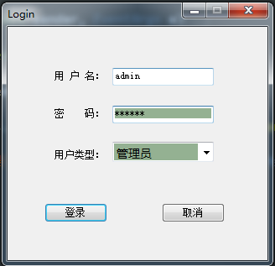

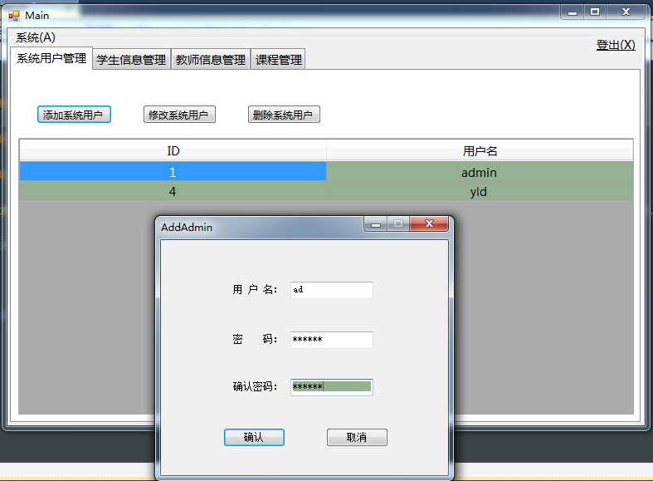

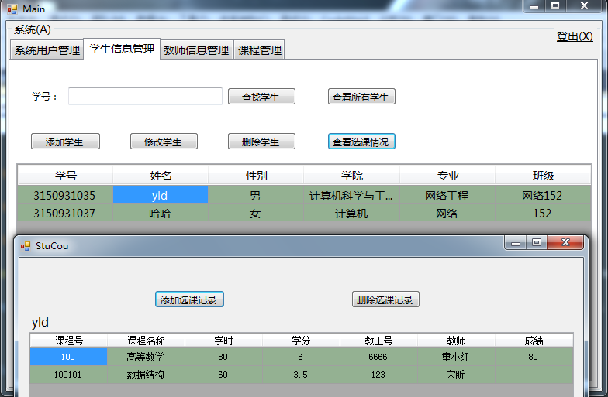

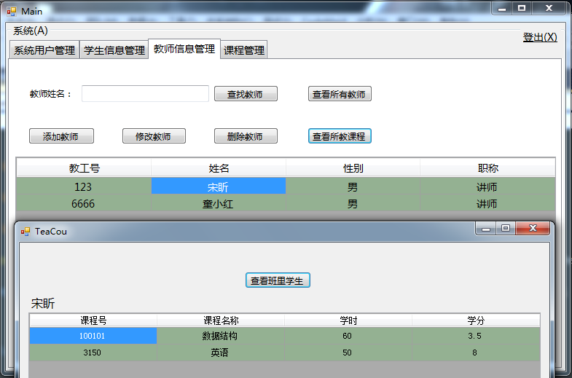

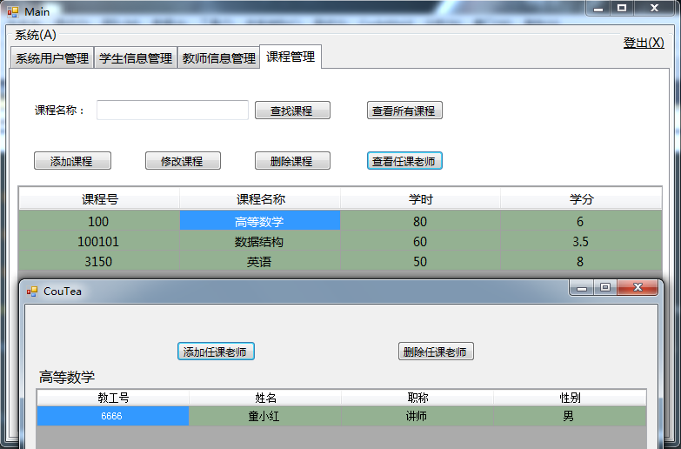

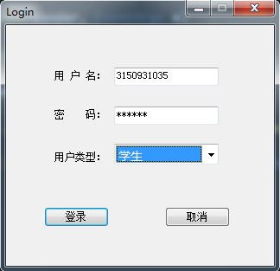

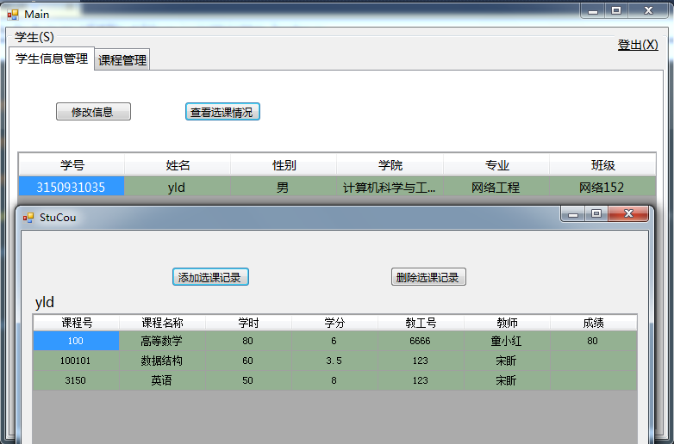

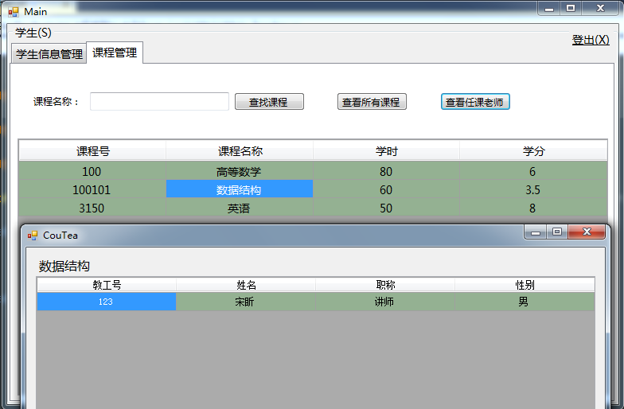

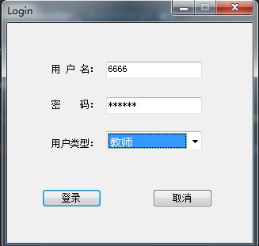

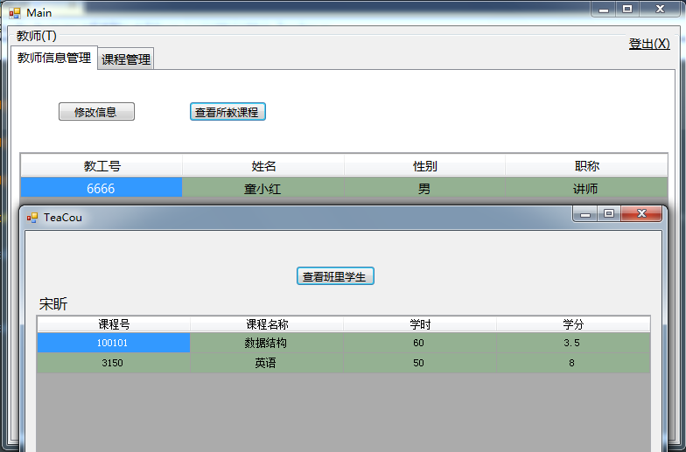

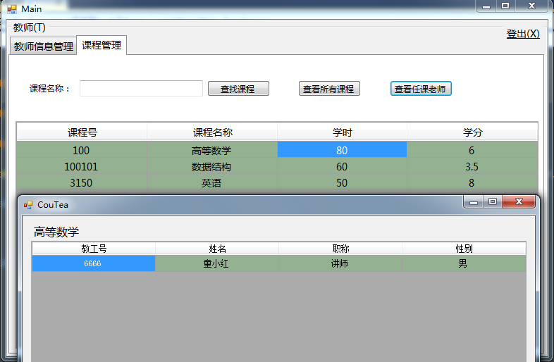

五、实验总结

此次实验内容丰富，难度也有些大，但经过几天的努力，我和其他组员最终共同完成了这个选课系统。在完成本次选课系统中我遇到了一些困难，如数据库表关系错乱，数据库表增删查改导致数据不一致，SQL语句执行出错，跨窗体传参数，DataGridView使用等，不过最终还是有幸得以解决。本次完成的选课系统还并不完美，比如登录界面应该改善，选课记录应该统计，学分学时应该统计，删除修改操作要提供撤销选项，有些界面应该进行合并等。这些还待对C#语言，三层架构和软件开发技术的深入学习之后才能慢慢进行完善。