Experiment 2
Hotel Room Booking System
My Details
Name | Yarrapureddy Lakshmi Reddy
Register Number | 192324077
Department | Artificial Intelligence and Data Science, SIMATS Engineering
Course Code | CSA43
Course Name | Internet Programming
Aim
To develop a hotel room booking website using HTML5, CSS and JavaScript in which guests check room availability, book, change or cancel rooms, view hotel information, and the administrator manages room quantity, price, bookings and static pages.
Algorithm
- Start and open the hotel website; the guest can read the room types, about us, contact, Q&A, travel guide and privacy policy pages.
- A new guest registers with name, username, password, phone number and email.
- The user selects Guest or Administrator, enters the username and password and clicks Login to get verified.
- The guest chooses a room type, check-in and check-out dates and the system counts the free rooms for those dates.
- If a room is free, the guest enters the number of guests and books the room; the amount is calculated as nights multiplied by the price per night.
- The guest views the booking history, changes or cancels a booking only up to 3 days before arrival and updates the profile; the administrator changes room quantity and price, edits or cancels any booking and edits the static pages.
- The user logs out and the program stops.
Output
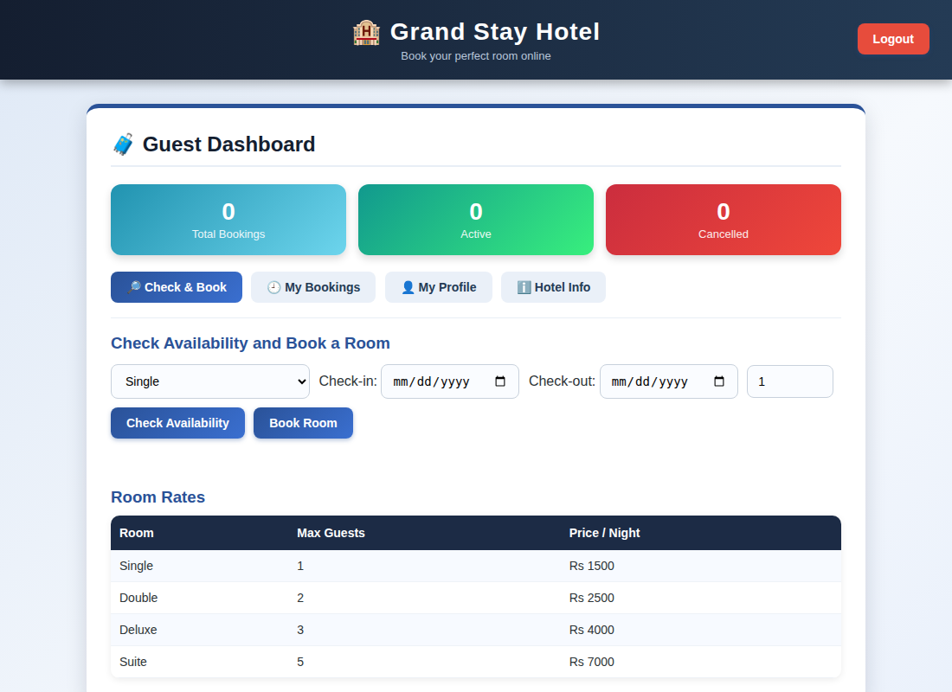
Guest dashboard displayed after login
Result
Thus the Hotel Room Booking System was designed and developed successfully using HTML5, CSS and JavaScript, and the output of the dashboard was verified.

