Experiment 3
Online Bus Ticket Booking
My Details
Name | Yarrapureddy Lakshmi Reddy
Register Number | 192324077
Department | Artificial Intelligence and Data Science, SIMATS Engineering
Course Code | CSA43
Course Name | Internet Programming
Aim
To design an online bus ticket booking system using HTML5, CSS and JavaScript where users search buses, choose seats, pay and cancel tickets, and the admin manages bus categories, buses, users, news, comments and booking reports.
Algorithm
- Start and open the page; the login page with Register and Forgot Password options is displayed.
- A new user registers with name, username, email and password; a forgotten password is reset using the username and registered email.
- The user selects the role, enters the credentials and clicks Login; the credentials are verified.
- The passenger searches buses by from, to, date and time of travel and the seats left for each bus are displayed.
- The passenger selects the bus, picks the seats on the seat layout, enters the passenger details, selects the payment method and pays; a booking ID and confirmation message are generated.
- The passenger views or cancels tickets, posts comments about a bus, reads the news and changes the password; the admin adds categories, buses with photos, manages users, news and comments and generates the report.
- The user logs out and the program stops.
Output
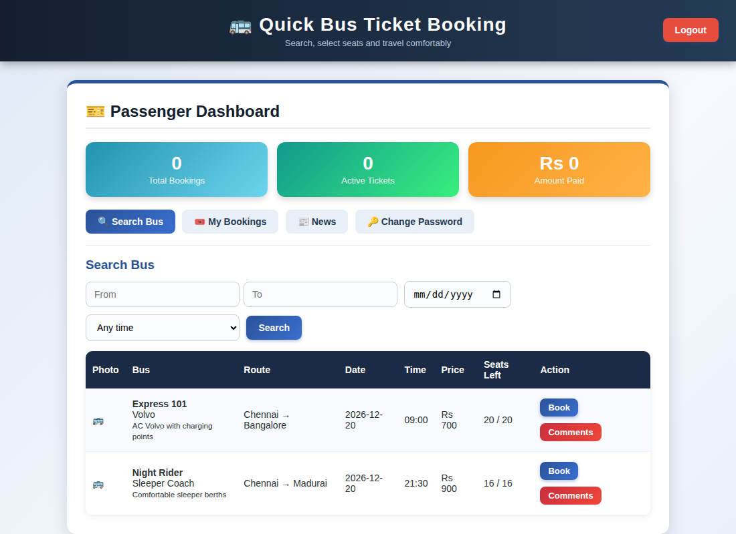
Passenger dashboard displayed after login
Result
Thus the Online Bus Ticket Booking was designed and developed successfully using HTML5, CSS and JavaScript, and the output of the dashboard was verified.

