Experiment 4
Online Train Reservation System
My Details
Name | Yarrapureddy Lakshmi Reddy
Register Number | 192324077
Department | Artificial Intelligence and Data Science, SIMATS Engineering
Course Code | CSA43
Course Name | Internet Programming
Aim
To develop a train reservation system using HTML5, CSS and JavaScript that allows passengers to search trains, book tickets with PNR generation, check PNR status and cancel tickets with refund, and allows the admin to manage trains, fares, payments and refunds.
Algorithm
- Start and open the page; the login page is displayed.
- A new passenger registers with name, username and password.
- The user selects the role, enters the credentials and clicks Login; if valid the dashboard is displayed.
- The passenger searches trains by origin, destination, date and class and the availability (Available, RAC or Waiting List) is shown.
- The passenger enters the details of up to four passengers, selects Online or Offline payment and books; a PNR number is generated and the ticket can be printed.
- The passenger checks the PNR status and cancels the ticket, and the refund percentage is calculated from the days left before the journey; the admin manages trains and fares, views payments and passes the refund.
- The user logs out and the program stops.
Output
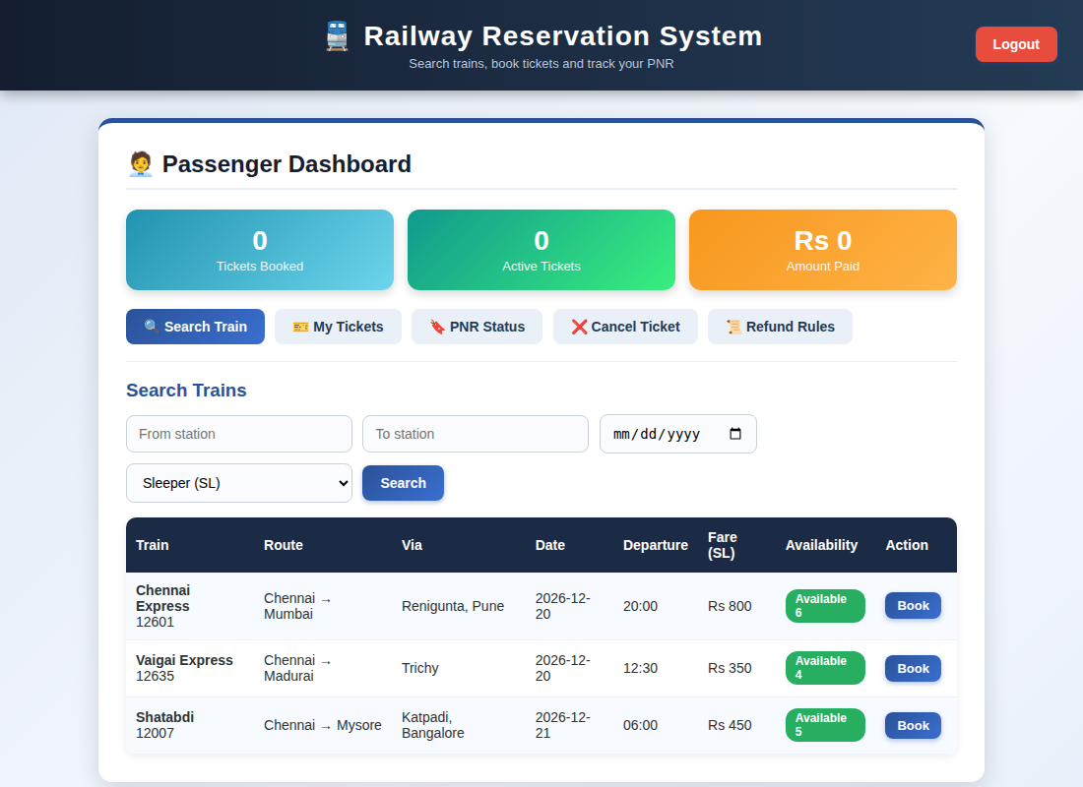
Passenger dashboard displayed after login
Result
Thus the Online Train Reservation System was designed and developed successfully using HTML5, CSS and JavaScript, and the output of the dashboard was verified.

