Experiment 5
Online Flight Reservation System
My Details
Name | Yarrapureddy Lakshmi Reddy
Register Number | 192324077
Department | Artificial Intelligence and Data Science, SIMATS Engineering
Course Code | CSA43
Course Name | Internet Programming
Aim
To design a flight reservation system using HTML5, CSS and JavaScript with search, seat selection, payment, e-ticket, booking status, ticket printing, cancellation, feedback and an administrator report.
Algorithm
- Start and open the page; the login page with Register and Forgot Password options is displayed.
- A new customer registers and a forgotten password is reset using the username and registered email.
- The user selects Customer or Administrator, enters the credentials and clicks Login.
- The customer searches flights by from, to, date and class and the fare and seats left are displayed.
- The customer selects the seats, enters the passenger details and goes to the payment page where the card details are validated; an e-ticket is generated after payment.
- The customer views the booking status, prints the ticket, cancels a ticket with a 75 percent refund and gives feedback; the administrator manages flights, customers, feedback and the report.
- The user logs out and the program stops.
Output
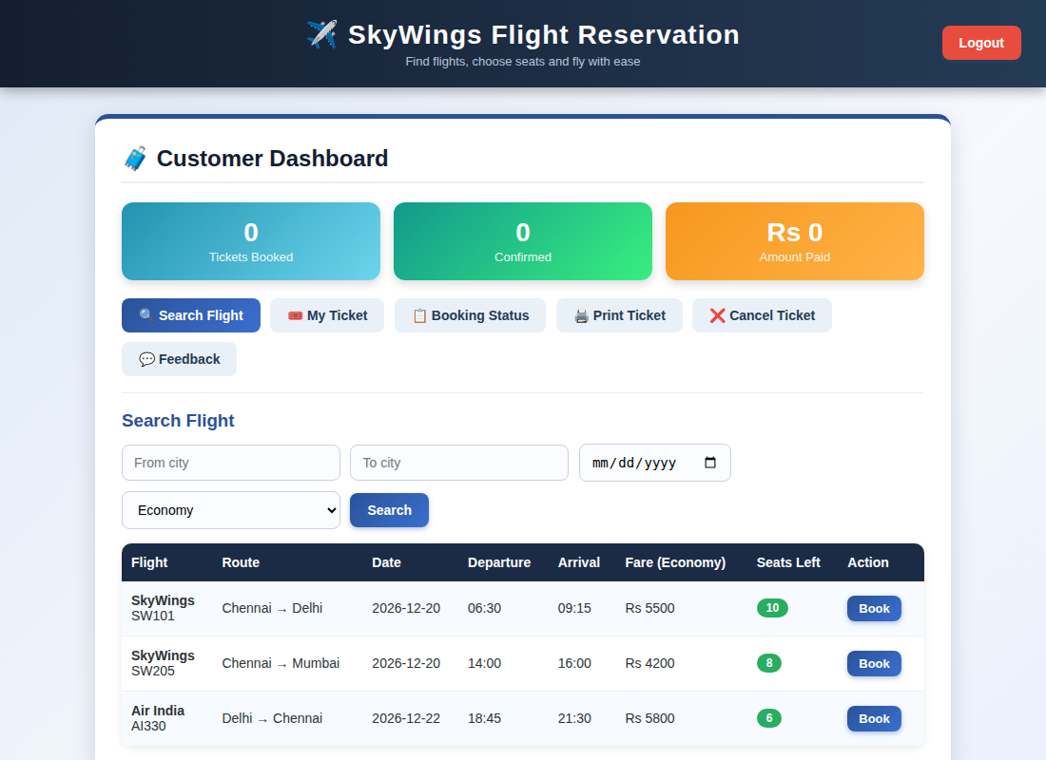
Customer dashboard displayed after login
Result
Thus the Online Flight Reservation System was designed and developed successfully using HTML5, CSS and JavaScript, and the output of the dashboard was verified.

