Experiment 6
Online Cake Ordering System
My Details
Name | Yarrapureddy Lakshmi Reddy
Register Number | 192324077
Department | Artificial Intelligence and Data Science, SIMATS Engineering
Course Code | CSA43
Course Name | Internet Programming
Aim
To develop an online cake ordering website using HTML5, CSS and JavaScript where customers search and filter cakes, customize size and message, order with a shipping address and track the order, and the admin posts cakes and manages orders.
Algorithm
- Start and open the page; the login page is displayed.
- A new customer registers with name, username, password, email and phone number.
- The user selects the role, enters the username and password and clicks Login; the dashboard is displayed if the credentials are valid.
- The customer searches cakes and filters them by category, sub category and price range, and views the details of a cake.
- The customer selects the cake size, types the message to be written on the cake and adds it to the cart; the quantity can be edited or the item removed.
- The customer adds or updates the shipping address, places the order and views the shipping status (Order Placed, Baking, Out for Delivery, Delivered); the admin posts cakes with images, manages orders and updates the status and shipping location.
- The user logs out and the program stops.
Output
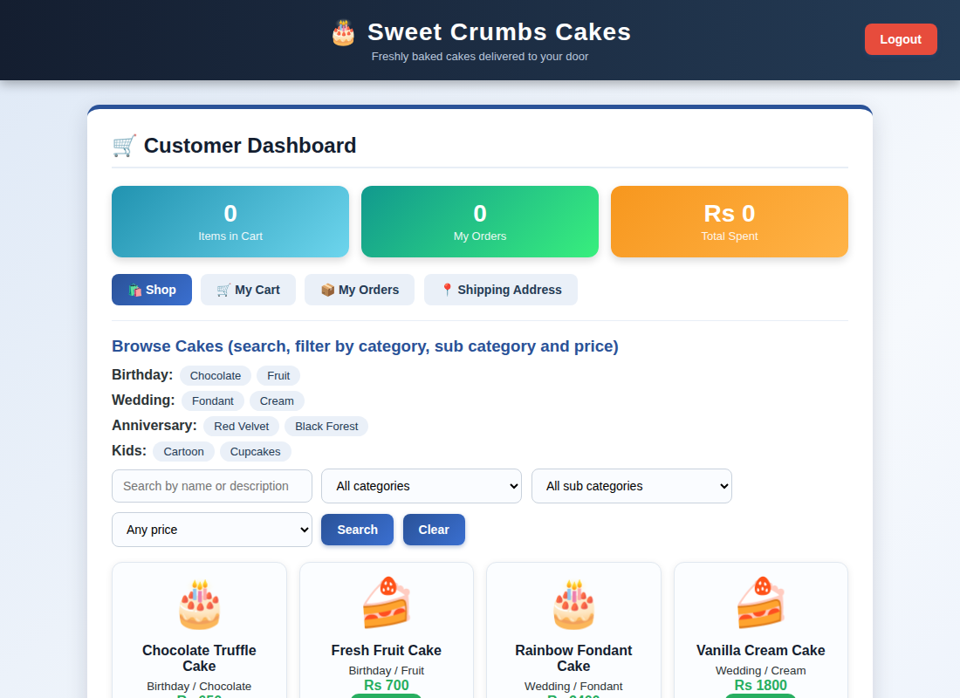
Customer dashboard displayed after login
Result
Thus the Online Cake Ordering System was designed and developed successfully using HTML5, CSS and JavaScript, and the output of the dashboard was verified.

