Experiment 7
Beauty Parlour Appointment Booking
My Details
Name | Yarrapureddy Lakshmi Reddy
Register Number | 192324077
Department | Artificial Intelligence and Data Science, SIMATS Engineering
Course Code | CSA43
Course Name | Internet Programming
Aim
To develop an online beauty parlour appointment system using HTML5, CSS and JavaScript where customers view services and stylists, book free time slots with payment options, reschedule or cancel, and the manager manages the reservation calendar.
Algorithm
- Start and open the page; the login page is displayed.
- A new customer registers with name, username, password, phone and email.
- The user selects Customer or Salon Manager, enters the credentials and clicks Login.
- The customer views the services and stylist profiles, selects a service, a stylist and a date, and the free time slots are shown while booked, locked and day-off slots are blocked.
- The customer chooses a slot and a payment option (full payment, 30 percent deposit or pay later) and confirms; unpaid reservations are cancelled automatically after 30 minutes.
- The customer reschedules or cancels upcoming reservations, views the history, updates personal data and gives feedback; the manager uses the calendar to lock hours, add, edit or cancel reservations, send SMS reminders and manage services and stylists.
- The user logs out and the program stops.
Output
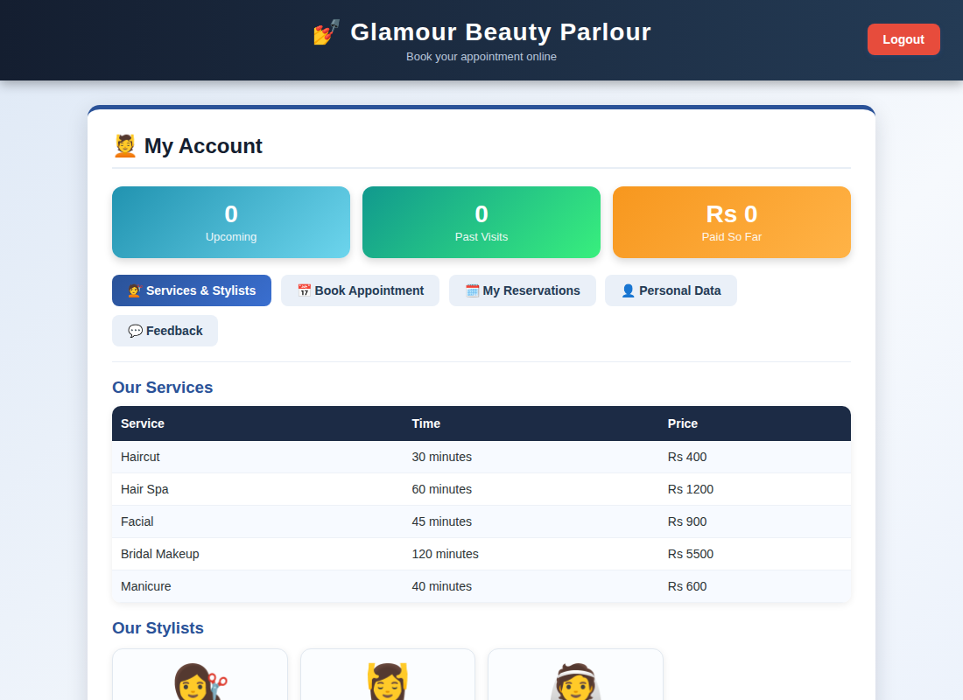
Customer account page displayed after login
Result
Thus the Beauty Parlour Appointment Booking was designed and developed successfully using HTML5, CSS and JavaScript, and the output of the dashboard was verified.

