Experiment 8
Online Hospital Appointment Booking
My Details
Name | Yarrapureddy Lakshmi Reddy
Register Number | 192324077
Department | Artificial Intelligence and Data Science, SIMATS Engineering
Course Code | CSA43
Course Name | Internet Programming
Aim
To design an online hospital appointment system using HTML5, CSS and JavaScript for patients, hospitals and the administrator with doctor search, slot booking, check-in form, reviews, hospital details, location map and statistics.
Algorithm
- Start and open the page; the login page with a Sign Up option is displayed.
- A patient or a hospital signs up; a hospital also gives the city, area and address.
- The user selects Patient, Hospital or Admin, enters the credentials and clicks Login.
- The patient searches doctors by location and specialty, sorted by rating, and views the hospital list with the Google map of a hospital.
- The patient selects a doctor, a date and a free time slot and books the appointment; the check-in form is submitted before the visit.
- The patient views the status, cancels appointments, sees past appointments and writes reviews; the hospital creates or updates its details, location, doctors and appointments; the admin manages appointments, doctors, statistics and ratings.
- The user logs out and the program stops.
Output
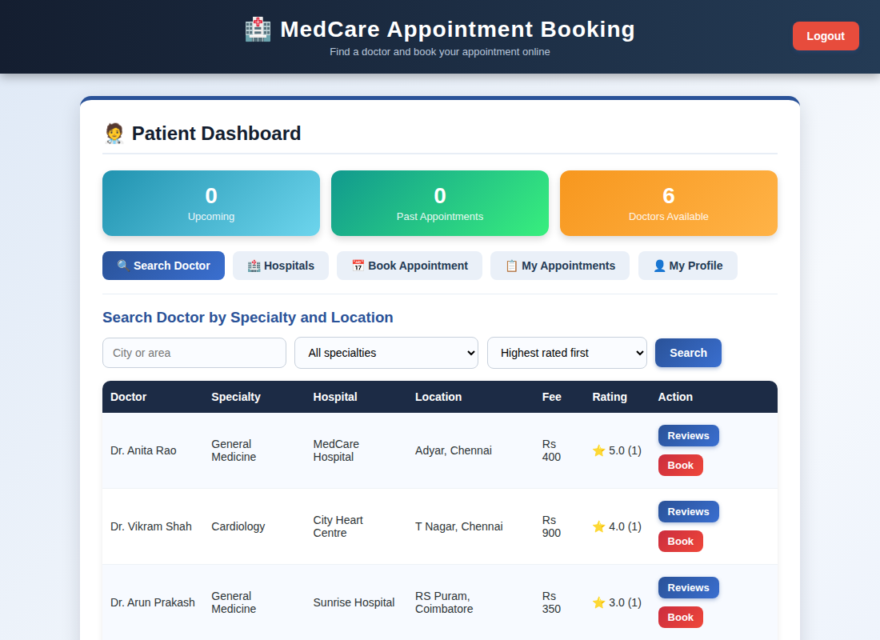
Patient dashboard displayed after login
Result
Thus the Online Hospital Appointment Booking was designed and developed successfully using HTML5, CSS and JavaScript, and the output of the dashboard was verified.

