Experiment 9
TechSavvy Online Shopping
My Details
Name | Yarrapureddy Lakshmi Reddy
Register Number | 192324077
Department | Artificial Intelligence and Data Science, SIMATS Engineering
Course Code | CSA43
Course Name | Internet Programming
Aim
To develop an online electronics shopping website using HTML5, CSS and JavaScript with categories, search, availability check, cart, checkout, wishlist, reviews, order tracking and an administrator panel.
Algorithm
- Start and open the home page; the login page is displayed.
- A new customer registers with name, username, password, email and phone number.
- The user selects the role, enters the credentials and clicks Login.
- The shop page lists all categories with their sub categories; the customer searches and filters by category, sub category and price and checks the stock availability.
- The customer opens the item details, reads or writes reviews, adds the item to the cart or the wishlist and edits or removes cart items.
- The customer enters the delivery address, selects the payment method and places the order, then views the order status and order history; the admin adds or removes items, modifies price, updates description and views customer information.
- The user logs out and the program stops.
Output
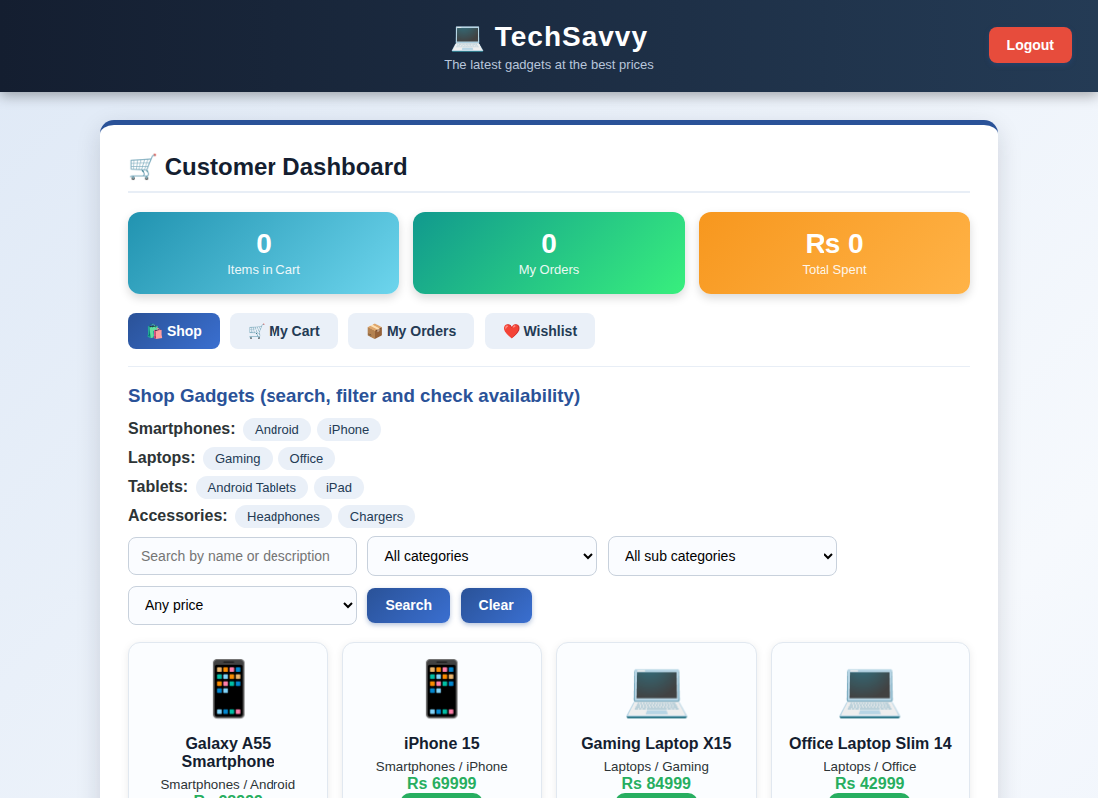
Customer dashboard displayed after login
Result
Thus the TechSavvy Online Shopping was designed and developed successfully using HTML5, CSS and JavaScript, and the output of the dashboard was verified.

