Experiment 13
BlossomGifts Flowers and Gifts
My Details
Name | Yarrapureddy Lakshmi Reddy
Register Number | 192324077
Department | Artificial Intelligence and Data Science, SIMATS Engineering
Course Code | CSA43
Course Name | Internet Programming
Aim
To develop a flower and gift shop website using HTML5, CSS and JavaScript with gifts organized by occasion, recipient and price, delivery date and time selection, order tracking and an administrator panel.
Algorithm
- Start and open the page; the login page is displayed.
- A new customer registers with name, username, password, email and phone number.
- The user selects the role, enters the credentials and clicks Login.
- The customer searches gifts and filters them by occasion, sub category, recipient and price range.
- The customer adds gifts to the cart, edits the quantity and checks out with the address, payment method, delivery date and delivery time slot.
- The customer tracks the order status and sends an inquiry by email; the admin manages inventory, views the order summary, edits or deletes customer information and reads inquiries.
- The user logs out and the program stops.
Output
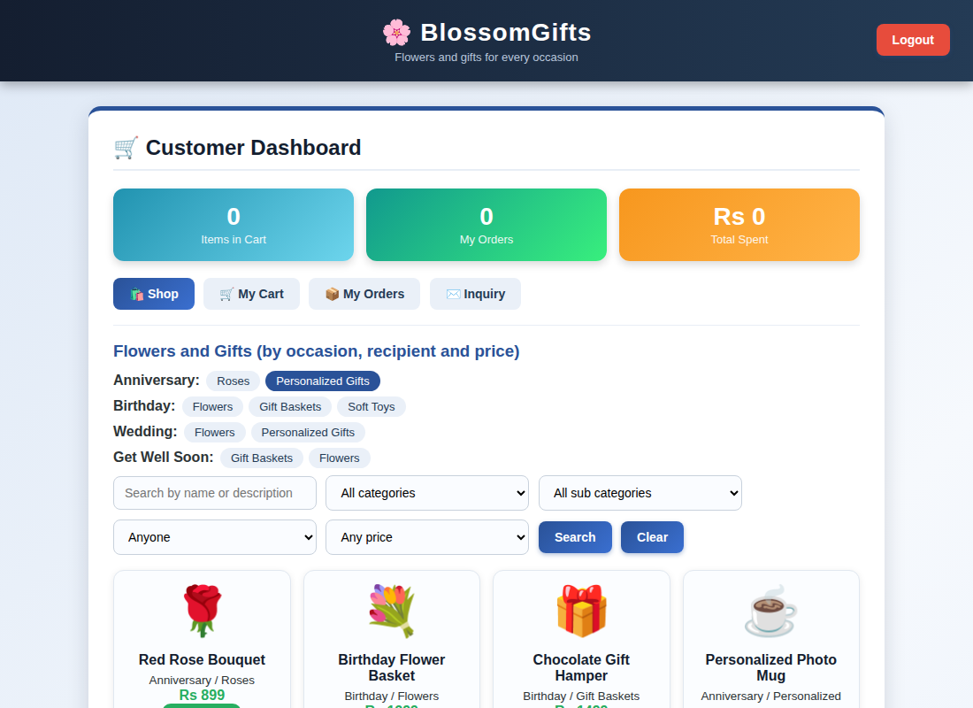
Customer dashboard displayed after login
Result
Thus the BlossomGifts Flowers and Gifts was designed and developed successfully using HTML5, CSS and JavaScript, and the output of the dashboard was verified.

