Experiment 15
EasyToll Toll Management System
My Details
Name | Yarrapureddy Lakshmi Reddy
Register Number | 192324077
Department | Artificial Intelligence and Data Science, SIMATS Engineering
Course Code | CSA43
Course Name | Internet Programming
Aim
To develop a toll management website using HTML5, CSS and JavaScript with eWallet, eTicket, toll pass application and renewal, QR codes, toll gate verification and an administrator panel.
Algorithm
- Start and open the page; the login page is displayed.
- A vehicle owner registers with vehicle number and vehicle type.
- The user selects Vehicle Owner, Toll Gate User or Admin, enters the credentials and clicks Login.
- The owner adds money to the eWallet and buys a one trip eTicket; the fee is deducted from the wallet.
- The owner applies for a toll pass and the admin approves it; the pass can be renewed and the QR code is generated.
- The toll gate user scans the QR code or verifies the pass or ticket ID and allows or stops the vehicle, and updates the toll location; the admin manages toll details, logins and users.
- The user logs out and the program stops.
Output
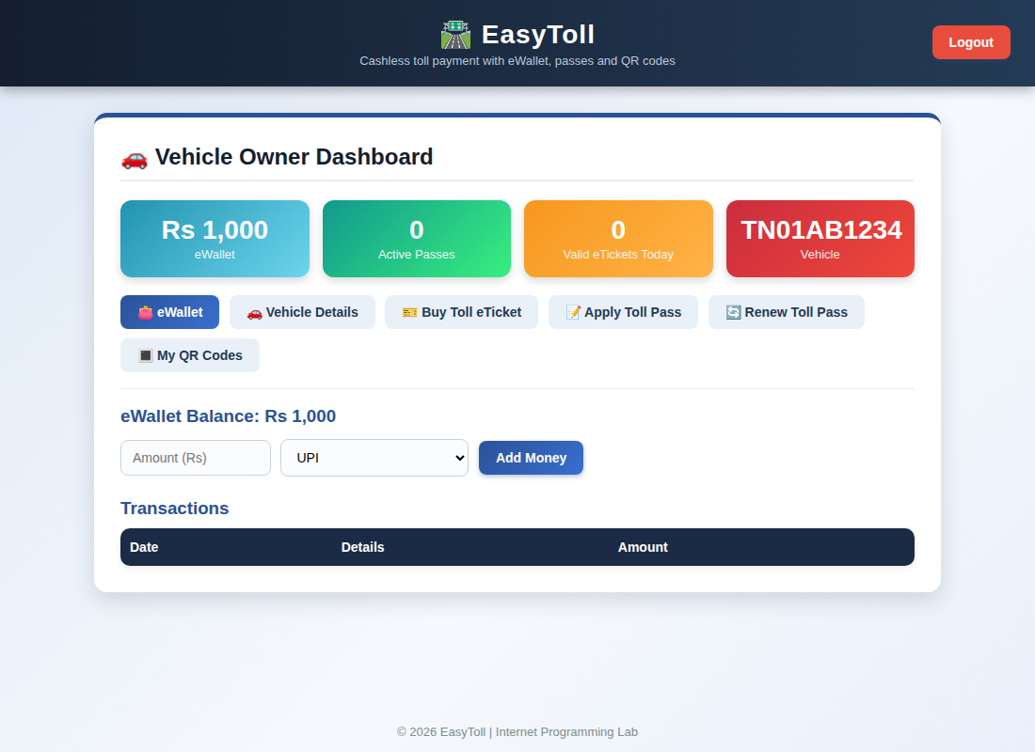
Vehicle owner dashboard displayed after login
Result
Thus the EasyToll Toll Management System was designed and developed successfully using HTML5, CSS and JavaScript, and the output of the dashboard was verified.

