Experiment 17
VoteOnline E-Voting System
My Details
Name | Yarrapureddy Lakshmi Reddy
Register Number | 192324077
Department | Artificial Intelligence and Data Science, SIMATS Engineering
Course Code | CSA43
Course Name | Internet Programming
Aim
To design a secure online voting system using HTML5, CSS and JavaScript with Voter ID login, OTP verification, candidate selection and vote submission, and an admin panel for elections, candidates, wards, voter lists and results.
Algorithm
- Start and open the page; the login page is displayed.
- The admin creates the elections, candidates, wards and the voter list, and can import voters.
- The voter enters the Voter ID and password and clicks Login; an OTP is sent for login verification.
- The voter enters the correct OTP and the dashboard with the elections of his or her ward is displayed.
- The voter selects an election and a candidate and clicks Get OTP for Voting.
- The voter enters the voting OTP and submits the vote; only one vote per election is allowed and a receipt is shown; the admin gets the results.
- The user logs out and the program stops.
Output
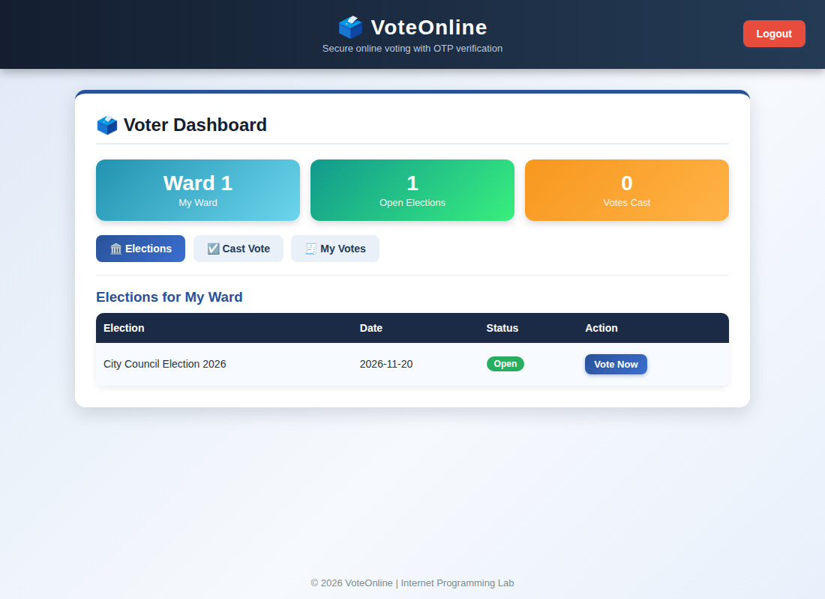
Voter dashboard (after OTP verification) displayed after login
Result
Thus the VoteOnline E-Voting System was designed and developed successfully using HTML5, CSS and JavaScript, and the output of the dashboard was verified.

