Experiment 19
VetCure Animal Care System
My Details
Name | Yarrapureddy Lakshmi Reddy
Register Number | 192324077
Department | Artificial Intelligence and Data Science, SIMATS Engineering
Course Code | CSA43
Course Name | Internet Programming
Aim
To develop an animal care website using HTML5, CSS and JavaScript where farmers send the signs and symptoms of their animals to doctors and receive solutions, and doctors manage cures, news, users and payments.
Algorithm
- Start and open the page; the login page is displayed.
- A farmer or a doctor registers with name, username, password, phone and village or hospital.
- The user selects Farmer or Doctor, enters the credentials and clicks Login.
- The farmer makes the subscription payment, which is required to post complaints.
- The farmer posts a complaint with the animal, the symptoms and an image, video or audio file.
- The doctor views the complaints and posts the solution; the farmer views the status and solution, the VetCure details, news, report and gives feedback.
- The user logs out and the program stops.
Output
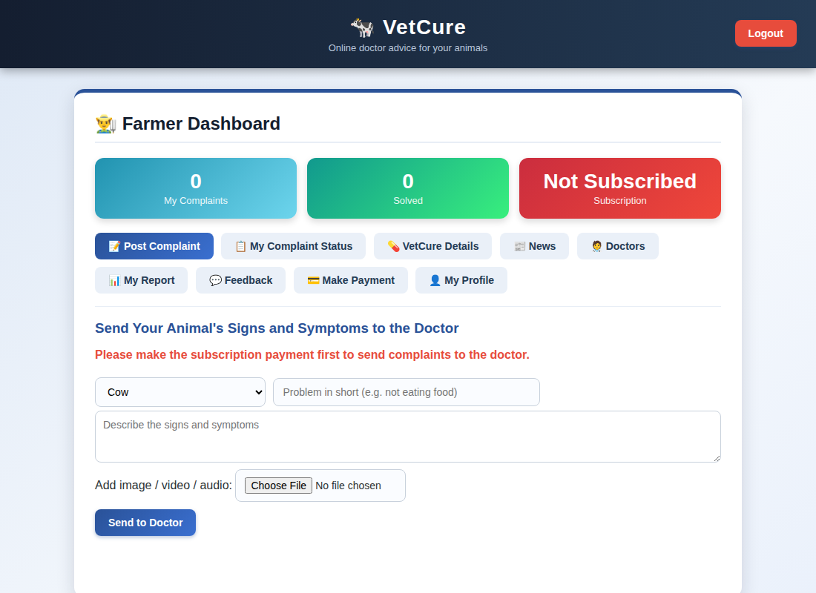
Farmer dashboard displayed after login
Result
Thus the VetCure Animal Care System was designed and developed successfully using HTML5, CSS and JavaScript, and the output of the dashboard was verified.

