Experiment 21
Online Job Portal
My Details
Name | Yarrapureddy Lakshmi Reddy
Register Number | 192324077
Department | Artificial Intelligence and Data Science, SIMATS Engineering
Course Code | CSA43
Course Name | Internet Programming
Aim
To develop a job portal using HTML5, CSS and JavaScript where directors post vacancies after admin approval, job seekers search and apply, and the admin views users and reports.
Algorithm
- Start and open the page; the login page is displayed.
- A job seeker or a director registers; a director can login only after the admin approves the account.
- The user selects the role, enters the credentials and clicks Login.
- The director posts a vacancy with title, category, location, salary, description and contact; all job seekers get a notification.
- The job seeker searches vacancies and filters them by location and category, views the details and applies with a short note.
- The director views the applied users, shortlists or rejects them and browses the resumes; the job seeker is notified of the status.
- The admin views the users and the director report; the user logs out and the program stops.
Output
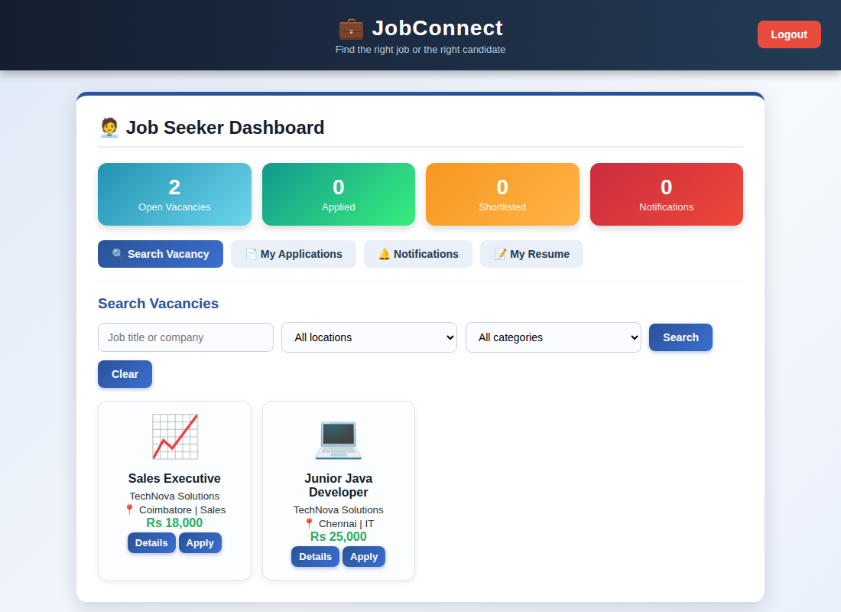
Job seeker dashboard displayed after login
Result
Thus the Online Job Portal was designed and developed successfully using HTML5, CSS and JavaScript, and the output of the dashboard was verified.

