Experiment 22
Solid Waste Management System
My Details
Name | Yarrapureddy Lakshmi Reddy
Register Number | 192324077
Department | Artificial Intelligence and Data Science, SIMATS Engineering
Course Code | CSA43
Course Name | Internet Programming
Aim
To develop a solid waste management website using HTML5, CSS and JavaScript where the admin manages garbage bins, drivers and routes, drivers collect garbage and update the load, and the public registers complaints.
Algorithm
- Start and open the page; the login page is displayed.
- A member of the public registers; the admin creates the driver logins.
- The user selects General Public, Driver or Administrator, enters the credentials and clicks Login.
- The admin creates, updates and deletes garbage bins with location, area, capacity and current load.
- The admin suggests the best bins (60 percent full or more) and assigns the route to a driver; the driver views the daily work and chooses the best route.
- The driver updates the garbage load after collection and the bin load is reduced; the citizen registers complaints and views their status; the admin views the garbage report and resolves complaints.
- The user logs out and the program stops.
Output
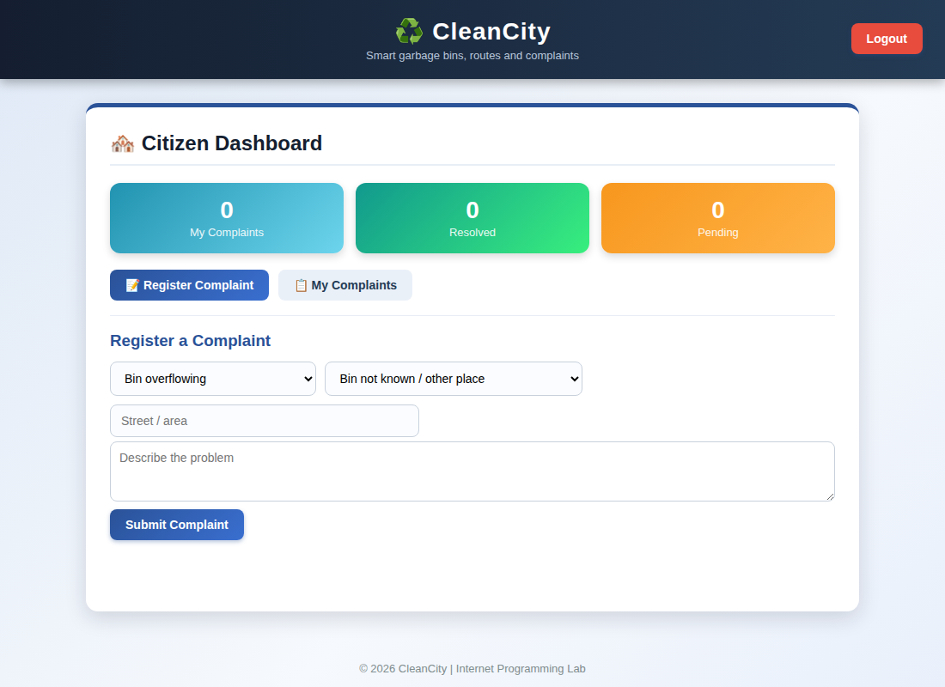
Citizen dashboard displayed after login
Result
Thus the Solid Waste Management System was designed and developed successfully using HTML5, CSS and JavaScript, and the output of the dashboard was verified.

