MET CS 555 Term Project
10 points

1. Assignment Description
Select a small data set from the available public data sets (you can find a list of public data sets here http://www.teymourian.de/public-data-sets-for-data-analytic-projects/ ).

Describe a research scenario and specify a research question based on data analytic methods that we learned in our class, for example methods like, one and two sample means, t-test, correlation tests, simple and multiple linear regression, ANOVA and ANCOVA, one and two-Sample Tests for Proportions and logistic regression.

Clean up your data and reduce it to no more than 500 observations if your data set is large.

2. Research Scenario Description (no more than 200 words)
Describe your research scenario in no more than 200 words. This is a general description of the use case. Similar to our class examples, we first describe the overall scenario and then we specify a specific research question based on it.

In this project, I will discuss about the benefit of data cleaning and different ways to select the proper combination of attributes.
Throughout the project, I will only build the model with attributes in only first degree.

For example, I won’t discuss the linear model with more than two degrees like this:
Y = X1 + X2^2 + X3^3 + …

In my opinion, a simple model is always useful and more generalized comparing to a complicated one, so a simple linear regression might be a good concept.

3. Describe the data set (no more than 200 words)
Briefly describe the data set. Describe each column of the data set if you use the column in your analysis. Clean up your data before usage, for example you can remove the outliers. Remove unused columns. If possible, provide a Link to the main data set source.

Dataset link: https://archive.ics.uci.edu/ml/datasets/Energy+efficiency

The dataset contains eight attributes, from X1 to X8, and two responses, y1 and y1. It is about how do the 8 independent variables, the shape of a building, affect the 2 response variables, which are the energy usage, and it has 768 data rows in total. The aim is to predict each of the two responses with the eight features.

In my project, I will only deal with y1, the heating load, and I will reduce the data down to 500 data rows in total.

X1 = Relative Compactness
X2 = Surface Area
X3 = Wall Area
X4 = Roof Area
X5 = Overall Height
X6 = Orientation
X7 = Glazing Area
X8 = Glazing Area Distribution
y1 = Heating Load
y2 = Cooling Load

3. Research Question (no more than 100 words)
Describe briefly in one or two sentences the main research question. This is similar to the last sentence of our class examples.

Q1: How will the model performance improve after data reduction from 768 rows to 500 rows with all attributes involved?
Q2: What’s the best MLR by personal observation?
Q3: What’s the best model formula provided by forward selection and backward selection? And compared all models.

4. Your solution R code
Copy your R code here. Start from read the data from a data file. Keep the following data read line.
This is similar to one of our R code examples.
Data reduction file
setwd('C:/Users/Lee/iCloudDrive/Document/Boston University/CS555 Data with R/Final Project')
getwd()

##### read csv
# X1 Relative Compactness
# X2 Surface Area
# X3 Wall Area
# X4 Roof Area
# X5 Overall Height
# X6 Orientation
# X7 Glazing Area
# X8 Glazing Area Distribution
# y1 Heating Load
# y2 Cooling Load
df = read.csv('ENB2012_data.csv')

##### clean
df = subset(df, select = -c(X, X.1)) # drop redundant columns
names(df)[names(df) == 'ï..X1'] = 'X1' # rename one column
df = na.omit(df) # drop na rows
df = df[colnames(df) != 'Y2'] # drop Y2, we are doing only hearing

n = nrow(df) # total rows of raw data
n

# reduce data rows into 500 data rows only
mBefore = lm(data = df, formula = Y1 ~ .) # make a MLR with raw data

temp = sort(abs(mBefore$residuals), decreasing = TRUE) # residual
index = names(temp[1:(n - 500)]) # extract the data index with top residual
index = as.numeric(index)
dfReduced = df[-index, ] # remove the data causing big residual, reduce the data into 500 rows
nrow(dfReduced) # check data rows after reducing

mAfter = lm(data = dfReduced, formula = Y1 ~ .) # make a MLR with reduced data

par(mfrow = c(1,2))
plot(mBefore, which = 1)
plot(mAfter, which = 1)

summary(mBefore)
sum(mBefore$residuals^2) # res SS

summary(mAfter)
sum(mAfter$residuals^2) # res SS

write.csv(dfReduced, file = 'reducedData.csv') # save the 500 data rows into a csv file

Main file

setwd('C:/Users/Lee/iCloudDrive/Document/Boston University/CS555 Data with R/Final Project')
getwd()

##### read csv
# X1 Relative Compactness
# X2 Surface Area
# X3 Wall Area
# X4 Roof Area
# X5 Overall Height
# X6 Orientation
# X7 Glazing Area
# X8 Glazing Area Distribution
# y1 Heating Load
dfReduced = read.csv('reducedData.csv')
dfReduced = dfReduced[colnames(dfReduced) != 'X'] # drop the index columns

##### My best selection
# correlation
# check correlation matrix first
library(psych)
pairs.panels(dfReduced,
method = "pearson", # correlation method
hist.col = "#00AFBB",
density = TRUE, # show density plots
ellipses = TRUE # show correlation ellipses
)

# do t-test on Correlation on X6, X7, X8, based on alpha = 0.95
a = 0.95

temp = cor.test(x = dfReduced$X6, y = dfReduced$Y1)
print(temp$p.value)
temp$p.value < (1 - a) / 2 # if False, fail to reject the null hypothesis

temp = cor.test(x = dfReduced$X7, y = dfReduced$Y1)
print(temp$p.value)
temp$p.value < (1 - a) / 2 # if False, fail to reject the null hypothesis

temp = cor.test(x = dfReduced$X8, y = dfReduced$Y1)
print(temp$p.value)
temp$p.value < (1 - a) / 2 # if False, fail to reject the null hypothesis

# after the t-test, we should drop X6 because there is no correlation between X5 and Y1
drop = c('X6') # drop three columns
dfReduced1 = dfReduced[, !(names(dfReduced) %in% drop)]
colnames(dfReduced1) # check if droping successfully

pairs.panels(dfReduced1[, 1:7],
method = "pearson", # correlation method
hist.col = "#00AFBB",
density = TRUE, # show density plots
ellipses = TRUE # show correlation ellipses
)

# X1 has -0.99 correlated to X2
# drop one of them, drop X2
a = 0.95
temp = cor.test(x = dfReduced1$X1, y = dfReduced1$X2)
print(temp$p.value)
temp$p.value < (1 - a) / 2 # if False, fail to reject the null hypothesis
drop = c('X2') # drop three columns
dfReduced1 = dfReduced1[, !(names(dfReduced1) %in% drop)]
colnames(dfReduced1) # check if droping successfully

# X4 has -0.98 correlated to X5
# drop one of them, drop X5
a = 0.95
temp = cor.test(x = dfReduced1$X1, y = dfReduced1$X2)
print(temp$p.value)
temp$p.value < (1 - a) / 2 # if False, fail to reject the null hypothesis
drop = c('X5') # drop three columns
dfReduced1 = dfReduced1[, !(names(dfReduced1) %in% drop)]
colnames(dfReduced1) # check if droping successfully

# check how much improvement we achieve
# mBefore is using the raw data
# mAfter is using the data after removing top residual, and reducing the data down to 500
# mAfterClean is using the data after dropping irrelevant columns
mAfterClean = lm(data = dfReduced1, formula = Y1 ~ .) # make a linear model for fully cleaned dataset

summary(mAfterClean)
sum(mAfterClean$residuals^2) # res SS

# compare between
# check if mAfter and mAfterClean have a significant difference
alpha = 0.95

anova(mAfter, mAfterClean)$`Pr(>F)`[2] < (1 - alpha) # if True, reject the null hypothesis

par(mfrow = c(1,2))
plot(mAfter, which = 1)
plot(mAfterClean, which = 1)

##### MLR modeling comparison
# dfReduced is the dataset with only 500 data rows

# my best
myBest = lm(data = dfReduced, formula = Y1 ~ X1 + X3 + X4 + X7 + X8)
summary(myBest)
# forward
m2 = lm(data = dfReduced, formula = Y1 ~ 1)
mForward = step(m2, direciton = 'forward', scope = ~ X1 + X2 + X3 + X4 + X5 + X6 + X7 + X8)
summary(mForward)
sum(mForward$residuals^2)
# backward
m3 = lm(data = dfReduced, formula = Y1 ~ X1 + X2 + X3 + X4 + X5 + X6 + X7 + X8)
mBackward = step(m3, direction = 'backward')
summary(mBackward)
sum(mBackward$residuals^2)

5. Execute your R code, Copy and Paste results here in this Box.
Run your code and copy the output of your code to here.

Q1: How will the model performance improve after data reduction from 768 rows to 500 rows with all attributes involved?

Before data reduction
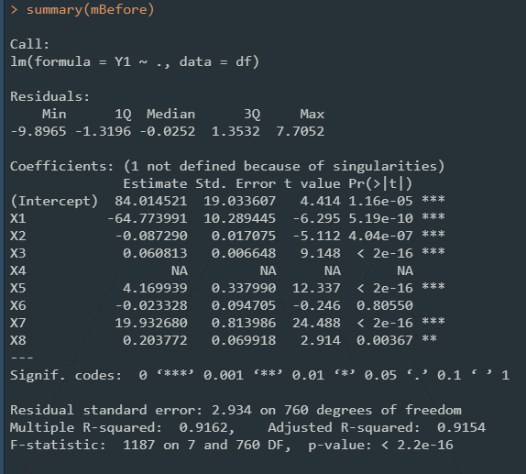
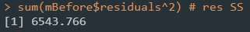

After data reduction
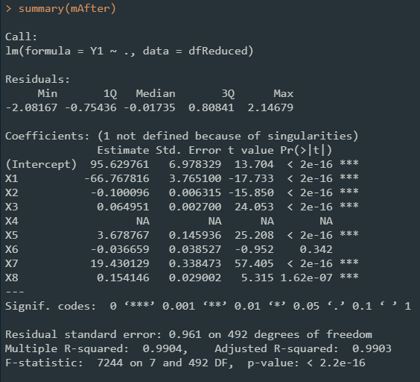
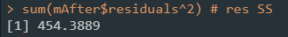

 | Adj.  R-squared | Residual SE | Residual SS
Before | 0.9154 | 2.934 | 6543.76
After | 0.9903 | 0.961 | 454.38

The data reduction not only reduce the ResSS, but also reduce the residual standard error.
It will improve the model performance after a proper data reduction.

Q2: What’s the best MLR by personal observation?

After the proper analysis on columns, I decide to drop X2, X5, and X6.
The detailed decision process is elaborated in the code script.
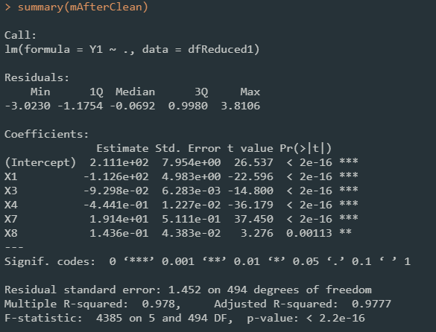
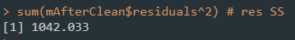

 | Adj.  R-squared | Residual SE | Residual SS
After Reduction | 0.9903 | 0.961 | 454.38
MySelection | 0.9777 | 1.452 | 1042.03

AfterReduction: Y1 ~ X1 + X2 + X3 + X4 + X5 + X6 + X7 + X8
MySelection: Y1 ~ X1 + X3 + X4 + X7 + X8

Apply a f-test between the two models to check if there is a significant difference.
With alpha = 0.95
TRUE means it rejects the null hypothesis. In other words, AfterReduction is better than MySelection.

Q3: What’s the best model formula provided by forward selection and backward selection? And compared all models.

Forward selection
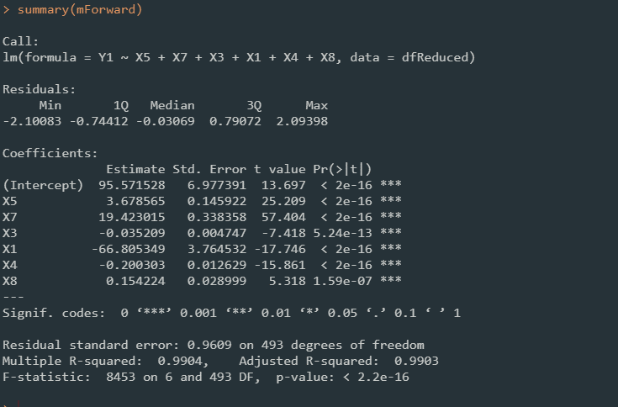
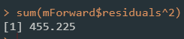

Backward selection
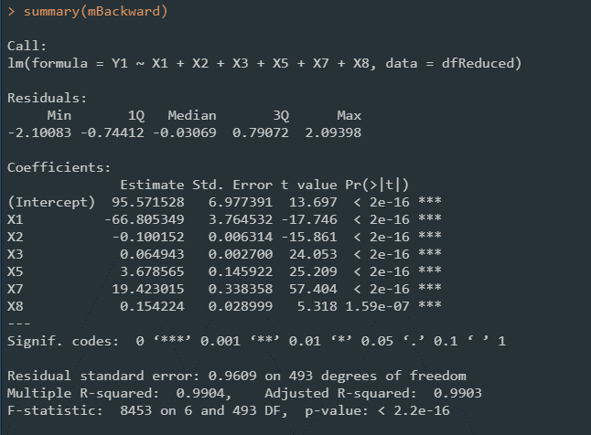
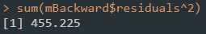

 | Adj.  R-squared | Residual SE | Residual SS
RawData | 0.9154 | 2.934 | 6543.76
AfterReduction | 0.9903 | 0.961 | 454.38
MySelection | 0.9777 | 1.452 | 1042.03
mForward | 0.9903 | 0.961 | 455.225
mBackward | 0.9903 | 0.961 | 455.225

RawData | Y1 ~ X1 + X2 + X3 + X4 + X5 + X6 + X7 + X8, with full data rows, which is 768
AfterReduction | Y1 ~ X1 + X2 + X3 + X4 + X5 + X6 + X7 + X8
MySelection | Y1 ~ X1 + X3 + X4 + X7 + X8
mForward | Y1 ~ X1 + X3 + X4 + X5 + X7 + X8
mBackward | Y1 ~ X1 + X2 + X3 + X5 + X7 + X8

6. State Your Conclusion (no more than 100 words)
State the conclusion so that a none-statistician can understand.
First, data cleaning is a necessary process when doing data science, as we can see the difference between modeling with raw data and modeling with reduced data.

Second, when doing the attributes selection, human is never better than computer’s algorithms, as the results shown between MySelection and AfterReduction. In Myselection, I choose the attributes with the help of correlation test and correlation matrix only.

Third, forward selection and backward selection might provide different combination of attributes selection, but they will probably provide the model with similar performance.

Solution Submission

- Fill up this word file and upload it.
- Upload your data set. This is the data set after cleaning (a small CSV file)
- Upload your R file as a file with name “mini-project-solution.R”

Grading will be done based on
- Originality of selected data set and data analysis approach
- Data Preparation set and cleanup
- General Correctness of data analysis
- Quality of your R code and output results
- Correct final conclusion

