________________________________________________________

启动过程（view-based application）

1. main

int main(int argc, char *argv[]) {

NSAutoreleasePool

NSAutoreleasePool * pool = [[NSAutoreleasePool alloc] init];

int retVal = UIApplicationMain(argc, argv, nil, nil);

[pool release];

UIApplication

return retVal;

}

2. 整个过程都在 UIApplicationMain 中进行。

This function is called in the main entry point to create the **application object** and the **application delegate** and set up the event cycle.

3. MainWindow.xib 文件中包含：

<XXXAppDelegate>

NSObject

UIWindow

XXXAppDelegate

Liabrary inspector

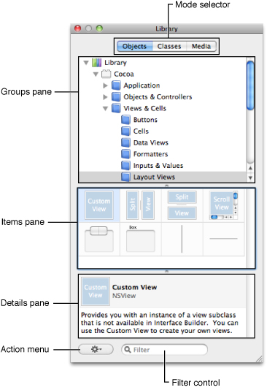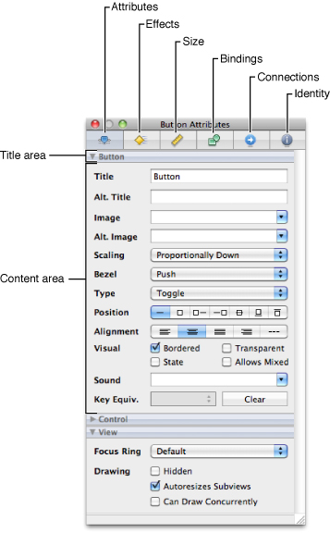

document

