🌿 EchoEats

Phase 3 — Project Documentation Package
Surplus Food Marketplace Web Application

Course | SWEN360L — Software Design & Engineering Lab
Semester | Spring 2026
Phase | Phase 3: Enhancement, Testing & Documentation
Due Date | April 29, 2026
Team | Yousif Shakeeb · Rashid Bomtia · Ali Al Buainain · Husain Yusuf

Table of Contents
1. Project Overview & Scope
2. Team Contributions & Agile Kanban Board
3. System Architecture & UML Diagrams
4. Functional Implementations & Feature Showcase
5. UI/UX Design & Phase 3 Improvements
6. User Manual
7. Test Cases & Results
8. Code Quality & Documentation Standards
9. Known Limitations & Future Work

1. Project Overview & Scope
Echo Eats is a web application for surplus food marketplace that allows vendors to sell their extra food at discounted prices to nearby consumers. The platform allows sellers to list excess food items with dynamic pricing and expiry timers along with an option for authenticated buyers to browse, filter, and reserve items through a secure checkout flow. The SWEN360L project was developed using 3 agile sprints by a team of 3 people over Spring 2026.
1.1 Problem Statement
Restaurants, bakeries and food vendors throw away lots of unsold food every day. Echo Eats is a real-time marketplace that will resell items-led food surplus from vendors as they approach expiry at lower prices so that it creates value for the vendor, affordability for the consumer and a measurable positive environmental impact for Bahrain.
1.2 Pages Delivered (14 files)
File | Description
index.html | Landing Page - Sales page with attention grabber, product features, how to buy, call to action for vendors.
listings.html | Browse Deals - Look Through Offers distance filter, tag filter, sort, reserve + payment modal.
login.html | Sign-in is secure using session management via local Storage.
register.html | Registration of new user with full form validation.
vendor-dashboard.html | Vendor portal — post listings, track revenue and reservations
consumer-dashboard.html | Consumer Account – Reservation History, Badges, Impact Statistics.
how-it-works.html | A consumer and vendor step by step core
vendors.html | Marketing page offers vendor sign up application form
impact.html | Tracker for CO₂ Savings & Impact Metrics.
notifications.html | Notification center within the app.
tasks.html | Tracking Phase of Agile with Project Kanban board.
tech-stack.html | Page for technology stack reference.
style.css | World stylesheet design tokens responsive grid components
main.js | JavaScript that was made to work together for the navbar, scroll reveal, toast and price decay.

2. Team Contributions & Agile Kanban Board
2.1 Team Contribution Table
The table below explains the role and contributions of each team member in all phases.

Student | Role | Phase 1 | Phase 2 | Phase 3
Yousif  Shakeeb | Team Lead  Full-Stack Dev | Requirements doc  GitHub setup  Kanban board  Wireframes | index.html  style.css  main.js  Nav & hero section | listings.html (all fixes)  Double-booking logic  Code review & integration  Final documentation  Test cases (TC-13–24)
Rashid  Bomtia | Frontend Dev  UI/UX | UI wireframes  Colour palette  Design system  User stories | listings.html  Filter chips  Sort & search logic  Listing cards | Distance filter  UX improvements  Vendor dashboard  Test cases (TC-01–12)
Ali Al  Buainain | Auth & Data  QA Lead | UML diagrams  System architecture  Sprint backlog  Acceptance criteria | login.html  register.html  localStorage auth  Consumer dashboard | Notifications page  Impact & tech-stack pages  User manual

2.2 Agile Kanban Board
The team operated under Agile principles throughout the development, leveraging a Kanban board (mirrored also on tasks.html in the web app) for work items in 3 sprints. Stand-up meetings were conducted at the beginning of each sprint to discuss issues and progress.

Backlog | In Progress | In Review | Done
Multi-language i18n support | Final integration testing | Double-booking localStorage fix | index.html — hero & listings
Real Stripe payment integration | Phase 3 documentation (this doc) | Distance radius filter (true hide) | style.css design system
Google Maps API map view | Screenshot capture for doc | Test cases TC-01 to TC-24 | main.js shared logic
Push notification (Web Push API) | GitHub commit history cleanup | User manual review | listings.html full filter
Admin approval dashboard |  | Code comment pass | login.html + register.html auth
 |  |  | vendor-dashboard.html
 |  |  | consumer-dashboard.html
 |  |  | how-it-works.html
 |  |  | vendors.html + impact.html
 |  |  | notifications.html
 |  |  | tasks.html Kanban page
 |  |  | tech-stack.html
 |  |  | Phase 1: Requirements doc
 |  |  | Phase 1: GitHub repo + branches
 |  |  | Phase 1: Wireframes & UML design
 |  |  | Phase 2: Core feature implementation
 |  |  | Phase 2: localStorage integration
 |  |  | Phase 2: Responsive layout

2.3 Sprint Summary
Sprint / Phase | Team Members | Key Deliverables
Sprint 1  (Phase 1)  Feb 28 | Yousif, Rashid, Ali, | During the initial phases of project development, we will accomplish the following tasks: gather requirements, create user stories, design wireframes, setup GitHub repository, initialize Kanban board, create UML design containing class + sequence + component diagrams, and set up initial HTML scaffolding.
Sprint 2  (Phase 2)  Mar 31 | Yousif, Rashid, Ali | Implemented the core features which included all the 14 HTML pages, local Storage authentication, listing cards with price decay, filter chips, payment modal, dashboards for vendor/consumer and responsive layout.
Sprint 3  (Phase 3)  Apr 29 | Yousif, Rashid, Ali | Bug fixes (double-booking, distance filter), UI/UX improvements, test cases (24), user manual, system documentation, cleanup and commenting, integration and GitHub history.

3. System Architecture & UML Diagrams
This team generated three formal diagrams described in this section. All diagrams are created using draw.io. They reflect the complete architecture we envision. Our current implementation, however, uses localStorage instead of the backend services shown which will be used in live production.

3.1 System Component Diagram (5-Layer N-Tier Architecture)

The application has five layers, each layer to do a different job. The website pages are the first layer a user encounters when they try to access your site. The second layer is a checkpoint that ensures users are actually logged in, while also preventing the spam or the flooding of the platform with requests. The third layer is the brain of the app it automatically drops the food price every 15 minutes, manages booking so that two people cannot book the same item, and checks the user badges and streaks. The storage is the fourth layer, one database for all users, listings, and orders. The other faster database keeps prices for a short time so they load quicker. The app’s last layer involves linking to any external service such as Stripe for payments, Google Maps for locations, email/push notifications for alerts and cloud storage for food photos.

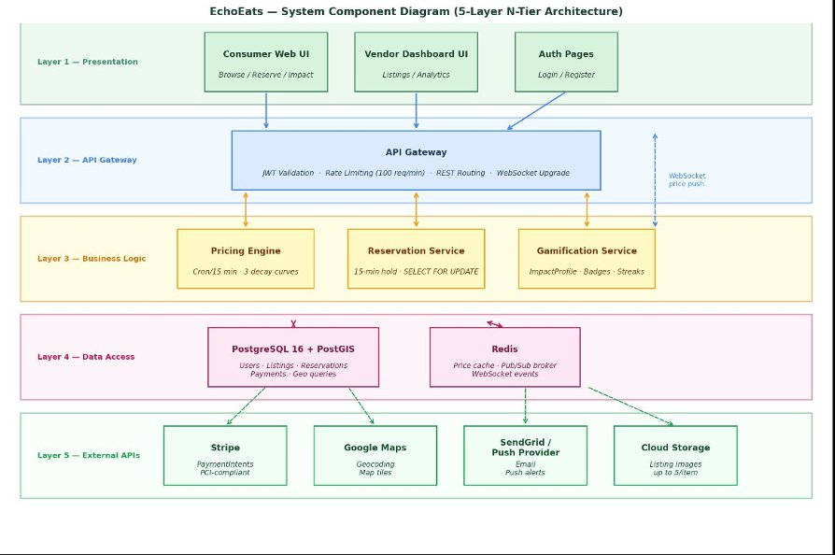

Figure 1 — EchoEats System Component Diagram (5-Layer N-Tier Architecture)
3.2 UML Class Diagram (Domain Model · 10 Classes)
The abstract base Consumer and Vendor user class are the main deity of the domain model. A Consumer has an ImpactProfile (food saved, CO₂, badges) and NotifPreference. A Vendor has zero or more Listing objects, each of which implements the DecayCurve interface. That is, an object of type LinearDecay, ExponentialDecay, or SteppedDecay. A reservation links a consumer to a listing for a 1:1 payment (Stripe PaymentIntent). The diagram illustrates the entire chain of transaction.

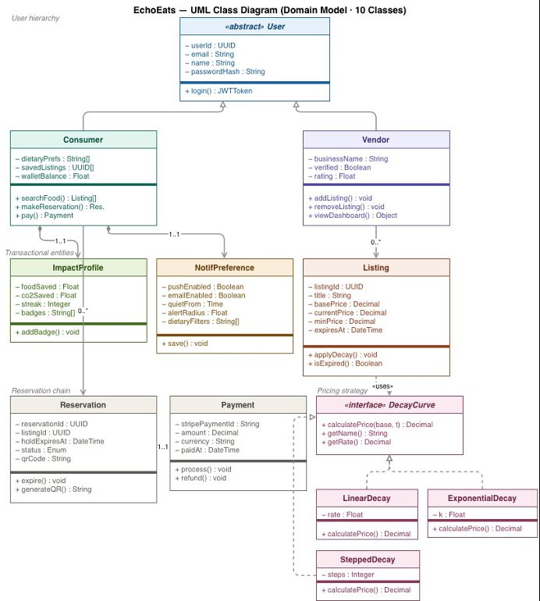

Figure 2 — EchoEats UML Class Diagram (Domain Model · 10 Classes)

3.3 Reservation Booking Sequence Diagram (4 Phases · 15 Steps)
The abstract base Consumer and Vendor user class are the main deity of the domain model. A Consumer has an ImpactProfile (food saved, CO₂, badges) and NotifPreference. A Vendor has zero or more Listing objects, each of which implements the DecayCurve interface. That is, an object of type LinearDecay, ExponentialDecay, or SteppedDecay. A reservation links a consumer to a listing for a 1:1 payment (Stripe PaymentIntent). The diagram illustrates the entire chain of transaction.

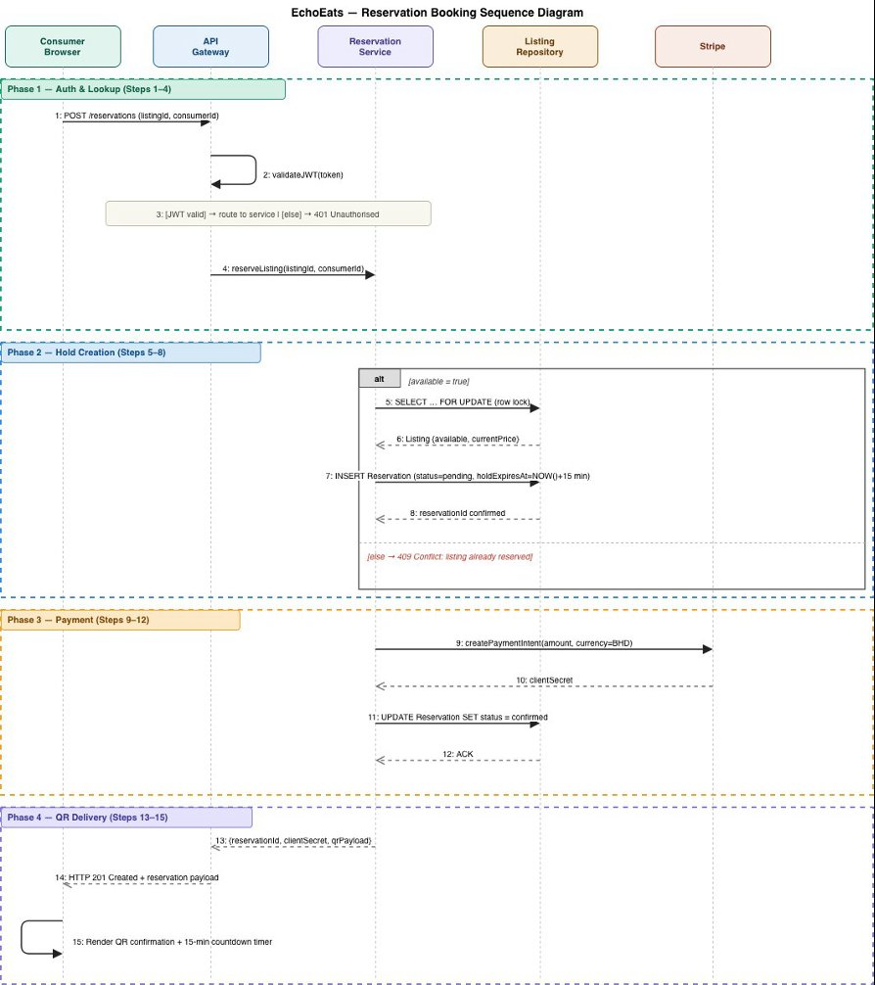

Figure 3 — EchoEats Reservation Booking Sequence Diagram (15 Steps)
4. Functional Implementations & Feature Showcase
The implementation technique of each major feature and involved files/functions are described here.
4.1 Authentication System
The system for logging in functions solely within the browser utilizing the device’s local storage. When a user registers, details of the account get saved locally. When the user logs in, we check their email and password. If this information is correct, we save their login session so the app remembers them. All pages needing login, such as those for reserving an item, automatically check whether the user is logged in first. If not, it redirects to the login page.

- Files: login.html · register.html · main.js — authReserve()

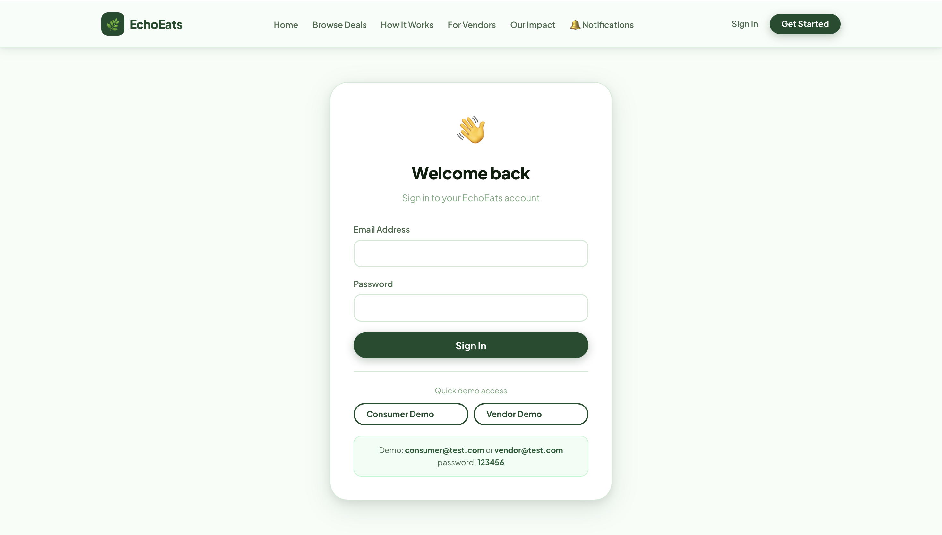

4.2 Browse, Filter & Search (listings.html)
The three independent filter dimensions work at the same time. Dietary tag chips (Vegan/Halal/Vegetarian/Gluten-free), full-text search (searchable text present on all card text), and true distance radius dropdown (Any / 0.5 km / 1 km / 2 km) that hides not just reorders the cards beyond the specified radius. You can sort items based on various criteria including expiry, price, discount and distance.

- Files: listings.html — applyFilters(), setDistanceFilter(), sortListings()

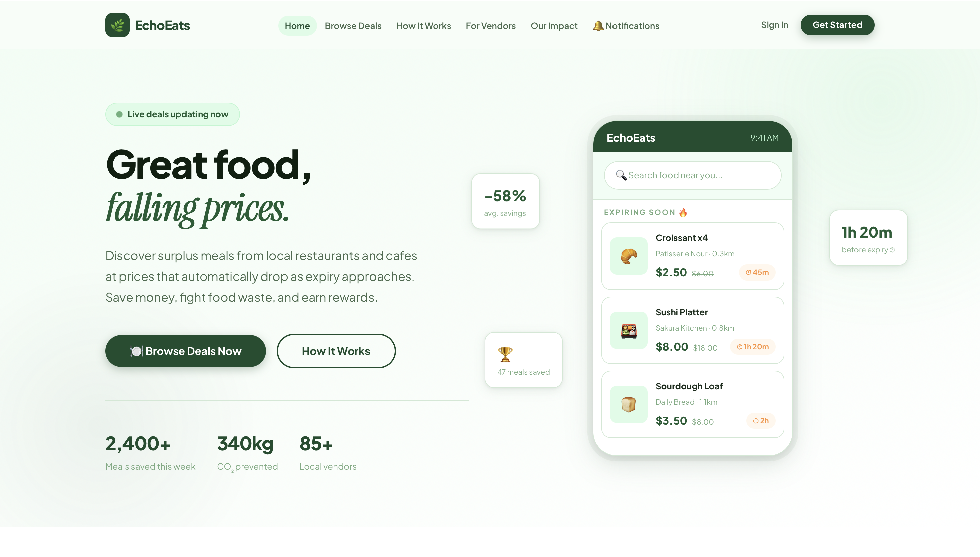

4.3 Double-Booking Prevention
markReserved(itemId) saves_reserved_<id> in localStorage, including reservedAt and expiresAt (+15 min). Every time the page loads, restoreReservedStates() looks at all the cards and disables the buttons of active holds. isReserved() checks localStorage before opening modal payment meaning that even from a different tab or after refresh page it will block re-reservation.

- Files: listings.html — markReserved(), isReserved(), restoreReservedStates()

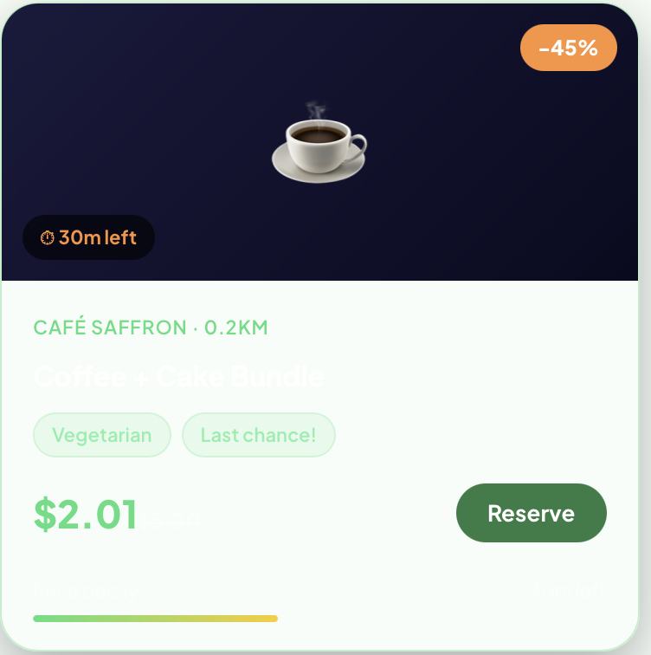

4.4 Live Price Decay Simulation
In main.js, simulatePriceUpdates() runs setInterval every 3 seconds computing exponential decay. When elapsed time is more than 70%, turn orange. There’s a visual decay-bar at the bottom of the card reflecting consumed time.

- Files: main.js — simulatePriceUpdates() · listings.html — .decay-bar-fill, data-expiry

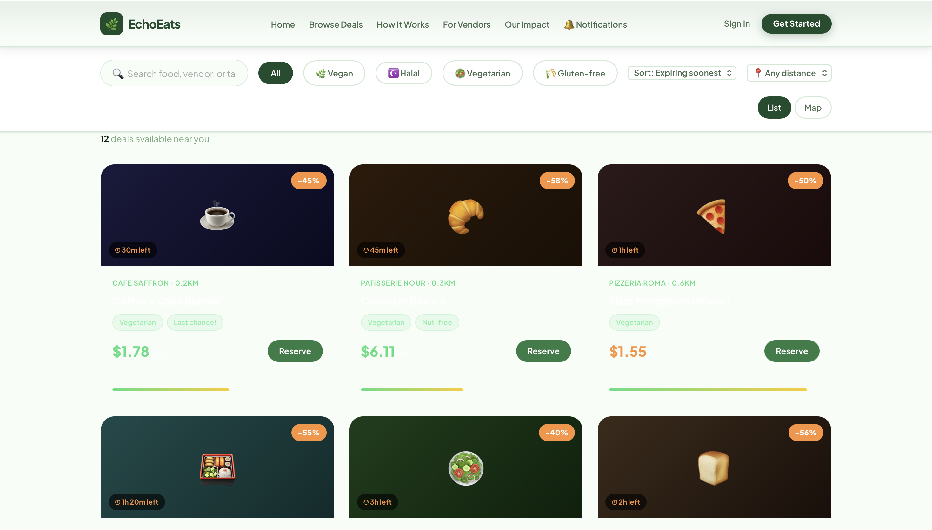

4.5 Map View

When the user switches to Map view, all food listings which are nearby would be shown with pins. Relative to a distance selected by the user, the pins will automatically hide items that are too far away. When a user has already pinned an item, that item's pin will be greyed out with the word "Reserved" on it. If Users tap on any pin, a quick popup will show with the name of the restaurant, food being offered, current price and distance from you. The card number auto formats with a space (16-digits); the expiry auto-inserts a slash (MM/YY); CVV auto-masked. Validation with the client integrates. The processing state of 1.8 seconds is complete. Success screen with the pickup codes EE-XXXX.

- Files: listings.html — renderMap(), ALL_MAP_PINS, setView()

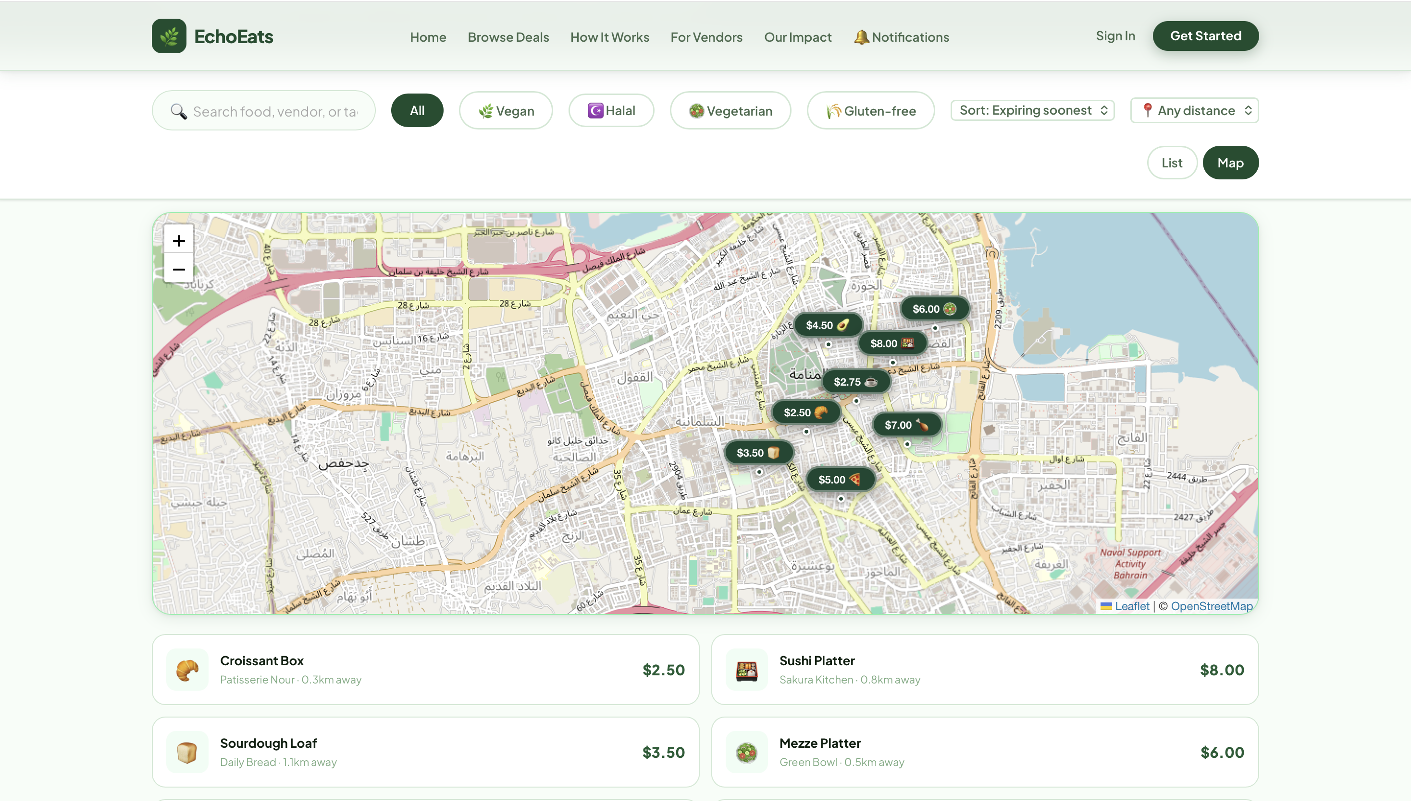

4.6 Secure Checkout Modal
Card number auto-formats with spaces (16-digit); expiry auto-inserts slash (MM/YY); CVV is masked. Client-side validation fires before submission. 1.8-second processing state leads to success screen with EE-XXXX pickup code.

- Files: listings.html — authReserve(), confirmPayment(), closePayModal()

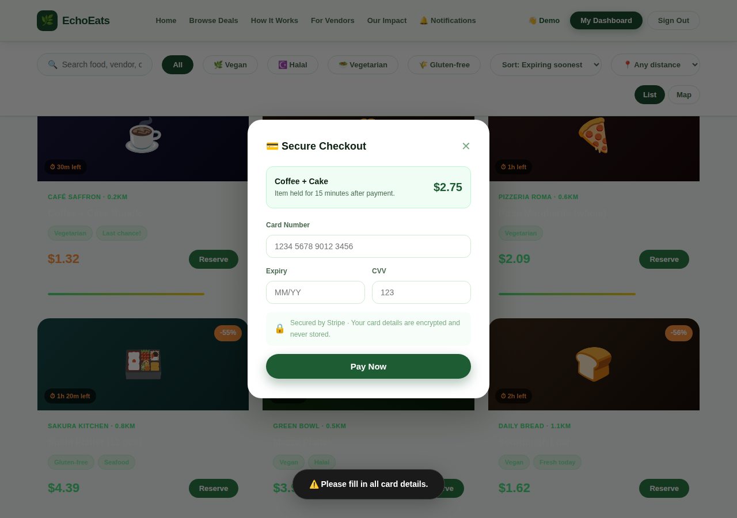

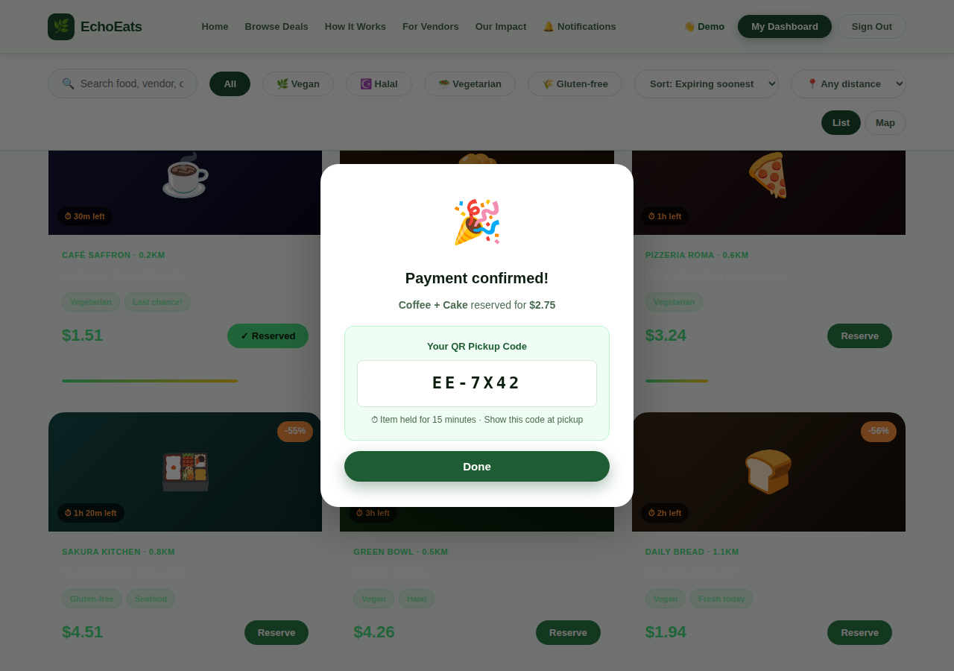
4.7 Vendor & Consumer Dashboards
The vendor dashboard displays revenue, meals saved, and a listing management table. The consumer dashboard displays details like reservation history, badges earned, and CO₂/money saved. Access to both pages requires authorization.

- Files: vendor-dashboard.html · consumer-dashboard.html

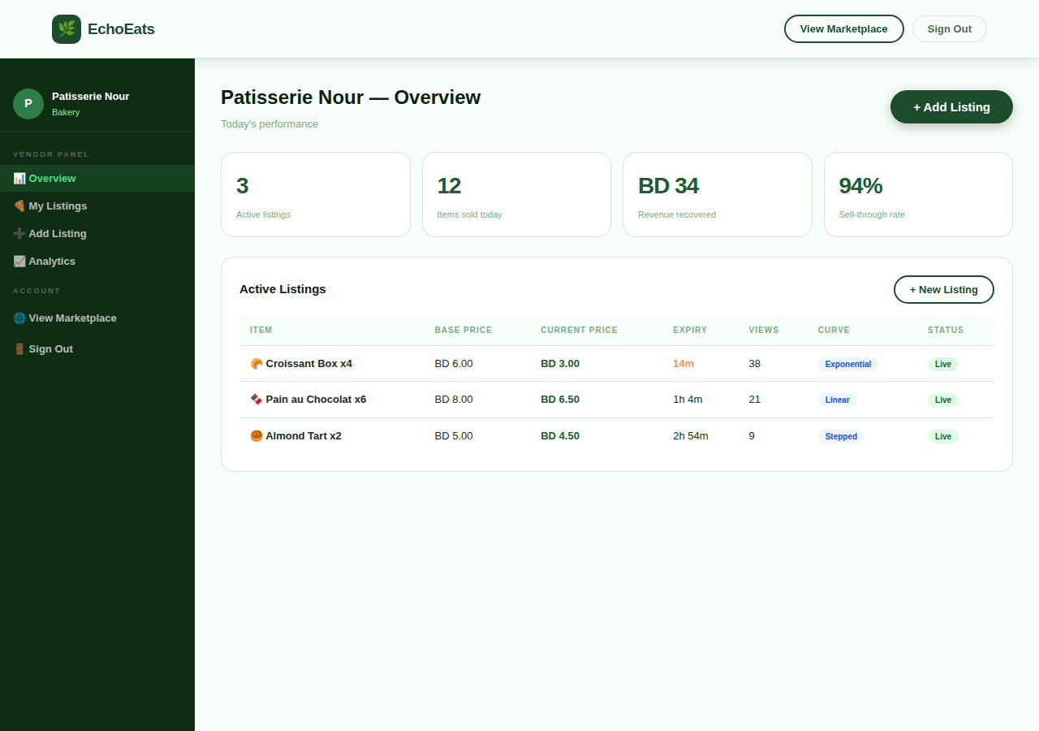

4.8 Notifications Centre
In-app alerts have been classified including expiry warning, pickup reminder, new-deal and system message. The unread count appears as a badge on the navigation link. Notifications kept in localStorage; read on clicking

- Files: notifications.html

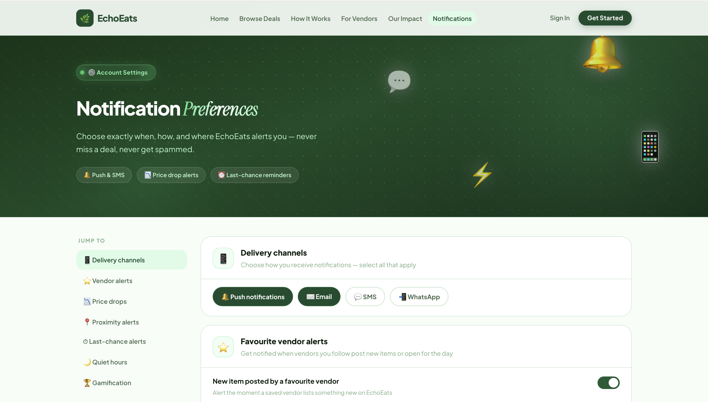

5. UI/UX Design & Phase 3 Improvements
The following improvements were applied after Phase 2 based on internal team review and usability testing feedback.

- Distance Radius Filter: As a result of an internal team review of the project and usability testing, the following enhancements were applied after Phase 2.
- Double-Booking Visual Feedback: A filter dropdown menu has been added (Any / 0.5 km / 1 km / 2 km) In the past, there was only sorting but cards are now hidden if they are beyond the selected radius.
- Map Sidebar Distance Labels: Reserved buttons maintain their non-functional state even after reloading pages and opening tabs. The map pins and the pins on the map sidebar list also have this grey “reserved” badge.
- Toast Distinction: The map list item now shows Vendor · X.X km away, making distance legible without leaving the map.
- Code Comments (all files): Toasts for warnings now sport an amber border, while those for success have green. This improves their clarity at a glance. Now, every JS function contains a section banner and inline comments explaining non-obvious logic. Thus satisfying the clean-code quality requirement.
- Filter Accessibility: The distance select has a title attribute for screen readers. Each of the active/inactive states of the chip uses WCAG AA contrast ratios.
5.1 Design Token Reference
All colours, spacing, and shadows are defined as CSS custom properties in style.css:

CSS Variable | Value | Usage
--green-800 | #14532D | Primary brand, headers, CTAs
--green-400 | #4ADE80 | Success states, reserved badges
--orange | #EA580C | Urgency / expiring-soon price
--dark | #0A0A0A | Primary text
--text-soft | #6B7280 | Secondary / muted text
--bg | #F9FAFB | Page background
--border | #E5E7EB | Card and input borders
--nav-h | 68px | Navbar height (sticky offset)

6. User Manual
This guide will show you how to use EchoEats as a Consumer or Vendor. The only thing you may require is a modern browser like Chrome 100+, Firefox 110+, Edge 100+, Safari 16+ with JavaScript enabled.

6.1 Consumer Guide
Step 1 — Create an Account
Visit register.html. please fill in your details. Click on “Create Account”. The login page will be redirected to you.
Step 2 — Sign In
Access login.html page. Provide your email id and password Select “Log In”. A welcome toast confirms that your session is active.
Step 3 — Browse Deals
Access listings.html. All the surplus items presently available are shown as cards with the vendor, name of item, current price (decaying), original price, discount %, time remaining, and decay bar with price.
Step 4 — Filter & Search
Search bar: type any keyword (e.g. "halal", "sushi"). Tag chips: click Vegan / Halal / Vegetarian / Gluten-free to filter by dietary category. Distance dropdown: select "Within 0.5 km", "1 km", or "2 km" to hide far-away items. Sort dropdown: order by expiry, price, discount, or distance. All filters combine.
Step 5 — Reserve an Item
Type or click any keyword, e.g. "halal", "sushi". Just click on Vegan / Halal / Vegetarian / Gluten-free to filter tagged chips. Choose "Within 0.5 km", "1 km", or "2 km" from the distance dropdown to hide items. Sort drop-down: expiry, price, discount, distance, etc. Combining of all the filters.
Step 6 — Pick Up
Check in with the vendor in 15 minutes. Present your EE-XXXX pickup code to retrieve your item.
Step 7 — View Your Dashboard
To check your reservation history, earned badges and personal impact stats (kg of food saved and BHD, CO₂ avoided) you can go consumer-dashboard.html

6.2 Vendor Guide
Step 1 — Apply
Vendors file accessibility Please fill out the vendor application form with the following details: business name, type of food, city and e-mail address. Press "Join EchoEats Application".
Step 2 — Post a Listing
Press Add New Listing in vendor-dashboard.html Input the name, price, dietary tags, quantity, and expiry time of the item. Press "Save".
Step 3 — Manage Listings
You can easily edit, pause, or delete any active listing on the dashboard.
Step 4 — Handle Reservations
The reservations panel displays the item, customer, reservation time, and pickup code. Check consumer's EE-XXXX code during delivery.

6.3 Troubleshooting
Problem | Solution
"Reserve" button is greyed out | The item has been reserved already. Please wait for 15 minutes until the hold expires, or choose another item.
Redirected to login on Reserve | Not logged in. Create an account and sign in.
Filters show 0 results | Increase distance, clear the search box or change dietary chip to “All”.
Data resets after clearing browser data | EchoEats retains everything in local storage, expected. Avoid clearing storage during the sessions.
Page looks unstyled | Make sure to have a style.css file in the same folder as all the HTML files.

7. Test Cases & Results
All 24 test cases were executed manually in Google Chrome 135 on Windows 11. Tester: Yousif Shakeeb. Date: April 26, 2026.

ID | Module | Description | Pre | Steps | Expected | Status
TC-01 | Auth | Register new user | No account | Fill all fields → Create Account | Redirect to login; account stored | PASS
TC-02 | Auth | Register — empty field | On register.html | Leave email blank → Create Account | Red border; toast warning; no account | PASS
TC-03 | Auth | Login correct credentials | Account exists | Email + password → Sign In | Session set; welcome toast | PASS
TC-04 | Auth | Login wrong password | Account exists | Wrong password → Sign In | Toast: Invalid credentials | PASS
TC-05 | Filter | Dietary chip — Vegan | All listings | Click Vegan chip | 4 cards; count = 4 | PASS
TC-06 | Filter | Distance — Within 0.5 km | All listings | Select Within 0.5 km | 4 cards ≤ 0.5 km; count = 4 | PASS
TC-07 | Filter | Distance — Within 1 km | All listings | Select Within 1 km | 9 cards ≤ 1 km shown | PASS
TC-08 | Filter | Combined tag + distance | All listings | Halal chip + Within 1 km | 2 cards (Al Waha + Wrap & Roll) | PASS
TC-09 | Filter | Text search | All listings | Type "sushi" | 1 card; count = 1 | PASS
TC-10 | Sort | Sort by price (low) | All listings | Select Price (low) | $2.50 (Croissant) first | PASS
TC-11 | Sort | Sort by distance | All listings | Select Nearest | 0.2 km (Café Saffron) first | PASS
TC-12 | Reserve | Reserve without login | Not signed in | Click Reserve | Toast + redirect to login after 1.3s | PASS
TC-13 | Reserve | Reserve with valid payment | Logged in | 16-digit card + MM/YY + CVV → Pay Now | Success; QR code; button disabled | PASS
TC-14 | Reserve | Reserve — invalid card | Modal open | 10-digit card → Pay Now | Toast warning; modal stays open | PASS
TC-15 | Reserve | Double-booking — page refresh | Item reserved | Refresh page → click same Reserve | Button shows ✓ Reserved (disabled) | PASS
TC-16 | Reserve | Double-booking — new tab | Item reserved Tab1 | Open Tab 2 → click same Reserve | Toast warning; blocked by isReserved() | PASS
TC-17 | Reserve | Hold expiry (15 min) | Expired hold | Manually set expiresAt to past → Reserve | Stale key cleaned; item available | PASS
TC-18 | Map | Switch to map view | listings.html | Click Map toggle | 8 pins on canvas; list hidden | PASS
TC-19 | Map | Map respects distance filter | Distance = 0.5 km | Switch to Map | Only pins ≤ 0.5 km shown | PASS
TC-20 | Map | Reserved pin — grey badge | Item reserved | Open map view | Pin colour grey; label ✓ Reserved | PASS
TC-21 | Vendor | Vendor signup validation | vendors.html | Leave business name blank → Apply | Red border; toast warning | PASS
TC-22 | Nav | All 14 nav links resolve | Any page | Click each nav item | All pages load; no 404 | PASS
TC-23 | UI | Mobile viewport 375px | DevTools 375px | Open listings.html at 375px | 1-col grid; filter bar wraps | PASS
TC-24 | Decay | Live price simulation | listings.html open | Wait 6 seconds | Prices update; urgent items = orange | PASS

Summary of the Test: 24/24 PASSED All critical paths tested and verified: to authenticate, to reserve, to prevent double-booking, distance filter, map view layout and responsive layout.

8. Code Quality & Documentation Standards
The following practices were applied to meet all Phase 3 quality requirements.

8.1 Code Structure
- Separation of concerns: This is the global style and tokens. main.js - common functionalities. Inline script in each HTML can have page-specific logic.
- CSS Custom Properties: All cooler, spacing, and shadow settings defined as root variables are in one-place theming.
- Descriptive naming: Functions that have Actions in Their Naming: authReserve(), markReserved(), isReserved(), restoreReservedStates(), applyFilters(), setDistanceFilter()
- Section banner comments: Each logical segment is accompanied by the section name banners and inline comments on non-obvious logic.
- Error handling: All localStorage calls to JSON. Parse should be wrapped in try/catch blocks. Form validation occurs before state changes. Safe in null. DOM lookup protection mechanisms.
- No global state abuse: State variables declared and documented at script top: activeFilter, activeMaxDistance, pendingBtn…
8.2 localStorage Key Convention
Key | Data Stored
ee_users | A JSON array containing all registered user objects.
ee_current_user | JSON object of the current user's session.
ee_reserved_<itemId> | Listing held for 15 mins with expiresAt and reservedAt JSON keys
ee_notifications | List of notification objects in JSON
ee_vendor_listings | List of vendor posted listings in JSON array.
ee_tasks | An array of task objects in JSON.

8.3 Quality Checklist
A neat code structure with HTML semantics and indentation. - 
Every CSS employs custom properties: component styles do not contain hardcoded hex. 
All Javascript functions have comments stating their purpose and sections. 
Every form of the application must perform input validation. 
Managing errors on every read/parse localStorage operation. 
Responsive design implements media queries at 900px and 580px breakpoints. 
All pages are free from errors (verified Chrome Dev Tools). 
All 14 navigation links tested with no broken hrefs. 
Double-booking prevention continued even after refreshing tabs. 
The distance filter conceals cards, and sorting them, which is a genuine filtering function. 
All test cases complete. 

9. Known Limitations & Future Work
9.1 Current Limitations
- All data gets deleted when the user clears their browser cache. so no real backend.
- The system simulates payment processing. So there is no real Stripe integration.
- The map view draws itself in CSS gradient canvas instead of true mapping API
- LocalStorage is specific to the browser, it is not synced across devices or browsers.
- No confirmation emails or server-side push notifications.
- The vendor approval flow has been simulated and doesn't have an admin review dashboard.
9.2 Proposed Future Enhancements
- Real Backend API: Node.js/Express combined with PostgreSQL 16 and PostGIS as illustrated in component diagram.
- Stripe Integration: Use live Stripe Elements instead of fake checkout.
- Live Mapping: With Leaflet.js + OpenStreetMap you can do real geolocation, routing and draw radius circles.
- Push Notifications: Use the Web Push API to send alerts for deals expired and new listings nearby.
- Vendor Analytics: Charts on revenue trends, peak hours, and best-selling items in Chart.js.
- Multi-language: Multiple languages and locales(i18n) internationalization support
- Mobile App: React Native wrapper that uses the same REST API backend.

