**FACE RECOGNITION BASED ATTENDANCE SYSTEM USING DEEP LEARNING**

**Abstract**

This paper is about the biometric attendance management. The automatic attendance management will replace the manual method, which takes a lot of time consuming and difficult to maintain. There are many biometric processes, in that face recognition is the best method. Here we are using the Deep Learning (DL) based Convolutional Neural Network (CNN) algorithm. We are considering the human faces as a dataset that which were train using CNN. For user interface webpage created using flask framework

**Keywords:** Attendance Management, Computer Vision, Deep Learning, Human Face Images.

**Existing System:**

In existing system biometric system is usually used in any organization which takes a lot of time and it also requires finger print of a person to take the attendance. Sometimes which will be failed in detecting the finger print that which could cause problem in taking attendance.

**Disadvantages:**

* Time taking.
* Sometimes failed in detecting the finger print.
* Cannot be used properly for biometrics.

**Proposed Method**

In this paper, we have created a model that which can take the attendance of student in the allotted times by the face recognition if student not recognized I the allotted attendance taken time they will be given attendance as late coming. The automatic attendance management will replace the manual method, which takes a lot of time consuming and difficult to maintain. There are many biometric processes, in that face recognition is the best method. Here we are using the computer vision which is a field of deep learning that is used for the camera reading and writing and using Flask to create a GUI application.

**Advantages:**

* Accurate option
* Increased productivity
* Easy and safe to use

**Project flow:**

The flow for the project is given below:

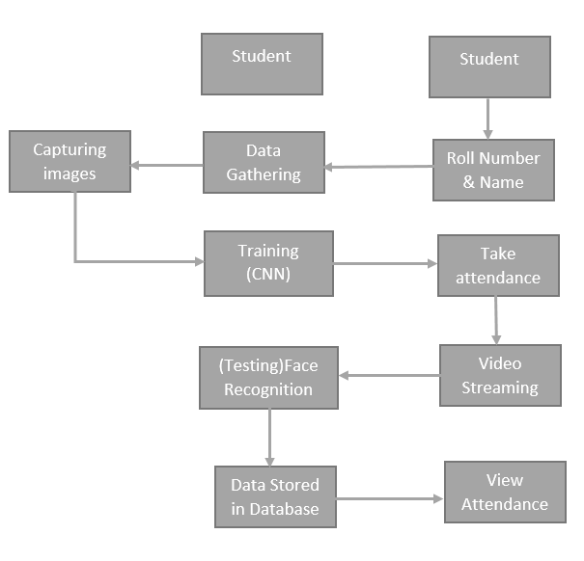

**MODULES**

**System**

**Data Gathering:**

After clicking the capture button the web cam will be opened for taking images and it captures 200 frames, after completion of taking images web cam will be automatically closed.

**Training:**

All captured images are stored into a Trainingimage folder. For training we use LBPHFaceRecognizer_create() method which is used for recognising the face features and we use CNN algorithm for classifying the faces. After training with CNN the model will be saved in to directory.

**Testing and considering the attendance**

Whenever a student made a click on the button provided, a web cam will gets opened.

The web cam has ability to capture the image of the particular students face and then the image is converted into greyscale and it undergoes for scaling

The scaled image is converted into the form of vectors with the help of LBPHFaceRecognizer_create

Now the converted data will be helpful to predict the outcomes.

There are 4 conditions to collect the attendance

1: Before 10AM – Early come 2. After 10AM – Late

3. Before 4PM – Early out 4. After 4PM- Normal out

After checking the conditions data will be stored into MySQL database.

**STUDENT**

**Enter Data:**

After student adding the details like Roll number and Name.

After entering the details student click on the image capture button.

**Take Attendance**

Here student can select the options like take attendance button then only system can access the attendance. After that system stores the information into MYSQL database.

**View Attendance**

After entering the roll number student can view their attendance details of overall present hours in the college.

**Hardware & Software Requirements**

# H/W Configuration:

# Processor - I3/Intel Processor

* Hard Disk -160GB

**S/W Configuration:**

* Operating System : Windows 7/8/10
* IDE : Pycharm
* Server side scripts : HTML, CSS, Js
* Libraries Used : Numpy, CV2,OS, Flask
* Technology : Python 3.6+

**Learning Outcomes**

* Practical exposure to
  + - * Hardware and software tools
      * Solution providing for real time problems
      * Working with team/individual
      * Work on creative ideas
* Testing techniques.
* Error correction mechanisms.
* Scope of Real Time Application Scenarios.
* What is biometrics?
* What type of technology versions is used?
* Implementation of Deep Learning techniques.
* Working of Computer Vision.
* Working of Flask.
* Building of model creations
* Scope of project.
* Applications of the project.
* About Python language.
* About Deep Learning Frameworks.
* Use of Data Science.