🐍 What is Python Programming Language?
Python is a programming language that helps us communicate with a computer and tell it what to do.

What is Python Programming Language? 🐍
Python is a simple, easy-to-learn programming language used to give instructions to a computer.
In simple words, we use Python to tell a computer what to do, such as performing calculations, displaying messages, analyzing data, creating websites, and building Artificial Intelligence (AI) applications.

2. What can we do with Python?
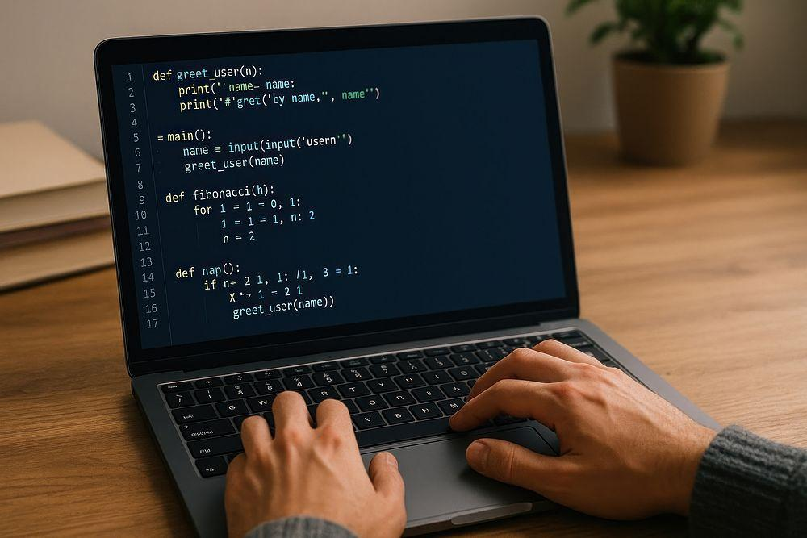
Programming
Write instructions and create useful computer programs.

Data Science
Analyze data, create charts, and discover useful information.
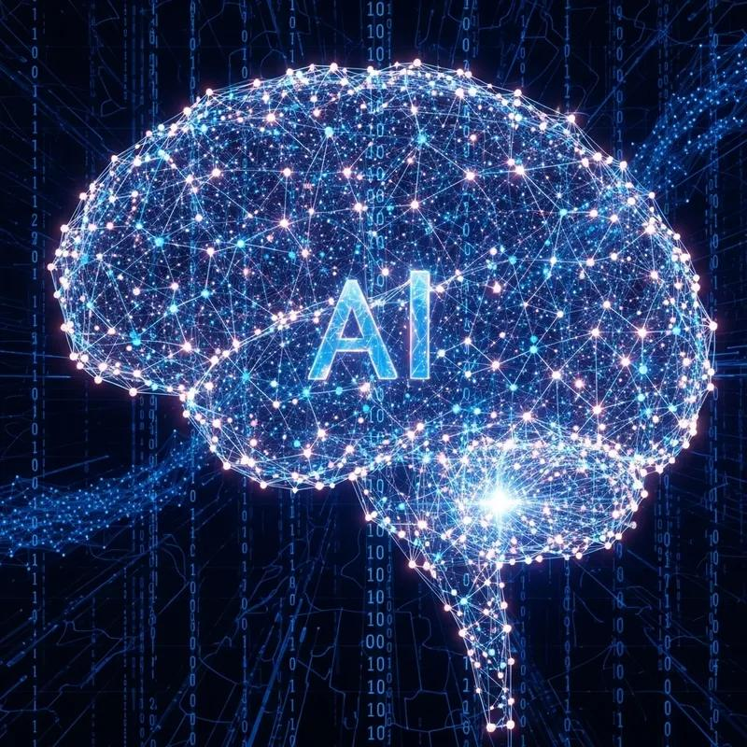
Artificial Intelligence (AI)
Build applications that learn from data and make predictions.
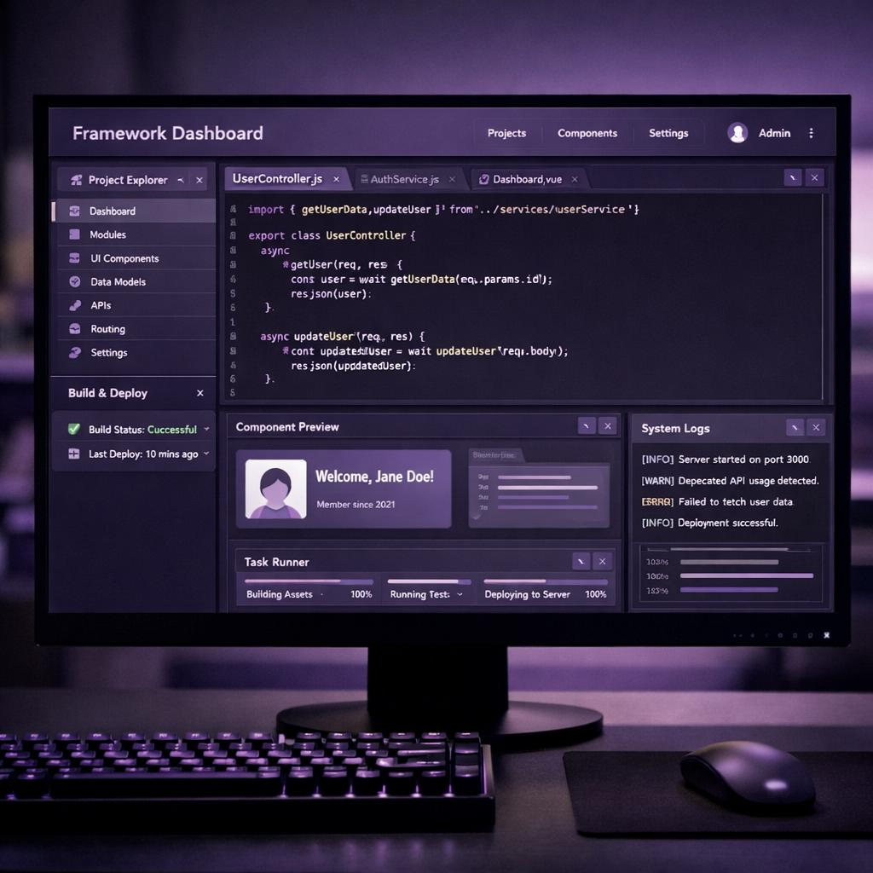
Web Development
Create websites and web applications.

Why is Python popular?
- Easy to learn: Its syntax is similar to simple English.
- Beginner-friendly: You can start without advanced programming knowledge.
- Free to use: Python is open-source.
- Versatile: It is used in data science, AI, automation, and web development.
- Large community: Many tutorials and learning resources are available.

