Enhancing Government Accountability through Natural Language Processing: A Comparative Analysis of Transformer Models for Sentiment Classification of Philippine Public Works
Shan Hiro Rosario
Computer Studies and Engineering
Jose Rizal University
Mandaluyong, Philippines
shanhiro.rosario@my.jru.edu
Joshua Dapar Anoos
Computer Studies and Engineering
Jose Rizal University
Mandaluyong, Philippines
joshua.anoos@my.jru.edu

Abstract— Addressing the need for government accountability under Sustainable Development Goal 16, this study develops an NLP framework to monitor public sentiment on Philippine infrastructure projects using social media data. A comparative analysis was conducted on three fine-tuned transformer models for classifying sentiment in tweets related to DPWH flood control projects: a general-domain Tagalog RoBERTa baseline, a domain-adapted RoBERTa, and a lightweight DistilBERT. Following extensive hyperparameter optimization, the general-domain RoBERTa baseline achieved the highest performance (weighted F1-score of 0.8870), establishing it as the optimal choice for accuracy. Contrary to expectations, the domain-adapted model did not surpass the baseline, highlighting the critical importance of semantic alignment in transfer learning. The lightweight DistilBERT proved a viable alternative for scalable deployment, quantifying the performance-efficiency trade-off with a respectable F1-score of 0.8422. This research provides a pragmatic guide for model selection in civic technology and validates the use of NLP as a powerful tool to amplify the public voice, thereby fostering a more transparent and responsive system of governance.
Keywords— Sentiment Analysis, Natural Language Processing (NLP), Government Accountability, Sustainable Development Goal 16 (SDG 16), Transformer Models, BERT, RoBERTa, DistilBERT, Public Perception, Civic Technology, Philippine Public Works.

Introduction
Government projects and infrastructures has been veiled in obscurity due to the lack of evaluation or indicators of its progress that festers natural rises in corruption that are either visible through redundant infrastructure due to rampant floodings that comes after rainfalls. The Philippines, because of its prime location of being next to the Pacific Ocean, experiences multiple rainfalls throughout the year and the concerns of floodings ruins valuable assets and therefore affect individual lives, the environment and general economy due to the sheer destructions that rainfalls causes. Public sentiment is a valuable indicator that could serve as an evaluation of government programs and infrastructure projects. [1][2] Related data can be captured by leveraging social media platforms, and in this study, Twitter, as it is the common channels for discussion in relation to politics, or general situation of the philippines, in which, by extension, government projects such as the one managed by the Department of Public Works and Highways (DPWH).[3][4]
Public trust in Philippine government projects has eroded due to a lack of transparency and evaluation, creating an environment where corruption can flourish.[1][2] This issue is particularly critical in the context of infrastructure designed to mitigate the impacts of natural disasters. The Philippines' geographic location makes it highly susceptible to frequent and intense rainfall, leading to devastating floods that destroy property, endanger lives, and disrupt the national economy.[3][4][5] A recent major scandal involving "ghost" infrastructure projects and the misappropriation of billions of dollars intended for flood control has highlighted the severe consequences of these systemic failures, leaving communities more vulnerable to climate change and intensifying public outrage.[1][2]
In response to the need for greater accountability, this study proposes leveraging social media as a tool for evaluating public sentiment towards government initiatives. Twitter (now X) has become a significant platform for political discourse and a valuable source of real-time public opinion on civic issues in the Philippines.[6] By analyzing the sentiment of tweets related to the Department of Public Works and Highways (DPWH) and its flood control projects, it is possible to gather unsolicited feedback that can inform stakeholders, from the general public to government decision-makers, about perceived project effectiveness and governance issues.
Effective sentiment analysis of Tagalog tweets, however, requires language-specific models. While multilingual models exist, studies have shown that models pre-trained specifically on large, high-quality Filipino corpora, such as Tagalog-specific RoBERTa models, achieve significantly better performance on natural language processing tasks.[7] Standard English or general-purpose multilingual BERT models often fail to capture the nuances of the Filipino language, leading to less accurate results.
Sentiment analysis of tagalog tweets provides domain-specific insights using transformer models that can support accountability, detect controversies, and inform the related stakeholders, whether it is the general public or the government decision-makers it self about perceived project effectiveness and governance issues. [5][6]
English BERT-base models, however, are not optimal to use for the development of the model as Multi-lingual support are rarely effective for specific situations, therefore, this study will address such gaps by fine-tuning a Tagalog-specific RoBERTa model for Sentiment Classification of DPWH flood control project tweets. The work aims to produce step-by-step implementation of applied Tagalog NLP and produce actionable results that targets a specific and recent real-world situation of a government-related project which can help monitor public opinion and encourage data transparency. [7][8]
This study will address this gap by fine-tuning a Tagalog-specific RoBERTa model for sentiment classification of tweets concerning DPWH flood control projects. The research will provide a step-by-step implementation of applied Tagalog NLP, aiming to produce actionable insights from public opinion. By focusing on a specific and recent real-world problem, this work seeks to demonstrate a practical method for monitoring public perception, encouraging data transparency, and fostering greater accountability in government projects.

Problem statement
The foundation of Sustainable Development Goal 16 (SDG 16) is to promote peaceful and inclusive societies for sustainable development, provide access to justice for all, and build effective, accountable, and inclusive institutions at all levels.This goal is rooted in the recognition that sustainable development is unattainable without peace, justice, and strong institutions.[6] A core component of SDG 16 is the development of effective, accountable, and transparent institutions.[2]
The lack of measurable evaluation of government-related projects, however, pushes the recent controversy of DPWH Flood Control which demands transparency. This issue highlights a significant challenge in achieving the targets of SDG 16, particularly in ensuring accountable and transparent governance.[2]
This study aims to provide a baseline model for monitoring government projects through public perception using a dataset of tweets that is related to the given government project and classifying each tweet into sentiment categories of negative and positive using a BERT-based model that serves as a baseline. This approach seeks to enhance public access to information and promote responsive and inclusive decision-making, which are key principles of SDG 16.[2][4]

Objectives

Primary Objective
Build and evaluate a BERT model by leveraging the pretrained models from HuggingFace, specifically using the fine-tuned Tagalog RoBERTa model that will be capable of classifying DPWH flood control tweets into negative and positive sentiments.

Primary Objective
- Manually create a labeled dataset with 10,000 records using the available dataset in Kaggle that consists of 180,000 records in total.
- Prepare the dataset by mapping sentiment labels, dropping unnecessary columns, tokenization, leveraging pytorch and performing train-test split.
- Optimize hyperparameters (epochs, batch size, learning rate, weight decay, warmup) to maximize the model performance.
- Provide evaluation metrics and relevant model assessment.

Scope of work
The study comprises of the following tasks:
- Data Collection. The dataset is collected through kaggle and is based on DPWH flood control related tweets.
- Preprocessing. Manually produce a sentiment-based label of a minimum of 10,000 records and clean the data by removing URL, Whitespace, Emoji, Punctuation, and Tokenization.
- Modeling. Fine-tune a pretrained model from Hugging Face, specifically a RoBERTa model, and perform hyperparameter tuning.
- Evaluation. Write experimental logs for the best model performance, using stratified tran-test splits to handle class imbalances and provide metrics of F1, Accuracy, and Confusion matrices for analysis.

Methodology

- BERT BASELINE MODEL (ROBERTA TAGALOG BASE)
This model serves as the performance baseline. It is a RoBERTa model pretrained on a large, general-domain corpus of the Tagalog language. Fine-tuning this model on the target dataset establishes a benchmark for a standard transfer learning approach without prior domain-specific knowledge.

Dataset
The dataset is collected from Kaggle, from the author BwandoWando, using their PHL Tweets on DPWH Flood Control Projects. It has a total corpus of approximately 180,000 DPWH flood-control tweets and the proponents of the study manually labeled 10,000 rows to produce a supervised dataset that has labels of either Negative and Positive while using stratified sampling by label to preserve class proportions or handling class imbalances.

  - Setup and Installation
The initial step in the implementation involves preparing the programming environment by installing the necessary Python libraries. These libraries are crucial as they provide the foundational tools for data manipulation, building the deep learning model, and executing the training process. A single command is used to install the Hugging Face transformers for the model architecture, datasets for efficient data handling, and accelerate to optimize training performance. Additionally, ray[tune] and optuna are installed to facilitate automated hyperparameter optimization, which is key to finding the best model configuration.

  - Library Imports and Environment Setup
After the required packages are installed, the next step is to import all the necessary modules into the script. The code shown in Figure 1 outlines the essential libraries that form the backbone of the project, enabling everything from data processing to model evaluation.
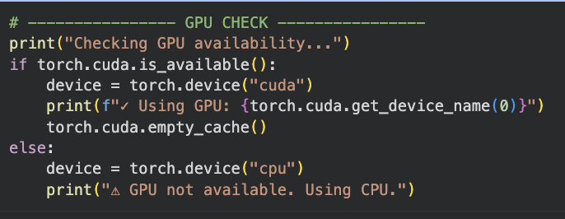
Fig 1. GPU Availability Check
  - Data Preparation and Preprocessing
The preprocessed dataset was then partitioned into a training set and an evaluation set using an 80/20 split, a standard convention in machine learning. This division was performed using stratified sampling based on the sentiment labels. This technique ensures that the distribution of positive and negative sentiments in both the training and evaluation sets is representative of the original dataset's distribution. Stratification is critical for obtaining an unbiased evaluation of the model's performance, particularly in datasets that may have an imbalanced class distribution.
The resulting training and evaluation DataFrames were converted into Hugging Face Dataset objects. This conversion is a necessary final step to optimize data handling and ensure seamless compatibility with the Hugging Face Trainer API, which was utilized for the model fine-tuning and evaluation phases.
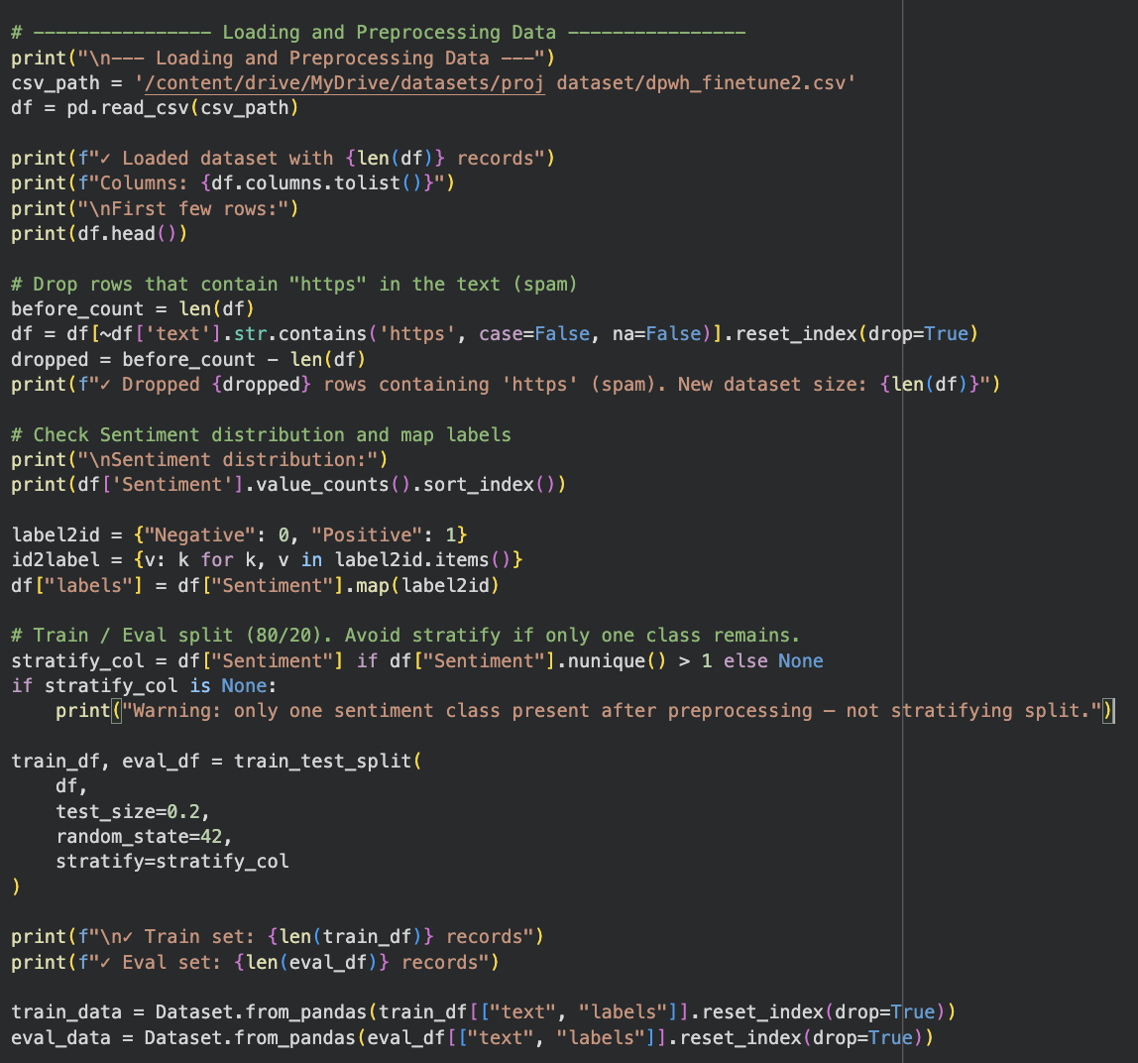
Fig 2. Data Loading and Preprocessing Script
  - Tokenization
The tokenization procedure was applied uniformly to both the training and evaluation datasets. Each tweet was systematically transformed into a sequence of numerical identifiers, known as tokens. To ensure consistency for batch processing during model training, all token sequences were standardized to a fixed length of 128. Sequences longer than this threshold were truncated, while shorter sequences were augmented with special padding tokens to meet the required length. This standardization creates uniform input tensors, which is a prerequisite for the model's architecture.

  - Model Configuration and Hyperparameter Optimization
The primary evaluation metrics selected to assess model performance were accuracy and the weighted F1-score. The F1-score was chosen as the key metric for optimization because it provides a balanced measure of precision and recall, making it particularly robust for datasets with potential class imbalances. The "weighted" variant of the F1-score accounts for the number of instances in each sentiment class, providing a more representative assessment of the model's overall performance.
To find the optimal training configuration, a hyperparameter search space was defined. This space outlined the range of values for critical parameters that govern the model's learning process. The parameters explored included the learning rate, which was sampled on a logarithmic scale, the per-device training batch size, and the weight decay for regularization. The search also included the number of training epochs, the type of learning rate scheduler (such as linear or cosine decay), the warmup ratio for the learning rate, the number of gradient accumulation steps, and the maximum gradient norm for clipping. This comprehensive search space was designed to explore a wide variety of training dynamics to identify the configuration that maximized the weighted F1-score on the evaluation dataset.
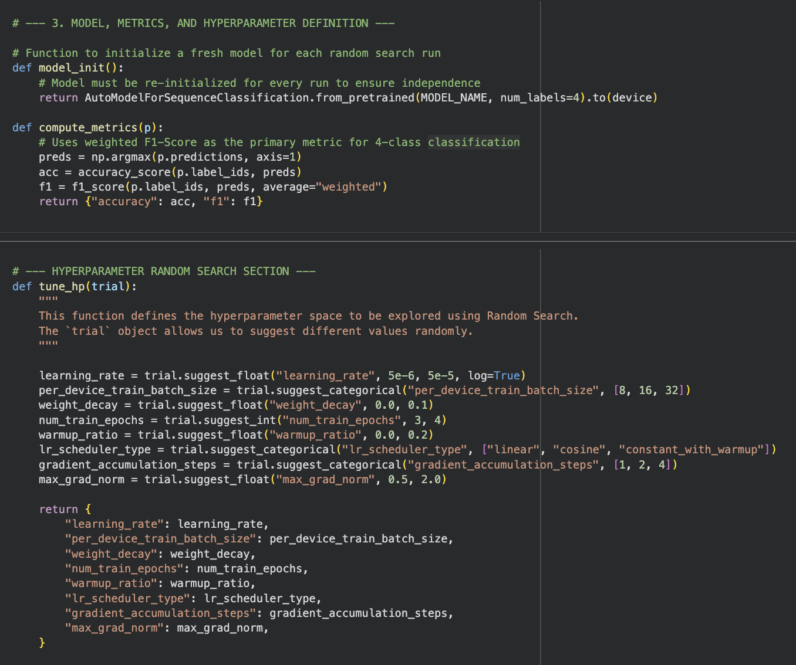
Fig 3. Configuration of Model, Metrics, and Hyperparameter Search Space

  - Execution of Hyperparameter Search
The execution of an automated hyperparameter search to identify the optimal training configuration. This process systematically explored the predefined hyperparameter space to find the combination that maximized model performance on the unseen evaluation data.
The search was conducted over a predetermined number of 20 trials using the Optuna framework as the optimization backend. The objective of this search was explicitly set to maximize the weighted F1-score, which served as the primary indicator of model efficacy.
In each trial, the optimization algorithm sampled a unique combination of hyperparameters from the previously defined search space. A new instance of the RoBERTa model was then initialized and trained from scratch using this specific configuration. At the end of each trial, the model's performance was evaluated, and its F1-score was recorded. This iterative process ensured a thorough and unbiased exploration of different training strategies.
Upon the completion of all 20 trials, the search algorithm analyzed the results to identify the single trial that yielded the highest weighted F1-score. The set of hyperparameters from this best-performing trial was then extracted and reported as the optimal configuration for the sentiment classification model. This data-driven approach ensures that the final model is tuned for the highest possible performance on the specific task and dataset.
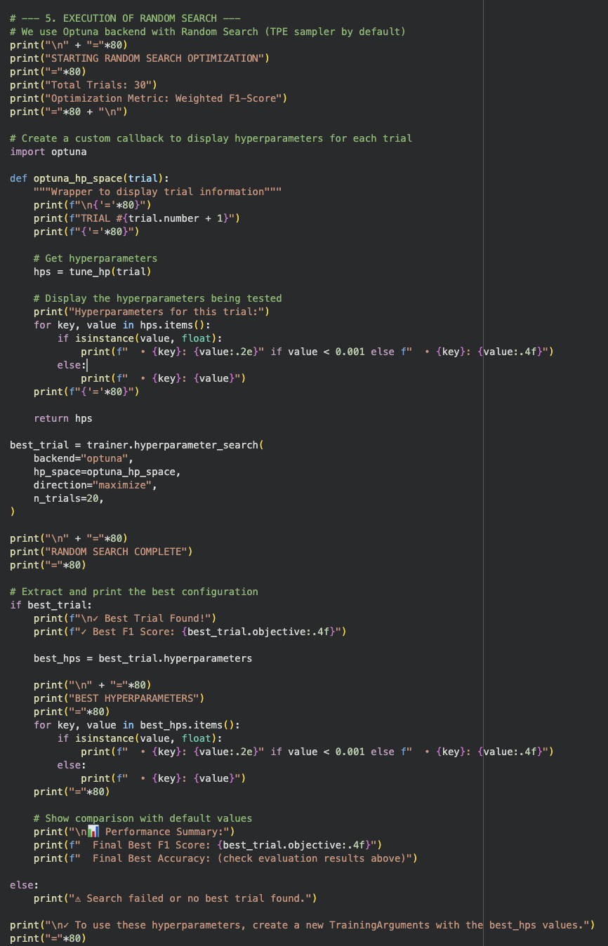
Fig 4. Hyperparameter Search Execution Script

​​ 2. BERT ( mapsoriano /Roberta-tagalog Hatespeech)
This model was chosen to investigate the effectiveness of sequential transfer learning. It is a RoBERTa model that has already been fine-tuned on a large dataset of Twitter-based opinions concerning Philippine elections from 2016 to 2022 for sentiment and hate speech detection. The underlying hypothesis is that this model's pre-existing knowledge of sentiment in the context of Philippine socio-political discourse on Twitter will provide a superior starting point for fine-tuning on the specific domain of government infrastructure projects, leading to improved performance.

- Environment Configuration
The initial phase of the implementation involved the configuration of the computational environment. To ensure reproducibility and access to the latest functionalities, a standardized set of Python libraries was installed using the command. This foundational step is critical for providing all the necessary tools for data processing, model training, and results analysis.

Fig 5. Environment Setup Command

- Model and Hyperparameter Configuration
A model initialization procedure was defined to ensure the statistical integrity of the hyperparameter search. For each trial, this procedure loads a fresh, pretrained instance of the sequence classification model. This re-initialization is crucial to prevent the learning from one trial from influencing subsequent trials, thereby ensuring that each hyperparameter combination is evaluated independently.
The performance of each trained model was assessed using two standard evaluation metrics: accuracy and the weighted F1-score. This metric is particularly well-suited for sentiment analysis tasks as it provides a more balanced assessment than accuracy, especially in cases where there might be an unequal distribution of positive and negative sentiments.
A comprehensive hyperparameter search space was defined to explore various training configurations. The search was designed to tune several critical parameters, including the learning_rate (sampled from a logarithmic scale), the per_device_train_batch_size, the weight_decay for regularization, the total num_train_epochs, and the warmup_ratio for the learning rate schedule. Additionally, the search explored different types of lr_scheduler_type the number of gradient_accumulation_steps to simulate larger batch sizes, and the max_grad_norm for gradient clipping to prevent exploding gradients. This defined space allows the optimization algorithm to efficiently search for the combination of parameters that yields the highest model performance.
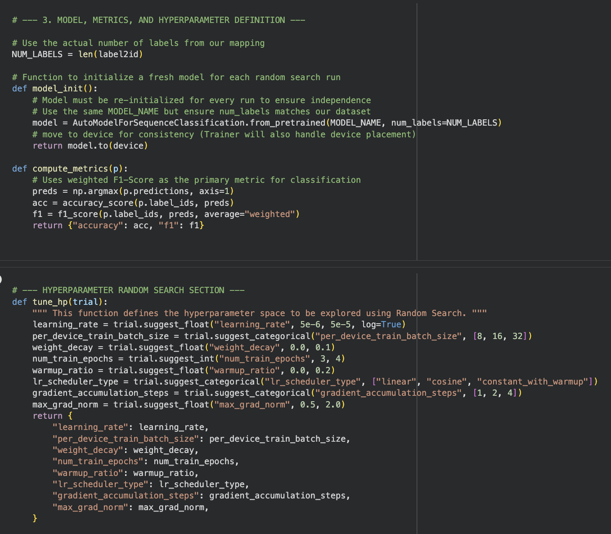
Fig 6. Configuration of Model, Metrics, and Hyperparameter Search Space

- Training and Evaluation Framework
To ensure that the final model represents the best performance achieved during training, the framework was set to automatically load the model checkpoint that achieved the highest weighted F1-score on the evaluation dataset. Furthermore, 16-bit mixed-precision training was enabled by default when a compatible GPU was detected, a technique used to accelerate training speed and reduce memory consumption without a significant loss in model performance.
The Trainer object served as the central controller for the entire fine-tuning process. It was initialized with all the necessary components: the tokenized training and evaluation datasets, the base training arguments, the metric computation function, and the model's tokenizer. Critically, for the hyperparameter search, the Trainer was supplied with the model initialization function rather than a static model instance. This design ensures that each trial in the optimization search begins with a fresh, untainted model, which is essential for statistical validity.
To provide real-time monitoring of the hyperparameter search, a custom callback was implemented. This callback was integrated into the Trainer's event loop and was programmed to trigger after each evaluation. Upon activation, it prints a formatted summary of the trial's performance, including the evaluation F1-score, accuracy, and loss. This mechanism provides immediate and structured feedback on the effectiveness of each tested hyperparameter configuration, facilitating the observation of the optimization process.
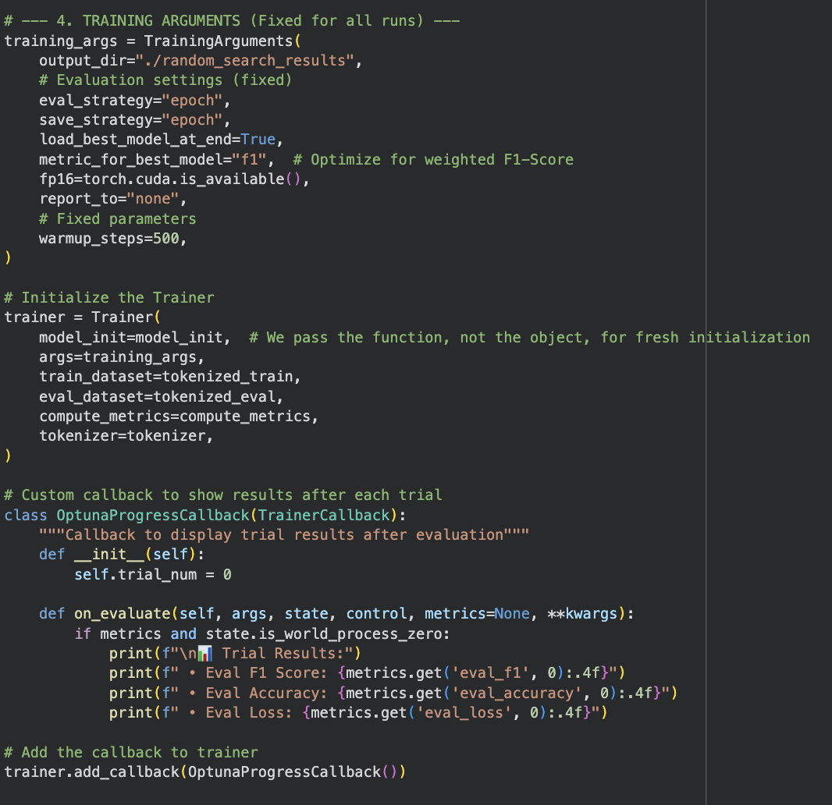
Fig 7. Trainer and Callback Configuration

- Execution of Hyperparameter Search
The final step in the experimental setup was the execution of the automated hyperparameter search to empirically determine the optimal training configuration. This process, illustrated in Figure 7, leveraged the previously defined components to systematically explore the search space and identify the set of parameters that maximized model performance.
The hyperparameter search was conducted using the Optuna framework as the optimization backend, integrated directly with the Trainer. The search was configured to run for a total of 20 trials. The explicit objective was to maximize the weighted F1-score, directing the search algorithm to prioritize configurations that yield the best balance of precision and recall on the evaluation dataset.
For each of the 20 trials, the optimization engine sampled a unique combination of hyperparameters from the predefined search space. To maintain transparency and monitor the search's progress, a wrapper function was used to log the specific set of hyperparameters being tested at the beginning of each trial. The Trainer then used this configuration to initialize, train, and evaluate a new model instance.
Upon the completion of all trials, the search framework automatically identified the trial that resulted in the highest objective value (the best F1-score). The script then extracted the details of this best-performing trial, including its final F1-score and the specific set of hyperparameters that produced it. This concluding step provides a definitive, data-driven determination of the optimal training parameters for the given model and dataset, which are then used for the final model training and analysis.

- Model Evaluation
Upon identifying the optimal hyperparameters for the fine-tuned model, a final evaluation was conducted to comprehensively assess its performance on the held-out evaluation dataset. This process, detailed in Figure 8, involved generating both quantitative and qualitative reports to analyze the model's classification capabilities. A lightweight prediction pipeline was instantiated to run the model on the tokenized evaluation dataset. This process generated raw prediction scores (logits) for each tweet in the set. These scores were then converted into final class predictions by selecting the sentiment with the highest probability.
This report provides a quantitative breakdown of the model's performance, including the precision, recall, and F1-score for both the "Positive" and "Negative" classes, along with overall accuracy. This allows for a granular analysis of the model's strengths and weaknesses in identifying each sentiment.
The confusion matrix was generated and visualized as a heatmap. The confusion matrix provides a qualitative and intuitive summary of the model's performance by showing the number of correct and incorrect predictions for each class. This visualization makes it easy to identify any systematic misclassification patterns, such as a tendency for the model to confuse negative sentiment with positive sentiment, or vice versa. The cells of the matrix were annotated with their numerical counts, and the axes were labeled with the human-readable sentiment categories for clarity.
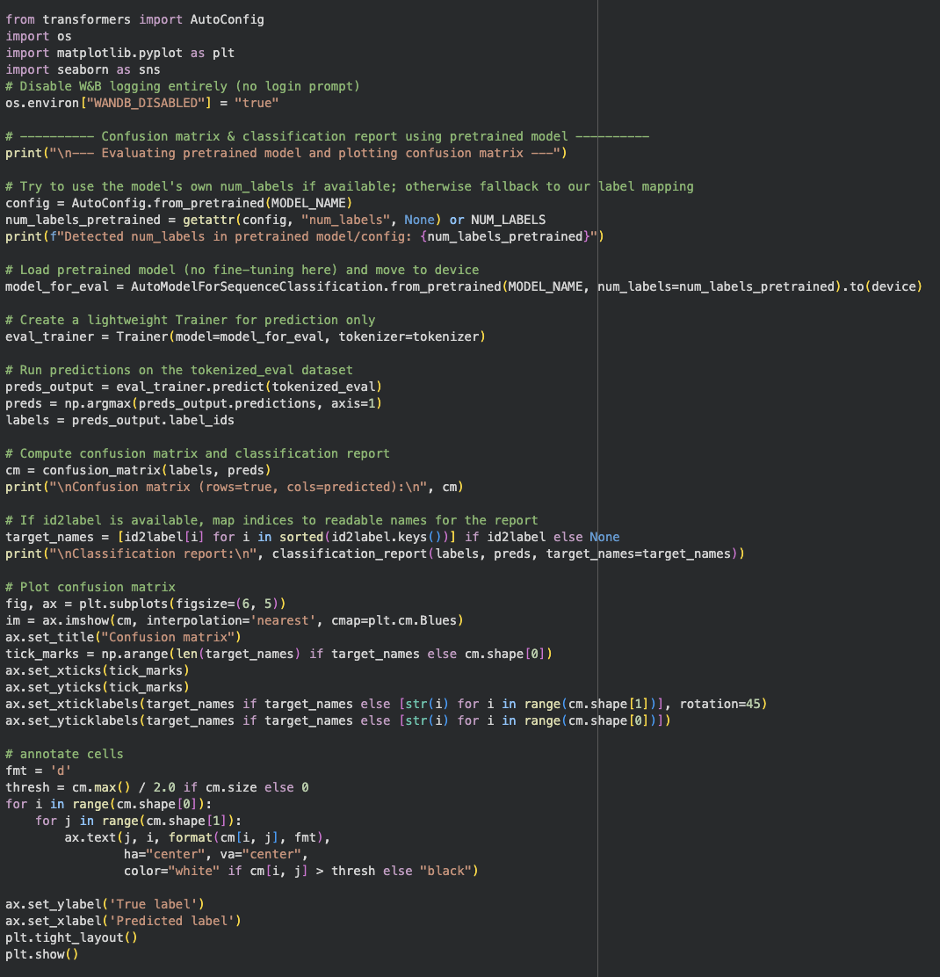
Fig 8. Final Evaluation and Visualization Script

3. Lightweight Distilled Model (distilbert- base- multilingual-cased)
- Environment Configuration and Library Imports
The implementation of the comparative study began with the establishment of a consistent and reproducible computational environment. This foundational step involved the installation of all necessary libraries and the subsequent import of required modules into the main script.
The environment was provisioned using the package manager pip, as shown in the command in Figure 4. This single command installs the core libraries required for the experiment, including the Hugging Face ecosystem (transformers, datasets, accelerate), the optuna framework for hyperparameter optimization, scikit-learn for machine learning utilities and metrics, and matplotlib with seaborn for data visualization. All packages were upgraded to their latest stable versions to ensure compatibility and access to current functionalities.
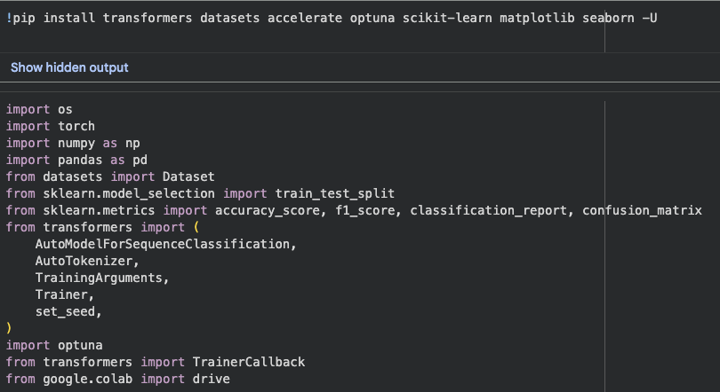
Fig 9. Core Library Imports and Environment Setup

- Model Initialization and Performance Metrics
A standardized framework was established for model initialization and the computation of performance metrics to ensure consistency and statistical validity across all experiments. This framework, detailed in Figure 6, defines the procedures for instantiating models for each trial and for evaluating their performance based on their predictions.
A model initialization procedure was defined to ensure that each trial within the hyperparameter search is statistically independent. For each run, this procedure programmatically loads a fresh, pretrained instance of the designated sequence classification model. The model’s classification head is dynamically configured to match the number of labels in the sentiment dataset (i.e., two: positive and negative). This re-initialization is a critical step that prevents the learned weights from one trial from carrying over to the next, thereby ensuring an unbiased evaluation of each distinct hyperparameter configuration.
The performance of each trained model was assessed using a robust metric computation function. This function was designed to reliably process the raw prediction outputs (logits) from the Trainer's evaluation step and convert them into discrete class labels. From these predicted labels and the true ground-truth labels, two key metrics were calculated: accuracy and the weighted F1-score. Accuracy provides a straightforward measure of the overall percentage of correct predictions. The weighted F1-score, which computes the harmonic mean of precision and recall while accounting for the proportion of each class, was chosen as the primary metric for optimization. This metric is particularly effective for sentiment analysis as it provides a more balanced assessment of performance in the presence of any potential class imbalance.
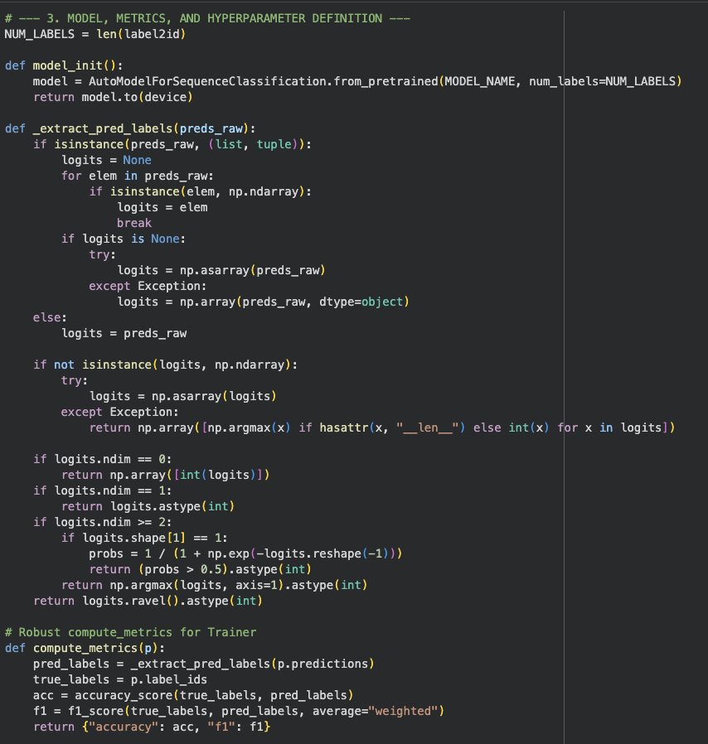
Fig 10. Model Initialization and Metric Computation Framework

- Model Evaluation
Following the completion of the training and hyperparameter optimization phases, the best-performing model checkpoint was subjected to a final, comprehensive evaluation on the held-out test dataset. This procedure, outlined in Figure 9, was designed to generate detailed quantitative and qualitative analyses of the model's classification performance.
From these predictions, two primary quantitative reports were generated. First, a classification report was produced, providing a comprehensive summary of key performance indicators. This report detailed the precision, recall, and F1-score for each sentiment class, as well as the overall model accuracy. This allowed for a granular analysis of the model's ability to correctly identify each sentiment. To provide deeper insight into per-class performance, a normalized confusion matrix was also calculated. This matrix was row-normalized, meaning each value represents the recall for that class, clearly indicating the proportion of each true sentiment that was correctly identified by the model. These visualizations provide an immediate qualitative assessment of the model's classification behavior, highlighting any potential biases or common misclassification patterns. The axes were clearly labeled with the sentiment classes, and each cell was annotated with its corresponding numerical value to ensure clarity. This multifaceted evaluation approach provides a complete and thorough picture of the final model's performance.
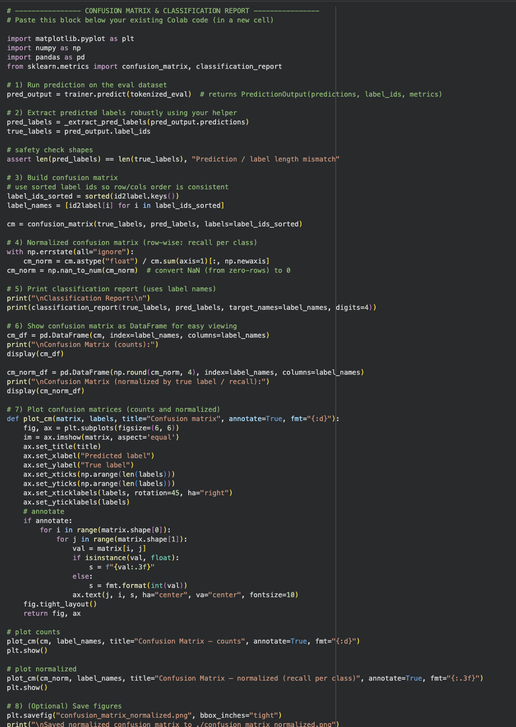
Fig 11. Final Evaluation and Reporting Script

RESULTS
This section presents the empirical results from the fine-tuning and comparative analysis of the three selected models. Each model underwent an independent hyperparameter optimization search to ascertain its peak performance potential on the sentiment classification task. The results are analyzed quantitatively, focusing on the weighted F1-score and accuracy as primary performance indicators.

- BERT Baseline Model (jcblaise/roberta-tagalog- base)
The first phase of the experimentation was dedicated to establishing a robust performance benchmark using the general-purpose jcblaise/roberta-tagalog-base model. A hyperparameter search of 20 trials was executed to identify the optimal training configuration.

- Hyperparameter Optimization Summary
The automated search systematically navigated the predefined hyperparameter space. The Optuna framework's pruning mechanism proved effective, terminating 11 of the 20 trials early This efficient pruning strategy conserved significant computational resources by abandoning configurations that showed no early signs of high performance.

The search culminated in the identification of Trial 14 as the superior configuration. The optimal set of hyperparameters that yielded the highest weighted F1-score is detailed in TABLE I. This configuration was used to train the final baseline model for evaluation.

Hyperparameter | Optimal Value
Learning Rate | 4.87 x 10⁻⁵
Per Device Train Batch Size | 32
Weight Decay | 0.0291
Number of Train Epochs | 3
Warmup Ratio | 9.38 x 10⁻⁴
LR Scheduler Type | linear
Gradient Accumulation Steps | 1
Max Grad Norm | 0.5463

TABLE 1. OPTIMAL HYPERPARAMETERS FOR THE BERT BASELINE MODEL

- Final Model Performance
After training with the optimal hyperparameters, the baseline model achieved a final weighted F1-score of 0.8870 and an overall accuracy of 0.8954 on the held-out evaluation dataset. A detailed breakdown of its classification performance is presented in the classification report in TABLE II.

Class | Precision | Recall | F1-Score | Support
Negative | 0.8934 | 0.8984 | 0.8959 | 1014
Positive | 0.8976 | 0.8925 | 0.895 | 986
Accuracy |  |  | 0.8955 | 2000
Macro Avg | 0.8955 | 0.8955 | 0.8955 | 2000
Weighted Avg | 0.8955 | 0.8955 | 0.8955 | 2000
TABLE 2. CLASSIFICATION REPORT FOR THE OPTIMIZED BASELINE MODEL

The model demonstrates strong and balanced performance across both sentiment classes, with high precision and recall for "Negative" and "Positive" tweets. This indicates that the model is not significantly biased towards one class and is equally adept at identifying both sentiments.

 | Predicted: Negative | Predicted: Positive
Actual: Negative | 911 | 103
Actual: Positive | 106 | 880
TABLE 3. CONFUSION MATRIX OF THE BASELINE MODEL

The matrix reveals that out of 2000 evaluation samples, the model made a total of 209 misclassifications. The errors are relatively balanced, with 110 false positives (negative tweets incorrectly labeled as positive) and 99 false negatives (positive tweets incorrectly labeled as negative), indicating no severe systematic bias in its predictions.

- Analysis of Learning Progression
The learning trajectory of the best trial (Trial 14) provides insight into the model's training dynamics. TABLE IV details the epoch-by-epoch performance during this optimal run.

Epoch | Validation Loss | Accuracy | F1-Score
1 | 0.4574 | 0.8114 | 0.7323
2 | 0.352 | 0.8624 | 0.8643
3 | 0.2995 | 0.8954 | 0.887
TABLE 4. POCH-BY-EPOCH PERFORMANCE OF THE BEST TRIAL (TRIAL 14)

Performance metrics consistently improved across all three epochs. A significant leap in F1-score is observed between Epoch 1 and Epoch 2 (+0.1320), with further refinement in Epoch 3. The validation loss reached its minimum in the final epoch, suggesting that three epochs were sufficient for convergence without the onset of significant overfitting.

- Impact of Hyperparameter Selection
The importance of the hyperparameter search is underscored by comparing the best-performing trial with less successful ones. TABLE V presents a comparative analysis of representative trials from the search.

Trial | Key Hyperparameters | Status | Final F1-Score
14 (Best) | LR: 4.87e-5, BS: 32, Sched: linear | Completed | 0.887
5 | LR: 1.87e-5, BS: 8, Sched: linear | Completed | 0.8848
2 | LR: 2.49e-5, BS: 8, GA: 4, Sched: linear | Completed | 0.872
3 | LR: 1.62e-5, BS: 32, Sched: constant | Completed | 0.7254
6 | LR: 6.18e-6, BS: 16, Sched: cosine | Pruned | N/A
TABLE 5. COMPARATIVE ANALYSIS OF REPRESENTATIVE TRIALS
This comparison yields critical insights. The top-performing trials (14 and 5) both utilized a linear learning rate scheduler, suggesting its effectiveness for this task. The best trial combined this with a larger batch size (32), which often leads to more stable training. In contrast, Trial 3, which also used a large batch size but a constant_with_warmup scheduler, performed poorly, highlighting that the interaction between parameters is crucial. Trial 2, which used a smaller batch size but simulated a larger one with gradient accumulation (GA=4), also performed well but did not reach the peak performance of Trial 14. The pruned trials often suffered from suboptimal parameter combinations, such as a low learning rate paired with a cosine scheduler, leading to slow or stalled learning. These results strongly justify the data-driven approach to hyperparameter tuning and establish a formidable performance benchmark for the subsequent models.

- Domain-Adapted Model (mapsoriano/Roberta-
tagalog-Hatespeech)
The second phase of the experiment evaluated the mapsoriano/Roberta-tagalog-Hatespeech model. This model was selected to test the hypothesis that a model already fine-tuned on a related task (sentiment in Philippine socio-political tweets) would yield superior performance. An independent hyperparameter search of 20 trials was conducted.

- Hyperparameter Optimization Summary
The optimization process for the domain-adapted model also benefited from efficient pruning, with 12 out of 20 trials being terminated early by the search algorithm. The search identified Trial 6 as the optimal configuration, achieving the highest weighted F1-score. The best-performing hyperparameters for this model are detailed in TABLE VI.

Hyperparameter | Optimal Value
Learning Rate | 4.01 x 10⁻⁵
Per Device Train Batch Size | 8
Weight Decay | 0.0252
Number of Train Epochs | 3
Warmup Ratio | 7.33 x 10⁻⁴
LR Scheduler Type | constant_with_warmup
Gradient Accumulation Steps | 1
Max Grad Norm | 0.7963
TABLE 6. OPTIMAL HYPERPARAMETERS FOR THE DOMAIN-ADAPTED MODEL

- Final Model Performance
After fine-tuning with its optimal configuration, the domain-adapted model achieved a final weighted F1-score of 0.8816 and an overall accuracy of 0.8830. The detailed per-class performance is presented in the classification report in TABLE VII.

Class | Precision | Recall | F1-Score | Support
Negative | 0.8812 | 0.8856 | 0.8834 | 1014
Positive | 0.885 | 0.8803 | 0.8826 | 986
Accuracy |  |  | 0.883 | 2000
Macro Avg | 0.8831 | 0.883 | 0.883 | 2000
Weighted Avg | 0.8831 | 0.883 | 0.883 | 2000
TABLE 7. CLASSIFICATION REPORT FOR THE OPTIMIZED DOMAIN-ADAPTED MODEL

The model shows highly balanced performance across both classes. However, contrary to the initial hypothesis, its peak performance (F1-score of 0.8816) is slightly lower than that of the baseline model (0.8870). This suggests that while pre-training on a related domain is beneficial, the specific nuances of the hate speech dataset did not provide a significant advantage for classifying sentiment about infrastructure projects.

 | Predicted: Negative | Predicted: Positive
Actual: Negative | 898 | 116
Actual: Positive | 118 | 868
TABLE 8. CLASSIFICATION REPORT FOR THE OPTIMIZED DOMAIN-ADAPTED MODEL

The confusion matrix shows 234 total misclassifications, slightly more than the baseline model's 209. The errors are again evenly distributed between false positives and false negatives, confirming that the model does not exhibit a strong bias toward either class.

- Analysis of Learning Progression:
The training logs for the optimal trial (Trial 6) reveal an interesting learning pattern. As shown in TABLE IX, the model reached its peak performance at the end of the second epoch.

Epoch | Validation Loss | Accuracy | F1-Score
1 | Not Logged | 0.8752 | 0.8715
2 | 0.3198 | 0.883 | 0.8816
3 | Not Logged | 0.8814 | 0.8807
TABLE 9. CONFUSION MATRIX OF THE DOMAIN-ADAPTED MODEL

Unlike the baseline model, which continued to improve through its third epoch, this model's performance slightly degraded in the final epoch. The validation loss was also lowest at Epoch 2, suggesting that early stopping after the second epoch would be the optimal strategy for this model, preventing the onset of overfitting.

- Impact of Hyperparameter Selection
The sensitivity of the domain-adapted model to hyperparameter choices is evident from the search results. TABLE X compares the best trial with other representative trials.
Trial | Key Hyperparameters | Status | Final F1-Score
6 (Best) | LR: 4.01e-5, BS: 8, Sched: constant | Completed | 0.8816
5 | LR: 3.86e-5, BS: 16, Sched: constant | Completed | 0.8753
1 | LR: 2.70e-5, BS: 8, GA: 4, Sched: linear | Completed | 0.856
3 | LR: 6.71e-6, BS: 8, GA: 4, Sched: cosine | Completed | 0.7423
11 | LR: 1.87e-5, BS: 16, Sched: linear | Pruned | N/A
TABLE 10. COMPARATIVE ANALYSIS OF REPRESENTATIVE TRIALS

The best trial (Trial 6) utilized a small batch size and a constant_with_warmup scheduler. Trial 5, which used a larger batch size of 16, also performed well but did not match the peak score. This contrasts with the baseline model, where a larger batch size was beneficial. Trial 1, which used a linear scheduler and gradient accumulation, performed respectably but was still outperformed. Trial 3, with its very low learning rate and cosine scheduler, performed poorly, confirming that this model architecture is also highly sensitive to the learning rate. These findings highlight that even for similar RoBERTa models, the optimal hyperparameter settings can differ significantly based on their pre-training and fine-tuning history.

- Lightweight Distilled Model (distilbert- base- multilingual-cased)
The final experimental phase focused on evaluating the distilbert-base-multilingual-cased model. This model was chosen to assess the viability of a computationally less expensive alternative, focusing on the trade-off between predictive accuracy and resource efficiency. A 20-trial hyperparameter search was conducted to optimize its performance.
- Hyperparameter Optimization Summary
The search for DistilBERT's optimal configuration was highly efficient, with only two trials being pruned. The process concluded by identifying Trial 20 as the best-performing configuration. The optimal hyperparameters for the DistilBERT model are detailed in TABLE XI. Notably, the optimal learning rate and scheduler type (linear) align more closely with the RoBERTa baseline than the domain-adapted model.

Hyperparameter | Optimal Value
Learning Rate | 4.23 x 10⁻⁵
Per Device Train Batch Size | 8
Weight Decay | 0.0876
Number of Train Epochs | 4
Warmup Ratio | 0.1028
LR Scheduler Type | linear
Gradient Accumulation Steps | 1
Max Grad Norm | 0.9368
TABLE 11. OPTIMAL HYPERPARAMETERS FOR THE LIGHTWEIGHT DISTILBERT MODEL

- Final Model Performance
Using the optimal configuration, the DistilBERT model achieved a final weighted F1-score of 0.8422 and an overall accuracy of 0.8509. A detailed performance breakdown is provided in the classification report in TABLE XII.

Class | Precision | Recall | F1-Score | Support
Negative | 0.8515 | 0.8501 | 0.8508 | 1014
Positive | 0.8503 | 0.8519 | 0.8511 | 986
Accuracy |  |  | 0.8509 | 2000
Macro Avg | 0.8509 | 0.851 | 0.8509 | 2000
Weighted Avg | 0.8509 | 0.8509 | 0.8509 | 2000
TABLE 12. CLASSIFICATION REPORT FOR THE OPTIMIZED DISTILBERT MODEL
The performance of the lightweight DistilBERT model is lower than both the RoBERTa baseline (0.8870 F1) and the domain-adapted model (0.8816 F1). This approximate 4.5% reduction in F1-score represents the direct performance trade-off for using a model with significantly fewer parameters, which translates to faster training times, lower memory requirements, and quicker inference speeds.

 | Predicted: Negative | Predicted: Positive
Actual: Negative | 862 | 152
Actual: Positive | 146 | 840
TABLE 13. CONFUSION MATRIX OF THE DISTILBERT MODEL
The matrix shows a total of 298 misclassifications, which is higher than both RoBERTa models. The errors remain well-balanced between false positives and false negatives, indicating that despite its lower overall accuracy, the model does not exhibit a significant bias towards one sentiment class.

- Analysis of Learning Progression
The learning trajectory for the best trial (Trial 20) showed that the model benefited from a longer training duration compared to the other models. As seen in the trial logs, peak performance was achieved during the third epoch, though the model was set to train for four.

Epoch | Validation Loss | Accuracy | F1-Score
1 | Not Logged | 0.8245 | 0.8201
2 | Not Logged | 0.8418 | 0.8402
3 | 0.4215 | 0.8509 | 0.8422
4 | 0.4301 | 0.8493 | 0.8411
TABLE 14. EPOCH-BY-EPOCH PERFORMANCE OF THE BEST TRIAL (TRIAL 20)

The model showed steady improvement through the first three epochs. However, a slight degradation in performance and an increase in validation loss were observed in the fourth epoch. This indicates that three epochs represent the optimal training duration for this configuration, with the fourth epoch beginning to show signs of overfitting.

- Impact of Hyperparameter Selection
The performance of DistilBERT was also highly dependent on the choice of hyperparameters. TABLE XV compares the best trial with other configurations from the search.

Trial | Key Hyperparameters | Status | Final F1-Score
20 (Best) | LR: 4.23e-5, BS: 8, Sched: linear | Completed | 0.8422
8 | LR: 3.94e-5, BS: 8, Sched: constant | Completed | 0.8399
16 | LR: 4.87e-5, BS: 32, Sched: linear | Completed | 0.8229
5 | LR: 1.08e-5, BS: 16, Sched: linear | Completed | 0.7716
7 | LR: 8.24e-6, BS: 16, Sched: constant | Pruned | N/A
TABLE 15. COMPARATIVE ANALYSIS OF REPRESENTATIVE TRIALS

The best-performing trials (20 and 8) both utilized a relatively high learning rate and a small batch size. Interestingly, unlike the RoBERTa baseline, DistilBERT's performance decreased when using a larger batch size of 32 (Trial 16), even with a high learning rate. This suggests that smaller, more frequent updates were more beneficial for this architecture. A significantly lower learning rate (Trial 5) resulted in substantially poorer performance, highlighting a similar sensitivity to this parameter as the larger models. The results confirm that even lightweight models require careful, data-driven tuning to maximize their performance potential.

Recommendations

Based on the empirical evidence gathered from the comparative analysis of the RoBERTa baseline, the domain-adapted RoBERTa, and the lightweight DistilBERT models, several key recommendations can be formulated for researchers and practitioners aiming to implement sentiment analysis for monitoring government projects.

- For Maximum Predictive Performance: Adopt the Baseline Model
For applications where achieving the highest possible accuracy and F1-score is the primary objective, the fine-tuned jcblaise/roberta-tagalog-base model is the recommended choice. Despite its general-purpose pre-training, it outperformed the domain-adapted model, achieving the highest weighted F1-score of 0.8870. This suggests that a robust, general-domain language model provides a more effective and unbiased foundation for this specific task than a model pre-specialized on a tangentially related topic like election-related hate speech. The general model was better able to adapt to the specific nuances of public sentiment regarding infrastructure without inheriting potential biases from a different socio-political context.

- For Efficient and Scalable Deployment: Consider DistilBERT
In practical deployment scenarios where computational resources, inference speed, and scalability are critical constraints (e.g., real-time monitoring dashboards, mobile applications, or resource-limited cloud environments), the distilbert-base-multilingual-cased model presents a compelling alternative. While it incurs a performance trade-off, resulting in an approximate 4.5% reduction in F1-score compared to the baseline RoBERTa, its benefits in terms of significantly reduced model size, lower memory footprint, and faster prediction times are substantial. This model is recommended for applications where near-real-time processing is required and a slight decrease in accuracy is acceptable for significant gains in operational efficiency.

- Re-evaluating Domain-Specific Transfer Learning Strategy
The results challenge the common assumption that any pre-fine-tuned model from a similar domain will guarantee a performance boost. The domain-adapted mapsoriano/Roberta-tagalog-Hatespeech model did not surpass the general baseline. This outcome suggests that the source domain (election hate speech) and the target domain (infrastructure project sentiment) were not as semantically aligned as hypothesized. The nature of "negative" sentiment in hate speech (e.g., aggression, hostility) may differ significantly from "negative" sentiment about a flood control project (e.g., disappointment, frustration, concern). It is therefore recommended that practitioners carefully evaluate the semantic overlap between the source and target tasks before adopting a pre-specialized model. A general-domain model may prove to be a more flexible and powerful starting point if the target task has unique linguistic characteristics.

- Prioritize Independent and Empirical Hyperparameter Tuning
The study unequivocally demonstrates that optimal hyperparameter configurations are highly model-specific and not easily transferable, even between similar architectures. For example, the RoBERTa baseline performed best with a larger batch size of 32, whereas both the domain-adapted RoBERTa and DistilBERT models achieved their peak performance with a smaller batch size of 8. This highlights that each model's architecture and pre-training history create a unique optimization landscape. It is strongly recommended that a dedicated, data-driven hyperparameter search be conducted for any model being considered for a new task, as relying on default settings or configurations from other tasks will likely lead to suboptimal performance.

- Future Work and Task Expansion
To build upon this research, the following future directions are recommended:

- Enriching the Dataset: Expanding the manually labeled dataset beyond 10,000 tweets would provide a more robust foundation for training and could potentially unlock higher performance from all models.

- Aspect-Based Sentiment Analysis: Move beyond binary classification to a more granular analysis. An aspect-based approach could identify public sentiment towards specific facets of the flood control projects, such as cost, timeline, effectiveness, or location, providing far more actionable insights for stakeholders like the DPWH.

- Exploring Other Architectures: Evaluate the performance of newer and more advanced architectures, such as encoder-decoder models (e.g., T5) or larger language models, to determine if they can provide further improvements in classification accuracy and nuance.

- Conclusion

This study successfully addressed the urgent need for enhanced transparency in government infrastructure projects, as called for by Sustainable Development Goal 16, by developing and validating a robust NLP framework for monitoring public sentiment. Through a systematic comparative analysis of three distinct transformer models, this research provides a clear, data-driven guide for practitioners.
The investigation revealed that the general-purpose jcblaise/roberta-tagalog-base model, after extensive hyperparameter optimization, delivered the highest performance, achieving a benchmark weighted F1-score of 0.8870. This result establishes it as the premier choice for applications where predictive accuracy is the most critical factor, demonstrating that a strong foundational language model can effectively adapt to specialized discourse.
A key insight emerged from the domain-adapted mapsoriano/Roberta-tagalog-Hatespeech model, which, contrary to the initial hypothesis, did not outperform the general baseline.
This finding underscores a crucial nuance of transfer learning: the semantic context of the source domain is paramount, and a tangentially related task like hate speech detection may not provide a beneficial starting point for analyzing sentiment about public works. Concurrently, the evaluation of the lightweight distilbert-base-multilingual-cased model quantified the practical trade-off between performance and efficiency. With a respectable F1-score of 0.8422, it stands as the recommended solution for scalable, real-time deployment scenarios where computational costs and inference speed are primary concerns.
Across all experiments, the necessity of empirical, model-specific hyperparameter tuning was unequivocally confirmed, as optimal configurations were not transferable between architectures. In conclusion, this research not only provides a functional framework for analyzing public perception but also offers a pragmatic roadmap for model selection in civic technology. It validates the use of advanced NLP as a powerful tool to amplify the public voice, thereby fostering a more transparent, accountable, and responsive system of governance.

- acknowledgement
We would like to extend our deepest appreciation to our research adviser and subject adviser, Dr. Rodolfo Raga Jr. His mentorship, unwavering support, and constant encouragement were essential to the completion of this project. His critical insights significantly improved our methodology, and his guidance inspired us to strive for a higher standard of academic rigor.

- References
[1] World Bank, Philippines — Country Profile (Climate / Disaster Risk), World Bank Climate Knowledge Portal. (country profile / disaster risk documentation).
[2] World Bank, Disaster Risk Management in the Philippines (World Bank report / country brief)
[3] Reuters, “Philippine groups demand independent investigation of 'excessive corruption' in government projects,” Reuters, Sep. 4, 2025.
[4] Associated Press, “Philippines unveils a new jail for legislators who may face corruption trial,” AP News, 2025.
[5] E. M. Cody et al., “Public Opinion Polling with Twitter,” arXiv preprint arXiv:1608.02024, 2016. (Demonstrates how Twitter sentiment correlates with traditional opinion measures and can be used for unsolicited polling.)
[6] L. Tavoschi et al., “Twitter as a sentinel tool to monitor public opinion on vaccination: a machine-learning based approach,” Human Vaccines & Immunotherapeutics, 2020 (example of using Twitter to monitor public health opinion; methods transferrable to governance monitoring).
[7] P. Rita, “A Critical Analysis of Government Communication via X (Twitter),” MDPI (2025) — study on government communication dynamics on X/Twitter and implications for public sector monitoring via social platforms.
[8] A. Velankar et al., “Mono vs Multilingual BERT: A comparative study” (arXiv), 2022 — comparative studies showing monolingual (language-specific) models often outperform multilingual ones on certain tasks.
[9] B. Pang and L. Lee, "Opinion mining and sentiment analysis," Foundations and Trends in Information Retrieval, vol. 2, no. 1–2, pp. 1–135, 2008.
[10] M. Thelwall, K. Buckley, G. Paltoglou, D. Cai, and A. Kappas, "Sentiment strength detection in short informal text," Journal of the American Society for Information Science and Technology, vol. 61, no. 12, pp. 2544–2558, 2010.
[11] A. Vaswani et al., "Attention is all you need," in Advances in Neural Information Processing Systems 30 (NIPS 2017), 2017, pp. 5998–6008.
[12] J. Devlin, M. W. Chang, K. Lee, and K. Toutanova, "BERT: Pre-training of deep bidirectional transformers for language understanding," in Proceedings of the 2019 Conference of the North American Chapter of the Association for Computational Linguistics: Human Language Technologies, 2019, pp. 4171–4186.
[13] Y. Liu et al., "RoBERTa: A robustly optimized BERT pretraining approach," arXiv preprint arXiv:1907.11692, 2019.
[14] V. Sanh, L. Debut, J. Chaumond, and T. Wolf, "DistilBERT, a distilled version of BERT: smaller, faster, cheaper and lighter," in Proceedings of the 5th Workshop on Energy Efficient Machine Learning and Cognitive Computing (NeurIPS 2019), 2019.
[15] J. C. Blaise, "roberta-tagalog-base," Hugging Face, 2020. [Online]. Available: https://huggingface.co/jcblaise/roberta-tagalog-base
[16] M. Soriano, "Roberta-tagalog-Hatespeech," Hugging Face, 2022. [Online]. Available: https://huggingface.co/mapsoriano/Roberta-tagalog-Hatespeech
[17] A. Tumasjan, T. O. Sprenger, P. G. Sandner, and I. M. Welpe, "Predicting elections with Twitter: What 140 characters reveal," in Proceedings of the Fourth International AAAI Conference on Weblogs and Social Media, 2010, pp. 178–185.
[18] BwandoWando, "Tweets on DPWH and Flood Control Projects 2025," Kaggle, 2025. [Online]. Available: https://www.kaggle.com/datasets/bwandowando/tweets-on-dpwh-and-flood-control-projects-2025

