#Note-In all the methods mentioned (only) in this file, the variable
#passed as a parameter can be not only a set but also any collection
#like list, tuple, dictionary.
#***If it is a dictionary then only the keys are taken into
#consideration***.

#1) union() - ye aapko ek naya set dega, jisme diye gaye dono
#set ke saare elements honge(without repitition)

cities = {"Tokyo", "Madrid", "Berlin", "Delhi"} . . .(A)
cities2 = {"Tokyo", "Seoul", "Kabul", "Madrid"} . . .(B)
cities3 = cities.union(cities2) . . . . . . . . .(C$=$A $∪$ B)
print(cities3)

Output:
{'Berlin', 'Madrid', 'Kabul', 'Seoul', 'Delhi', 'Tokyo'}

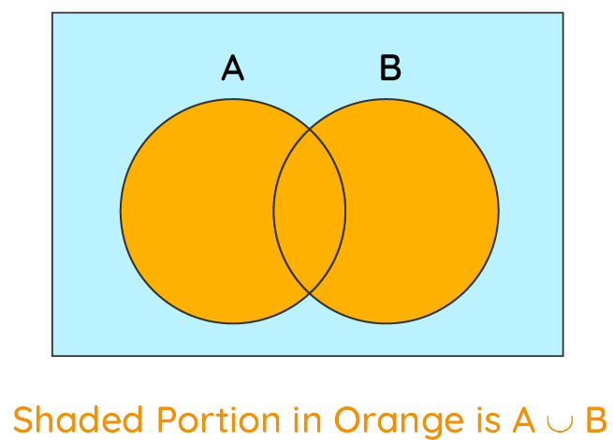

#2) update() - it will add all the elements of the set passed
#as the parameter in the set on which the operation is carried out

cities = {"Tokyo", "Madrid", "Berlin", "Delhi"}
cities2 = {"Tokyo", "Seoul", "Kabul", "Madrid"}
cities.update(cities2). . . . . . . . . . . . . .(A$=$A$∩$B)
print(cities)

Output:
{'Berlin', 'Madrid', 'Kabul', 'Seoul', 'Delhi', 'Tokyo'}

#3) intersection() and intersection_update() -
#intersection will give you a new set having the elements
#common in both the given sets

#intersection_update() works similar to update()

cities = {"Tokyo", "Madrid", "Berlin", "Delhi"}
cities2 = {"Tokyo", "Seoul", "Kabul", "Madrid"}
cities3 = cities.intersection(cities2) . . . . . . .(C$=$A $∩$ B)
print(cities3)

Output:
{'Madrid', 'Tokyo'}

cities = {"Tokyo", "Madrid", "Berlin", "Delhi"}
cities2 = {"Tokyo", "Seoul", "Kabul", "Madrid"}
cities.intersection_update(cities2)
print(cities)

Output:
{'Madrid', 'Tokyo'}

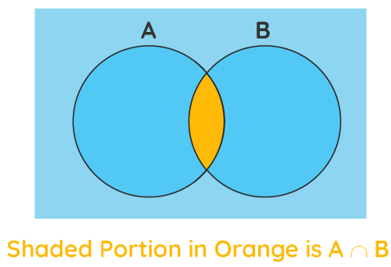

#4)symmetric_difference() and symmetric_difference_update(): -
# symmetric_difference() gives you a new set having only
# those elements which are not common in the given two sets

cities = {"Tokyo", "Madrid", "Berlin", "Delhi"}
cities2 = {"Tokyo", "Seoul", "Kabul", "Madrid"}
cities3 = cities.symmetric_difference(cities2) ...( C$=[$A $∪$ B] – [A$∩$B])
print(cities3)

Output:
{'Berlin', 'Delhi', 'Kabul', 'Seoul'}

cities = {"Tokyo", "Madrid", "Berlin", "Delhi"}
cities2 = {"Tokyo", "Seoul", "Kabul", "Madrid"}
cities.symmetric_difference_update(cities2)
print(cities)

Output:
{'Berlin', 'Delhi', 'Kabul', 'Seoul'}

SYMMETRIC DIFFERENCE ( A$∆$B )

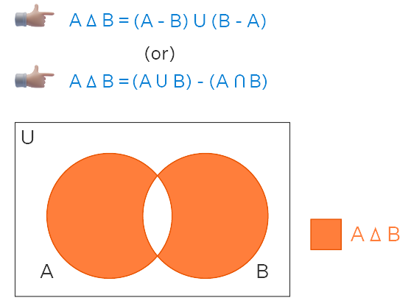

#5)difference() and difference_update(): -
#gives you a new set having items that are only present in
#the original set and not in both the sets.

cities = {"Tokyo", "Madrid", "Berlin", "Delhi"}
cities2 = {"Seoul", "Kabul", "Delhi"}
cities3 = cities.difference(cities2) ...( C$=$[A$–$B]$=$A – [A$∩$B])
print(cities3)

Output:
{'Berlin', 'Madrid', 'Tokyo'}

cities = {"Tokyo", "Madrid", "Berlin", "Delhi"}
cities2 = {"Seoul", "Kabul", "Delhi"}
print(cities.difference(cities2))

Output:
{'Berlin', 'Madrid', 'Tokyo'}

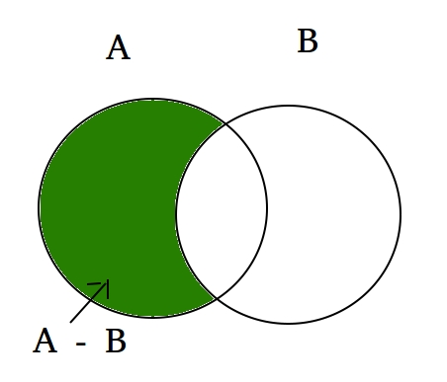

#6) isdisjoint()-
#If the given two sets have no element in common,
#then it will return True, otherwise False.

cities = {"Tokyo", "Madrid", "Berlin", "Delhi"}
cities2 = {"Tokyo", "Seoul", "Kabul", "Madrid"}
print(cities.isdisjoint(cities2))

#Output:
#False

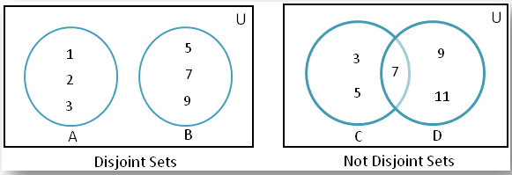

#7) issuperset()-
#Will return True if the original set consists of all
#the items present in the set,which is passed as the
#parameter

cities = {"Tokyo", "Madrid", "Berlin", "Delhi"}
cities2 = {"Seoul", "Kabul"}
print(cities.issuperset(cities2))
cities3 = {"Tokyo", "Madrid","Delhi"}
print(cities.issuperset(cities3))

#Output:
#False
#True

#8) issubset()-
#Returns True if the set passed as the parameter consists
#of all the elements present in the original set

cities = {"Tokyo", "Madrid", "Berlin", "Delhi"}
cities2 = {"Delhi", "Madrid"}
print(cities2.issubset(cities))

#Output:
#True

