Switch 1 | Switch2 | Switch3 | LED1 | LED2
0 | 0 | 0 | 0 | 0
1 | 0 | 1 | 0 | 1
1 | 1 | 0 | 1 | 0
1 | 1 | 1 | 1 | 1

LED2
SWITCh3
LED1
SWITCH2
SWITCH1
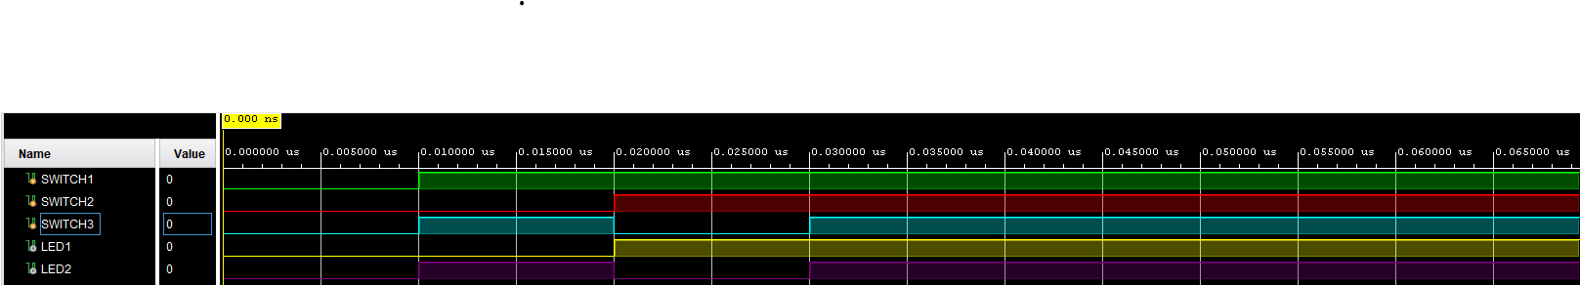
0 – 10 ns
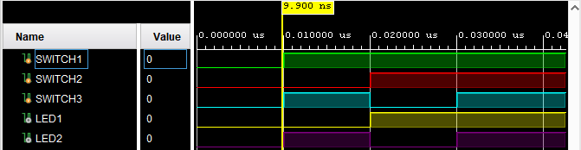
10ns - 20.20ns
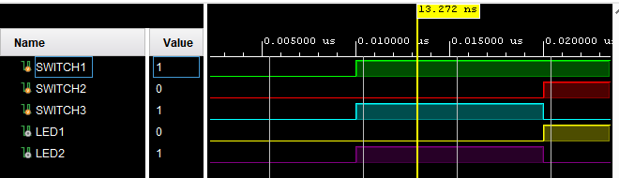
20.20ns – 30.2 ns
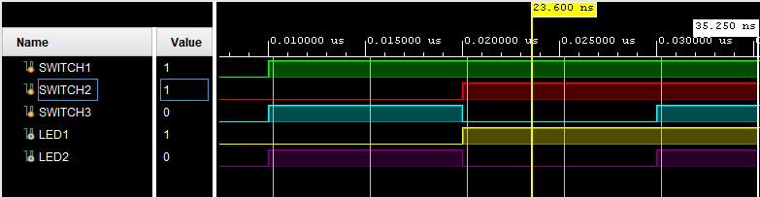

30.2 ns – 122040ns
