試験報告書
プロジェクト１
グループ G
提出日：2016年6月2日

- はじめに

本報告書は，ネットワーク対戦型オセロゲームシステムの試験方法および試験結果を記すものである．試験対象であるシステムのソースコードおよびクラス図は以下の通りである．

ソースコード一覧：
User.java UserDataDriver.java (テスト用ドライバ)
Offline.java OfflineDataDriver.java (テスト用ドライバ)
OthelloTest.java(テスト用プログラム)

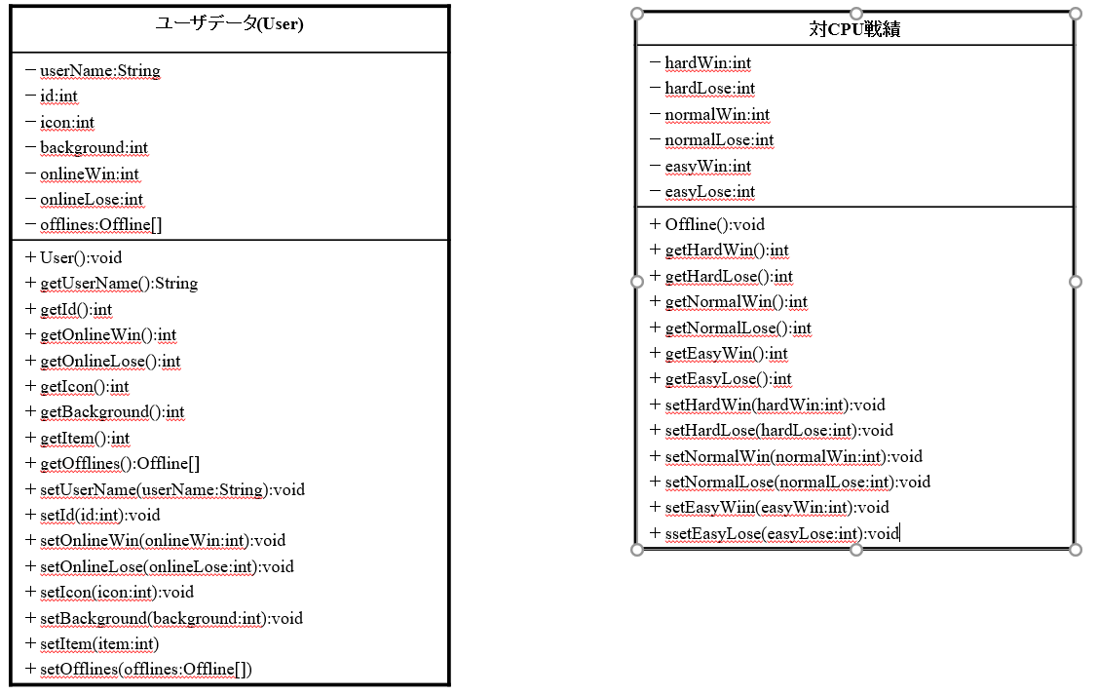
クラス図
- 単体テスト
  - Offlineクラス
以下のドライバを用いてOfflineクラスの単体テストを行った．なお，スタブは使用していない．
public class OfflineDataDriver {

public static void main(String[] args) {
System.out.println("Offline Data Driver Start");
Offline lOffline = new Offline();
System.out.println("Put data: Easy=7/0, Normal=4/2, Hard=2/3");
lOffline.setEasyWin(7);
lOffline.setEasyLose(0);
lOffline.setNormalWin(4);
lOffline.setNormalLose(2);
lOffline.setHardWin(2);
lOffline.setHardLose(3);
System.out.printf("getEasyWin()/Lose():%d/%d,"
+ " getNormalWin()/Lose():d/%d,"
+ " getHardWin()/Lose():%d/%d\n",
lOffline.getEasyWin(), lOffline.getEasyLose(),
lOffline.getNormalWin(),lOffline.getNormalLose(),
lOffline.getHardWin(), lOffline.getHardLose()
); System.out.printf("getWLLists():{{%d,%d},{%d,%d},{%d,%d}}",
lOffline.getWLLists()[0][0], lOffline.getWLLists()[0][1],
lOffline.getWLLists()[1][0], lOffline.getWLLists()[1][1],
lOffline.getWLLists()[2][0], lOffline.getWLLists()[2][1]
);
}
}

試験結果：
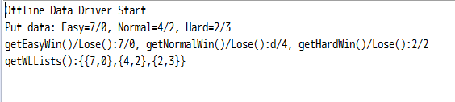

  - Userクラス
以下のドライバを用いてUserクラスの単体テストを行った.なおOfflineクラスは(ア)においてテスト済みである.
public class UserDataDriver {

public static void main(String[] args) {
User lUser = new User();
System.out.println("Set name=9s, id=43, online=5/3, icon=1, background=3, item=15");
lUser.setUserName("9s");
lUser.setId(43);
lUser.setOnlineWin(5);
lUser.setOnlineLose(3);
lUser.setBackground(3);
lUser.setIcon(1);
lUser.setItem(15);

// オフライン戦績ダミー
Offline lOffline = new Offline();
lOffline.setEasyWin(7);
lOffline.setEasyLose(0);
lOffline.setNormalWin(4);
lOffline.setNormalLose(2);
lOffline.setHardWin(2);
lOffline.setHardLose(3);

// テスト済み
lUser.setOfflines(new Offline[]{lOffline, new Offline(),
new Offline(), new Offline()}
);

System.out.printf("getUserName():%s\n"
+ "getId():%d\n"
+"getOnlineWin()/Lose():{%d/%d}\n"
+ "getIcon():%d\n"
+ "getBackground():%d\n"
+ "getItem():%d\n",
lUser.getUserName(),
lUser.getId(),
lUser.getOnlineWin(), lUser.getOnlineLose(),
lUser.getIcon(),
lUser.getBackground(),
lUser.getItem());

System.out.printf("getOfflines()[0]:{{%d,%d},{%d
,%d},{%d,%d}}\n",
lUser.getOfflines()[0].getWLLists()[0][0], lUser.getOfflines()[0].getWLLists()[0][1],
lUser.getOfflines()[0].getWLLists()[1][0], lUser.getOfflines()[0].getWLLists()[1][1],
lUser.getOfflines()[0].getWLLists()[2][0], lUser.getOfflines()[0].getWLLists()[2][1]
);
}
}

試験結果:
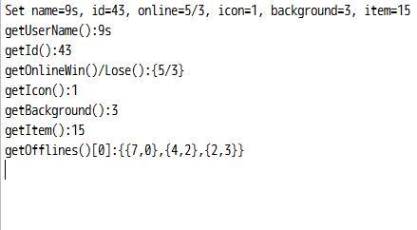

  - Othelloクラス
以下のクラスを用いてOthelloクラスの単体テストを行った．JUnitで実行した。
public class OthelloTest {

private Othello othello;

private Stone[][] defaultBoard = {
{Empty, Empty, Empty, Empty, Empty, Empty, Empty, Empty},
{Empty, Empty, Empty, Empty, Empty, Empty, Empty, Empty},
{Empty, Empty, Empty, Empty, Empty, Empty, Empty, Empty},
{Empty, Empty, Empty, Black, White, Empty, Empty, Empty},
{Empty, Empty, Empty, White, Black, Empty, Empty, Empty},
{Empty, Empty, Empty, Empty, Empty, Empty, Empty, Empty},
{Empty, Empty, Empty, Empty, Empty, Empty, Empty, Empty},
{Empty, Empty, Empty, Empty, Empty, Empty, Empty, Empty}
};
@Before
public void setUp() {
othello = new Othello(new PlayCallback() {
@Override
public void onTurnChange(boolean isMyTurn, int[] pCountStones) {
public void onOpponentUseItem() {
// TODO 自動生成されたメソッド・スタブ
}
@Override
public void onGameOver(int result) {
// TODO 自動生成されたメソッド・スタブ
}
@Override
public void onGameAborted() {
// TODO 自動生成されたメソッド・スタブ
}
@Override
public void onGainItem(boolean playerTurn) {
// TODO 自動生成されたメソッド・スタブ
}
@Override
public void enableItem() {
// TODO 自動生成されたメソッド・スタブ

}

@Override
public void disableItem() {
// TODO 自動生成されたメソッド・スタブ

}
}, BaseAI.class, 0, true);
}

@Test
public void testOthelloBoard() throws Exception {
Class c = othello.getClass();
Field fld = c.getDeclaredField("board");
fld.setAccessible(true);

assertArrayEquals(defaultBoard, (Stone[][])(fld.get(othello)));
}

@Test
public void testOthelloItemPoints() throws Exception {
Class c = othello.getClass();
Field fld = c.getDeclaredField("itemPoints");
fld.setAccessible(true);

assertEquals(Othello.ITEM_COUNT, ((List<Point>)(fld.get(othello))).size());
}

@Test
public void testActionPerformed() throws Exception {
// sourceがnullだと例外を吐くので適当に指定
ActionEvent event = new ActionEvent(new Object(), 10000, "5,4");
Stone[][] newBoard = BoardHelper.cloneBoard(defaultBoard);
newBoard[5][4] = White;
newBoard[4][4] = White;

Class c = othello.getClass();
Field fld1 = c.getDeclaredField("buttonBoard");
fld1.setAccessible(true);
((JButton[][])(fld1.get(othello)))[5][4].doClick();

Field fld2 = c.getDeclaredField("board");
fld2.setAccessible(true);
assertArrayEquals(newBoard, (Stone[][])(fld2.get(othello)));
}

@Test
public void testMakeHint() {
List<Point> expected = new ArrayList<>();
expected.add(new Point(2, 4));
expected.add(new Point(3, 5));
expected.add(new Point(4, 2));
expected.add(new Point(5, 3));

List<Point> actual = othello.makeHint(Black);

assertEquals(expected, actual);
}

@Test
public void testUseItemTriple() throws Exception {
// アイテム使用後に石を置く
othello.useItem(Item.TRIPLE);
Class c = othello.getClass();
Field fld1 = c.getDeclaredField("buttonBoard");
fld1.setAccessible(true);
((JButton[][])(fld1.get(othello)))[5][4].doClick();

Field fld2 = c.getDeclaredField("triplePoints");
fld2.setAccessible(true);
int actual = ((List<Point>)(fld2.get(othello))).size();

assertEquals(1, actual);
}

@Test
public void testReflectBan() throws Exception {
List<Point> banPoints = new ArrayList<>();
banPoints.add(new Point(0, 0));
banPoints.add(new Point(1, 3));

othello.reflectBan(banPoints);
Class c = othello.getClass();
Field fld = c.getDeclaredField("board");
fld.setAccessible(true);
Stone[][] board = (Stone[][])(fld.get(othello));

assertEquals(Ban, board[0][0]);
assertEquals(Ban, board[1][3]);
}

@Test
public void testReflectDrop() throws Exception {
Point dropPoint = new Point(3, 5);

othello.reflectDrop(dropPoint);
Class c = othello.getClass();
Field fld = c.getDeclaredField("board");
fld.setAccessible(true);
Stone[][] board = (Stone[][])(fld.get(othello));

assertEquals(Empty, board[dropPoint.getRow()][dropPoint.getColumn()]);
}

@Test
public void testReflectGray() throws Exception {
othello.reflectGray();

Class c = othello.getClass();
Field fld = c.getDeclaredField("grayTurn");
fld.setAccessible(true);

assertTrue((Integer)(fld.get(othello)) > 0);
}

@Test
public void testReflectTriple() throws Exception {
Point triplePoint = new Point(5, 4);

othello.reflectTriple();
Class c = othello.getClass();
Field fld1 = c.getDeclaredField("buttonBoard");
fld1.setAccessible(true);
((JButton[][])(fld1.get(othello)))[triplePoint.getRow()][triplePoint.getColumn()].doClick();
Field fld2 = c.getDeclaredField("triplePoints");
fld2.setAccessible(true);
Point actual = ((List<Point>) (fld2.get(othello))).get(0);

assertEquals(triplePoint, actual);
}
}

// TODO 自動生成されたメソッド・スタブ
}
@Override
public void onOpponentUseItem() {
// TODO 自動生成されたメソッド・スタブ
}
@Override
public void onGameOver(int result) {
// TODO 自動生成されたメソッド・スタブ
}
@Override
public void onGameAborted() {
// TODO 自動生成されたメソッド・スタブ
}
@Override
public void onGainItem(boolean playerTurn) {
// TODO 自動生成されたメソッド・スタブ
}
@Override
public void enableItem() {
// TODO 自動生成されたメソッド・スタブ
}
@Override
public void disableItem() {
// TODO 自動生成されたメソッド・スタブ
}
}, BaseAI.class, 0, true);
}
@Test
public void testOthelloBoard() throws Exception {
Class c = othello.getClass();
Field fld = c.getDeclaredField("board");
fld.setAccessible(true);

assertArrayEquals(defaultBoard, (Stone[][])(fld.get(othello)));
}
@Test
public void testOthelloItemPoints() throws Exception {
Class c = othello.getClass();
Field fld = c.getDeclaredField("itemPoints");
fld.setAccessible(true);

assertEquals(Othello.ITEM_COUNT, ((List<Point>)(fld.get(othello))).size());
}

@Test
public void testActionPerformed() throws Exception {
// sourceがnullだと例外を吐くので適当に指定
ActionEvent event = new ActionEvent(new Object(), 10000, "5,4");
Stone[][] newBoard = BoardHelper.cloneBoard(defaultBoard);
newBoard[5][4] = White;
newBoard[4][4] = White;

Class c = othello.getClass();
Field fld1 = c.getDeclaredField("buttonBoard");
fld1.setAccessible(true);
((JButton[][])(fld1.get(othello)))[5][4].doClick();

Field fld2 = c.getDeclaredField("board");
fld2.setAccessible(true);
assertArrayEquals(newBoard, (Stone[][])(fld2.get(othello)));
}

@Test
public void testMakeHint() {
List<Point> expected = new ArrayList<>();
expected.add(new Point(2, 4));
expected.add(new Point(3, 5));
expected.add(new Point(4, 2));
expected.add(new Point(5, 3));

List<Point> actual = othello.makeHint(Black);

assertEquals(expected, actual);
}

@Test
public void testUseItemTriple() throws Exception {
// アイテム使用後に石を置く
othello.useItem(Item.TRIPLE);
Class c = othello.getClass();
Field fld1 = c.getDeclaredField("buttonBoard");
fld1.setAccessible(true);
((JButton[][])(fld1.get(othello)))[5][4].doClick();

Field fld2 = c.getDeclaredField("triplePoints");
fld2.setAccessible(true);
int actual = ((List<Point>)(fld2.get(othello))).size();

assertEquals(1, actual);
}

@Test
public void testReflectBan() throws Exception {
List<Point> banPoints = new ArrayList<>();
banPoints.add(new Point(0, 0));
banPoints.add(new Point(1, 3));

othello.reflectBan(banPoints);
Class c = othello.getClass();
Field fld = c.getDeclaredField("board");
fld.setAccessible(true);
Stone[][] board = (Stone[][])(fld.get(othello));

assertEquals(Ban, board[0][0]);
assertEquals(Ban, board[1][3]);
}

@Test
public void testReflectDrop() throws Exception {
Point dropPoint = new Point(3, 5);

othello.reflectDrop(dropPoint);
Class c = othello.getClass();
Field fld = c.getDeclaredField("board");
fld.setAccessible(true);
Stone[][] board = (Stone[][])(fld.get(othello));

assertEquals(Empty, board[dropPoint.getRow()][dropPoint.getColumn()]);
}

@Test
public void testReflectGray() throws Exception {
othello.reflectGray();

Class c = othello.getClass();
Field fld = c.getDeclaredField("grayTurn");
fld.setAccessible(true);

assertTrue((Integer)(fld.get(othello)) > 0);
}

@Test
public void testReflectTriple() throws Exception {
Point triplePoint = new Point(5, 4);

othello.reflectTriple();
Class c = othello.getClass();
Field fld1 = c.getDeclaredField("buttonBoard");
fld1.setAccessible(true);
((JButton[][])(fld1.get(othello)))[triplePoint.getRow()][triplePoint.getColumn()].doClick();
Field fld2 = c.getDeclaredField("triplePoints");
fld2.setAccessible(true);
Point actual = ((List<Point>) (fld2.get(othello))).get(0);

assertEquals(triplePoint, actual);
}
}

}
@Test
public void testOthelloItemPoints() throws Exception {
Class c = othello.getClass();
Field fld = c.getDeclaredField("itemPoints");
fld.setAccessible(true);
assertEquals(Othello.ITEM_COUNT, ((List<Point>)(fld.get(othello))).size());
}
@Test
public void testActionPerformed() throws Exception {
// sourceがnullだと例外を吐くので適当に指定
ActionEvent event = new ActionEvent(new Object(), 10000, "5,4");
Stone[][] newBoard = BoardHelper.cloneBoard(defaultBoard);
newBoard[5][4] = White;
newBoard[4][4] = White;
Class c = othello.getClass();
Field fld1 = c.getDeclaredField("buttonBoard");
fld1.setAccessible(true);
((JButton[][])(fld1.get(othello)))[5][4].doClick();
Field fld2 = c.getDeclaredField("board");
fld2.setAccessible(true);
assertArrayEquals(newBoard, (Stone[][])(fld2.get(othello)));
}
@Test
public void testMakeHint() {
List<Point> expected = new ArrayList<>(); expected.add(new Point(2, 4));
expected.add(new Point(3, 5));
expected.add(new Point(4, 2));
expected.add(new Point(5, 3));
List<Point> actual = othello.makeHint(Black);
assertEquals(expected, actual);
}
@Test
public void testUseItemTriple() throws Exception {
// アイテム使用後に石を置く
othello.useItem(Item.TRIPLE);
Class c = othello.getClass();
Field fld1 = c.getDeclaredField("buttonBoard");
fld1.setAccessible(true);
((JButton[][])(fld1.get(othello)))[5][4].doClick();

Field fld2 = c.getDeclaredField("triplePoints");
fld2.setAccessible(true);
int actual = ((List<Point>)(fld2.get(othello))).size();

assertEquals(1, actual);
}

@Test
public void testReflectBan() throws Exception {
List<Point> banPoints = new ArrayList<>();
banPoints.add(new Point(0, 0));
banPoints.add(new Point(1, 3));

othello.reflectBan(banPoints);
Class c = othello.getClass();
Field fld = c.getDeclaredField("board");
fld.setAccessible(true);
Stone[][] board = (Stone[][])(fld.get(othello));

assertEquals(Ban, board[0][0]);
assertEquals(Ban, board[1][3]);
}

@Test
public void testReflectDrop() throws Exception {
Point dropPoint = new Point(3, 5);

othello.reflectDrop(dropPoint);
Class c = othello.getClass();
Field fld = c.getDeclaredField("board");
fld.setAccessible(true);
Stone[][] board = (Stone[][])(fld.get(othello));

assertEquals(Empty, board[dropPoint.getRow()][dropPoint.getColumn()]);
}

@Test
public void testReflectGray() throws Exception {
othello.reflectGray();

Class c = othello.getClass();
Field fld = c.getDeclaredField("grayTurn");
fld.setAccessible(true);

assertTrue((Integer)(fld.get(othello)) > 0);
}

@Test
public void testReflectTriple() throws Exception {
Point triplePoint = new Point(5, 4);

othello.reflectTriple();
Class c = othello.getClass();
Field fld1 = c.getDeclaredField("buttonBoard");
fld1.setAccessible(true);
((JButton[][])(fld1.get(othello)))[triplePoint.getRow()][triplePoint.getColumn()].doClick();
Field fld2 = c.getDeclaredField("triplePoints");
fld2.setAccessible(true);
Point actual = ((List<Point>) (fld2.get(othello))).get(0);

assertEquals(triplePoint, actual);
}
}

// アイテム使用後に石を置く
othello.useItem(Item.TRIPLE);
Class c = othello.getClass();
Field fld1 = c.getDeclaredField("buttonBoard");
fld1.setAccessible(true);
((JButton[][])(fld1.get(othello)))[5][4].doClick();
Field fld2 = c.getDeclaredField("triplePoints");
fld2.setAccessible(true);
int actual = ((List<Point>)(fld2.get(othello))).size();
assertEquals(1, actual);
}
@Test
public void testReflectBan() throws Exception {
List<Point> banPoints = new ArrayList<>();
banPoints.add(new Point(0, 0));
banPoints.add(new Point(1, 3));
othello.reflectBan(banPoints);
Class c = othello.getClass();
Field fld = c.getDeclaredField("board");
fld.setAccessible(true);
Stone[][] board = (Stone[][])(fld.get(othello));
assertEquals(Ban, board[0][0]);
assertEquals(Ban, board[1][3]);
}
@Test
public void testReflectDrop() throws Exception {
Point dropPoint = new Point(3, 5);
othello.reflectDrop(dropPoint);
Class c = othello.getClass();
Field fld = c.getDeclaredField("board");
fld.setAccessible(true);
Stone[][] board = (Stone[][])(fld.get(othello));
assertEquals(Empty, board[dropPoint.getRow()][dropPoint.getColumn()]);
}
@Test
public void testReflectGray() throws Exception {
othello.reflectGray();

Class c = othello.getClass();
Field fld = c.getDeclaredField("grayTurn");
fld.setAccessible(true);

assertTrue((Integer)(fld.get(othello)) > 0);
}

@Test
public void testReflectTriple() throws Exception {
Point triplePoint = new Point(5, 4);

othello.reflectTriple();
Class c = othello.getClass();
Field fld1 = c.getDeclaredField("buttonBoard");
fld1.setAccessible(true);
((JButton[][])(fld1.get(othello)))[triplePoint.getRow()][triplePoint.getColumn()].doClick();
Field fld2 = c.getDeclaredField("triplePoints");
fld2.setAccessible(true);
Point actual = ((List<Point>) (fld2.get(othello))).get(0);

assertEquals(triplePoint, actual);
}
}

public void testReflectGray() throws Exception {
othello.reflectGray();
Class c = othello.getClass();
Field fld = c.getDeclaredField("grayTurn");
fld.setAccessible(true);
assertTrue((Integer)(fld.get(othello)) > 0);
}
@Test
public void testReflectTriple() throws Exception {
Point triplePoint = new Point(5, 4);
othello.reflectTriple();
Class c = othello.getClass(); Field fld1 = c.getDeclaredField("buttonBoard");
fld1.setAccessible(true);
((JButton[][])(fld1.get(othello)))[triplePoint.getRow()][triplePoint.getColumn()].doClick();
Field fld2 = c.getDeclaredField("triplePoints");
fld2.setAccessible(true);
Point actual = ((List<Point>) (fld2.get(othello))).get(0);
assertEquals(triplePoint, actual);
}
}

試験結果
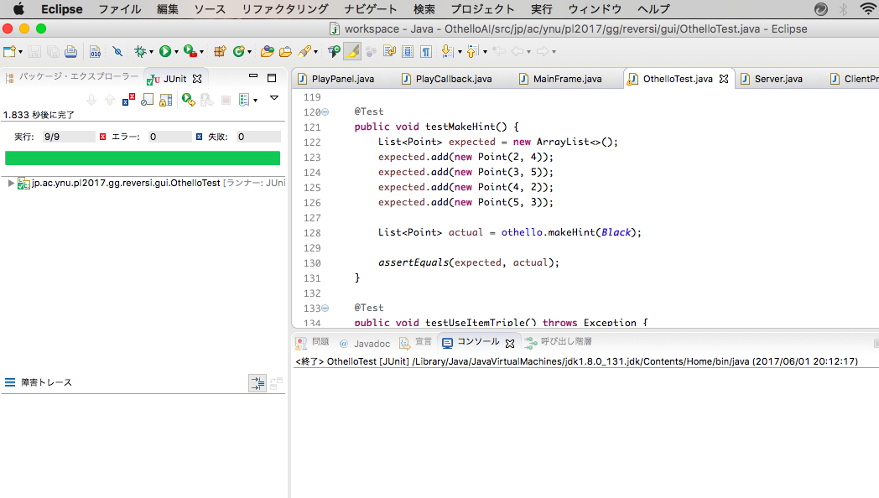

- 結合テスト

以下の手順に従い，結合テストを行った．
- Serverプログラムを起動
- Clientプログラム１を起動し、プレイヤ名「test」とそのパスワードを入力
- Clientプログラム２を起動し、プレイヤ名「newTest」とそのパスワードを入力
- Clientプログラム１からプレイヤ名「newTest」を指定し対戦申し込み
- Clientプログラム２からプレイヤ名「test」を指定し対戦申し込み
- ゲームを進行
- ゲーム終了後、Serverプログラムが各アカウントの結果を保存
- 再度対局し、ゲーム中、「test」側を強制終了
試験結果を次頁に示す．

クライアント側：
[２]
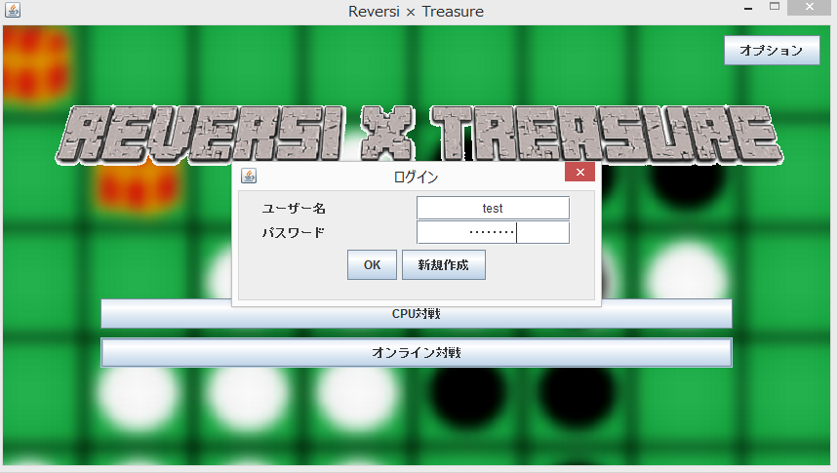

[３]
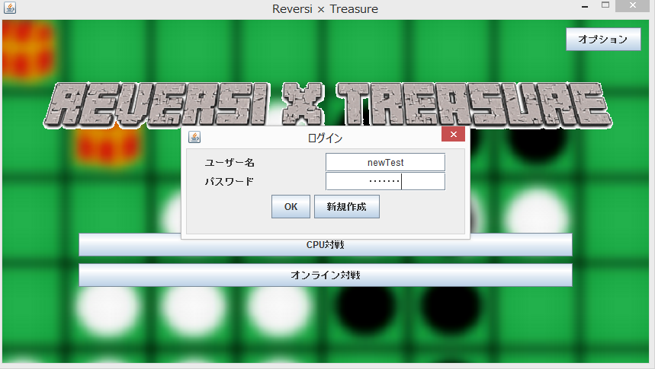

[４]
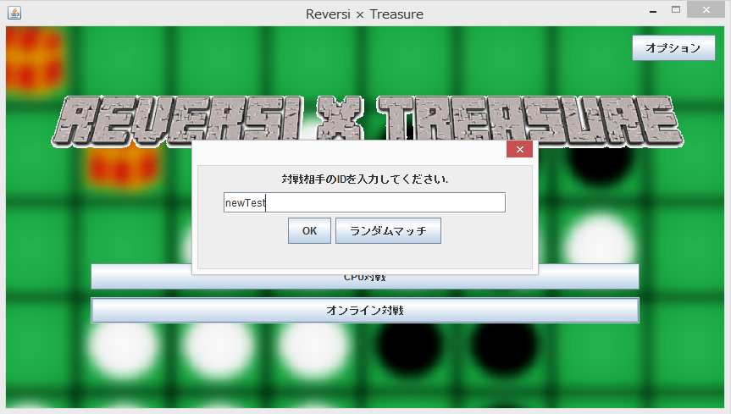
↓
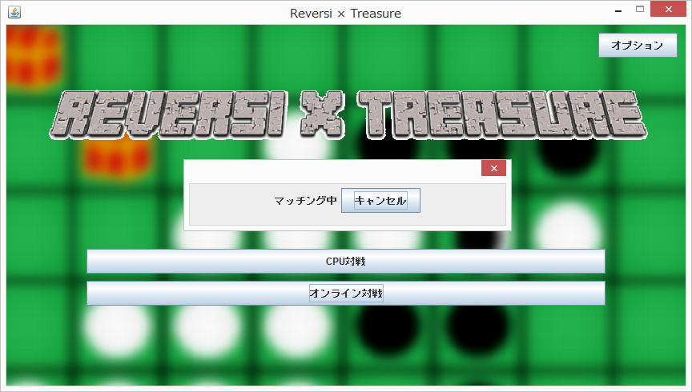

[５]
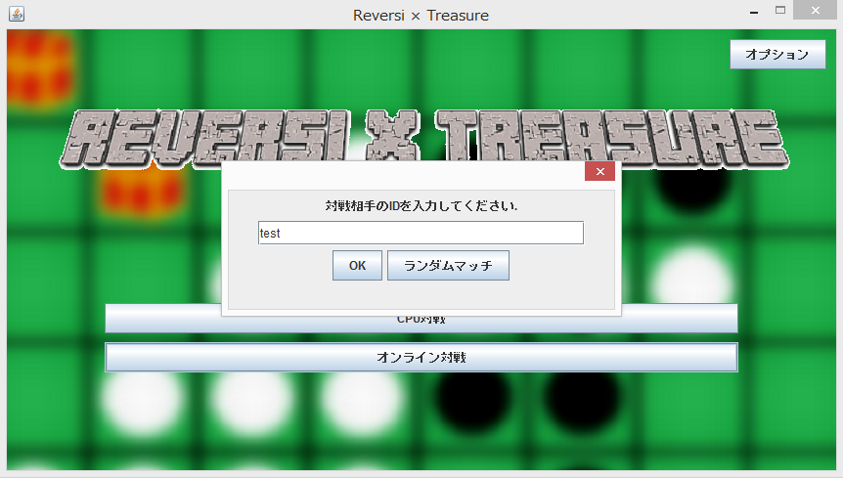

[６]
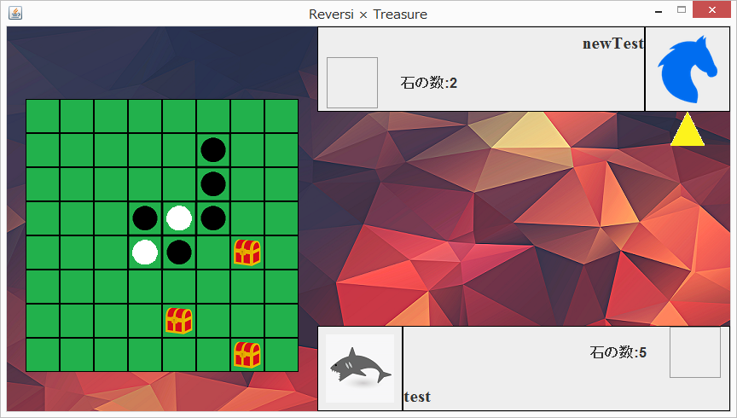

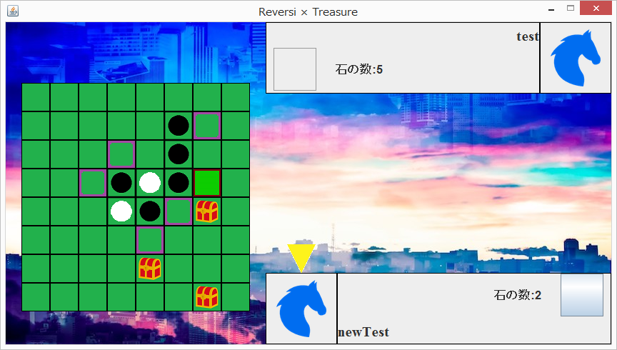

[７（newTest側）]
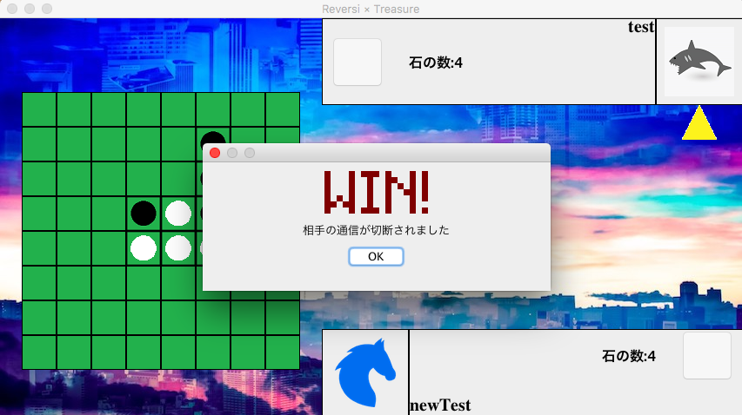

サーバ側：
[１〜３]
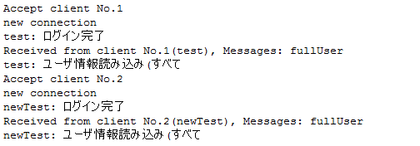

[４〜５]
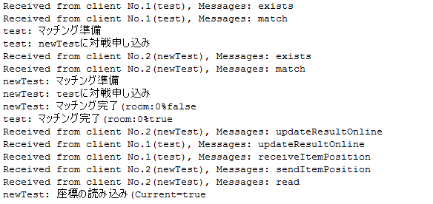

[６]
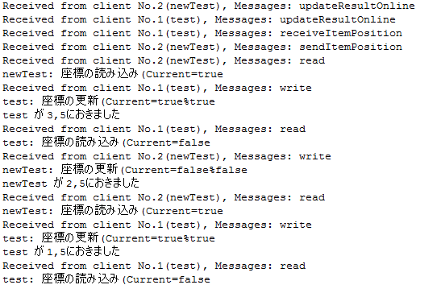

[７]
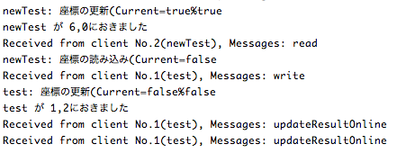

[８]
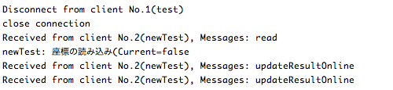

４． その他

AI同士の対局テスト結果及び、データベースの容量の検証をしたファイルを別途 添付する。

OthelloDBBackup.accdb データベースに百万個のアカウントを配置し、同時に 一万のアクセスが可能であると検証をしたファイル

各csv形式ファイル AIのレベル別、「強い」レベル同士のタイプ別 に戦わせた際の結果

AlphaAI1vsAlphaAI0_558-1000.csv
AlphaAI2vsAlphaAI1_650-1000.csv
BetaAI1vsBetaAI0_651-1000.csv
BetaAI2vsBetaAI1_651-1000.csv
GammaAI1vsGammaAI0_697-1000.csv
GammaAI2vsGammaAI1_597-1000.csv
OmegaAI1vsOmegaAI0_686-1000.csv
OmegaAI2vsOmegaAI1_591-1000.csv
OmegaAI2vsAlphaAI2_917-1000.csv
OmegaAI2vsBetaAI2_771-1000.csv
OmegaAI2vsGammaAI2_688-1000.csv

