**Assignment - 1**

NAME:-Y.NIKHIL REDDY

REG NO:-192211188

1. What is the exact output of the program below? #include <iostream> using namespace std; int main()

{ int n = 4, k = 2; cout << ++n << endl; cout << n << endl; cout << n++ << endl; cout << n << endl; cout << -n << endl; cout << n << endl;

cout << --n << endl; cout << n << endl;

cout << n-- << endl; cout << n << endl;

cout << n + k << endl; cout << n << endl; cout << k << endl; cout << n << k << endl; cout << n << endl; cout << " " << n << endl; cout << " n" << endl; cout << "\n" << endl; cout << " n * n = "; //CAREFUL!

cout << n * n << endl; cout << 'n' << endl;

return 0;

}

Output:

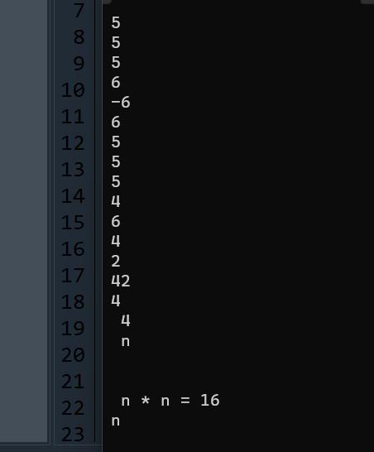

2. What is the output of the program below? #include <iostream>

using namespace std;

int main()

{

int n = 3; while (n >= 0)

{

cout << n * n << endl;

--n;

}

cout << n << endl; while (n < 4) {

cout << ++n << endl; cout << n << endl; while (n >= 0) cout << (n /= 2) << endl; return 0;

}

Output:

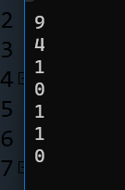

1. What is the output of the program below?

#include <iostream>

using namespace std;

int main()

{

int n;

cout << (n = 4) << endl; cout << (n == 4) << endl; cout << (n > 3) << endl; cout << (n < 4) << endl; cout << (n = 0) << endl; cout << (n == 0) << endl; cout << (n > 0) << endl; cout << (n && 4) << endl; cout << (n || 4) << endl; cout << (!n) << endl; return 0;

}

Output:

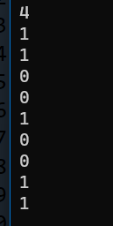

1. What is the output of the following program?

#include <iostream>

using namespace std;

int main()

{

enum color_type {red, orange, yellow, green, blue, violet}; color_type shirt, pants;

shirt = red; pants = blue;

cout << shirt << " " << pants << endl;

return 0;

}

Output:



1. What is the output when the following code fragment is executed?

#include<iostream>

Using namespace std;

Int main(){

int i = 5, j = 6, k = 7, n = 3;

cout << i + j * k - k % n << endl; cout << i / n << endl;

}

Output:

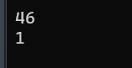

1. What is the output when the following code fragment is executed?

#include<iostream>

Using namespace std;

Int main(){

int found = 0, count = 5;

if (!found || --count == 0)

cout << "danger" << endl;

cout << "count = " << count << endl;

}

Output:

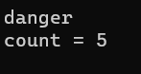

1. The loop shown below has been written by an inexperienced C++ programmer. The behavior of the loop is not correctly represented by the formatting.

#include<iostream>

Using namespace std;

Int main(){

int n = 10;

while (n > 0){

n /= 2;

cout << n * n << endl;

}

}

1. What is the output of the loop as it is written? 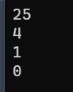
2. Correct the syntax of the loop so that the logic of the corrected loop corresponds to the formatting of the original loop. What is the output of the corrected loop? 
3. Correct the formatting of the (original) loop so that the new format reflects the logical behavior of the

original loop.

1. Remove all the unnecessary tests from the nested conditional statement below.

#include<iostream>

Using namespace std;

Int main(){

float income;

cout << "Enter your monthly income: ";

cin >> income;

if (income < 0.0)

cout << "You are going farther into debt every month." << endl;

else if (income >= 0.0 && income < 1200.00)

cout << "You are living below the poverty line." << endl;

else if (income >= 1200.00 && income < 2500.00)

cout << "You are living in moderate comfort." << endl;

else if (income >= 2500.00)

cout << "You are well off." << endl;

}

Output:



1. Answer the questions below concerning the following fragment of code.

#include<iostream>

Using namespace std;

Int main(){

int n;

cout << "Enter an integer: ";

cin >> n;

if (n < 10)

cout << "less than 10" << endl; else if (n > 5)

cout << "greater than 5" << endl; else

cout << "not interesting" << endl;

}

1. What will be the output of the fragment above if the interactive user enters the integer value 0 ? 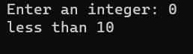
2. What will be the output of the fragment above if the interactive user enters the integer value 15 ? 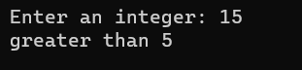
3. What will be the output of the fragment above if the interactive user enters the integer value 7 ? 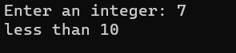
4. What values for n will cause the output of the fragment above to be "not interesting"? ans: -1,-2,-3,-

10. Rewrite the following code fragment so that it uses a "do...while..." loop to accomplish the same

task.

#include<iostream>

Using namespace std;

Int main(){

int n;

cout << "Enter a non-negative integer: "; cin >> n;

while (n < 0)

{

cout << "The integer you entered is negative." << endl; cout << "Enter a non-negative integer: ";

cin >> n;

} }

Ans.

#include<iostream>

using namespace std;

int main(){

int n;

cout << "Enter a non-negative integer: ";

cin >> n;

do

{

if(n>=0)

{

break;

}

cout << "The integer you entered is negative."<< endl;

cout << "Enter a non-negative integer: ";

cin >> n;

}while (n < 0);

}

Output:

