EXP NO -39

AIM-1. Design DFA using simulator to accept the string the end with abc over set {a,b,c)

W= abbaababc

INPUT:

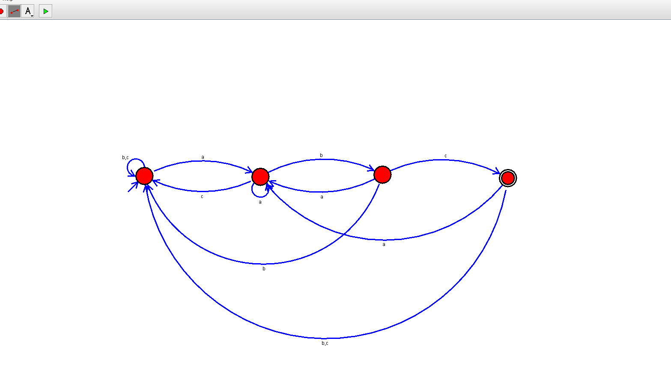

OUTPUT:



RESULT:Thus the the given string verified through dfa simulator