1. Critique
The following issues are grounded in the assigned case study. “Evidence” identifies what the narrative actually says; an inference is labeled as such. Each issue is linked to a primary software construction principle and explains its effect on students or staff.

01 Requirements and design were skipped
Case reference: The intern began coding without a formal requirements document or design diagram (case study, p. 1).
User/system impact: The team never specified basic policies such as payment expiry and limits on active bookings. These omissions had to be handled urgently after students were affected.
Construction principle: Minimizing complexity — a short design phase would have made the hidden rules and edge cases manageable before implementation.

02 Only a fixed booking journey was supported
Case reference: The narrative describes a single login → select → allocate → confirm → logout process, with no later workflow (p. 1).
User/system impact: A system built around just this path provides no supported way to reuse availability and allocation behavior for later actions. The narrative does not prove how the intern organized the source code.
Construction principle: Reuse — shared reservation and availability operations should serve booking, cancellation, switching and expiry.

03 No one-active-booking restriction
Case reference: Re-entering the portal assigned another room to the same roll number (pp. 1–2).
User/system impact: A student could hold several rooms, leaving genuine applicants with an inaccurate impression that all rooms were taken.
Construction principle: Constructing for verification — the invariant “at most one active reservation per student” must be enforced and tested on every booking.

04 Room allocation was not protected against competing requests
Case reference: Two students received references for the last single room in Block B (p. 2).
User/system impact: Both believed they had a valid booking; the conflict was only discovered when they arrived to move in.
Construction principle: Standards in construction — availability checking and assignment must be a single protected transaction, not two independent changes.

05 No deposit expiry or booking lifecycle
Case reference: Unpaid reservations remained marked “Booked” for weeks, although the normal deadline was 48 hours (p. 2).
User/system impact: Rooms that should have returned to inventory were withheld from students willing to pay.
Construction principle: Anticipating change — a reservation changes over time; it needs pending, confirmed and expired states with a deadline.

CRITIQUE / CONTINUED

06 Accessibility eligibility was not represented
Case reference: A student with a documented mobility need was allocated a third-floor room and had to complain (p. 2).
User/system impact: Booking by block and room type alone cannot protect accessible inventory or route an eligible student appropriately.
Construction principle: Standards in construction — room attributes and verified accommodation needs are essential correctness requirements for this portal.

07 No cancellation route
Case reference: The workflow ends on confirmation; it provides no student-facing way to give up a reservation (pp. 1–2).
User/system impact: A student who changes plans cannot return a held room directly to the pool, increasing manual workload and blocked inventory.
Construction principle: Anticipating change — ordinary cancellations must be supported as an explicit state transition.

08 No reservation-switch route
Case reference: A request to move from shared to double accommodation required emails and spreadsheet edits (p. 2).
User/system impact: Students and administrators were forced outside the portal, risking inconsistent room records when making ordinary changes.
Construction principle: Reuse — a switch should reuse existing eligibility, availability and allocation rules rather than relying on manual edits.

09 Repeated confirmation was not idempotent
Case reference: After an internet drop, a student retried and was allocated a second room (p. 2).
User/system impact: An uncertain network response should not turn one intended action into multiple reservations.
Construction principle: Standards in construction — a stable request ID must connect repeated attempts to the same stored outcome.

10 No reliable booking-status recovery
Case reference: After reconnecting, the student could not see the reference from the first successful request (p. 2).
User/system impact: Students cannot distinguish a failed action from a successful action whose confirmation was lost.
Construction principle: Minimizing complexity — a request lookup or booking-history screen gives one clear account of what happened.

11 Testing covered only the happy path
Case reference: The intern and three classmates each booked one room in an afternoon (p. 1).
User/system impact: Those checks did not exercise two competing users, retries, overdue payments or modifications.
Construction principle: Constructing for verification — normal, invalid, repeated and time-dependent cases require separate tests before release.

12 Insufficient audit and reconciliation capability (inferred)
Case reference: Staff maintained a parallel Excel sheet to reconcile payments, reservations and occupancy (p. 2).
User/system impact: The case does not explicitly say there were zero logs; the manual reconciliation does show the portal lacked sufficient usable tracking for its administrators.
Construction principle: Constructing for verification — timestamped events make booking decisions, changes and payment status traceable.

2. Redesign

2.1 Scope and assumptions
The case specifies Block A: 40 single, 30 double and 20 shared (four-person) rooms; Block B: 25 single, 35 double and 15 shared rooms; and accessibility-reserved Block C: 20 ground-floor single and 10 ground-floor double rooms. A security deposit is due within 48 hours and a student may have no more than one active room reservation.
Design assumption: one unique room ID is allocated exclusively to one reservation. The case gives capacities but no bed-by-bed allocation policy for double/shared rooms. The Java prototype covers Block A only; a full deployment would require an agreed bed-allocation policy and all three blocks.

2.2 Entities, statuses and timestamps
Record | Fields and purpose
Student | rollNumber (unique), login credential (production), eligibilityStatus, accessibilityNeed/verification, registeredAt, activeBookingRef (nullable).
Room | roomId, block, roomType, capacity, floor, accessibleEntrance/feature flags, physicalStatus, occupiedByBookingRef (nullable), lastChangedAt. Available if in service and not held by an active booking.
Booking | bookingRef, studentRoll, roomId, status, createdAt, depositDueAt, paidAt (nullable), closedAt (nullable), previousBookingRef (for a switch). Preserve history.
Request ledger | studentRoll + action + requestId, input fingerprint, stored response, recordedAt. Reused IDs with different inputs must fail.
Payment (production) | providerTransactionId (unique), bookingRef, amount, providerStatus, confirmedAt; prevent duplicate posting/reconcile finance.
Audit event | eventId, timestamp, actor, action, bookingRef, old/new room and outcome; append new events instead of erasing history.

2.3 State rules and invariants
A new booking begins PENDING_DEPOSIT. Verified payment before its deadline moves it to CONFIRMED. Otherwise it becomes EXPIRED when current time reaches its deadline. Cancellation produces CANCELLED; a successful replacement marks the old booking SWITCHED and creates a new booking record. EXPIRED, CANCELLED and SWITCHED are historical/inactive; PENDING_DEPOSIT and CONFIRMED are active.
- One student has at most one active booking; one exclusively allocated room has at most one active booking.
- A room’s displayed availability is derived from the authoritative reservation/room link, not a separately trusted counter.
- At time >= depositDueAt, an unpaid pending booking is expired before a new decision is made.

REDESIGN / VALIDATIONS & ATOMIC OPERATIONS

2.4 Booking flow: validation order
1. Confirm the student identity (production login); the teaching console instead registers a roll number.
2. Process expired unpaid reservations before checking active-booking or room availability.
3. Look up (student, BOOK, requestId). Same ID and matching inputs: return the stored result/reference without another mutation; different inputs: reject. The status lookup can show the booking’s current state.
4. For a new request, reject if the student already has a PENDING_DEPOSIT or CONFIRMED reservation.
5. Check room type and eligibility. A registered accessibility need routes to Block C; Block C is restricted to eligible students.
6. Atomically select an available, eligible room; reserve it, create a PENDING_DEPOSIT booking, set depositDueAt = now + 48h, and append the audit event. If no room can be claimed, commit nothing.
7. Only after success, return the new booking reference and exact deposit deadline; a rejected request returns an actionable reason.

2.5 Last-room race and consistency
The dangerous gap is between finding an AVAILABLE room and changing its state. In production, put the room claim, booking creation and student-assignment update in one database transaction. A conditional UPDATE of a free room must affect exactly one row; a competing transaction affecting zero rows is rejected. Add database constraints or equivalent serialized checks that also prevent two active bookings for one student. A method call alone does not provide concurrent safety.
In the submitted single-process Java simulation, synchronized BookingService methods protect the in-memory check-and-update sequence. The demonstration makes two back-to-back requests against exactly one free room; the second request must fail. It does not claim to test distributed concurrency.

2.6 Deposit processing and automatic release
A pending booking expires precisely when now >= depositDueAt unless payment was confirmed earlier. Expiry marks the booking EXPIRED, clears the student/room active links, makes the room available and writes RELEASED_UNPAID with a timestamp. A production scheduler plus pre-operation checks handles expiry; the prototype uses an advanceable simulation clock. Repeated payment submissions must not charge twice: the console only records simulated payment, while real finance integration would additionally require provider-side idempotency and reconciliation.

2.7 Cancellation and switching
Cancel: verify ownership and active state, then mark CANCELLED, release room, clear the active link and log the action atomically. Switch: validate a suitable replacement first; if none is free, do not alter the original. On success, move the old booking to SWITCHED, claim the new room and make a new booking reference as one operation. Preserve the original unpaid deposit deadline, or carry forward an already verified payment. Refund policy for a paid cancellation is not specified and needs university approval.

REDESIGN / REQUIRED FLOW DIAGRAM

2.8 booking flow
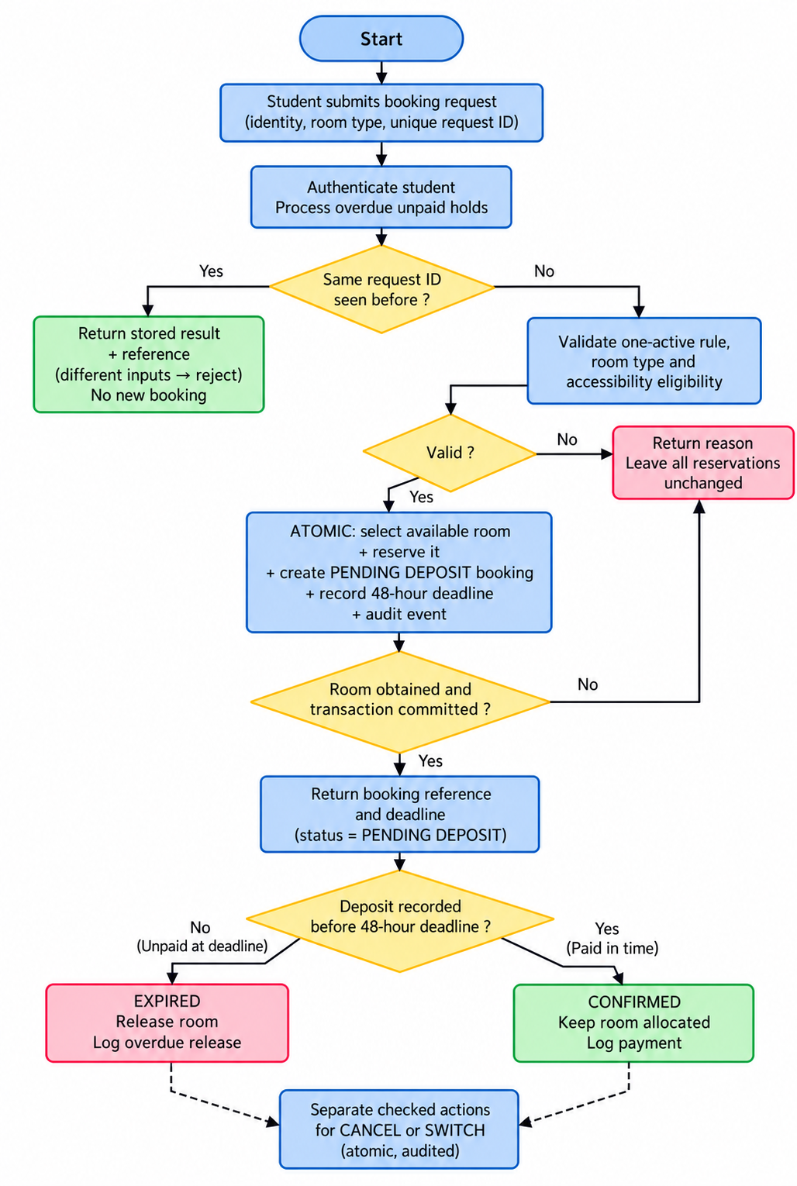REDESIGN / RECOVERY & VERIFICATION

2.9 Interrupted requests and recovery
The client generates one request ID when the user confirms. If the network drops, it resends that same ID with the same inputs. The server’s persisted request ledger returns the original result/reference rather than creating another reservation; mismatched reuse is refused. Because the original booking may subsequently be paid, expired or cancelled, a separate lookup displays its current status. Every returned confirmation comes from a stored booking, not from an assumption that the network call succeeded.

2.10 Verification matrix
Scenario | Expected observation
Single-active restriction | Second NEW request for the same student is rejected; there remains exactly one active booking.
Last eligible room | Student A books it; Student B is rejected; no two references occupy one room.
Lost response / retry | Replaying the same request ID returns the original reference; inventory does not change again.
Unpaid 48h deadline | At 48h without payment, booking becomes EXPIRED and room is released.
Confirmed deposit | Simulated payment before due time yields CONFIRMED; advancing time does not release the room.
Cancel and switch | Cancel frees its room; switch uses a free replacement or leaves old booking untouched.
Expiry through switch | An unpaid switch keeps the prior deposit deadline; no extension of a hold.
Audit and accessibility | Booking/payment/expiry/cancel/switch events have times; inaccessible Block A rejects an accessible request.

2.11 Prototype-to-design mapping and limitations
The attached Java source has Room, Student, Booking and BookingService records; synchronized operations; an in-memory request history; audit events; status lookup; an advanceable clock; a menu; a --demo mode; and --self-test checks. Block A starts with the case-study room quantities, while the last-room demo uses a separate one-room inventory.
The program does not implement actual password authentication, Block C allocation, real payments, a database, background scheduling, real concurrent threads or per-bed assignments. These belong to the proposed full design, not to the required one-block console demonstration. All in-memory records reset on restart.

3. Reflection
I can see why the intern started coding immediately. The department needed a working portal in one month, and the request sounded straightforward: show rooms, let someone choose, and confirm. A requirements document or state diagram might have looked like paperwork that delayed the visible part of the project. Four successful test bookings then made the first version appear more reliable than it actually was.
What was missing was an understanding of what happens after the first confirmation. Students can lose their connection, change their plans, fail to pay, or submit a request at the same time as someone else. Each event changes what the system should allow next. When those decisions are not made during design, they appear as emergencies after launch. The hostel office ended up tracking bookings in Excel, and two students even reached move-in day believing they owned the same room.
I would advise a junior developer to spend a little time on the risky rules before writing the main program. First state the invariants: one active reservation per student and only one claimant per exclusive room. Draw the booking states, decide what happens at 48 hours, and give cancellation and switching a safe path. Then write tests for a repeated click, an overdue payment, an unavailable replacement and two competing requests. That is a small amount of preparation compared with rebuilding a system that people already depend on.
For me, the lesson is that “it works once” is not a sufficient definition of software quality. Good construction means the same rules continue to hold when real users and unexpected events put pressure on the system.

Source and implementation note
Primary source: Bahria University, SEN-311, “Assignment 1: Case Study Critique and Redesign,” 23 September 2026, pp. 1–4. Evidence and required behavior come from that case; technical choices (transaction rules, request ledger and simulated clock) are proposed design decisions. The screenshot areas below are intentionally blank for the student’s genuine program output.

Appendix A. Output Screenshot Spaces
Insert genuine terminal screenshots in the empty bordered areas below. No screenshots have been generated or inserted.

Screenshot 1 — Last-room contention + single active reservation
Use java HostelBookingSystem --demo. Capture the Scenario 1 output showing one success and one rejection.

Screenshot 2 — Retry after dropped confirmation
Capture Scenario 2: original request ID returns the same booking reference; active reservation count is 1.

Appendix A. Output Screenshot Spaces (continued)
Insert genuine terminal screenshots in the empty bordered areas below. No screenshots have been generated or inserted.

Screenshot 3 — 48-hour expiry and room release
Capture Scenario 3: advance 49 hours, EXPIRED status and room available for a new student.

Screenshot 4 — Deposit confirmation and payment retry
Capture Scenario 4: payment recorded, replay is safe, and booking remains CONFIRMED after time passes.

Appendix A. Output Screenshot Spaces (continued)
Insert genuine terminal screenshots in the empty bordered areas below. No screenshots have been generated or inserted.

Screenshot 5 — Cancellation and switching
Capture Scenarios 5 and 6 (or two images combined): cancelled room is free and an unpaid switch keeps the old deposit deadline.

Screenshot 6 — Audit events and automated checks
Capture Scenario 7 audit lines and/or java HostelBookingSystem --self-test showing the complete PASS result.

