Week 2 Final Report
Footprinting & Network Scanning — W2-PM1 & W2-PM5
Program | Cybersecurity & Pentesting — Networkwalks Academy
Batch | B082
Student | [Your Name]
Instructor | Sir Waqas Karim (CCIE)
Date | 22 August 2026

Note: All personal identifiers (usernames, private IP addresses, MAC addresses, cookie values and verification tokens) have been redacted from this report and its screenshots. Target-domain data is public information obtained from public whois/DNS services.
1. Executive Summary
This report documents the completion of the Week 2 project, consisting of two project modules: W2-PM1 (Domain Footprinting against networkwalks.com) and W2-PM5 (Network Scanning with Zenmap on my own LAN).
Module | Key result
W2-PM1 | GoDaddy registration, HostGator hosting, Apache + WordPress stack, IP 192.232.216.135, DNSSEC unsigned
W2-PM5 | 3 live hosts discovered: router (ports 53/80), firewalled device, my PC (Windows SMB ports)

Part A — W2-PM1: Domain Footprinting
Target: www.networkwalks.com — passive reconnaissance using public services only.
Task 1 — whois: Domain Registration Details
whois networkwalks.com
Field | Finding
Registrar | GoDaddy.com, LLC (IANA ID 146)
Creation Date | 2019-11-06
Updated Date | 2025-11-12
Registry Expiry Date | 2027-11-06
Name Servers | NS6135.HOSTGATOR.COM, NS6136.HOSTGATOR.COM
DNSSEC | unsigned
Domain Status | clientDeleteProhibited, clientRenewProhibited, clientTransferProhibited, clientUpdateProhibited

Interpretation: domain registered at GoDaddy; website hosted at HostGator. The four "client*Prohibited" statuses protect the domain from unauthorized transfer or deletion.
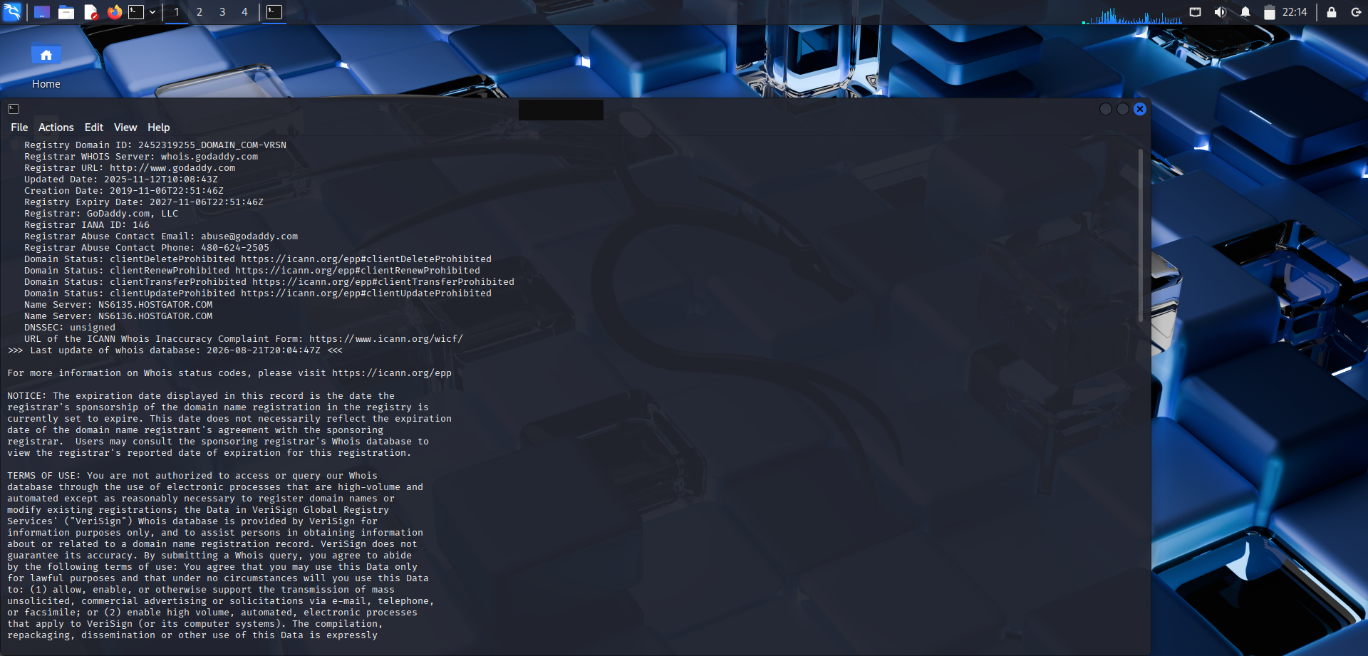
Task 1 — whois output (username redacted)
Task 2 — whatweb: Web Technology Fingerprinting
whatweb networkwalks.com
Finding | Value
Status | 301 Moved Permanently (http -> https redirect)
Web server | Apache
IP | 192.232.216.135
Country | UNITED STATES
Cookies | _wpdm_client (HttpOnly) — WordPress Download Manager plugin
Uncommon headers | x-redirect-by, x-endurance-cache-level, x-nginx-cache, permissions-policy, referrer-policy

Note: The automatic HTTPS follow-up probe returned "no address for networkwalks.com" — a temporary DNS failure inside the lab VM; later tasks resolved the domain normally.
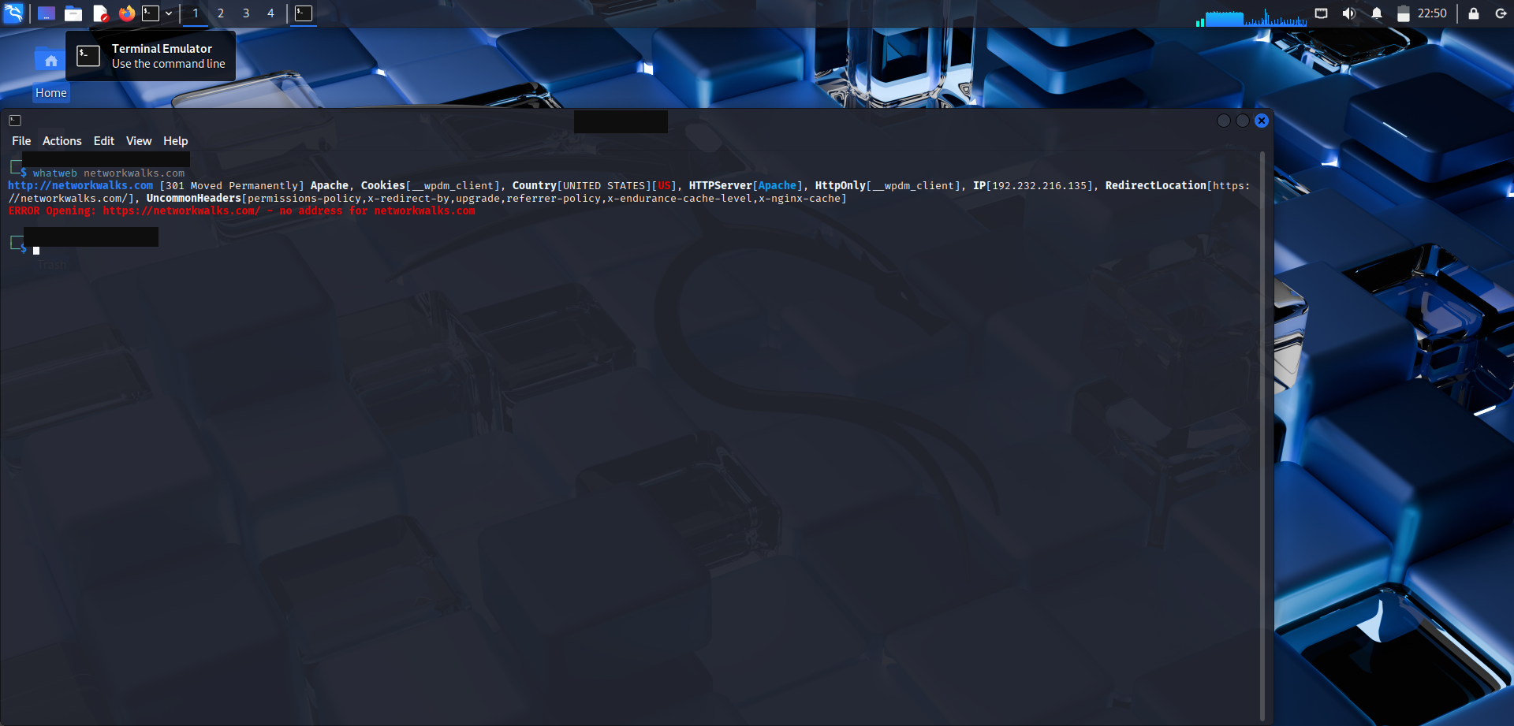
Task 2 — whatweb output (username redacted)
Task 3 — nslookup: Resolve the Domain to Its IP Address
nslookup networkwalks.com
- Result: networkwalks.com → 192.232.216.135
- DNS server used: 8.8.8.8#53 (Google public DNS, non-authoritative)
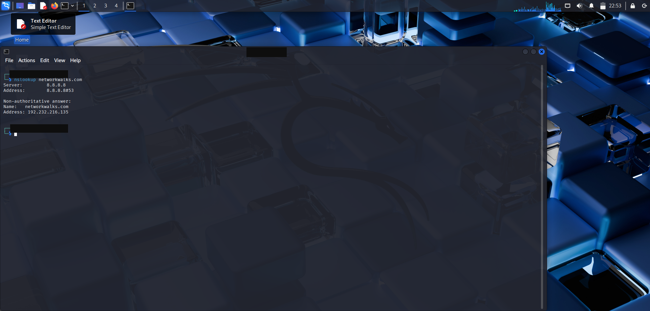
Task 3 — nslookup output (username redacted)
Task 4 — curl -I: HTTP Response Headers
curl -I https://networkwalks.com
Header | Finding
Status | HTTP/2 200 — the site is up
server | Apache
content-type | text/html; charset=UTF-8
x-nginx-cache | WordPress (WordPress behind nginx caching)
link | wp-json REST API links — WordPress (page ID 53)
permissions-policy | present
set-cookie | _wpdm_client=<redacted>; secure; HttpOnly (value masked)

Interpretation: Apache + nginx cache + WordPress + WordPress Download Manager — a classic shared-hosting WordPress stack, consistent with HostGator.
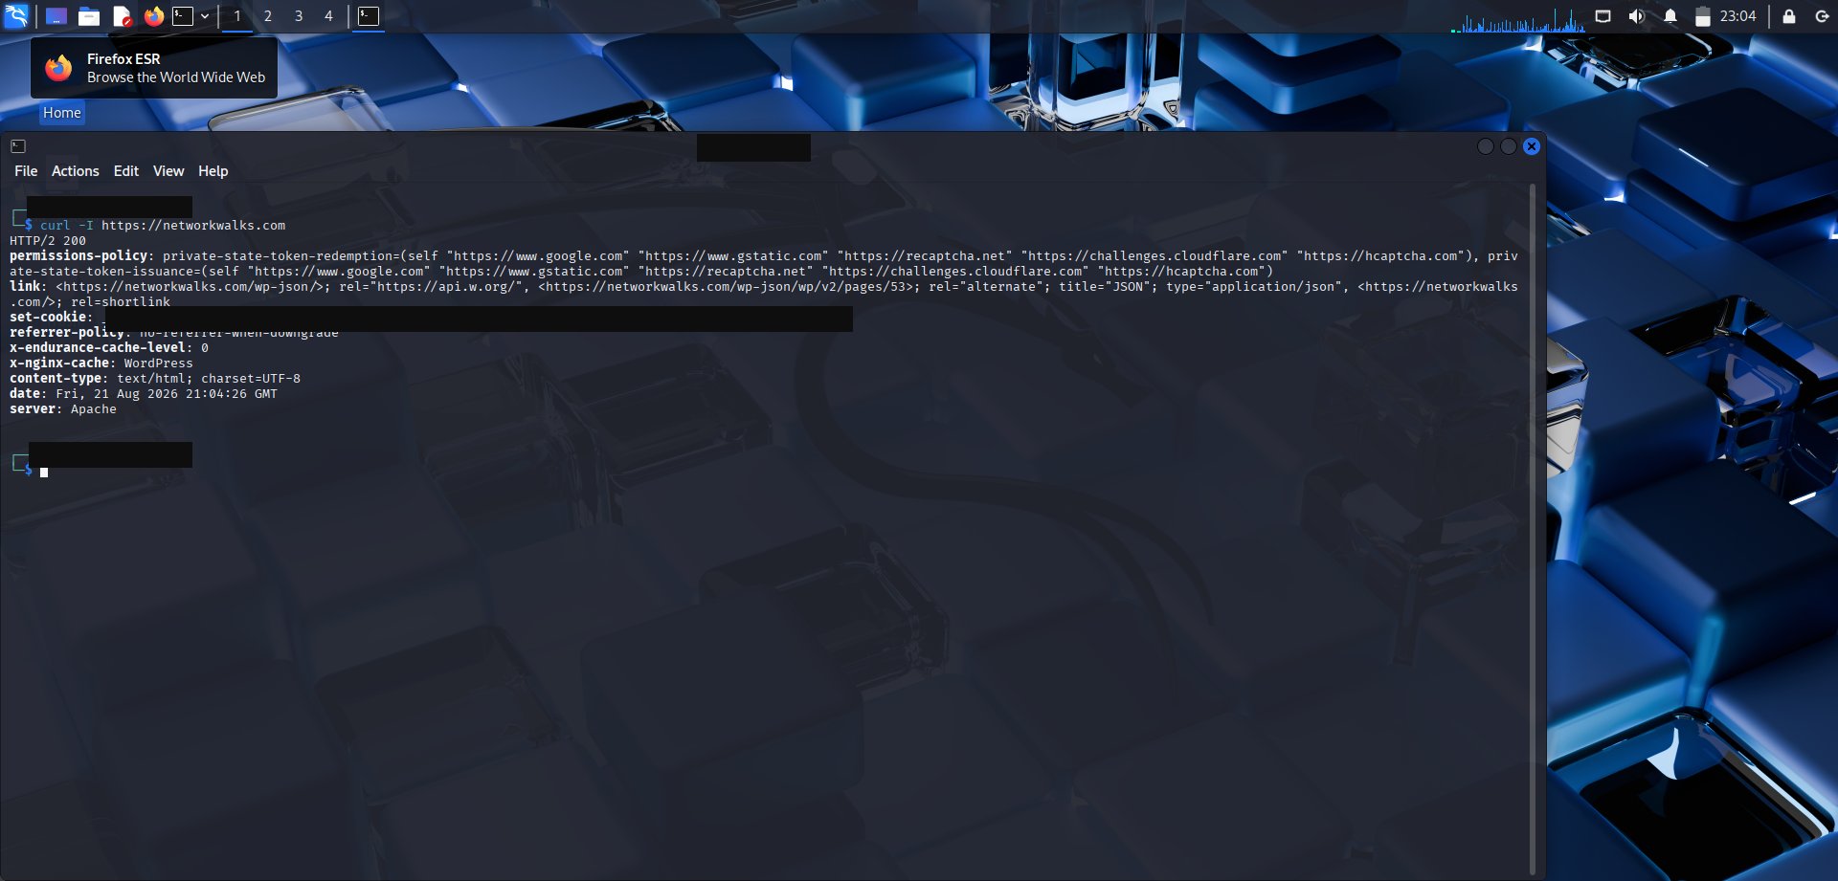
Task 4 — curl -I output (cookie value redacted)
Task 5 — wafwoof: Web Application Firewall Detection
wafwoof networkwalks.com
Result of this run: the probe failed before fingerprinting — the lab VM hit a temporary DNS failure (NameResolutionError: Failed to resolve 'networkwalks.com') and the tool reported the site "appears to be down".
- Tool executed correctly and probed https://networkwalks.com
- Site confirmed UP minutes later (curl -I → HTTP/2 200)
- Follow-up: re-run wafwoof with stable DNS to obtain the final WAF verdict
Interpretation: inconclusive run caused by a lab environment issue (VM DNS), not by the target. Documented honestly per good recon practice.
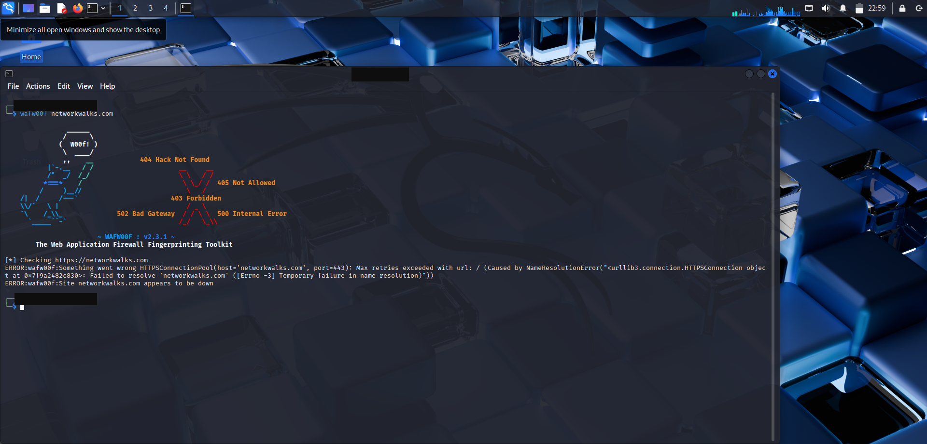
Task 5 — wafwoof output (username redacted)
Task 6 — dnsrecon: Enumerate All DNS Records
dnsrecon -d networkwalks.com
Record type | Finding
DNSSEC | Not configured (hardening gap)
NS | ns6136.hostgator.com → 192.232.216.131
TXT (SPF) | v=spf1 +a +mx +ip4:50.87.144.87 +include:websitewelcome.com ~all
TXT | google-site-verification=<redacted> (token masked)
SRV | No SRV records found

Interpretation: SPF permits mail from the site IP and HostGator's mail relay. The Google verification token confirms the owner uses Google Search Console.
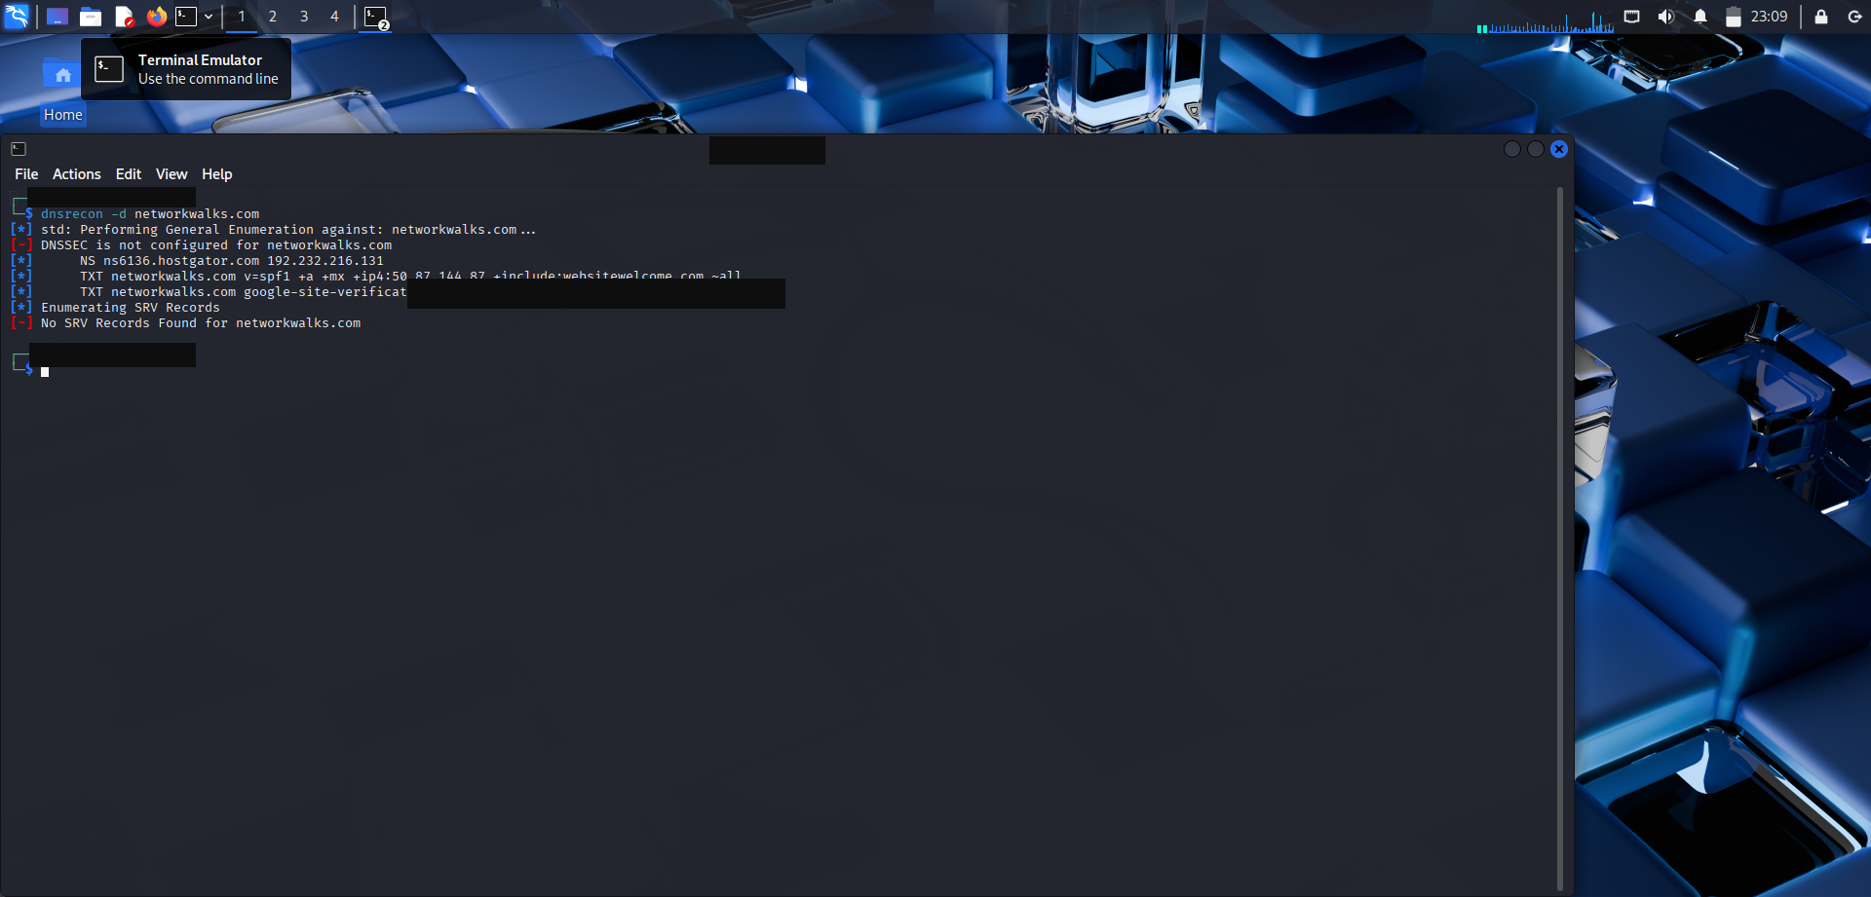
Task 6 — dnsrecon output (verification token redacted)
PM1 Summary
Tool | Question answered | Answer
whois | Who registered it? | GoDaddy, since 06 Nov 2019, expires 06 Nov 2027
whatweb | What runs it? | Apache + WordPress (HostGator hosting)
nslookup | What IP? | 192.232.216.135
curl -I | Server headers? | HTTP/2 200, Apache, WordPress via nginx cache
wafwoof | Is there a WAF? | Inconclusive (VM DNS failure) — to be re-run
dnsrecon | What DNS records? | HostGator NS, SPF, Google verification TXT, no DNSSEC

Part B — W2-PM5: Network Scanning with Zenmap
Scope: my own home LAN only — authorized scanning of my own network.
Task 1 — Download & Install Zenmap
Installed the official Nmap/Zenmap Windows bundle from nmap.org (includes the Npcap driver required for scanning).
Task 2 — Find My Local IP Address & LAN Subnet
ipconfig
Item | Result (masked)
Active adapter | Wi-Fi
IPv4 address | 192.168.x.101
Subnet mask | 255.255.255.0 (/24)
Default gateway | 192.168.x.1 (router)
Other adapter | 192.168.x.1 — VirtualBox Host-Only network (from the Week 1 lab)

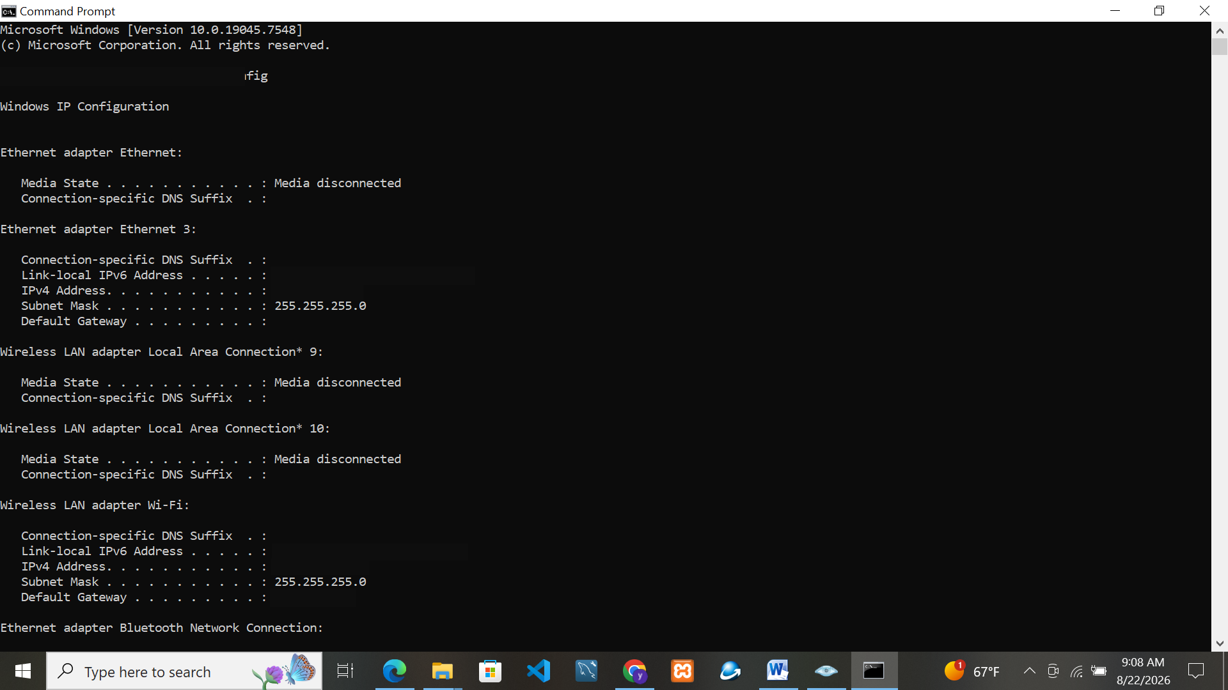
Task 2 — ipconfig output (IPs & username redacted)
Task 3 — Find the List of Live Hosts in the Subnet
nmap -T4 -F 192.168.x.0/24 (Zenmap "Quick scan" profile)
Result: Nmap done: 256 IP addresses (3 hosts up) scanned in 9.57 seconds
Tasks 4–6 — Count, IP Addresses and MAC Addresses of Live Hosts
# | IP (masked) | Role | MAC (masked) | Open ports
1 | 192.168.x.1 | Router / gateway | 3C:67:C9:XX:XX:XX | 53/tcp domain, 80/tcp http
2 | 192.168.x.100 | Other device (firewalled) | AA:77:28:XX:XX:XX | all filtered
3 | 192.168.x.101 | My PC | own adapter | 7, 9, 13, 135 msrpc, 139 netbios-ssn, 445 microsoft-ds, 5357 wsdapi

Answers: 3 hosts live in the /24 subnet. Ports 135/139/445 on my PC are the classic Windows RPC/SMB services — the exact attack surface exploited by worms such as EternalBlue (WannaCry), which is why SMB must stay patched.
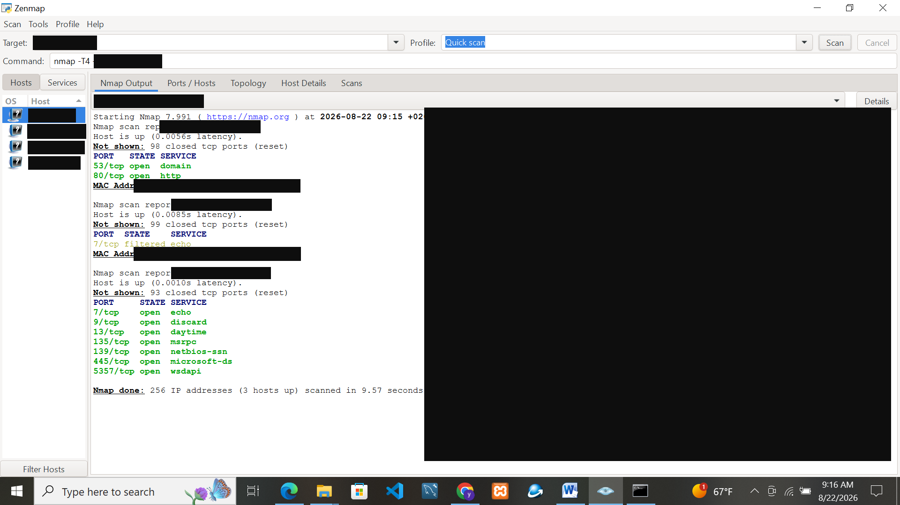
Tasks 3–6 — Zenmap Quick scan (IPs & MACs redacted)
Bonus — Intense Scan
Also ran the Intense scan profile (nmap -T4 -A -v) — OS detection, service version detection and NSE scripts on top of the quick scan.
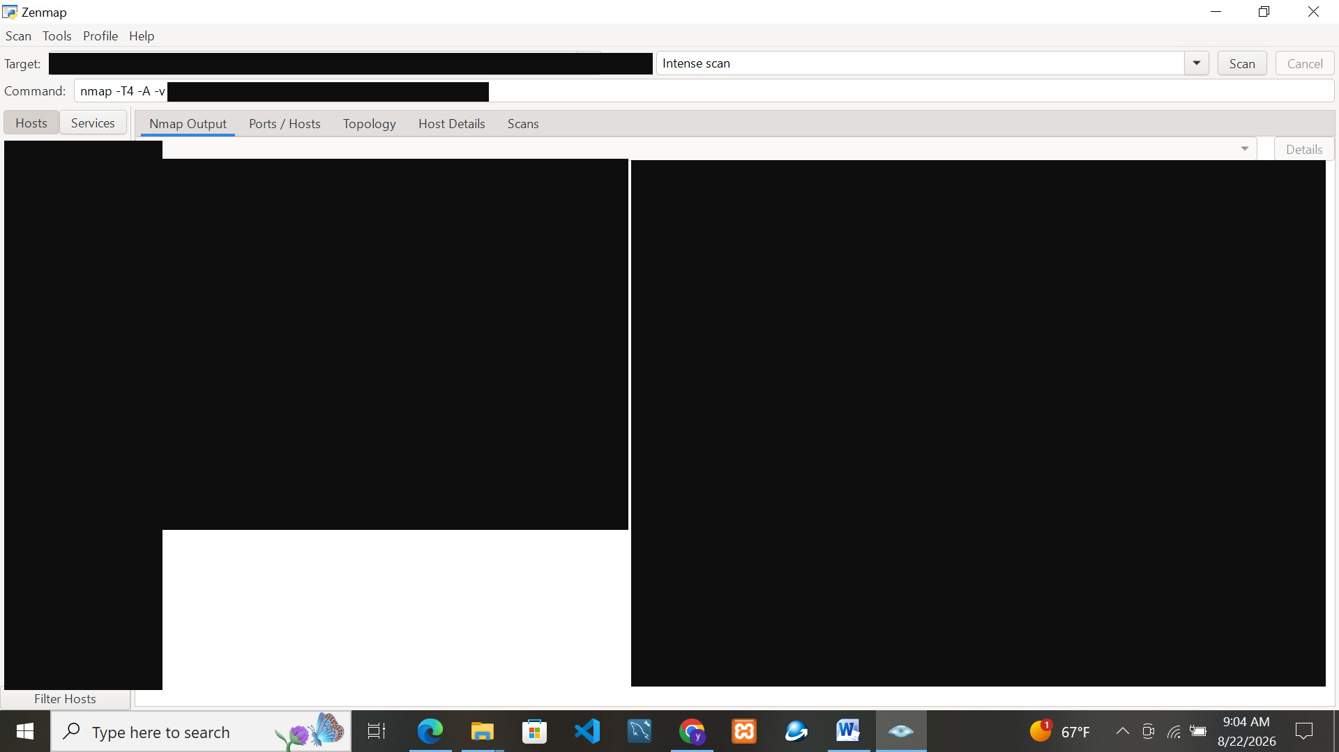
Bonus — Zenmap Intense scan (values redacted)
Task 7 — Save the Topology as PDF
Zenmap → Topology tab → Controls → Save Graphic → PDF → saved to Desktop (network_topology.pdf). The PDF is attached separately with the submission.
2. Lessons Learned
- Footprinting is legal, passive intelligence — whois, DNS and HTTP headers are public data anyone may query; the skill is knowing what each source reveals.
- Toolchain thinking — no single tool answers every question: registration (whois) → technology (whatweb) → addressing (nslookup/dnsrecon) → hardening (wafwoof) → reachability (curl).
- Host discovery is the universal first step — one quick scan maps an entire LAN in seconds.
- Everything announces itself — server headers, DNS records and open ports together draw the target's attack surface.
- Report sanitization is a professional skill — masking usernames, private IPs, MACs, cookies and tokens before publishing is standard practice.
3. Privacy & Ethics Statement
- All scanning was performed only on my own home network and against the course-designated target domain (networkwalks.com).
- All reconnaissance was passive and non-intrusive (public services only).
- Personal identifiers were redacted from screenshots and this report.
- This work is for educational purposes; unauthorized scanning of networks you do not own is illegal.
4. Acknowledgements
Special thanks to Sir Waqas Karim (CCIE) and the Networkwalks team for the guidance and support throughout Batch B082.
5. References
- Nmap / Zenmap — https://nmap.org/download.html
- Nmap Host Discovery — https://nmap.org/book/man-host-discovery.html
- Kali tools — https://www.kali.org/tools/
- IANA whois — https://www.iana.org/whois
Appendix A — Assignment Briefs (from course drive)
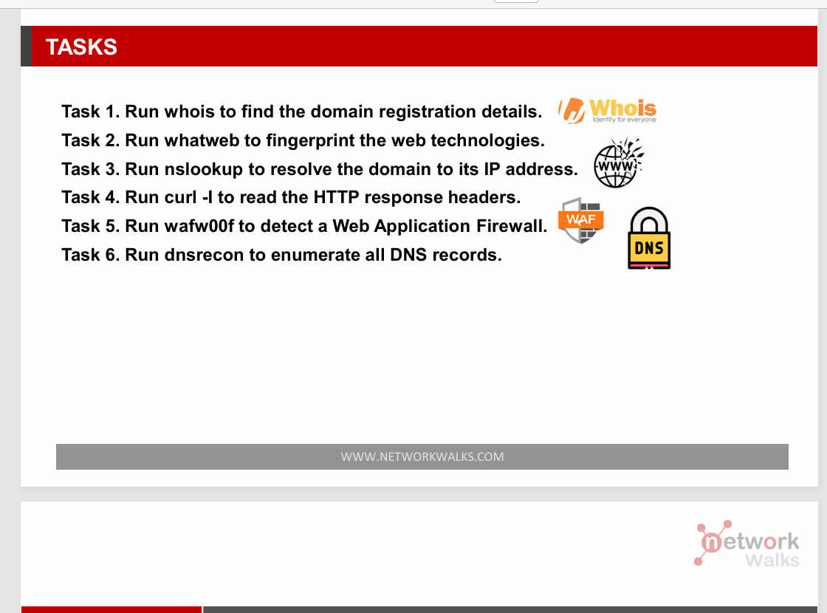
Official brief — W2-PM1
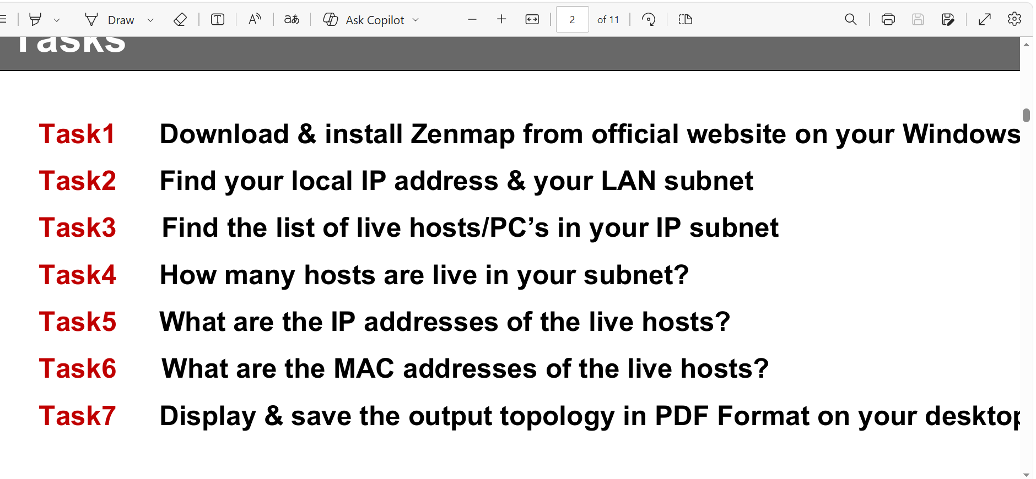
Official brief — W2-PM5

