ANAM data Quality report
Yoda Adaman

Quarto

title: “Quarto Basics” format: html: code-fold: true jupyter: python3 —
For a demonstration of a line plot on a polar axis, see Figure 1.
import numpy as np
import matplotlib.pyplot as plt
r = np.arange(0, 2, 0.01)
theta = 2 * np.pi * r
fig, ax = plt.subplots(
subplot_kw = {'projection': 'polar'}
)
ax.plot(theta, r);
ax.set_rticks([0.5, 1, 1.5, 2]);
ax.grid(True);
plt.show()
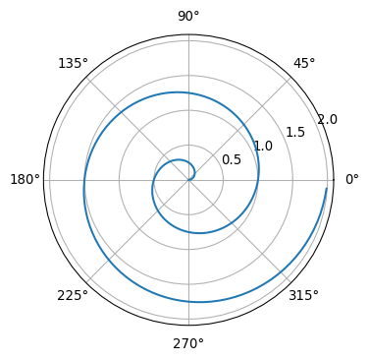
Figure 1: A line plot on a polar axis

