**A SYNOPSIS ON**



**A Framework for Fall Detection Using Audio and Video Features**



**Submitted in partial fulfillment of the requirement for the award of the degree of**

**BACHELOR OF TECHNOLOGY**

**IN**

**COMPUTER SCIENCE & ENGINEERING**

**Submitted by:**

**Medha Bisht** **2017341**

**Yogesh Thakur** **2017397**

**Aryamann Singh** **2017313**

**Divyam Kholia** **2017324**

***Under the Guidance of***

**Dr. Durgaprasad Gangodkar**

**Professor, Department of Computer Science & Engineering**

**Project Team ID: MP23CE004**



**Department of Computer Science and Engineering**

**Graphic Era (Deemed to be University)**

**Dehradun, Uttarakhand**

**September-2023**

.

**Table of Contents**

| **Chapter No.** | **Description** | **Page No.** |
| --- | --- | --- |
| Chapter 1 | Introduction and Problem Statement | **1** |
| Chapter 2 | Background/ Literature Survey | **4** |
| Chapter 3 | Objectives | **6** |
| Chapter 4 | Hardware and Software Requirements | **7** |
| Chapter 5 | Possible Approach/ Algorithms | **8** |
|  | References | **11** |

**Chapter 1**

**Introduction and Problem Statement**

* 1. **Introduction**

According to WHO data an estimated 684 000 fatal falls occur each year, for seniors aged 79 and above, falls are the primary reason for injury-related deaths, making it the second leading cause of unintentional death, after road injuries. While anyone can fall and all people who fall are at risk of injury, the age and health of an individual can affect the severity of the injury. Globally death rates due to fall are higher in adults over the age of 60. In 2022, there were 771 million people aged 65+ years globally, that is 10% of the world population. This is expected to increase to 16% by 2050. The financial cost of fall related injuries and long-term care are substantial all over the world, usually leading to some sort of disability.

The current methods commonly used to detect falls are portable sensors which need to be worn or embedded on various parts of the human body, in order for them to be able to detect falling events experienced by the person. If the wearer of these portable devices falls down, a signal is sent to a response center for analysis and subsequent resolution. For instance, some researchers have attempted to detect falls using different types of sensors, ranging from accelerometers to microphones or gyroscopes, or a combination of all these. However, the majority of senior citizens are not comfortable wearing these devices wherever they go, and to make matters worse, the standard portable sensors do not generate easily interpretable information, making the detection of falls difficult and unreliable. Computer-vision-based fall-detection overcomes these problems, since it provides fully passive monitoring and can also be used for other tasks, such as security. Therefore, the use of a video-based fall-detection system can be advantageous over active sensors.

The main issue with fall detection system is to differentiate any fall from daily life activities like crouching, sitting down etc. So, to achieve that the event of fall can be divided into three parts on is the pre-fall phase represents the daily life activities. Secondly, the critical phase which last for a very brief moment which represents the movement of body towards the ground or the shock of the body’s impact with the ground. Thirdly, the post fall phase representing the motionlessness of the person after falling on the ground.

Some fall detection algorithms also assume that falls of-ten end with a person lying prone horizontally on the ﬂoor. These kinds of systems use change of body orientation as an indicator for falls. But they are less effective when a person is not lying horizontally, e.g., a fall may happen on stairs

Recently, artificial neural networks can solve complex problems in industry and academia. They can solve many engineering problems and intelligent systems currently play crucial roles in the advancement and innovation of products worldwide. In the medical field, they are used to monitor the patients’ daily health in hospitals Debard et al. and in all areas of life. In the engineering field, the neural networks are used to classify patterns; to develop nonlinear filters which are adaptable to any situations and they are utilized in system identification as well. Nowadays, the neural network is considered an important available artificial intelligence tool to humankind.

A neural network is a structure which can receive inputs, process these inputs to produce the output where the input data can be of any dimensional value. The basic building block of a neural network is the neuron, which consists of a black box with weighted inputs and an output.

In this research paper, we'll explore the latest in fall detection technology. We'll see how these tools could make a real difference in healthcare. Our proposed system integrates audio features as an additional layer of assessment to not only detect falls but also verify the well-being of the individual. This innovative approach aims to enhance the safety of elderly individuals by ensuring timely aid in emergency situations. However, addressing the technical intricacies and ethical considerations in implementing such a system poses significant challenges that must be overcome to create a reliable and privacy-conscious solution.

* 1. **Problem Statement**

Falls can lead to severe injuries, diminished quality of life, and, in unfortunate cases, even fatal consequences. As the elderly population grows worldwide, there is a demand for better surveillance systems, specifically fall detection systems to tackle this issue. A fall detection system based on vision, that can automatically monitor and detect falls, recognize distress calls from the injured and send out help messages to local emergency numbers for timely medical care. When the system identifies a potential fall and determines distress through audio cues, it automatically triggers a call for help.

**Chapter 2**

**Background/ Literature Survey**

Various fall-detection solutions have been previously proposed to create a reliable surveillance system for elderly people with high requirements on accuracy, sensitivity, and specificity. All those systems can be divided into four approaches.

1. The first approach is based on accelerometers.
2. The second approach uses gyroscopes, which measure orientation.
3. Visual detection without posture reconstruction
4. Visual detection with posture reconstruction, markers are placed on human body. Marker coordinates are used as input data.

The problems that were faced in using an accelerometer for a fall detection system was its sensitivity and specificity. Also, it is hard to calibrate an accelerometer for maintaining its accuracy. As the accelerometer gets triggered due to sudden movements causing the rise of false positive and false negative situations leading to low accuracy.

The problems that were faced in using a gyroscope for a fall detection system was its energy consumption and cost. As the gyroscopes are costly but they are not made specially for fall detection and are sensitive to even small movements leading to false detections and missed detections.

The problem with using back brace sensors to detect falls is the placement of the sensor. Also the back brace sensors are heavy and uncomfortable to wear over a period of time. Also the could not detect a fall if the person falls on their face making it an expensive option and also less effective at the same time.

Real-time is a key feature for fall detection systems, especially for commercial products. Considering that certain falls can be fatal or detrimental to the health, it is crucial that the deployed fall detection systems have high computational efficiency, preferably operating in (near) real-time. Below, we comment how the methods proposed in the reviewed literature fit within this aspect.

The percentage of studies applying real-time detection by static visual sensors are lower than that of wearable devices. For the studies using wearable devices, It illustrates that six out of 20 studies that we reviewed can detect falls and send alarms. There are, however, few studies which demonstrate the ability to process data and send alerts in real-time for work conducted using individual visual sensors. One can note that although 40.9% (nine out of 22) of the studies claim that their systems can be used in real-time only one study showed that an alarm can actually be sent in real-time. The following are a couple of reasons why a higher percentage of vision-based systems cannot be used in real time. Firstly, visual data is much larger and, therefore, its processing is more time consuming than that of one-dimensional signals coming from non-vision-based wearable devices. Secondly, most of the work using vision sensors conducted their experiments with off-line methods, and modules like data transmission were not involved.

In their paper, the researchers introduce an innovative method for extracting data from the built-in accelerometer and orientation sensor of the Google Nexus One smartphone. This approach, which is based on a single-class SVM algorithm, tests with a variety of categories, such as falling posture while carrying a smartphone with a falling orientation.

In video-based fall detection, human activity is captured in a video that is further analyzed using image processing techniques. Since video cameras have been widely used for surveillance as well as home and health care applications, we use this approach for our fall detection method. The study in paper presents an automated method for detecting human falls in video footage. It comprises two main components: object detection and a fall model. Object detection employs adaptive background subtraction using a Gaussian Mixture Model in the YCbCr color space. The fall model extracts feature like aspect ratio, gradient values, and fall angle from detected objects.

Other notable mentions include paper, it introduces an innovative fall monitoring system that analyzes human fall behaviors using AI algorithms, IP cameras, and a cost-effective microcomputer. Unlike previous systems, it efficiently processes data from up to eight cameras simultaneously, enhancing accuracy. The system can work with both low and high-resolution cameras, allowing extensive monitoring in various settings. It excels at differentiating falls from regular activities, even in complex backgrounds. The goal is widespread implementation in senior homes, rehab centers, and high-risk areas to reduce fall-related injuries and fatalities.

Other researchers propose to use 3D cameras in order to get specific coordinates of the human inside of the room with respect to the floor. This approach proved to have nice results but because of the use of 3D cameras, it is very expensive for the healthcare home environment where you will need multiple cameras to cover all the rooms.

**Chapter 3**

**Objectives**

The objectives of the proposed work are as follows:

1. To accurately detect falls on the basis of the video and live time camera feed, even in

challenging environments.

1. To accurately detect falls on the basis of the distress call made by the person during or

after the fall for help, even in noisy environment.

1. To minimize the delay between the occurrence of a fall and the system's detection for

emergency situations.

1. To minimize the number of false alarms, which can be caused by other activities, such

as sitting down or lying down.

1. To provide alerts quickly so that help can be provided to the person who has fallen as

soon as possible.

1. To Provide additional information about the fall, such as potential injuries, to assist

caregivers and medical professionals.

**Chapter 4**

**Hardware and Software Requirements**

**4.1 Hardware Requirements**

| Sl. No | Name of the Hardware | Specification |
| --- | --- | --- |
| 1 | Camera | Resolution-720p & FOV – 80° |
| 2 | Computer | 2.5 Ghz & 4 GB RAM |
| 3 | Storage (Hard drive) | 128 – 512 GB |
| 4 | Network Connection | 4 – 40 Mbps |

**4.2 Software Requirements**

| Sl. No | Name of the Software | Specification |
| --- | --- | --- |
| 1 | Operating System | Windows |
| 2 | Programming Language | Python |
| 3 | Machine Learning Library | Tensorflow, scikit-learn |
| 4 | Video Processing Library | OpenCV |
| 5 | Software Tools | VS Code |
| 6 | Dataset | Photos, videos, audio |
| 7 | Fall Detection Algorithm | Using CNN/RNN |

**Chapter 5**

**Possible Approach/ Algorithms**

* 1. **Support Vector Machine**

SVM (Support Vector Machine) is a supervised machine learning model mostly used for classification problems. The SVM works by finding a hyperplane that separates the two classes of data. In this case the two classes would be falls and not falls. R[9]

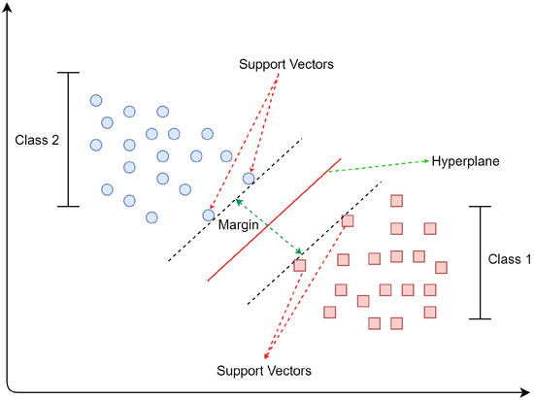

**Fig - 5.1.1 (Graphical representation of SVM)**

* 1. **Random Forest**

Random forests (RFs) are a type of ensemble learning algorithm that combines multiple decision trees to make predictions. RFs can be used for fall detection because they are able to learn complex patterns in the data and they are relatively robust to noise. R[9]

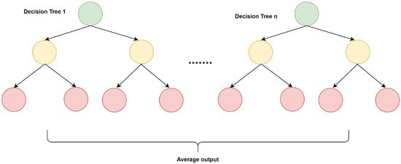

**Fig - 5.2.1 (Decision tree derived from Random Forest)**

* 1. **K-Nearest Neighbors**

kNN is a supervised learning model for solving classification models. kNN works on the principle that same things lie in close proximity. It tries to find the distance between two data points using different metrics most commonly used is Euclidean distance. It creates a sorted list containing distances between points and the first entries get selected. So, it can help in distinguishing between fall and non-fall situations or behaviors. Formula used to find the distance between two points is:

d = √ (((x2 – x1) ^2) + ((y2-y1) ^2))

Where:

d is the distance between two points

(x1, y1) and (x2, y2) are coordinates of first and second point respectively. R[9]

The following piece of code shows how to create and predict with a kNN model:

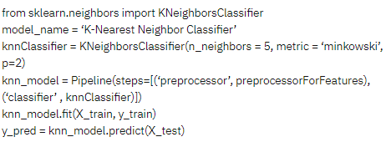

**Fig - 5.3.1 (Snippet of kNN)**

* 1. **Convolutional Neural Network**

Convolutional neural networks (CNNs) are a type of deep learning algorithm that are well-suited for image recognition tasks. CNNs can be used to extract features from images, such as the edges and shapes of objects. CNNs can also be used for audio/ speech recognition. As it can also features from audio signals like frequency and amplitude of the signal to classify the audio signal. These features can then be used to classify the images and audio signals into different categories, such as falls or not falls. R[6]

* 1. **Recurrent neural networks**

RNNs are another type of deep learning algorithm that can be used for audio/speech recognition. RNNs are also used to model the temporal dynamics of audio signals, such as the changes in frequency and amplitude over time. These features can then be used to classify the audio signal as a fall or not a fall. The only disadvantage of using RNNs is that it requires a quiet environment to recognize audio while CNNs might be a better choice in noisy environment. R[7]

* 1. **Artificial Neural Network**

An ANN is a machine learning algorithm whose methodology is inspired by the working of the human brain. The human brain is composed of billions of neurons that process information in the form of electric signals. The neurons generally make a decision based on the electric signal strength. Similarly, the ANN consists of many interconnected processing elements to solve a specific problem. R[6]

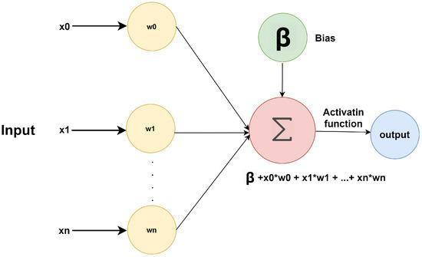

**Fig - 5.6.1 (Flow Chart of ANN)**

**References**

[1] Vo Viet1 and Deok-Jae Choi1 1 School of Electronics and Computer Engineering, Chonnam National University **“**Fall Detection with SmartPhone Senso” The 3rd International Conference on Internet (ICONI) 20112011 KSII .

[2] Vinay Vishwakarma, Chittaranjan Mandal, and Shamik Sural , “Automatic Detection of Human Fall in Video”, School of Information Technology Indian Institute of Technology, Kharagpur, India

[3] Rancy Shu1 and Jef Shu2 “An eight-camera fall detection system using human fall pattern recognition via machine learning by a low-cost android box” from [www.nature.com/articles](http://www.nature.com/articles)

[4] Video-Based Fall Detection in the Home Using Principal Component Analysis.

# Source: <https://link.springer.com/chapter/10.1007/978-3-540-88458-3_27>

[5] Implementation of an intelligent and video-based fall detection system using a neural network. Source: <https://www.sciencedirect.com/science/article/abs/pii/S156849461400043X>

[6] Computer vision based fall detection by a convolutional neural network.

Source : <https://dl.acm.org/doi/abs/10.1145/3136755.3136802>

[7] Indoor human fall detection system based on automatic vision using computer vision. Source:<https://jestec.taylors.edu.my/Vol%2013%20issue%208%20August%202018/13_8_22.pdf>

[8] Implementation of a monitoring system for fall detection in elderly healthcare.

Source: <https://www.sciencedirect.com/science/article/pii/S1877050910004114>

[9] Implementation of fall detection in elderly healthcare.

Source: <https://www.mdpi.com/1424-8220/21/15/5134>