**Project Progress Report on**



**A Framework for Fall Detection Using Audio and Video Features**



**Submitted in partial fulfilment of the requirement for the award of the degree of**

**BACHELOR OF TECHNOLOGY**

**IN**

**COMPUTER SCIENCE & ENGINEERING**

**Submitted by:**

**Medha Bisht** **2017341**

**Yogesh Thakur** **2017397**

**Aryamann Singh** **2017313**

**Divyam Kholia** **2017324**

***Under the Guidance of***

**Dr. Durgaprasad Gangodkar**

**Professor, Department of Computer Science & Engineering**

**Project Team ID: MP23CE004**

**Project Progress Report No: 1**



**Department of Computer Science and Engineering**

**Graphic Era (Deemed to be University)**

**Dehradun, Uttarakhand**

**2023-24**



**CANDIDATE’S DECLARATION**

I/We hereby certify that the work which is being presented in the project progress report entitled**“A Framework for Fall Detection Using Audio and Video Features”** in partial fulfillment of the requirements for the award of the Degree of Bachelor of Technology in Computer Science and Engineering in the Department of Computer Science and Engineering of the Graphic Era (Deemed to be University), Dehradun shall be carried out by the undersigned under the supervision of **Dr. Durgaprasad Gangodkar, Professor**, Department of Computer Science and Engineering, Graphic Era (Deemed to be University), Dehradun.

Medha Bisht University Roll no: 2017341 Signature:

Yogesh Thakur University Roll no: 2017397 Signature:

Aryamann Singh University Roll no: 2017313 Signature:

Divyam Kholia University Roll no: 2017324 Signature:

The above mentioned students shall be working under the supervision of the undersigned on the **“A Framework for Fall Detection Using Audio and Video Features”**

**Supervisor** **Head of the Department**

**Examination**

**Name of the Examiners: Signature with Date**

1.

2.

**Table of Contents**

|  |  |  |
| --- | --- | --- |
| **Chapter No.** | **Description** | **Page No.** |
| Chapter 1 | Introduction and Problem Statement |  |
| Chapter 2 | Objectives |  |
| Chapter 3 | Project Work Carried Out |  |
| Chapter 4 | Future Work Plan |  |
| Chapter 5 | Weekly Task |  |
|  | References |  |

**Chapter 1**

**Introduction and Problem Statement**

**1.1** **Basic Overview:**

According to WHO data an estimated 684 000 fatal falls occur each year, for seniors aged 79 and above, falls are the primary reason for injury-related deaths, making it the second leading cause of unintentional death, after road injuries. The financial cost of fall related injuries and long-term care are substantial all over the world, usually leading to some sort of disability.

The current methods commonly used to detect falls are portable sensors which need to be worn or embedded on various parts of the human body, in order for them to be able to detect falling events experienced by the person. Our framework for fall detection is based on vision, that can automatically monitor and detect falls, recognize distress calls from the injured and send out help messages to local emergency numbers for timely medical care. When the system identifies a potential fall and determines distress through audio cues, it automatically triggers a call for help.

**1.1.1 Vision:**

Our vision is both simple and profound: to equip travelers with the tools and insights necessary to embark on their dream adventures with confidence. The Travel Buddy's conception is rooted in the intuition that technology, when applied thoughtfully, can cultivate deeper connections with the world. It seeks to bridge cultural gaps, overcome language barriers, and explore the unknown, all while creating memorable and transformative travel experiences.

**1.1.2** **Why a fall detection framework using audio and video features ?**

The main issue with existing fall detection systems is to differentiate any fall from daily life activities like crouching, sitting down etc. So, the event of fall can be divided into three parts one is the pre-fall phase represents the daily life activities. Secondly, the critical phase which represents the movement of body towards the ground or the shock of the body’s impact with the ground. Thirdly, the post fall phase representing the motionlessness of the person after falling on the ground.

**1.2** **Problem Statement:**

Falls can lead to severe injuries, diminished quality of life, and, in unfortunate cases, even fatal consequences. As the elderly population grows worldwide, there is a demand for better surveillance systems, specifically fall detection systems to tackle this issue. A fall detection system based on vision, that can automatically monitor and detect falls, recognize distress calls from the injured and send out help messages to local emergency numbers for timely medical care. When the system identifies a potential fall and determines distress through audio cues, it automatically triggers a call for help.

**1.3** **Key Features:**

Our AI powered Travel Companion offers the following features:

1. **Personalized Recommendations:** Our AI engine learns your preferences and suggests tailored experiences, from restaurants to cultural activities, ensuring every moment of your journey is curated to your liking.
2. **Real-Time Google API Integration:** Seamlessly access Google's vast database to translate languages, navigate unfamiliar streets, and discover nearby points of interest, all in real-time.
3. **Safety Assurance:** Rest easy with our Travel Buddy's real-time safety alerts and emergency assistance features, which connect you to local authorities and support when needed.
4. **Travel Itinerary Planning:** Let our platform take care of the logistics. Plan your trip, book flights and accommodations, and receive timely suggestions for optimizing your itinerary.
5. **Weather Forecast:** Stay prepared with up-to-date weather forecasts for your destination, ensuring you pack and plan accordingly for any weather conditions.
6. **Famous Places to Visit:** Discover hidden gems and iconic landmarks alike with insights on must-visit places, historical significance, and local legends.

In a world brimming with exploration possibilities, the AI-powered Travel Buddy is your gateway to unlocking the full potential of your adventures. As we navigate the future of travel companionship, we invite you to join us on this transformative journey. Whether you seek adventure, cultural immersion, or a stress-free vacation, our Travel Buddy is your steadfast companion, ready to turn your travel dreams into unforgettable realities. Together, let's redefine the way the world explores and connects—one journey at a time.

**Chapter 2**

**Objectives**

The objectives of the proposed work are as follows:

1. **Detect fall in complex situation:** To accurately detect falls on the basis of the video and live time camera feed, even in challenging environments.
2. **Distress Call:** To accurately detect falls on the basis of the distress call made by the person during or after the fall for help, even in noisy environment.
3. **Fast Response:** To minimize the delay between the occurrence of a fall and the system's detection for emergency situations.
4. **Removal of False alarm:** To minimize the number of false alarms, which can be caused by other activities, such as sitting down or lying down.
5. **Real-Time Assistance:** To provide alerts quickly so that help can be provided to the person who has fallen as soon as possible.
6. **User Assistance:** To Provide additional information about the fall, such as potential injuries, to assist caregivers and medical professionals.

**Chapter 3**

**Project Work Carried Out**

**3.1. Research Done so Far:**

1. This foundational study delineates the concept of AI Travel Buddies, underscoring their pivotal role in furnishing personalized travel recommendations, real-time assistance, and safety features. [1]
2. This study delves into the realm of machine learning algorithms to personalize travel itineraries and recommendations, drawing insights from user preferences, historical data, and real-time context. [2]
3. A comprehensive exploration of recommender systems in the tourism industry, shedding light on their applications within AI Travel Buddies for suggesting accommodations, activities, and dining options. [3]
4. This research paper introduces methodologies for real-time translation of foreign languages and navigation assistance, addressing crucial aspects of AI Travel Buddies. [4]
5. Investigating the integration of AI algorithms, this study focuses on real-time safety alerts and emergency assistance, ensuring the well-being of travelers throughout their journeys. [5]
6. Delving into the technical intricacies, this paper explores the integration of third-party APIs, encompassing Google Maps, weather forecasting, and booking platforms to enhance user experiences within AI Travel Buddies. [6]
7. A research endeavor exploring the amalgamation of various modalities, including visual, auditory, and augmented reality, to offer travelers immersive and informative experiences. [7]
8. Examining the impact of Artificial Intelligence in Travel and Tourism, this study navigates the delicate balance between delivering an exceptional user experience and ensuring responsible handling of user data, addressing privacy concerns associated with AI Travel Buddies. [8]

**3.2 Research Progress Overview:**

To estimate human body, pose in a video/image we used media pipe – pose estimation by google. Its land marker task lets us to detect different points of human body in an image or video as well as in live feed. So, to detect a fall the model measures if the center of gravity of a person in the feed is in between the co ordinates of the feet else the system detects a fall in the feed.

* **Step 1: Extracting Landmarks**

Using the media pipe landmark function, we extracted the landmarks for different body parts of a human in the feed. The co ordinates for different joints are calculated in different manner the different manners are displayed in the images below. 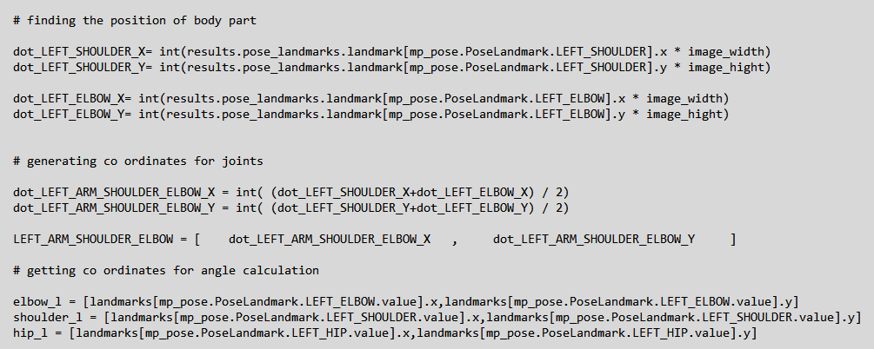

Fig – 3.2.2 – Extracting landmarks.

* **Step 2: Calculating Angles**

Using the landmarks extracted from the last step we calculate the angles between different joints of human body. The method is displayed in images below. 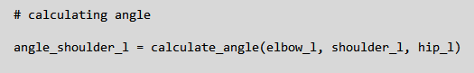

Fig – 3.2.3 – Calculating angles using extracted landmarks.

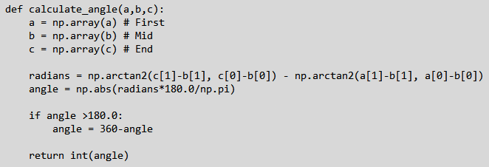

Fig – 3.2.4 – Function of calculating angles.

* **Step 3: Extracting Points for Base of Human Body**

This part is most important as we are calculating and generating the co ordinates of the base of human body which will be one of the deciding factors of a fall. These points will be extracted using the landmarks extracted in the *Step 1.* These points are denoted as points of action and the way these points of actions are calculated is shown below.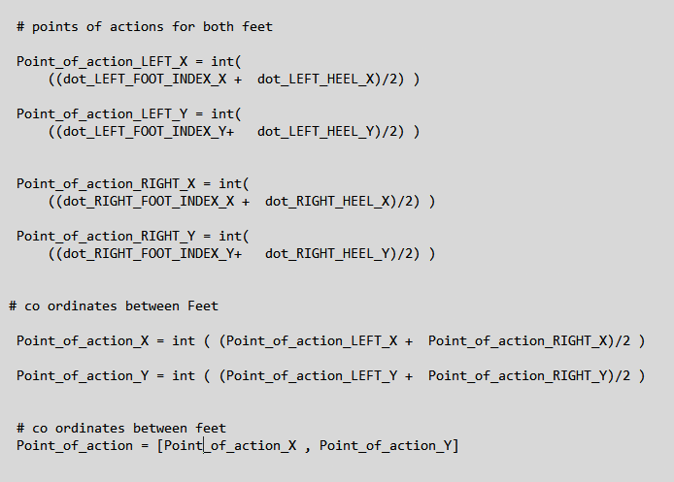

Fig -3.2.5 – Points of action calculation.

* **Step 4: Detecting Fall**

To detect the fall, we subtract the value of x coordinate of base (point of action) with the x coordinate of the center of mass/gravity of the body and then if it meets certain conditions then it is considered as a fall else the person is considered as standing. The conditions are in the image below.

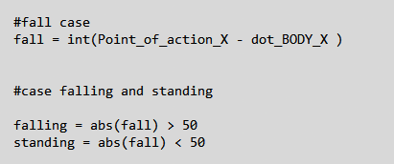

Fig – 3.2.6 – Fall Detection.

**3.3 Algorithm Used:**

The model uses media pipe by google to detect and find all the landmarks for all the major parts of the body and later using these coordinates finds the base of the human in the feed and the center of mass of that human for upper, lower and full body and then if the center of mass of the body goes out from the base of the human body, then it considers it as a fall.

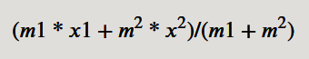

Fig – 3.3.1 – Formula to calculate rectangle’s center of gravity

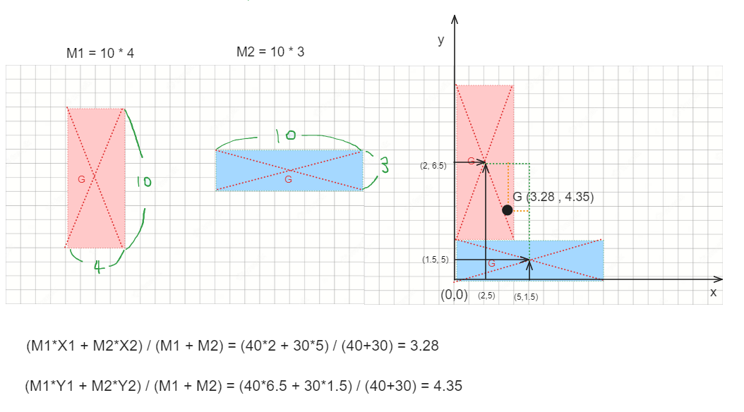

Fig – 3.3.2 – Example of center of mass of a rectangle

So, measuring the fall for human body will work like as follow:

Human’s Body center of mass * 0.75 > | x-axis center of feet – x-axis center of mass of body |

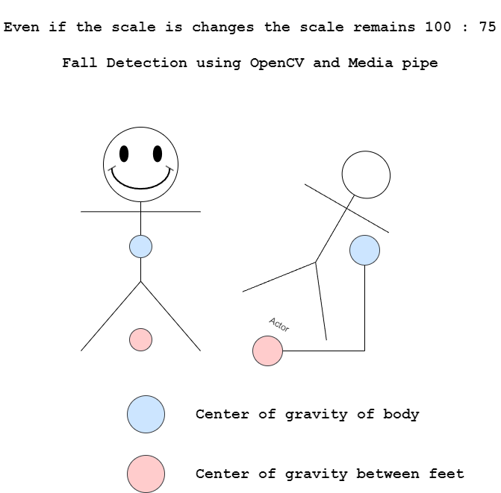

Fig – 3.3.3 – Representation.

**3.4 Tools used:**

* **Media Pipe** – For pose estimation
* **Open CV** – For using videos/images as input

**3.5 Results**

* **Standing:**

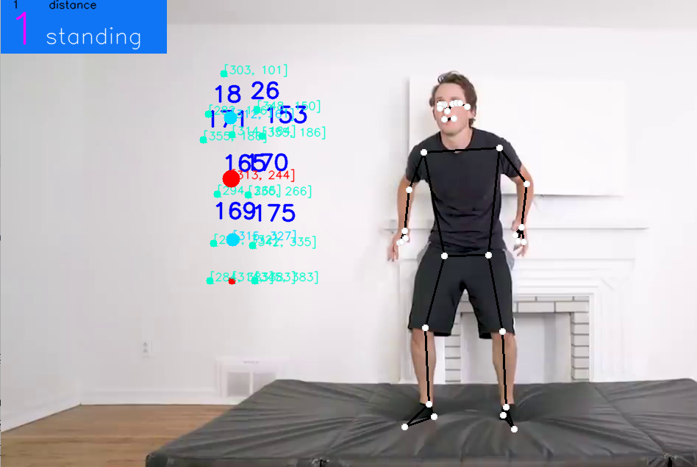

Fig – 3.5.1 – Standing.

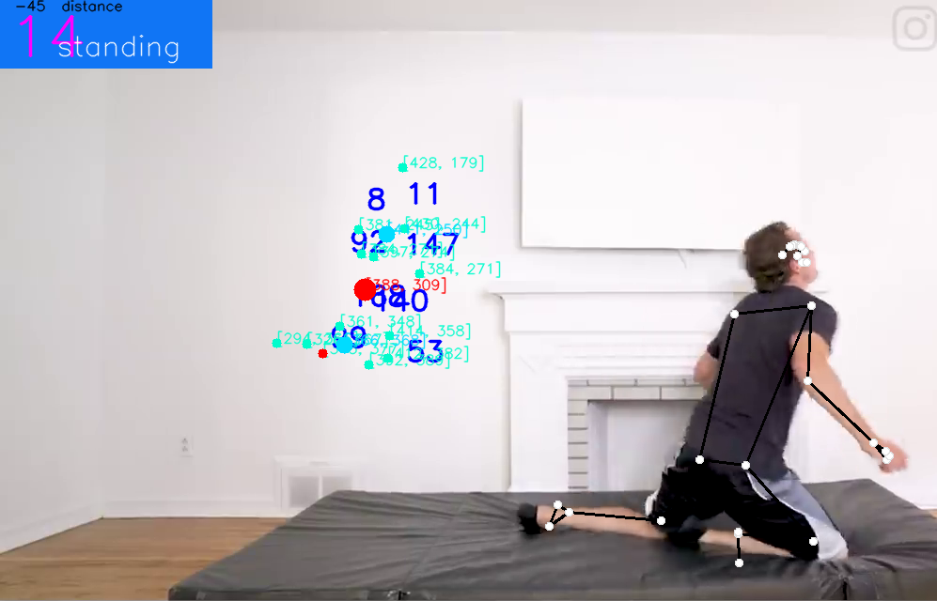

Fig – 3.5.2 – Standing as on knees.

* **Fallen:**



Fig – 3.5.3 – Fallen.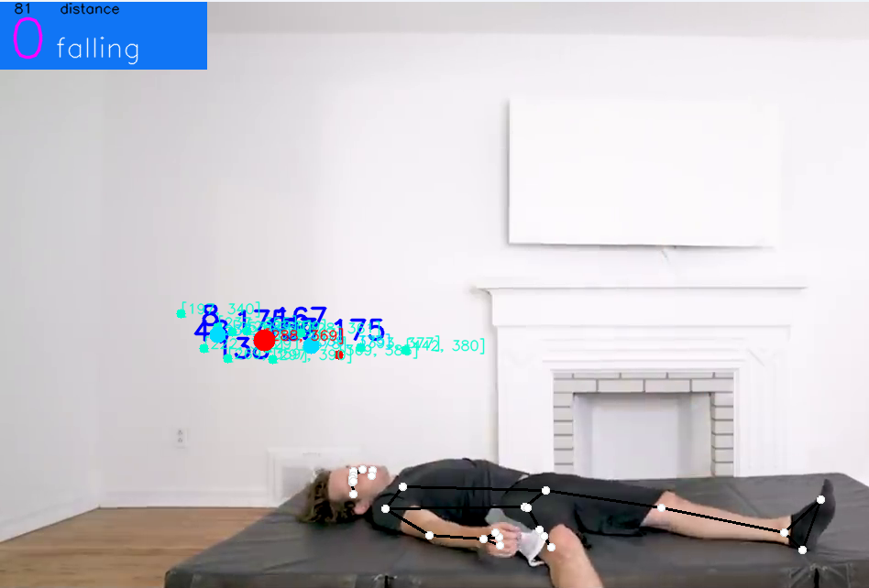

Fig – 3.5.4 – Fallen.

**Chapter 4**

**Future Work Plan**

The future work plan of our project are as follows:

|  |  |  |
| --- | --- | --- |
| **Sl. No.** | **Work Description** | **Duration in Days** |
| **1** | We plan to generate alerts to send a notification or any other type of alert when ever a fall is detected. It can be done by using telepot library of python. |  |
| **2** | We plan to integrate audio features into our fall detection framework. The addition of audio-based analysis aims to provide complementary information to enhance the overall effectiveness of fall detection. |  |
|  |  |  |
|  |  |  |

**Chapter 5**

**Weekly Task**

The report of project work allocated by the supervisor is as follows:

|  |  |  |  |  |  |
| --- | --- | --- | --- | --- | --- |
| **Week No.** | **Date:**  **From-To** | **Work Allocated** | **Work Completed**  **(Yes/No)** | **Remarks** | **Guide Signature** |
| 1 |  |  |  |  |  |
| 2 |  |  |  |  |  |
| 3 |  |  |  |  |  |
| 4 |  |  |  |  |  |
| 5 |  |  |  |  |  |
| **Add rows, if required** | | | | | |

**References**

[1] V. Viet and D.-J. Choi, "Fall Detection with Smartphone Sensor," in Proc. 3rd Int. Conf. Internet (ICONI), Chonnam National University, 2011, pp. 2011-2011.

[2] V. Vishwakarma, C. Mandal, and S. Sural, "Automatic Detection of Human Fall in Video," School of Information Technology, Indian Institute of Technology, Kharagpur, India.

[3] R. Shu1 and J. Shu2, "An eight-camera fall detection system using human fall pattern recognition via machine learning by a low-cost android box," www.nature.com/articles.

[4] L. Hazelhoff, J. Han, and P.H.N. de With, "Video-Based Fall Detection in the Home Using Principal Component Analysis," in Advanced Concepts for Intelligent Vision Systems, J. Blanc-Talon et al. (eds.), Lecture Notes in Computer Science, vol. 5259, Springer, Berlin, Heidelberg, 2008, pp. 27-36.

[5] L. Alhimale, H. Zedan, and A. Al-Bayatti, "The implementation of an intelligent and video-based fall detection system using a neural network," Applied Soft Computing, vol. 18, pp. 59-69, 2014.

[6] Miao Yu, Liyun Gong, and Stefanos Kollias. 2017. Computer vision based fall detection by a convolutional neural network. In Proceedings of the 19th ACM International Conference on Multimodal Interaction (ICMI '17). Association for Computing Machinery, New York, NY, USA, 416–420.

[7] K. Gunale and P. Mukherji, "Indoor human fall detection system based on automatic vision using computer vision," Journal of Engineering Science and Technology, vol. 13, no. 8, pp. 2587-2605, Aug. 2018.

[8] S. Khawandi, B. Daya, and P. Chauvet, "Implementation of a monitoring system for fall detection in elderly healthcare," Procedia Computer Science, vol. 3, pp. 216-220, 2011.

[9] T.H. Noor, "Human Action Recognition-Based IoT Services for Emergency Response Management," Mach. Learn. Knowl. Extr., vol. 5, pp. 330-345, 2023.

[10] S. Usmani, A. Saboor, M. Haris, M.A. Khan, and H. Park, "Latest Research Trends in Fall Detection and Prevention Using Machine Learning: A Systematic Review," Sensors, vol. 21, pp. 5134, 2021.