**WATER QUALITY ANALYSIS**

**Data Loading & Data Processing**

**Introduction:**

In the world of data science, the quality of your analysis or machine learning model heavily depends on the quality of your data. Raw data, as it's collected, is often messy, inconsistent, and incomplete. Data loading and preprocessing are the foundational steps in any data-related project. This introduction explores why these steps are vital and how they set the stage for meaningful insights and reliable models.

**Data Loading:**

In water quality analysis, loading data accurately and efficiently is crucial for obtaining meaningful results. Here is a step-by-step guide on how to load and handle data for water quality analysis

**1. Define Your Objectives:**

Clearly define the objectives of your water quality analysis. Understand what parameters you need to measure, and what kind of data (e.g., chemical, physical, biological) you will be dealing with.

**2. Data Collection:**

Collect water samples from various sources such as rivers, lakes, wells, or wastewater treatment plants. Ensure that the samples are collected using proper techniques and stored appropriately to maintain their integrity.

**3. Data Types:**

Water quality data can include various types such as numerical (pH levels, chemical concentrations), categorical (water type, pollution level), spatial (location data), and temporal (time and date of sample collection) data.

**4. Data Sources:**

Obtain data from reliable sources such as government agencies, research institutions, or your own field measurements. Ensure that the data is accurate, complete, and relevant to your analysis.

**5. Data Storage:**

Organize your data in a structured format. Consider using spreadsheets, databases, or specialized software designed for environmental data management. Each parameter should ideally have its own column, and each row should represent a unique sample.

**Code:**

**import pandas as pd**

**df=pd.read­_csv(“water­_probability.csv”)**

**Print(df)**

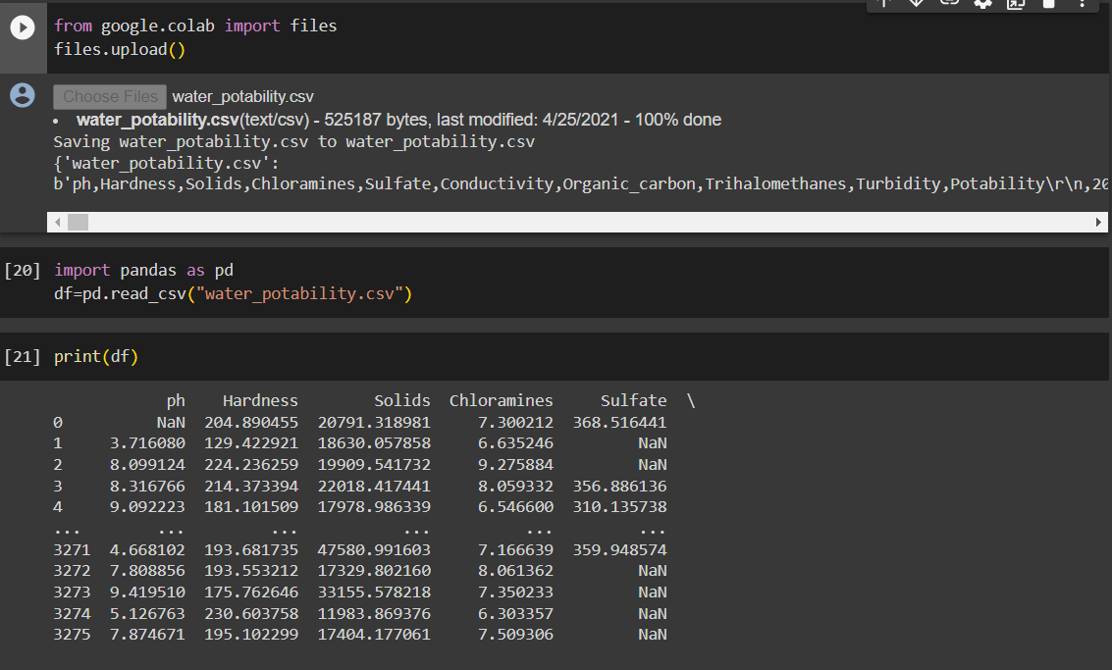

**Fiq – 1 : Data Loading**

**Data Preprocessing:**

Data preprocessing is a crucial step in any data analysis or machine learning project. It involves cleaning, transforming, and organizing the raw data into a format suitable for analysis or modeling. Here's why data preprocessing is essential

**1. Handling Missing Data:**

Real-world datasets often have missing values. Preprocessing techniques such as imputation (filling in missing values) ensure that the analysis or model-building process is not compromised due to missing data.

**2. Dealing with Noisy Data:**

Noise in data can come from various sources, leading to inaccuracies. Preprocessing techniques such as smoothing can help reduce noise, ensuring that the data used for analysis is more reliable.

**3. Handling Categorical Data:**

Machine learning algorithms usually work with numerical data, so categorical variables need to be converted into numerical representations. Techniques like one-hot encoding or label encoding are used to convert categorical data into a format suitable for algorithms.

**4. Feature Scaling:**

Features often have different scales. Algorithms like Support Vector Machines and k-Nearest Neighbors are sensitive to feature scales. Preprocessing techniques like min-max scaling or standardization (Z-score normalization) bring all features to a similar scale, preventing one feature from dominating due to its larger scale.

**5. Feature Engineering:**

Preprocessing involves creating new features from existing ones to enhance the model's performance. These new features might capture important patterns in the data, improving the model's accuracy and interpretability.

**Code:**

**new_data = df.dropna(axis = 0, how = ’any’)**

**Df = df.dropna(how = ’all’)**

**Print(df)**

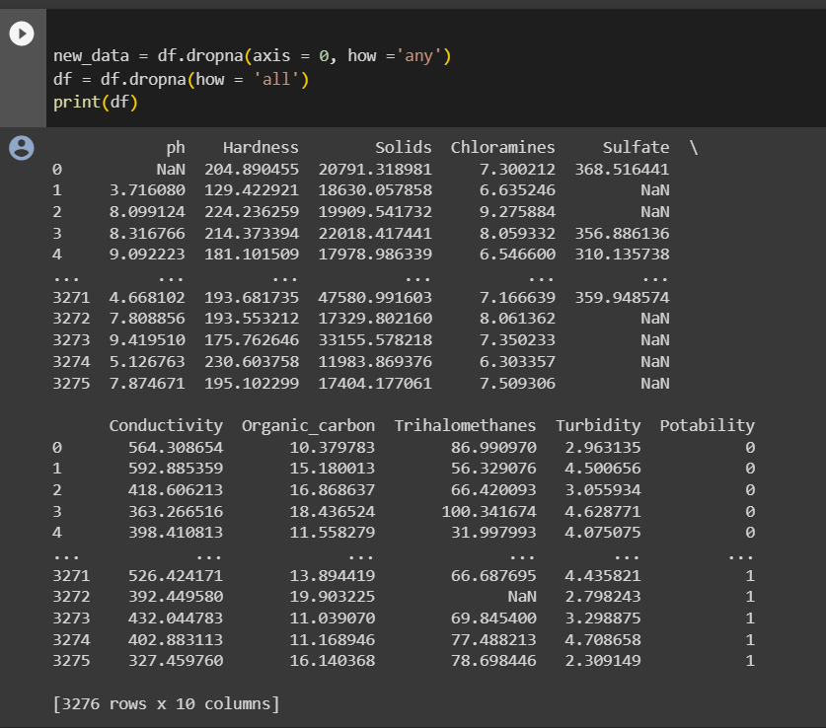

**Fiq – 2 : DataPreprocessing**

**Visualization:**

Loading the dataset allows you to create visualizations. Data visualizations (charts, graphs, maps, etc.) provide a clear and intuitive way to convey complex information and help stakeholders understand the insights derived from the data**.**

**Code:**

**import matplotlib.pyplot as plt**

**import seaborn as sns**

**import pandas as pd**

**data = pd.read_csv('water_portability.csv')**

**plt.figure(figsize=(8, 6))**

**plt.hist(data['column_name'], bins=30, color='skyblue', edgecolor='black')**

**plt.xlabel('X-Axis Label')**

**plt.ylabel('Y-Axis Label')**

**plt.title('water Quality Analysis')**

**plt.show()**

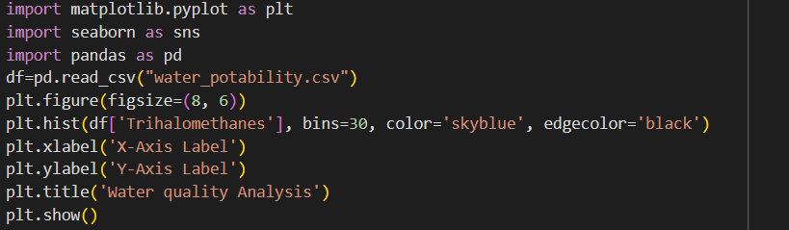

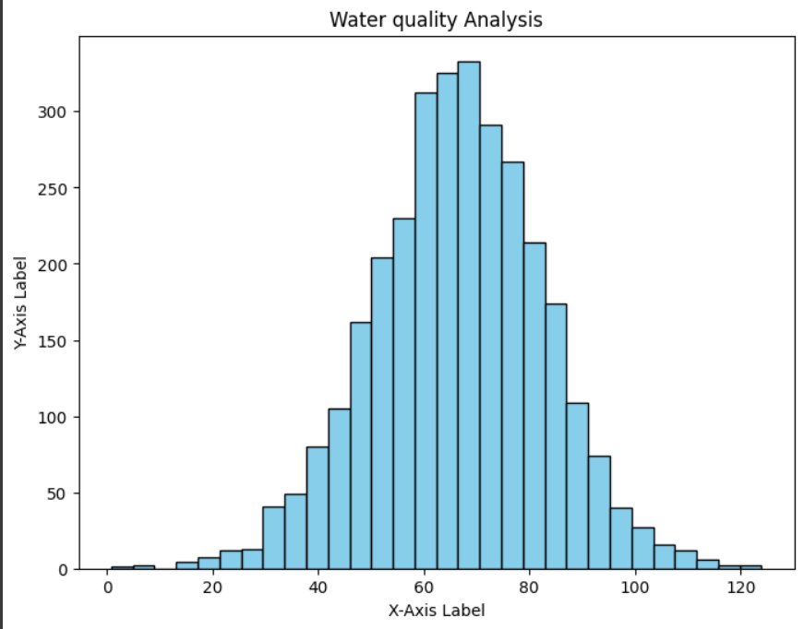**`**

**Fiq – 3: Virtualization for Histogram**