Day4 LSP 19/7/24

Shell Scripting and Linux CMD

Title: Create, Write, and Read Files Using Shell Script

Objective:  
Develop a shell script that can create a file, write user-provided content into the file, and then read and display the content of the file.

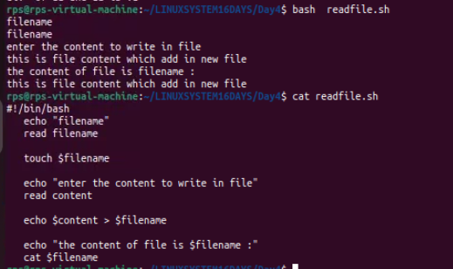

Ques Create calculator using shell scripting

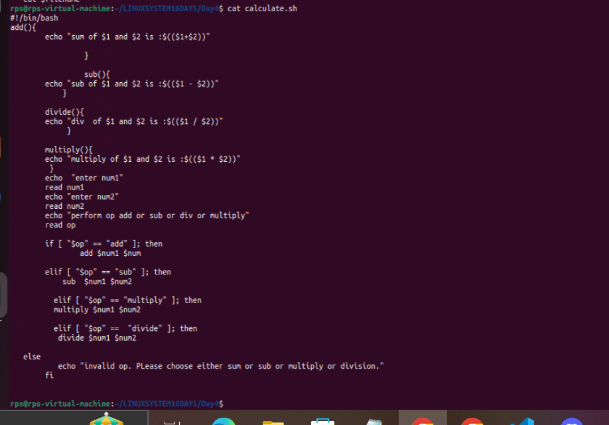

Ps– it tells about the process which are currently running

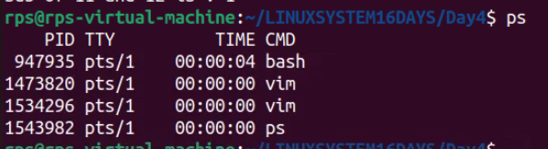

ps x – This command lists processes that have a controlling terminal. It's useful when you want a quick list of processes associated with your current terminal session. It doesn't show processes without a controlling terminal, such as background daemons or services.

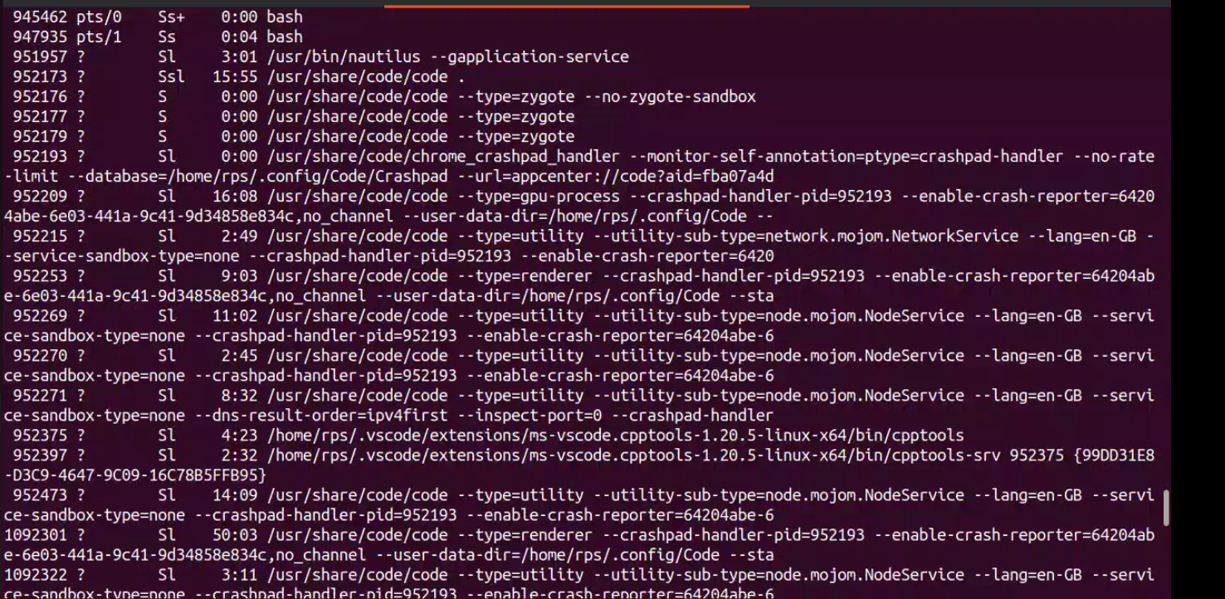

ps aux- This command lists all processes on the system, including those without a controlling terminal. It provides more comprehensive information, making it ideal for system monitoring, troubleshooting, or when you need to see a complete list of running processes

echo- to Print statement



echo $?-- it means the above command you have given before echo $? is true that’s why the result is 0. Other than 0 any other value will be considered false.

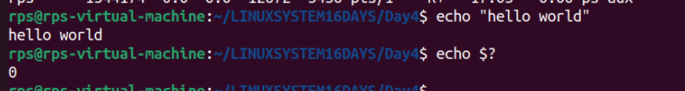

Any other value than 0 it means the previous command is failed or terminated.

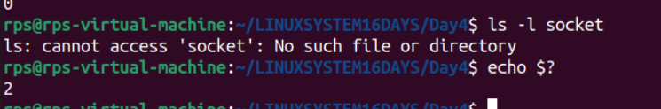

**$# – to pass n no of arguments**

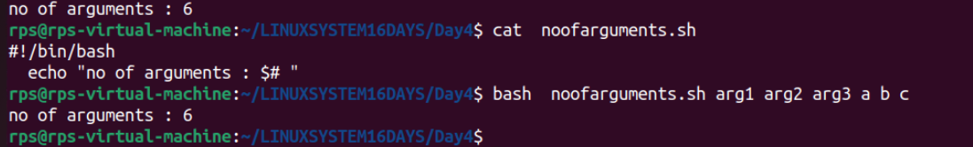

$*- to check all arguments

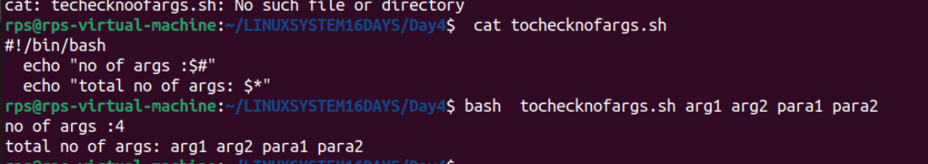

**Show all files of desktop folder**



**Create file inside folder and print all file exist in folder**

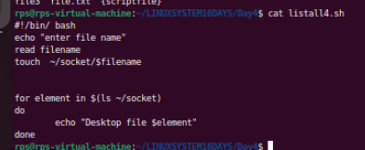

**Ques You can create a shell script named `timely_greeting.sh` to print a greeting based on the current time. If 5am to 12pm print “Good morning” . if 12pm to 6pm print “good evening”. Otherwise print “Good night”**

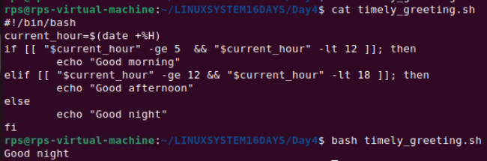

**Difference between / and ~**

**/- it define root directory. It contain system configuration files such as bin,boot, sys, dev,tmp, etc**

**~ - it define home directory. It is personal directory of user.**

**It contain file such as Desktop, Documents, home,Downloads, Music etc**

File Management:

Create, rename, or delete multiple files based on a pattern or criteria.

Organize files into a specific directory structure.

Back up or archive important files.

Text Processing:

Search and replace text within a group of files.

Extract specific information from log files or data sets.

Format text files in a particular way