**17/7/24 Day2 LSP Commands**

• su switch user

•passwd change password

• useradd create new user account

• userdel delete user account

•mount mount file system

• umount unmount file system

• df show disk space usage

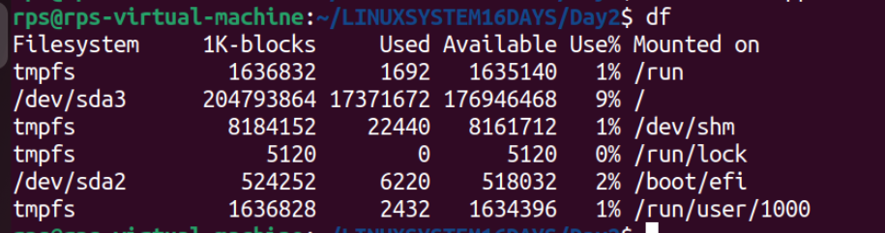

•shutdown reboot or turn off machine

•Relative Path

**Pwd— Present Working directory**



**cd . — It stands for change the current directory**

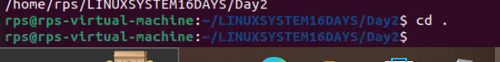

**cd ..**

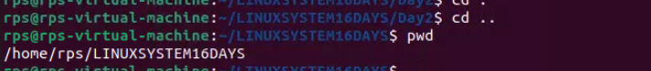

**cd— current directory**

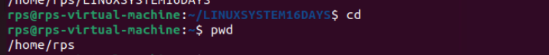

**Absolute Path**

cd—-- current directory



mkdir mydir —------ create new directory mydir

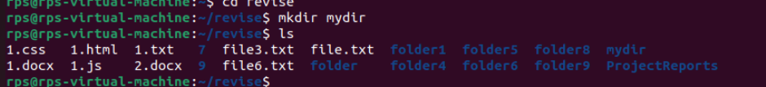

pwd



cd /Users/invite

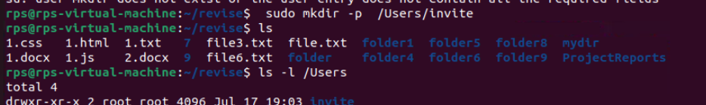

pwd

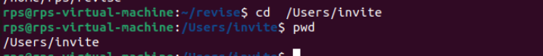

cd /Users

pwd

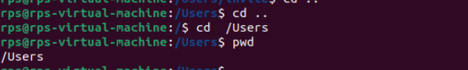

cd /

pwd

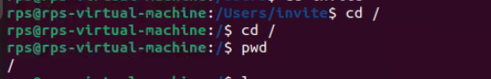

cd ~/mydir



**Permissions**

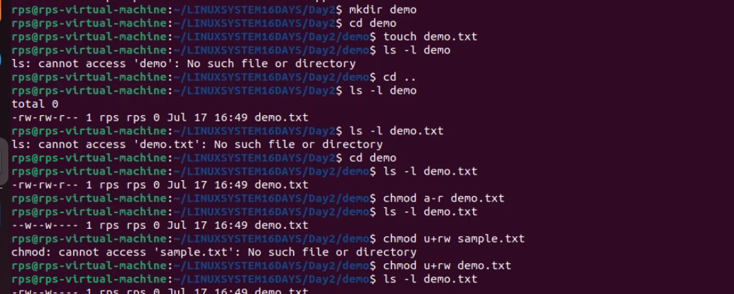

1> mkdir demo - create demo folder

2>cd demo - make demo as current directory

3> touch demo.txt- create demo text file

4>ls -l demo.txt- check permission for demo.txt

-rw-rw-r-- 1 rps rps 0 Jul 17 16:49 demo.txt

-rw- -> owner has read and write permission

-rw- -> group has read and write permission

-r- - ->other has read permission

5> chmod a-r demo.txt

It will remove the read permission for all

6>ls -l demo.txt

- - w- - - - - > read permission removed for all now only owner has write permission.

7>chmod u+rw demo.txt

chmod—> to change file permission

u—> stands for user

+----> to add permission

rw—--> it stands for read and write

So the above commands states that user get read and write permission for demo.txt

**-rw- -w- - - -**

**1>vim—- It is used to edit the file if it is not created then it will create it and then allow to edit that file.**



**2> make—-- It will help to compile dowhile.cpp into an executable name dowhile using the rules defined in the `Makefile`**



**3> Run the command ./dowhile**

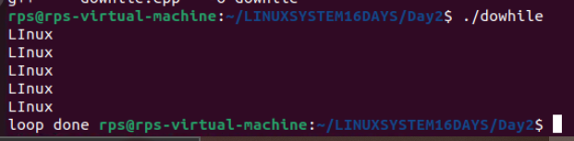

**head - show the first few line of program**

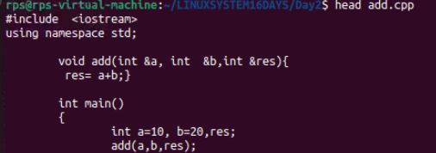

**tail- show last few line of program**

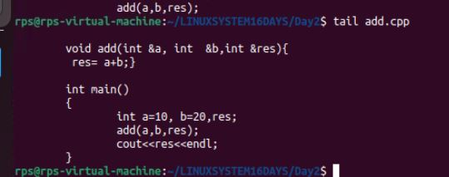

**less-It allows you to view the contents of text files in an interactive manner.**

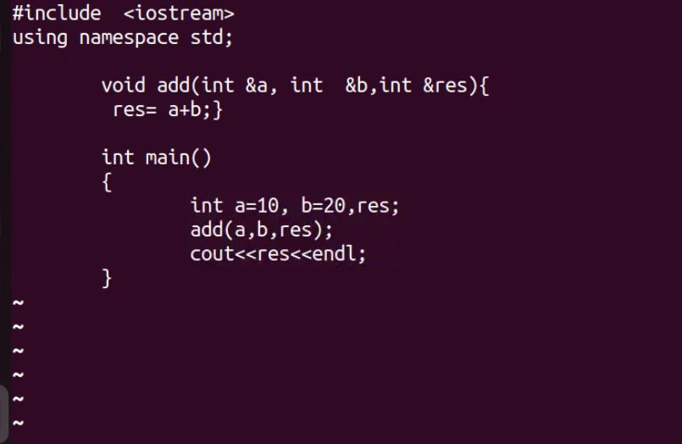

**Grep- is used to search for patterns in text files or output from other command.**

