Chapter 1:

EDA — Exploratory Data Analysis

1.1 Dataset Overview
The dataset used in this project is the Kaggle Understanding Clouds from Satellite Images dataset. It consists of satellite images and corresponding cloud segmentation annotations for four cloud categories: Fish, Flower, Gravel, and Sugar.
The dataset contains 5,546 unique satellite images and 22,184 annotation records, with 5,546 records for each cloud category. The segmentation annotations are provided in Run-Length Encoding (RLE) format through the EncodedPixels column of the training CSV file.
The original dataset images have a resolution of 1400 × 2100 pixels. For this project, the images were processed and resized to 576 × 384 pixels, corresponding to a NumPy shape of 384 × 576 × 3.
The dataset is provided through several files:
- train.csv: contains the RLE-encoded segmentation masks for each image and cloud-label pair in the training set.
- train_images.zip: contains the training satellite images used for model development.
- test_images.zip: contains the test satellite images.
- sample_submission.csv: provides an example of the required output format for segmentation predictions. This file was not used in the current project.
Not all annotation records contain a segmentation mask. Approximately 53.35% of the annotation records contain valid RLE masks, while the remaining records have missing EncodedPixels values. These missing values indicate that no segmentation mask is provided for that particular cloud category in the corresponding image.
The satellite images were obtained from NASA Worldview and were captured by the TERRA and AQUA polar-orbiting satellites using the MODIS instrument. Because an image may be constructed from two satellite orbits, an uncovered area between successive orbits can appear as a black band. This area is not part of the valid image region and must not be considered as a cloud prediction area.
The ground-truth annotations were created through a crowdsourcing process involving 68 scientists. Each image was labeled by approximately three scientists, and the final ground truth was obtained from the union of their annotations after removing the black band areas.
The dataset therefore provides satellite imagery and pixel-level cloud annotations that can be used to formulate the project as a multi-class image segmentation task.

1.2 Dataset Structure
The training annotations are stored in a CSV file containing two main columns: Image_Label and EncodedPixels.
Table 1.1 Initial dataframe of the training dataset
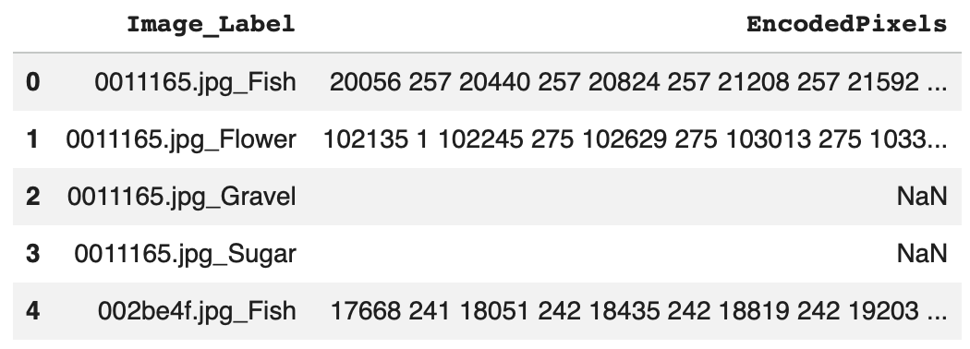
The Image_Label column contains both the image identifier and the corresponding cloud category. To make the data easier to process, this column was split into two separate columns: Image_id and Cloud_Type.
Table 1.2 Dataset structure after separating image identifiers and cloud categories
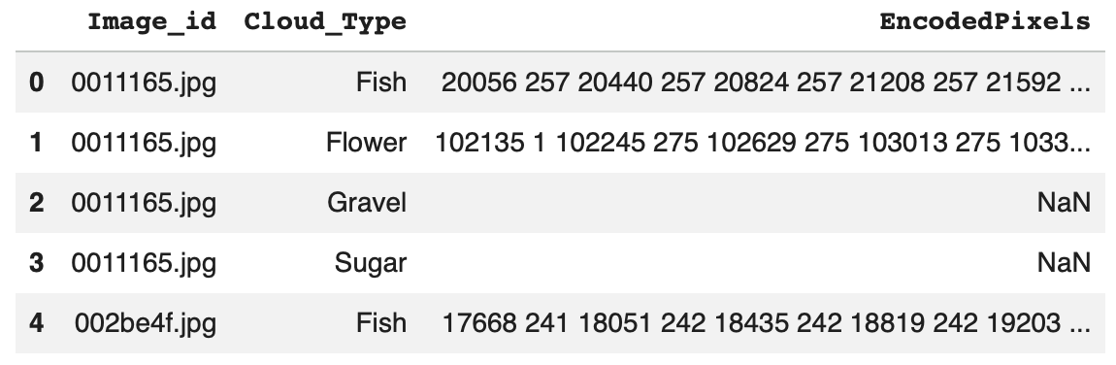
For example, an entry such as 0011165.jpg_Fish is separated into the image identifier 0011165.jpg and the cloud category Fish.
Each image can appear up to four times in the annotation file, once for each cloud category: Fish, Flower, Gravel, and Sugar.
The EncodedPixels column contains the segmentation mask information using Run-Length Encoding (RLE). When a cloud of a given category is present and annotated, its pixel locations are stored as an RLE sequence. Missing values in this column indicate that no mask is available for that particular image-category pair.
The RLE-encoded annotations were later decoded and converted into multi-channel segmentation masks for model training. The detailed preprocessing steps are described in Chapter 2.
This structure allows each satellite image to be associated with a corresponding pixel-level target containing the segmentation information for all four cloud categories.

1.3 Data Exploration and Visualization

1.3.1 Class Distribution
The distribution of available segmentation masks was analyzed for the four cloud categories: Fish, Flower, Gravel, and Sugar. The analysis shows that the number of annotated masks is not exactly equal across the four classes.
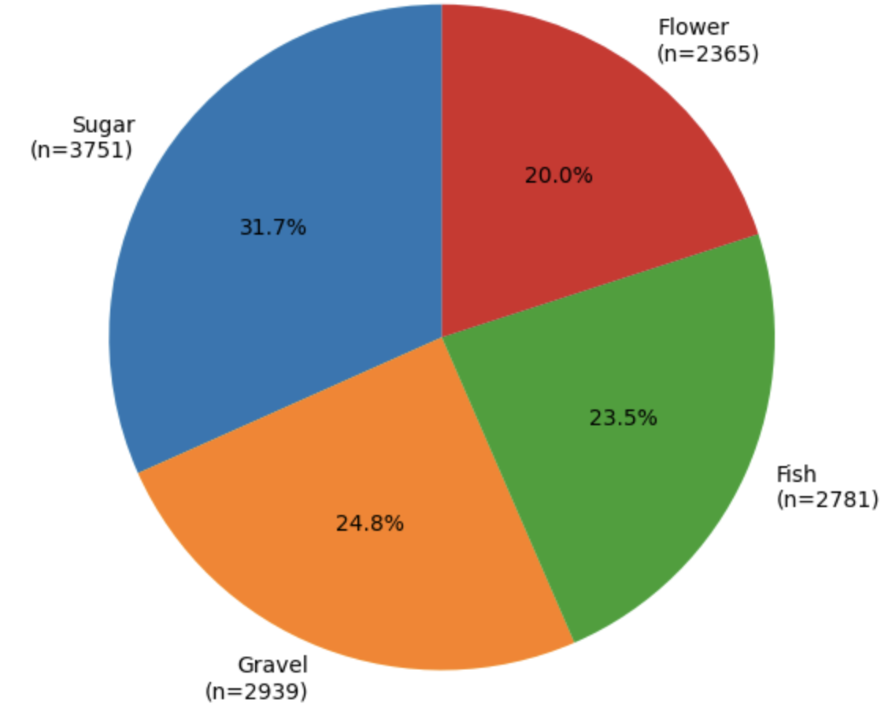
Figure 1.1: Distribution of available segmentation masks by cloud type
The pie chart shows the proportion of available masks belonging to each cloud category. Sugar represents the largest proportion, while Flower has the smallest proportion.
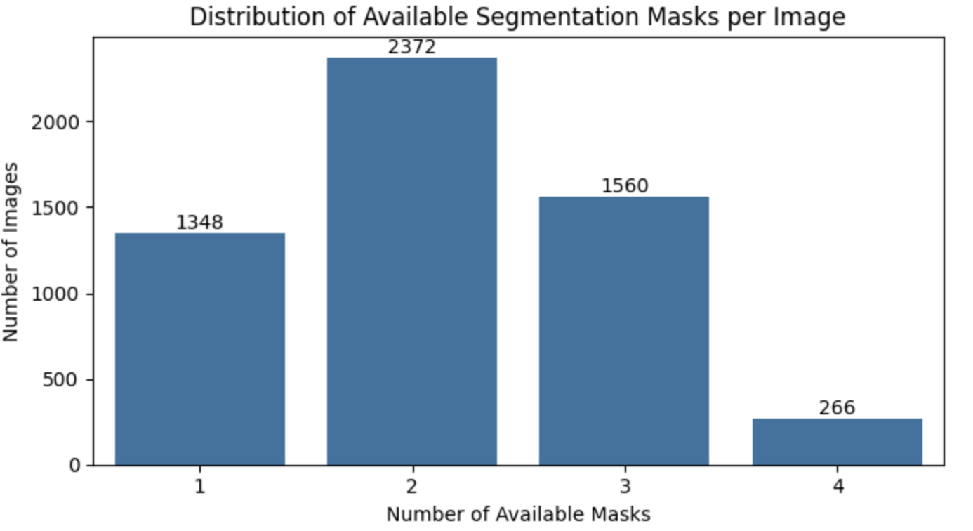
Figure 1.2: Number of available segmentation masks for each cloud type

The count plot provides a direct comparison of the number of available masks for each class. Sugar has the highest number of masks (3,751), followed by Gravel (2,939), Fish (2,781), and Flower (2,365).
Overall, the dataset shows a moderate class imbalance. Sugar has the highest number of available masks, while Flower has the lowest.

1.3.2 Mask Availability and Cloud Categories per Image
The training dataset contains 22,184 image-category annotation records. Among these records, 11,836 contain valid segmentation masks, while 10,348 have missing EncodedPixels values. Therefore, 53.35% of the annotation records contain an available segmentation mask, while 46.65% do not.
A missing value indicates that no segmentation mask is available for that particular cloud category in the corresponding image. However, this does not mean that the image contains no clouds, since each image can contain one or more of the four cloud categories.
The number of cloud categories present in each image was also analyzed. The results show that images contain between one and four cloud categories. Most images contain two cloud masks, followed by images containing three cloud masks. A smaller number of images contain only one cloud category, while only a limited number contain all four categories.
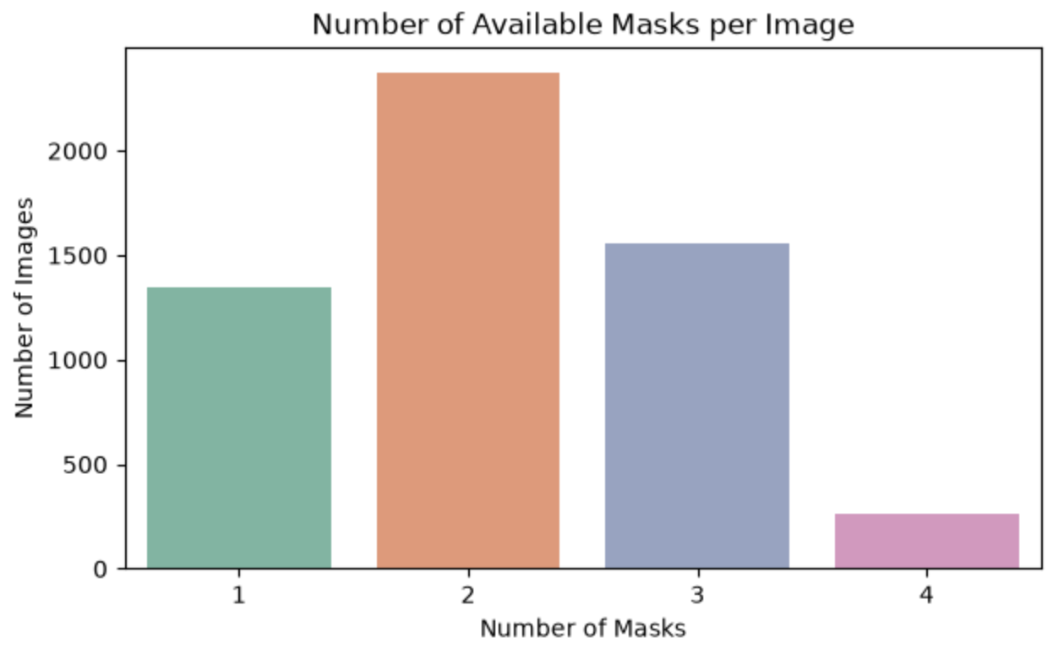
Figure 1.3: Number of cloud categories per image
This distribution shows that most satellite images contain multiple cloud types. This highlights the complexity of the segmentation task, as the model needs to identify and distinguish several cloud categories within the same image.

1.3.3 Sensor Gap Analysis
During the exploration of the satellite images, a black band was observed in some images. This band is caused by an uncovered area between successive satellite orbits and represents a sensor gap rather than a valid image region.
The sensor gap was analyzed to understand the structure of the satellite images and to distinguish the black band from actual cloud regions.

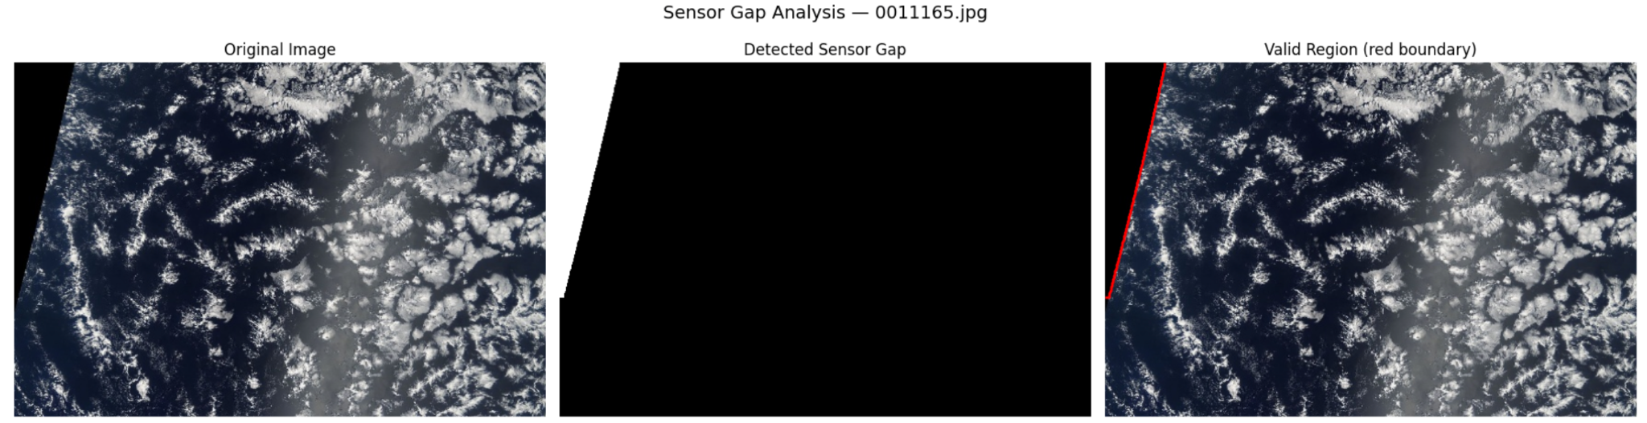
Figure 1.4: Example of sensor gap detection
Left: Original satellite image.
Middle: Detected sensor gap (white = gap).
Right: Valid image region with its boundary.
The visualization shows that the black band does not contain valid satellite information and should not be interpreted as a cloud region. The ground truth annotations already exclude these areas.
In the modeling stage, no additional sensor-gap mask was applied during training or prediction. This approach avoids introducing errors from heuristic pixel-based gap detection and keeps the modeling process focused on the provided ground truth annotations.

Chapter 2

Data Pre-processing

2.1 RLE Decoding
The segmentation masks in the training dataset are provided in Run-Length Encoding (RLE) format through the EncodedPixels column. RLE represents the locations of segmented pixels using pairs of start positions and run lengths.
To use these annotations for image segmentation, the RLE-encoded values were decoded into binary masks. Each decoded mask has the same spatial dimensions as the processed images, 384 × 576 pixels. Pixels belonging to the corresponding cloud category are assigned a value of 1, while the remaining pixels are assigned a value of 0.
Missing EncodedPixels values were treated as empty masks, since they indicate that no segmentation mask is available for that image-category pair.
The decoded binary masks were then used as the basis for creating the multi-channel ground truth masks described in the next section.

2.2 Multi-channel Mask Creation
After decoding the RLE annotations, the binary masks were combined into a single multi-channel mask for each satellite image. Four channels were created, one for each cloud category: Fish, Flower, Gravel, and Sugar.
Each channel represents the segmentation mask of one cloud category, with 1 indicating the presence of the corresponding cloud type and 0 indicating background pixels. Therefore, each processed image is associated with a four-channel ground truth mask with a shape of 384 × 576 × 4.
This representation allows the model to predict the four cloud categories independently for each pixel and provides the ground truth required for multi-class cloud segmentation.

2.3 Image and Ground Truth Mask Visualization
To verify the segmentation annotations, a selected satellite image was visualized together with its corresponding ground truth masks. The masks were displayed separately for each cloud category to examine their spatial alignment with the original image.
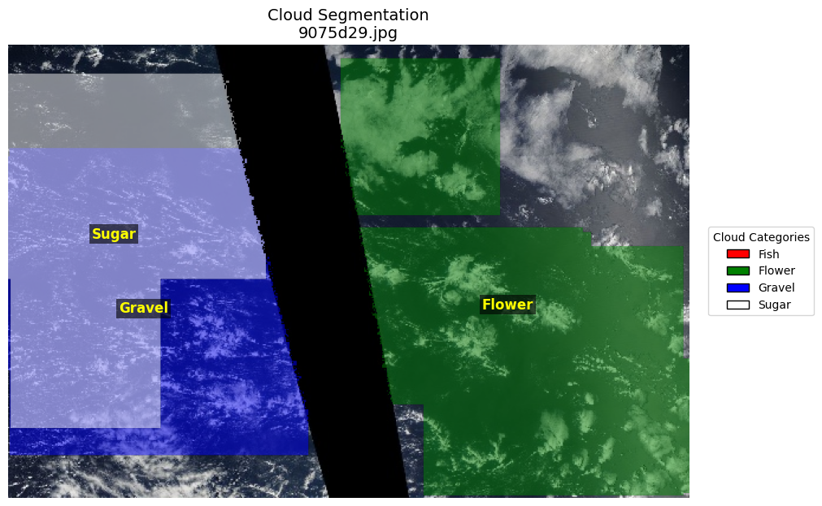
Figure 2.1: Satellite image 9075d29.jpg with ground truth segmentation masks for Flower, Gravel, and Sugar cloud categories
The selected image contains three cloud categories: Flower, Gravel, and Sugar. Their ground truth masks show different shapes, sizes, and spatial distributions, providing examples of both clear and irregular cloud boundaries.
The black band represents the sensor gap and is not part of the valid image region. The ground truth annotations already exclude this area.
This visualization confirms that the ground truth masks are correctly aligned with the satellite image and provides a visual check of the segmentation annotations before model training.

2.4 Image Resizing
The original satellite images have a resolution of 1400 × 2100 pixels. To reduce the computational cost and make the images suitable for model training, the images were resized to 576 × 384 pixels.
The same spatial dimensions were used for the corresponding ground truth masks to ensure that the images and masks remained correctly aligned. After resizing, each image had a shape of 384 × 576 × 3, while each ground truth mask had a shape of 384 × 576 × 4.
This resizing step reduced the input size while preserving the spatial information required for cloud segmentation and made the dataset more suitable for efficient model training.

2.5 Normalization

After resizing, image normalization was applied to prepare the input images for the neural network. The pixel values were normalized using the mean and standard deviation of the ImageNet dataset.
The normalization was applied separately to the three RGB channels. This step helps to bring the input data to a suitable scale and is particularly important because the ResNet34 encoder was initialized with ImageNet-pretrained weights.
The same normalization procedure was applied to the training and validation images, while the segmentation masks were not normalized because they contain binary class labels.

2.6 Data Augmentation
Data augmentation was applied to the training images to increase the diversity of the training data and improve the model’s ability to generalize to new satellite images.
Several augmentation techniques were used, including horizontal and vertical flipping, small shifts, scaling, and rotation. In addition, brightness and contrast changes, gamma adjustment, CLAHE, Gaussian noise, Gaussian blur, and motion blur were randomly applied.
The augmentation operations were applied to both the images and their corresponding segmentation masks when spatial transformations were used. This ensured that the images and masks remained correctly aligned.

Data augmentation was applied only to the training set. The validation images were not augmented in order to provide a consistent and unbiased evaluation of the model’s performance.

ImageNet: A large-scale image dataset commonly used for training and evaluating computer vision models. Its images are organized into many object categories and are widely used for pre-training neural networks. https://www.image-net.org/

