Cloud Segmentation Using U-Net
Method, Project Implementation, and Validation Results
Project report | September 2026
Prepared by: Mahsa Nakhostinrouhi

Table 1. Project overview.
Task | Semantic segmentation of cloud patterns in satellite images
Image size | 384 × 576 pixels, RGB input
Current output | Four independent masks: Fish, Flower, Gravel, Sugar

1. Executive Summary
This report describes the U-Net method used in the cloud-segmentation project, explains why it is suitable for the task, documents the network architecture applied in the project, and interprets the available validation results. The current model performs four-channel segmentation, producing independent Fish, Flower, Gravel, and Sugar masks for each 384 × 576 RGB image.
The learning curves show consistent improvement over 15 epochs. Training and validation losses both decrease and remain close to one another, while Dice scores increase. This indicates that the model is learning and there is no strong sign of overfitting in the displayed run. However, the final validation Dice coefficient of 0.2462 is still modest, so the current model should be treated as a baseline that requires further improvement before strong segmentation accuracy can be claimed.
Table 2. Key validation results.
Key validation results: Dice = 0.2462, IoU = 0.3466, loss = 1.0770. These metrics were computed with different definitions in the project code, so Dice and IoU should not be compared as if they were mathematically paired values.

2. U-Net Method
U-Net is a convolutional neural network architecture designed for image segmentation. Instead of assigning one label to an entire image, it produces a spatial prediction at pixel level. Its characteristic U-shaped structure combines a contracting encoder with an expanding decoder and connects corresponding levels with skip connections.
Table 3. Core U-Net components and their role in the cloud project.
Component | Role in U-Net | Role in this project
Encoder | Extracts increasingly abstract image features while reducing spatial resolution. | Learns cloud texture, shape, brightness, and larger spatial patterns.
Bottleneck | Represents the most compressed and high-level feature description. | Combines broad contextual information about cloud organization.
Decoder | Upsamples the compressed representation back toward the original image size. | Reconstructs the location and extent of cloud regions.
Skip connections | Pass fine spatial detail directly from encoder layers to matching decoder layers. | Help preserve boundaries and local cloud structure that could be lost during pooling.
Output layer | Produces one or more segmentation maps. | Produces four sigmoid probability maps: Fish, Flower, Gravel, and Sugar.

For the current four-mask task, the output is multi-label rather than softmax multiclass segmentation. A pixel can receive independent probabilities for the four cloud masks, so the final layer uses four sigmoid channels. This differs from the earlier binary version of the project, where the four masks were merged into one cloud/non-cloud mask.

3. Common Applications of U-Net
U-Net was originally introduced for biomedical image segmentation, but its encoder-decoder structure is useful in many domains where object location and shape matter. Typical applications include:
- Medical imaging: segmenting organs, tumors, lesions, and cells.
- Remote sensing and Earth observation: mapping clouds, water, vegetation, land cover, roads, and buildings.
- Agriculture and environmental monitoring: crop boundaries, disease areas, burned regions, and habitat mapping.
- Autonomous and robotic vision: separating roads, vehicles, pedestrians, and other scene components.
- Industrial inspection: locating defects, cracks, or damaged regions in imagery.

4. Why U-Net Was Used in This Cloud Project
The project requires spatial masks, not only image-level labels. It must determine where cloud-pattern regions occur in each satellite image. U-Net is therefore appropriate because it returns a prediction for each pixel while preserving spatial structure.
Table 4. Project requirements and reasons for using U-Net.
Project requirement | Why U-Net fits
Pixel-level output | U-Net produces full-resolution segmentation maps rather than a single image label.
Irregular cloud regions | Convolutions learn local texture while deeper layers capture larger cloud structures.
Need for spatial detail | Skip connections restore fine information lost during downsampling.
Four cloud masks | The final layer can be changed from 1 output channel to 4 independent channels.
Moderate training-data size | Data augmentation and a compact U-Net can be trained without requiring a very large foundation model.

5. Application of U-Net in the Project

5.1 U-Net Architecture
The project uses a compact U-Net that receives a 384 × 576 RGB satellite image and returns four full-resolution probability masks, one for each cloud class: Fish, Flower, Gravel, and Sugar. The architecture preserves the standard U-Net encoder–bottleneck–decoder structure with skip connections, while using a relatively small number of filters to keep the model computationally manageable.
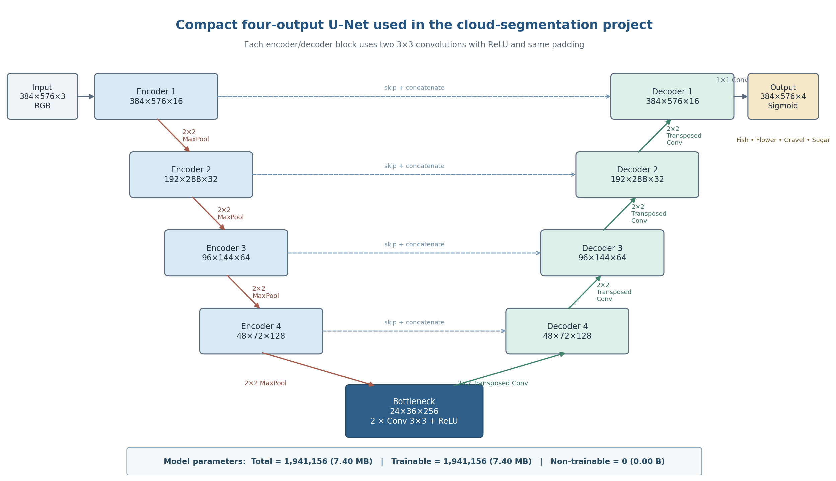
Scheme 1. U-Net architecture used in the four-class cloud-segmentation model.
Input and encoder. The input is a 384 × 576 × 3 RGB image. Four encoder levels progressively learn richer cloud features. Each level applies two 3 × 3 convolutions with ReLU activation and same padding, followed by 2 × 2 max pooling. The number of feature channels increases from 16 to 32, 64, and 128, while the spatial resolution is reduced from 384 × 576 to 48 × 72.
Bottleneck. After the final pooling operation, the bottleneck operates at 24 × 36 pixels with 256 feature channels. It contains two 3 × 3 convolutional layers and captures the most compressed, high-level representation of the cloud patterns.
Decoder and skip connections. The decoder restores spatial resolution using 2 × 2 transposed convolutions. At each level, the upsampled decoder features are concatenated with the corresponding encoder features through a skip connection. These skip connections help recover spatial detail and boundaries that may be weakened during pooling. The decoder channels decrease from 128 to 64, 32, and 16 as the image returns to its original resolution.
Output layer. A final 1 × 1 convolution produces four channels with sigmoid activation. Each channel is an independent probability map for Fish, Flower, Gravel, or Sugar. Sigmoid is appropriate because the cloud masks are treated independently rather than forcing every pixel to belong to exactly one class.
Model size. The network contains 1,941,156 parameters (7.40 MB). All 1,941,156 parameters are trainable, and there are 0 non-trainable parameters. This matches the architecture shown in Scheme 1 and confirms that the model does not include layers with stored non-trainable statistics such as Batch Normalization in this baseline configuration.

6. Results and Interpretation

6.1 Training and validation curves
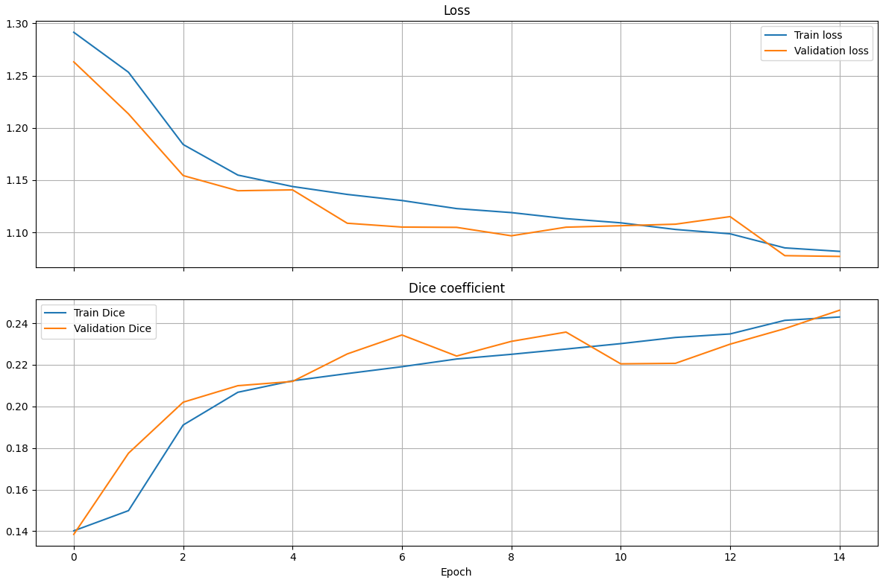
Figure 1. Training and validation loss and Dice coefficient across 15 displayed epochs.
The loss curves decrease consistently. Training loss falls from approximately 1.29 at the beginning to about 1.08 by the final displayed epoch, while validation loss falls from approximately 1.26 to 1.077. The two curves remain close throughout training. This is a positive sign because it indicates that the model is improving on both training and unseen validation data, with no clear divergence that would indicate strong overfitting.
The Dice coefficient also improves. Training Dice rises from about 0.14 to roughly 0.24, and validation Dice rises to approximately 0.246. The validation curve fluctuates slightly, which is normal, but the overall trend remains upward. The final validation Dice being slightly above training Dice is not concerning in this setup; training data are augmented on the fly, which can make training batches harder than the unaugmented validation images.
The important limitation is the absolute Dice level. A Dice value around 0.25 indicates that predicted cloud-pattern regions still overlap the ground truth only modestly. Therefore, the learning trend is encouraging, but the segmentation quality is not yet strong.

6.2 Final validation metrics
Table 5. Final validation metrics.
Metric | Validation value | Interpretation
Dice coefficient | 0.2462 | Higher is better. The current overlap is modest and indicates room for substantial improvement.
IoU coefficient | 0.3466 | Higher is better. This value is threshold-based in the current implementation and should be interpreted independently of the soft Dice value.
Loss | 1.0770 | Lower is better. The reduced loss relative to early epochs confirms that optimization progressed.

Taken together, the results show successful training behavior but limited final segmentation accuracy. The absence of a large train–validation gap suggests that the main issue is not obvious overfitting. Instead, the model may still be underfitting the complexity of the four cloud patterns, may be affected by class imbalance, or may require better thresholding and stronger feature extraction.
Table 6. Interpretation of training and validation behavior.
Observation | What it means
Loss decreases for train and validation | The optimizer is learning useful parameters and generalization is improving during the displayed epochs.
Train and validation curves remain close | No strong evidence of overfitting is visible in this run.
Dice increases but remains low | The model is learning the task, but predicted masks still have limited overlap with reference masks.
Validation Dice slightly exceeds train Dice | This can occur because training images are augmented while validation images are not.
IoU is numerically above Dice | The project uses different aggregation/threshold rules for the two metrics, so the two values should not be directly compared.

7. Results Still Needed for a Complete Final Model Assessment
The uploaded results are sufficient to describe the current training run, but several additional results would strengthen a final scientific or project report. They are not available in the supplied screenshots and should be added when generated:
- Per-class Dice and IoU for Fish, Flower, Gravel, and Sugar. These results show whether one cloud class is much harder than the others.
- A threshold-selection result on the validation set. A global threshold can be used for simple comparison, followed by per-class threshold optimization for the selected final model.
- Qualitative validation examples showing: original image, true mask, predicted probability, and predicted mask for each class.
- A model-selection table if additional architectures are trained. Use mean validation Dice as the primary selection metric, mean validation IoU as secondary, and validation loss as supporting information.
- Final predictions on the Kaggle test images. Because the provided test images do not have ground-truth masks, they can be visualized and submitted but cannot provide true test Dice/IoU.

8. Recommended Next Improvements
Table 7. Recommended next improvements.
Priority | Action | Reason
1 | Calculate per-class Dice/IoU and inspect class frequencies. | Identifies weak classes and possible imbalance.
2 | Optimize the segmentation threshold on validation data. | The default 0.5 cutoff may not be optimal; class-specific thresholds may improve final masks.
3 | Compare a stronger U-Net variant (e.g., more filters, BatchNorm, or pretrained encoder). | Current Dice suggests the baseline may not capture enough discriminative features.
4 | Review augmentation strength and class balance. | Ensures training data remain realistic and minority cloud classes are represented.
5 | Save model, CSV training history, split lists, thresholds, and configuration. | Makes results reproducible after Colab/kernel restarts.

9. Conclusion
U-Net is well suited to this project because the task requires spatial cloud masks rather than only image-level labels. The encoder-decoder structure and skip connections allow the model to combine broad cloud context with fine spatial detail. The implementation was adapted from binary segmentation to four independent cloud-pattern channels by preserving Fish, Flower, Gravel, and Sugar masks separately and using a four-channel sigmoid output layer.
The current validation run shows stable learning: both losses decrease and Dice improves without a clear sign of overfitting. Nevertheless, the final Dice coefficient of 0.2462 indicates that segmentation overlap remains limited. The current model should therefore be considered a baseline. Per-class evaluation, threshold optimization, qualitative mask inspection, and comparison with stronger U-Net variants are the most important next steps.

10. References
Ronneberger, O., Fischer, P., & Brox, T. (2015). U-Net: Convolutional Networks for Biomedical Image Segmentation. MICCAI 2015; arXiv:1505.04597.
Kaggle competition dataset: Understanding Clouds from Satellite Images / Understanding Cloud Organization (satellite images with Fish, Flower, Gravel, and Sugar mask annotations).
Project tools: TensorFlow/Keras, OpenCV, NumPy, pandas, Albumentations, and Matplotlib.

