Cloud Segmentation Using PSPNet
Method, Project Implementation, and Validation Results
Table 1. Project overview.
Item | Value
Task | Semantic segmentation of cloud patterns in satellite images
Model | PSPNet with a ResNet-34 encoder pre-trained on ImageNet (segmentation_models_pytorch 0.5.0)
Input | 384 × 576 pixels, RGB
Output | Four independent masks: Fish, Flower, Gravel, Sugar (multi-label)
Data | 5,546 labelled images, split 4,991 train / 555 validation
Framework | PyTorch, Albumentations, OpenCV

1. Summary
This chapter documents the PSPNet model trained for the cloud-segmentation project: the method, the concrete configuration used, and the validation results. The model predicts four independent masks per image, one for each cloud organisation pattern (Fish, Flower, Gravel, Sugar). Because a pixel can belong to several patterns at once, the task is multi-label rather than multi-class.
Training over 25 epochs is stable: training and validation loss decrease together and the validation Dice score rises from 0.5338 after the first epoch to 0.6039 at the end, without a widening train–validation gap. The final model reaches a macro Dice of 0.6039 and a macro IoU of 0.4357 on the 555 held-out validation images. That is close to the U-Net (ResNet-50) model trained on the identical validation split (macro Dice 0.6118), so the two architectures perform on par on this dataset.

2. The PSPNet Method
PSPNet (Pyramid Scene Parsing Network) is a segmentation architecture built around one central idea: a pixel is easier to classify when the model also knows the global context of the scene it sits in. A plain fully-convolutional network decides each pixel from a limited receptive field, which causes locally plausible but globally inconsistent labels. PSPNet adds a pyramid pooling module on top of the encoder feature map that pools the same features at several spatial scales at once and concatenates the results, so every pixel decision is informed by both local texture and the layout of the whole image.
Table 2. Core PSPNet components and their role in this project.
Component | Role in PSPNet | Role in this project
Encoder (backbone) | A CNN — here ResNet-34 — produces a downsampled feature map with rich semantic content. | Learns cloud texture, brightness and edge structure; ImageNet weights give a usable starting point despite the moderate dataset size.
Pyramid pooling module | Average-pools the encoder features onto 1×1, 2×2, 3×3 and 6×6 grids, reduces each level with a 1×1 convolution, upsamples all levels back and concatenates them with the un-pooled features. | Cloud patterns are large, diffuse and defined by their arrangement over the whole scene, which is exactly the global context this module adds.
Decoder head | A convolution over the concatenated pyramid features, followed by bilinear upsampling back to input resolution. | Produces the four full-resolution mask channels. The head is light — PSPNet has no U-Net-style skip connections, so fine boundaries are less sharp, which matters little for the soft cloud boundaries here.
Output layer | One channel per class with sigmoid activation in the multi-label case. | Four independent probability maps for Fish, Flower, Gravel and Sugar, thresholded at 0.5.

The trade-off against U-Net is therefore: U-Net recovers spatial detail through skip connections, while PSPNet trades some of that detail for an explicit model of global context. For the diffuse, large-scale regions in this dataset the second property is the more relevant one, which is why PSPNet was selected as the counterpart architecture.

3. Application of PSPNet in the Project

3.1 Architecture as instantiated
The model is created from segmentation_models_pytorch as PSPNet(encoder_name="resnet34", encoder_weights="imagenet", classes=4). Scheme 1 shows the resulting forward path with the tensor shapes it actually produces for a 384 × 576 input.
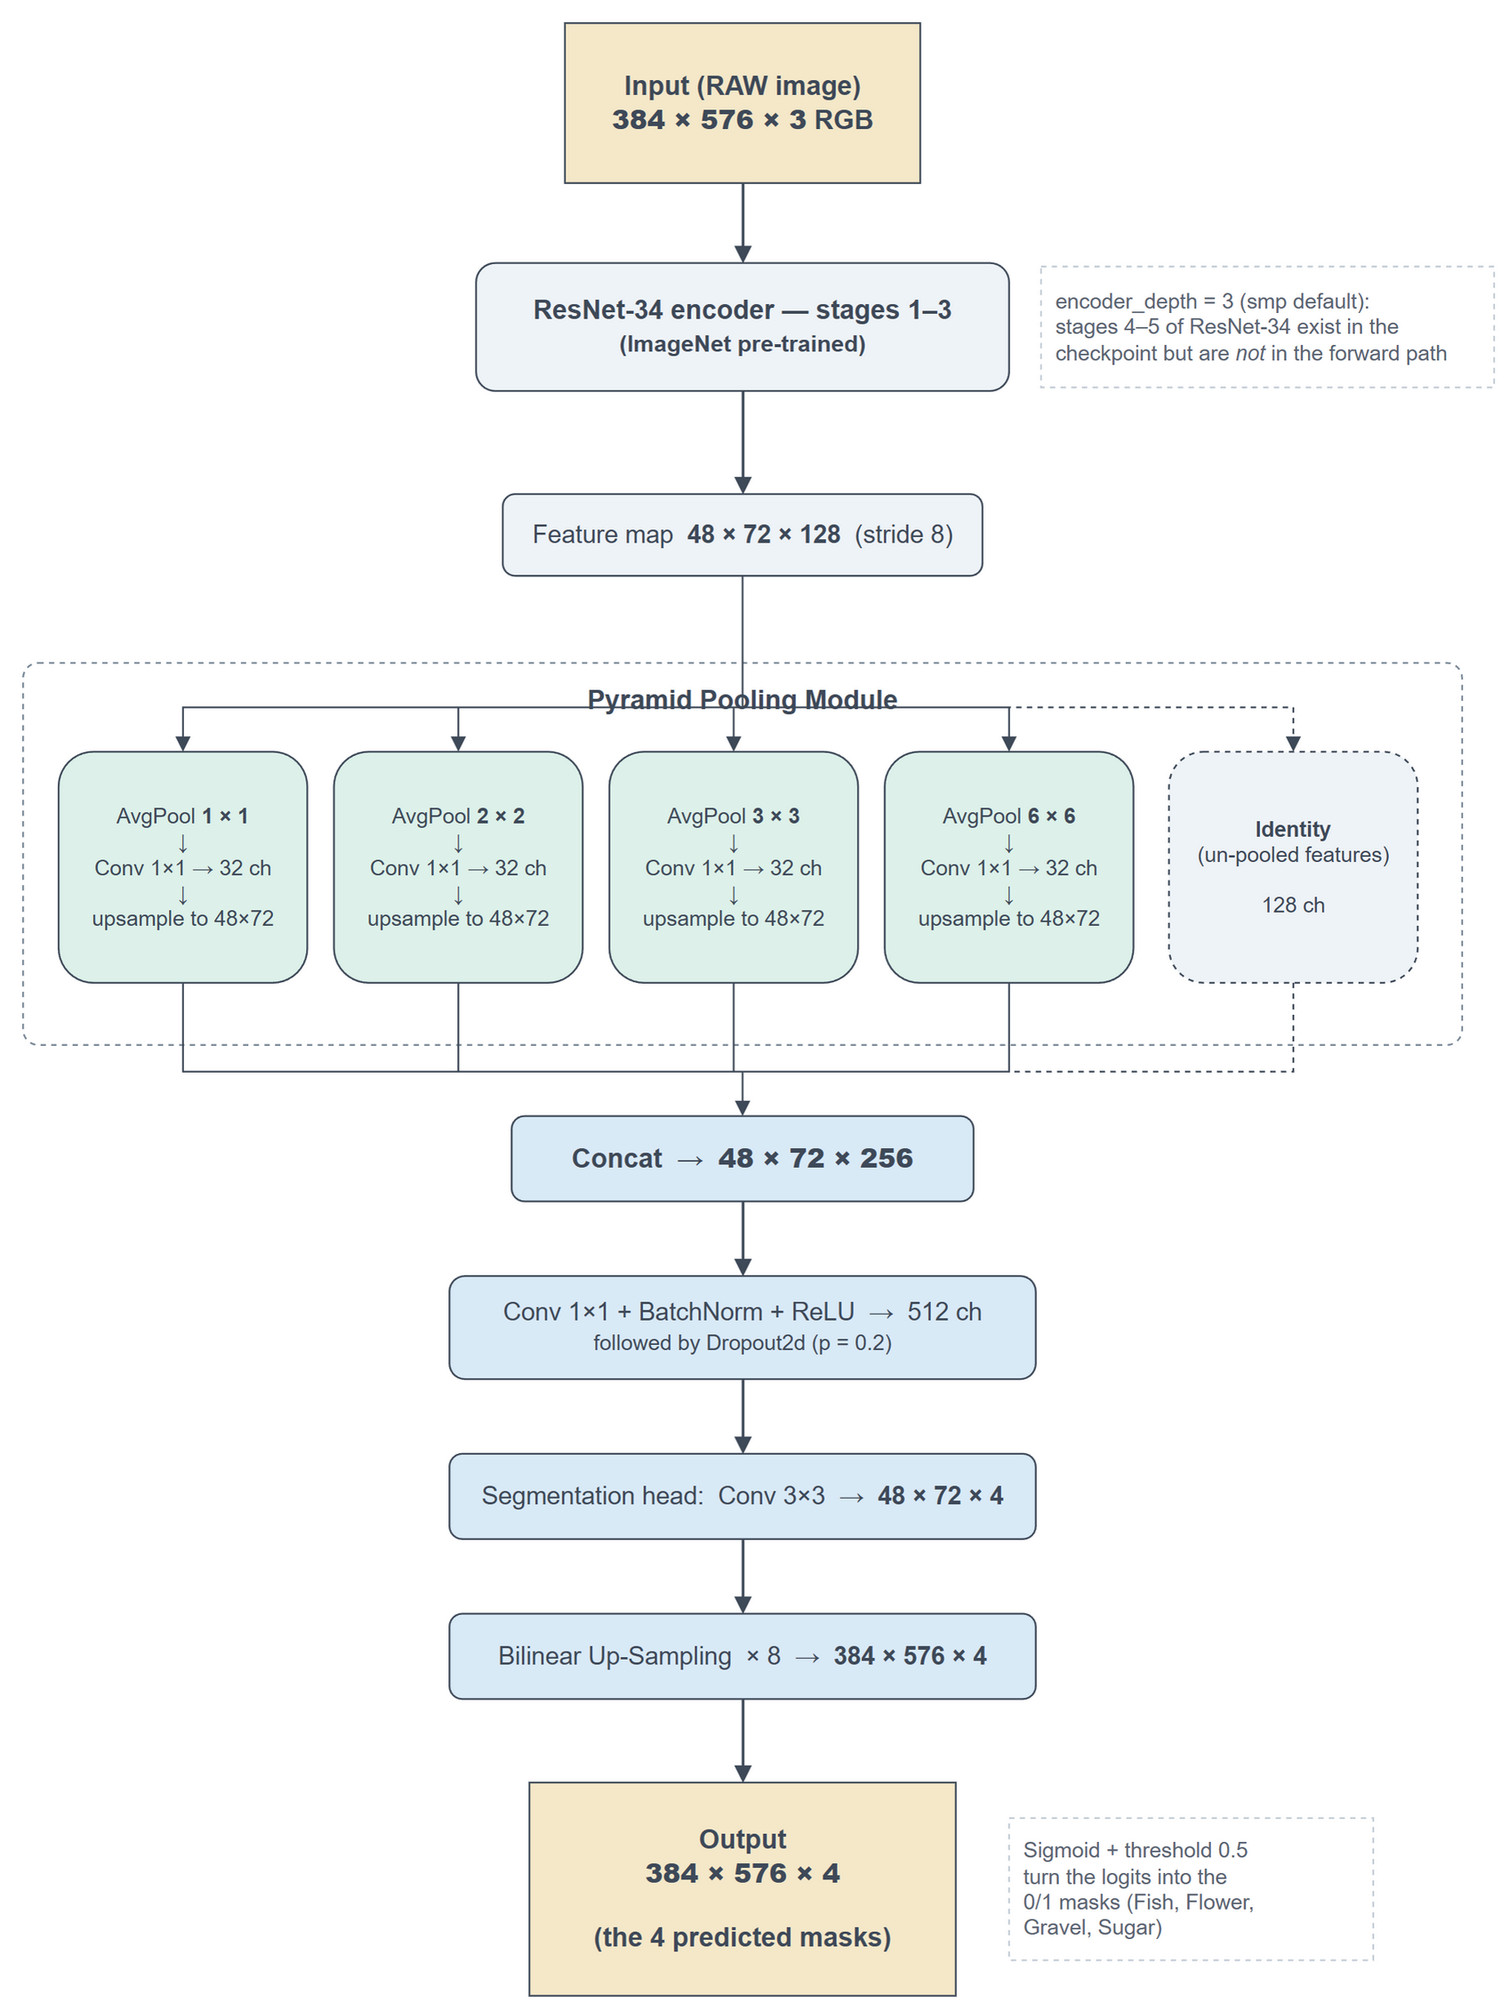
Scheme 1. PSPNet architecture as instantiated in this project: ResNet-34 encoder (stages 1–3), pyramid pooling module, segmentation head and bilinear upsampling.
One property of this configuration deserves to be stated explicitly, because it shapes the interpretation of every result below. The library default encoder_depth = 3 was not overridden, so only the first three stages of ResNet-34 are part of the forward path: the encoder output is a 48 × 72 feature map with 128 channels (stride 8), and the deeper stages 4 and 5 — which hold roughly 20 of the checkpoint’s 21.45 million parameters — are instantiated and stored but never evaluated. Effectively about 1.5 million parameters are trained and used. The model is therefore a PSPNet on a truncated ResNet-34 rather than on the full network. Training and inference use the same setting, so the reported scores are internally consistent; the point is that this was not a deliberate design choice but an unnoticed library default, and that the resulting model is small enough to be the most likely reason the learning curves flatten early.

3.2 Training setup
Images and masks are loaded at 384 × 576 by a custom dataset class that decodes the run-length-encoded masks from train.csv, applies the augmentation pipeline, and normalises the image with the ImageNet statistics the encoder expects.
Table 3. Training configuration.
Setting | Value
Loss | BCEWithLogitsLoss + multi-label Dice loss (weighted 1 : 1)
Optimizer | Adam, learning rate 1e-4, no scheduler
Epochs / batch size | 25 / 8
Augmentation (train only) | Horizontal flip (p = 0.3), vertical flip (p = 0.3), random brightness / contrast (p = 0.8), rotation (p = 0.6)
Train / validation split | Random 90 / 10 split on unique image names (random_state = 42), so all four label rows of an image stay on the same side
Parameters | 21.45 M stored in the checkpoint, of which ≈ 1.5 M lie in the forward path (see section 3.1)
Hardware | Single CUDA GPU

Two details are worth naming. First, the split is performed on unique image names, not on the label rows, which rules out leakage between training and validation. Second, validation data is never augmented, so the reported scores reflect the un-modified images. The split is a plain random split; a stratified split over the label combinations is planned as a separate optimisation step and is deliberately not part of this baseline.

4. Results

4.1 Training and validation curves
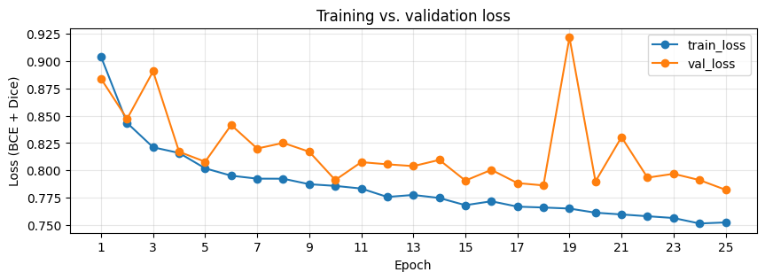
Figure 1. Training and validation loss (BCE + Dice) over 25 epochs.
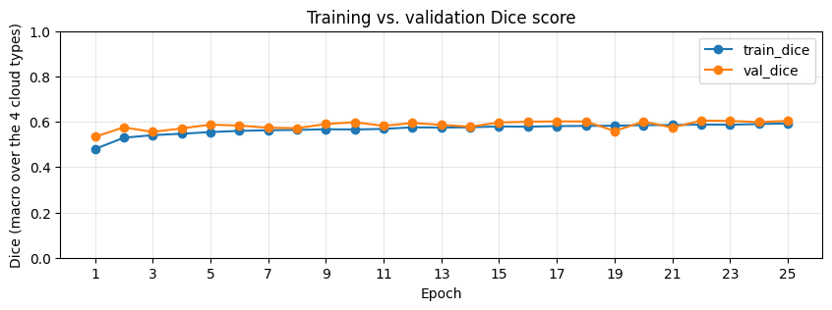
Figure 2. Training and validation Dice score (macro over the four cloud types) over 25 epochs.
Training loss falls smoothly from 0.9038 to 0.7524. Validation loss falls from 0.8838 to 0.7823, but does so far less evenly: from roughly epoch 4 onwards it sits consistently a little above the training curve and oscillates around a slowly falling trend, with one pronounced outlier at epoch 19 (0.9216, worse than the very first epoch). The training side of that epoch is entirely undisturbed — its loss step of −0.0010 is an ordinary value for this run, and training Dice even improves slightly — so whatever happened was invisible to the optimisation and affected only the evaluation.
The Dice curves are correspondingly flat. Training Dice rises from 0.4797 to 0.5927 and validation Dice from 0.5338 to 0.6039, with the best single epoch at 0.6053 (epoch 22). Almost all of that gain happens in the first ten epochs; from roughly epoch 10 onwards validation Dice moves within a band of about ±0.02 around 0.60 and the epoch-19 dip is the only visible excursion. The model has converged to what this configuration can reach, and more epochs alone would not help.
Validation Dice sits marginally above training Dice throughout. This is expected here rather than suspicious: the training scores are accumulated from the logits of the update steps, i.e. over a model that is still changing and over augmented images, while the validation scores describe a fixed model on untouched images.

4.2 Final validation metrics
The numbers below are produced by re-loading the saved checkpoint and scoring it on the validation loader, on the thresholded 0/1 masks the model actually outputs (threshold 0.5). Macro averages the four per-class scores, so a rare cloud type counts as much as a common one; micro pools the pixels of all four classes and is therefore dominated by the large ones.
Table 4. Final validation metrics of the saved model.
Metric | Macro | Micro | Interpretation
Dice coefficient | 0.6039 | 0.6074 | Higher is better. Roughly 60 % overlap between predicted and true regions.
IoU | 0.4357 | 0.4362 | Higher is better. The stricter of the two overlap measures.
Loss (BCE + Dice) | 0.7823 | — | Lower is better. The quantity optimised, not a score.

Macro and micro scores differ by less than 0.004, which means no single cloud type dominates the pixel count badly enough to distort the aggregate. The per-class table shows where the remaining differences sit.
Table 5. Per-class validation scores.
Cloud type | Dice | IoU
Fish | 0.5125 | 0.3446
Flower | 0.6947 | 0.5322
Gravel | 0.5829 | 0.4114
Sugar | 0.6253 | 0.4548
Mean (macro) | 0.6039 | 0.4357

Flower is segmented best and Fish clearly worst, a spread of 0.18 Dice between them — considerably larger than any difference between the two architectures compared in section 5.

4.3 Predictions on unseen test images
The Kaggle test images carry no ground-truth masks, so they allow a qualitative check only. The trained model is run on the raw image and its output is thresholded into the same mask format the labelled data uses, which makes the existing overlay visualisation applicable to predictions. A cloud type counts as detected when its predicted mask covers at least 500 pixels.
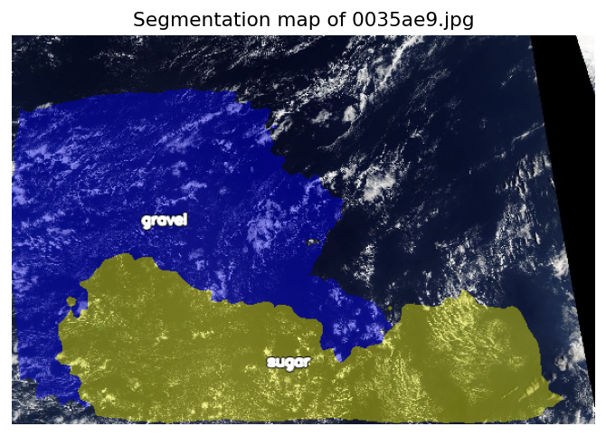
Figure 3. Predicted segmentation map for test image 0035ae9.jpg (detected: Gravel, Sugar).
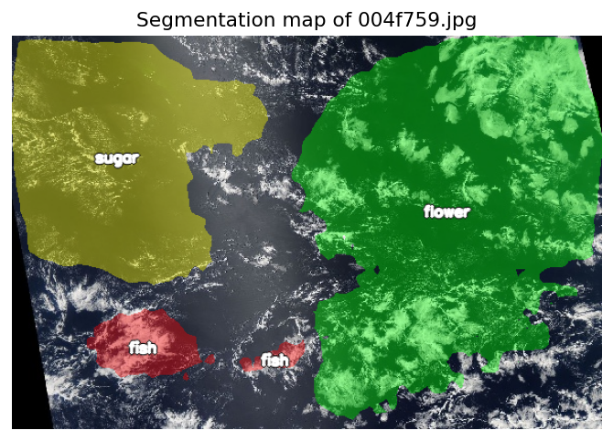
Figure 4. Predicted segmentation map for test image 004f759.jpg (detected: Fish, Flower, Sugar).
The predicted regions are large, contiguous and plausibly placed, which is consistent with the pyramid pooling module working as intended: the model commits to one pattern per area rather than scattering labels. Their boundaries are smooth and follow the cloud structure only approximately — the expected consequence of an architecture without skip connections whose output is upsampled by a factor of eight, and a visual explanation of why Dice stalls around 0.60. Figure 4 also shows the Fish weakness from Table 5: the Fish regions are small, fragmented patches, whereas Flower and Sugar are recovered as single coherent areas.

5. Comparison with the U-Net (ResNet-50) Model
The PSPNet and the U-Net (ResNet-50) notebooks were deliberately aligned on their validation data: both build the image list from the same train.csv in the same order and split it with test_size = 0.1 and random_state = 42, so both are evaluated on the identical 555 images, with identically decoded ground truth. The scores below are therefore directly comparable. Everything else — encoder, augmentation pipeline and loss weighting — is part of the respective model recipe and was not aligned.
Table 6. Macro Dice per cloud type, PSPNet vs. U-Net (ResNet-50), on the identical 555-image validation split.
Cloud type | PSPNet (ResNet-34) | U-Net (ResNet-50) | Difference
Fish | 0.5125 | 0.5478 | − 0.0353
Flower | 0.6947 | 0.6962 | − 0.0015
Gravel | 0.5829 | 0.5729 | + 0.0100
Sugar | 0.6253 | 0.6301 | − 0.0048
Mean (macro) | 0.6039 | 0.6118 | − 0.0079

The overall difference of 0.0079 Dice is an order of magnitude smaller than the 0.18 spread between cloud types within either model, so neither architecture is meaningfully ahead on this dataset. The per-class column is more informative than the mean: on Flower, Gravel and Sugar the two models are within 0.01 of each other and the PSPNet is in fact a net +0.0009 ahead across those three. The entire mean gap comes from Fish, where the U-Net leads by 0.0353 — the same class the PSPNet handles worst in absolute terms (Table 5). As section 4.2 sets out, that weakness is not explained by the geometry of the Fish masks, so the difference should be read as an observation about these two runs rather than as evidence about skip connections.
Two caveats apply to reading this as an architecture comparison. The two models do not use the same encoder (ResNet-34 versus ResNet-50), and the PSPNet uses only the first three stages of its encoder, as described in section 3.1. The fair conclusion is therefore that a much smaller PSPNet — small by accident rather than by design — matches a considerably larger U-Net on three of four cloud types here, not that the architectures have been separated cleanly.

6. Conclusion and Next Steps
PSPNet is a suitable architecture for this task: the cloud patterns are large, diffuse regions whose identity depends on the arrangement of the whole scene, which is what the pyramid pooling module models explicitly. Training was stable over 25 epochs with no sign of overfitting, and the model reaches a macro Dice of 0.6039 and a macro IoU of 0.4357 on the held-out validation set — on par with the U-Net (ResNet-50) baseline evaluated on the identical split, and reached with roughly 1.5 million active parameters. This model should be regarded as a baseline, not as a tuned final model.
The following steps are the most promising ones from here, in this order:
- Give the encoder more depth than the library default of 3. The curves flatten after ten epochs and only about 1.5 million parameters are being trained, so capacity is the most plausible limit. Note that encoder_depth and upsampling are coupled: depth 4 requires upsampling 16 and depth 5 requires upsampling 32, otherwise the model silently returns masks smaller than the input. More depth also means a coarser feature map for the pyramid pooling module (24 × 36 or 12 × 18 instead of 48 × 72), so this should be run as an ablation over the three settings rather than assumed to be an improvement; depth 4 is the natural first attempt.
- Stratified train/validation split over the label combinations, so rare combinations are represented proportionally in both sets — planned as an explicit before/after comparison against this baseline.
- Per-class threshold optimisation on the validation set instead of the global 0.5 cutoff, which mainly targets the weak Fish class.
- Stabilise the batch-normalisation statistics — a larger batch size, or a lower batch-norm momentum — so that the validation score stops depending on which images happen to end an epoch. Section 4.1 traces the epoch-19 spike to this rather than to the optimiser, which makes it the more targeted fix; a learning-rate schedule is still worth adding, but for smoother convergence rather than to remove that outlier.

7. References
Zhao, H., Shi, J., Qi, X., Wang, X., & Jia, J. (2017). Pyramid Scene Parsing Network. CVPR 2017; arXiv:1612.01105.
He, K., Zhang, X., Ren, S., & Sun, J. (2016). Deep Residual Learning for Image Recognition. CVPR 2016; arXiv:1512.03385.
Iakubovskii, P. (2019). Segmentation Models PyTorch. https://github.com/qubvel/segmentation_models.pytorch
Kaggle competition dataset: Understanding Clouds from Satellite Images (Fish, Flower, Gravel and Sugar mask annotations).
Project notebook: notebooks/3.0-rosner-modeling-psp-net.ipynb

