Technical Documentation – Invoice Tokenization Platform (CoinFinance)

1. Overview
The platform is centered on the main smart contract InvoiceToken.sol, built on the ERC‑1155 standard.
Goal: enable companies to tokenize invoices, investors to finance them, and clients to repay them—while managing collateral, fees, investment pools, and compensation in case of default.

2. Roles & Governance
The system uses AccessControl (OpenZeppelin) with Roles.sol.
- DEFAULT_ADMIN_ROLE: full access
- ADMIN_ROLE: parameters management (fees, collateral, treasury, stablecoin)
- OPERATOR_ROLE: operational management (pools, invoices)
Security: timelock for sensitive operations; emergency mechanisms (pause/unpause, emergency recovery).

3. Data Structures
Defined in Interfaces.sol:
- Invoice (InvoiceDetails, InvoiceFinancials, InvoiceReferences)
- Collateral (initial deposit, retention, status)
- Pool (diversification, minInvestment, maxInvoiceCount, maxPoolAmount)
- CommissionRates (entryFee, performanceFee, poolFee, issuanceFee)

4. Invoice Lifecycle
- Creation → by the company (with/without collateral)
- Activation → via collateral deposit if required
- Investment → investors finance and receive ERC‑1155 tokens
- Company withdraws funds → after collection
- Client repayment → in stablecoin
- Investors claim → principal + interest
- Default → compensation via collateral

5. Pool Management
- Creation: createPool()
- Add invoices: addInvoiceToPool()
- Diversified investment: investInPool()
- Activation/deactivation: setPoolActive()

6. Collateral Management
- Initial deposit: depositCollateral()
- Retention on withdrawal: withdrawCollectedFunds()
- Release: releaseCollateral()
- Investor compensation: compensateInvestors()

7. Fee Management
- Entry Fee: up to 1%
- Performance Fee: on interest, up to 20%
- Pool Fee: up to 3%
- Issuance Fee: up to 5%
Fee updates are subject to timelock.

8. Security & Controls
- ReentrancyGuard for deposits/withdrawals
- Pause/Unpause (global lock)
- EmergencyFundsRecovery for emergencies
- Timelock for sensitive operations

9. Libraries
- InvoiceCalculations: calculateShares(), calculateFee(), calculateInterest()
- PoolLib: canAddInvoice() (eligibility validation)
- Math: min(a,b)

10. Custom Errors
Errors.sol defines specific reverts:
- Access: Unauthorized, InvalidAddress
- Parameters: InvalidAmount, InvalidStatus
- Time: DeadlinePassed, DeadlineNotPassed
- Finance: InsufficientFunds, AlreadyFullyFunded
- Invoices: InvoiceNotActive, InvoiceAlreadyPaid
- Pools: PoolNotActive, PoolFull
- Collateral: NoCollateral, CollateralAlreadyReleased
- Timelock: TimelockNotExpired, TimelockAlreadyStarted
- Tokens: SameToken, InvalidToken

11. Key Events
- Invoice lifecycle: InvoiceCreated, Invested, Repaid, FundsClaimed, InvoiceActivated
- Pools: PoolCreated, InvoiceAddedToPool, PoolInvested, PoolStatusChanged
- Collateral: CollateralDeposited, CollateralReleased, InvestorsCompensated
- Admin: CommissionRatesUpdated, StablecoinUpdated, EmergencyFundsRecovery
- Timelock: TimelockStarted, TimelockExecuted

12. Use Cases
- Company: creates invoice, deposits collateral, withdraws funds, awaits repayment, retrieves collateral
- Investor: finances, receives ERC‑1155 tokens, claims funds or compensation
- Client: repays the invoice
- Admin: updates fees (timelock), manages treasury/stablecoin, handles emergencies

Annex – UML Diagrams
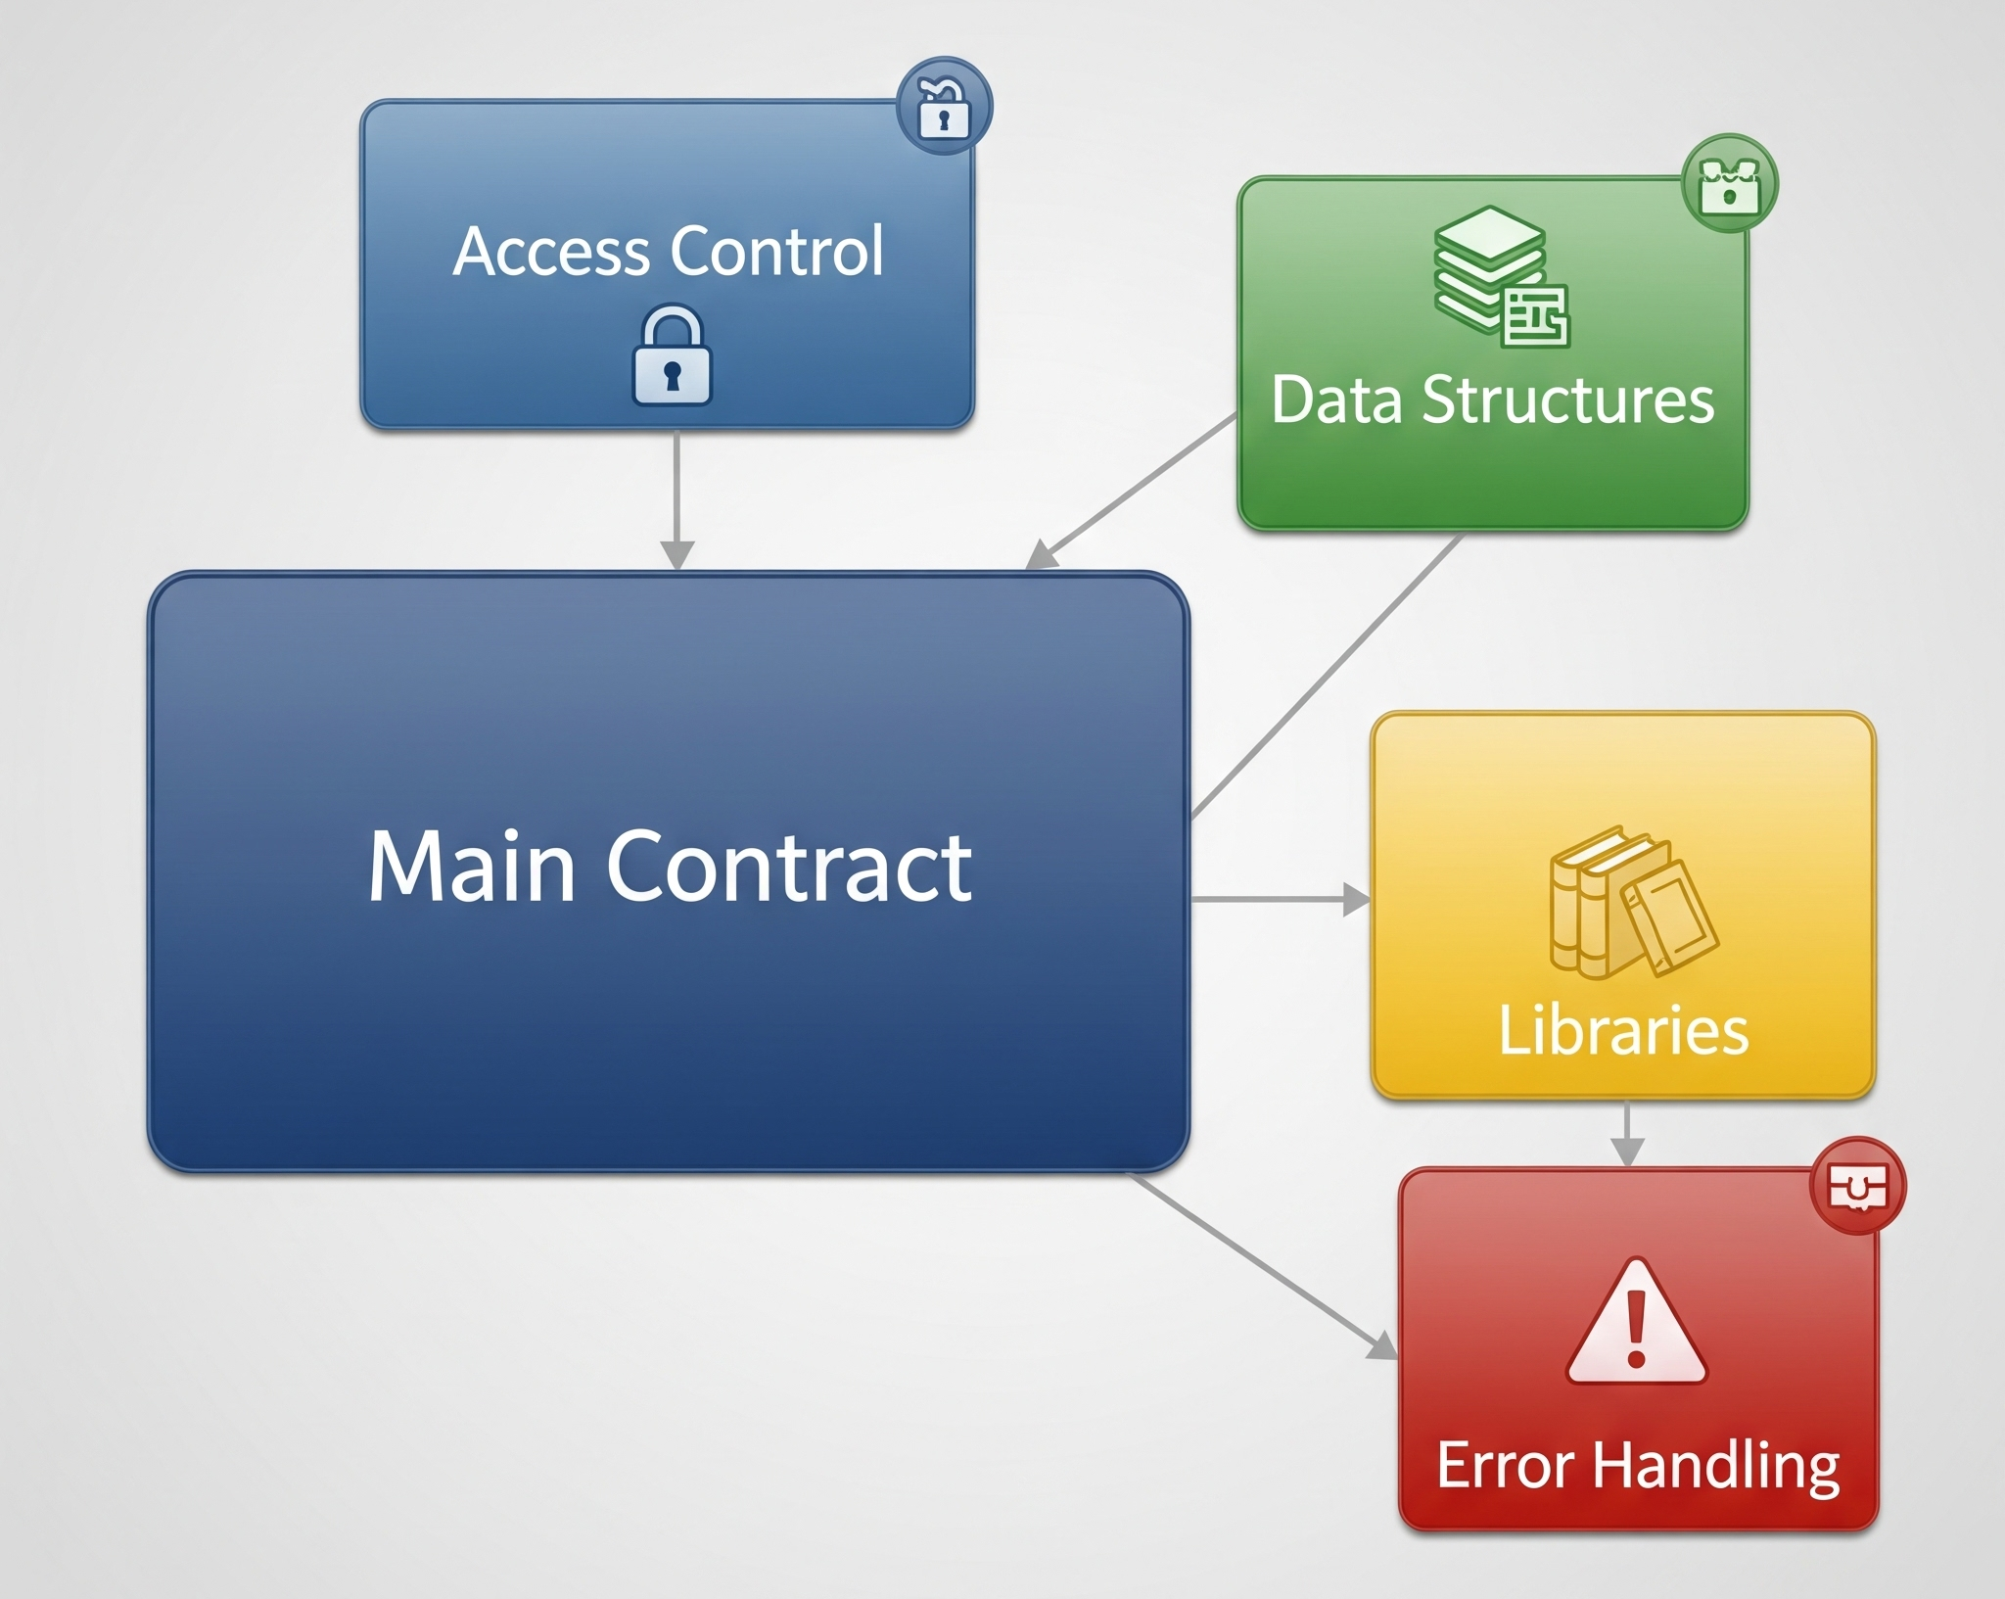
Figure 1 – Class/Component Overview
This diagram presents the overall architecture of the invoice tokenization platform. It shows the main system components and how they are connected.
- InvoiceToken (ERC-1155): The core smart contract, which manages the creation and handling of invoices and pools, as well as collateral and fees.
- Roles (AccessControl): Represents the management of roles and permissions within the platform, with the DEFAULT_ADMIN_ROLE, ADMIN_ROLE, and OPERATOR_ROLE.
- Interfaces: Defines the key data structures used by the system, such as Invoice, Collateral, and Pool.
- Structures: Details the actual data structures, including invoice details, pool limits, and commission rates.
- Libraries: Groups the helper libraries for calculations (e.g., InvoiceCalculations) and validation (PoolLib).
- Errors & Events: Defines the custom errors and events emitted for activity tracking.

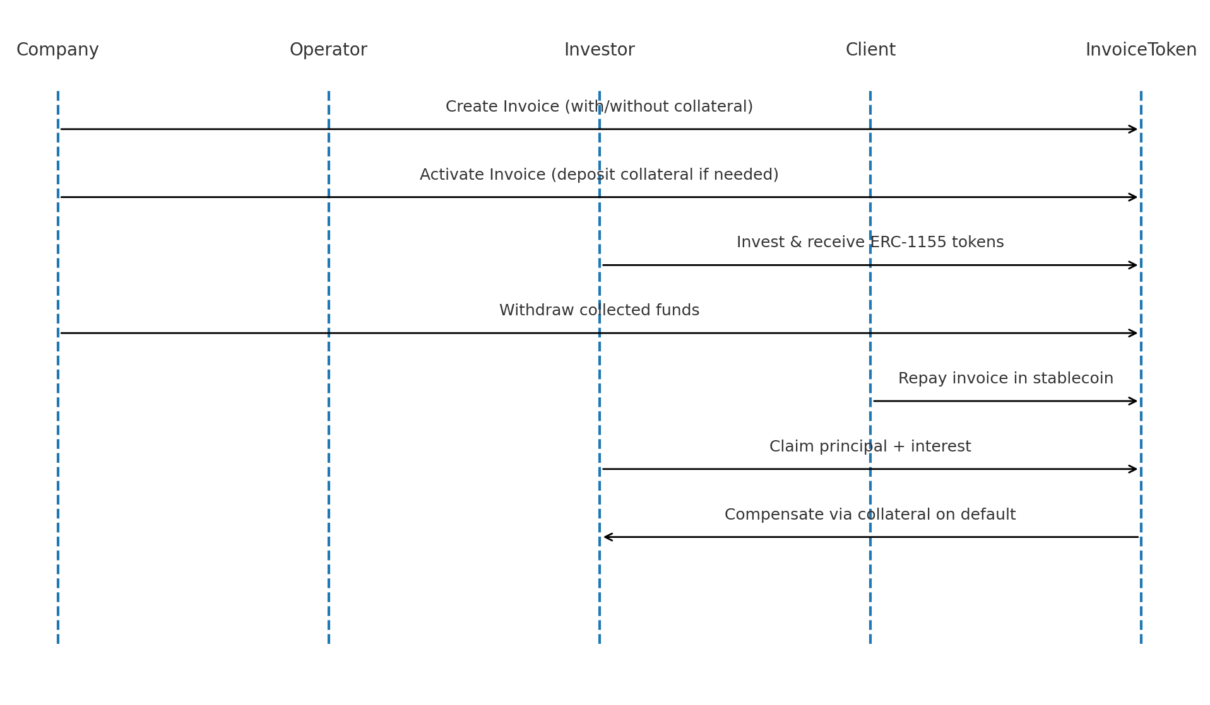
Figure 2 – Invoice Lifecycle (Sequence Diagram)

This diagram illustrates the chronological flow of actions and interactions between the different actors (Company, Investor, Client) and the smart contract (InvoiceToken).
- Creation: A company creates an invoice, with or without collateral.
- Activation: The invoice is activated by depositing the required collateral.
- Investment: Investors finance the invoice and receive ERC-1155 tokens in return.
- Withdrawal: The company can withdraw the collected funds.
- Repayment: The client repays the invoice using a stablecoin.
- Claiming Funds: Investors claim their principal and interest.
- Default: In case of a default, investors are compensated via the collateral.

