# Staff Detection Via Staff Tag

## Tools

### Roboflow

In this task, this tools are used to perform dataset labeling. This tools is used because it has a feature that extract the frame from video and able to make labeling manually on the exported dataset. When downloading the dataset, the label bolder details will be exported too with the dataset. It is also able to perform augmentation from this tool before export the processed dataset. This tools is also select because the dataset can be downloaded in YOLO supported format.

### Ultralytics YOLOv11

The latest version of YOLO is selected to perform object detection for the staff tag in this task. This model will be train with custom dataset which is the sample video provided with labeling on the staff tag.

### Streamlit

Other than that, the role of streamlit in this project is to host the model into interactable interface so that the user can interact with the model through the interface. Streamlit is a simple library that able the user to deploy their model into an interface with very simple and faster way.

## Roboflow

The dataset video is uploaded into Roboflow to extract the frame. After extracting the frame, manually annotation on the staff tag is perform and the frame without the staff tag will be delete. The above figure show the analysis of the processed dataset.

## Solution

### Model training

The YOLO model that select to be used is “yolo11m” which having the medium size of parameter. The hyperparameter that used is 100 epoch, 16 batch size.

From the validation result that shown in above figure, it can be show that the model is gaining a quite high precision/accuracy when the threshold is 0.5. But when the threshold is high, the performance will be decrease. This might caused by the lack of dataset to let the model learn the feature of the staff-tag. To increase the performance of this model, the step that can be done might be increase the dataset, perform data augmentation and generate new data set with the each adjustment of the augmentation so that the dataset can be enlarge in difference variance so that the model can learn more feature from it.

### Interactive Interface



The saved weight will be load into YOLO model in this streamlit file to use it to make predictions.

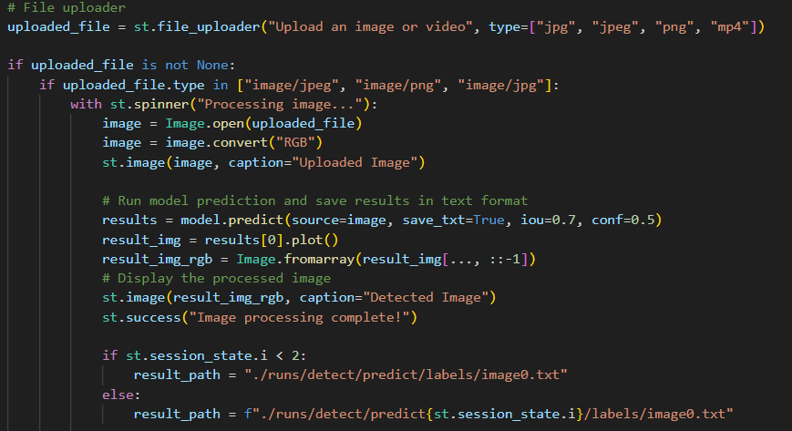

Above figure show that the function will be done when the user uploaded an image file.

Above figure show that the function will be done when the user uploaded video file. The processed video file will be converted into MP4 format since streamlit video player doesn’t support AVI video file format.

This is the function to convert the video from AVI format to MP4 Format.

## Interface

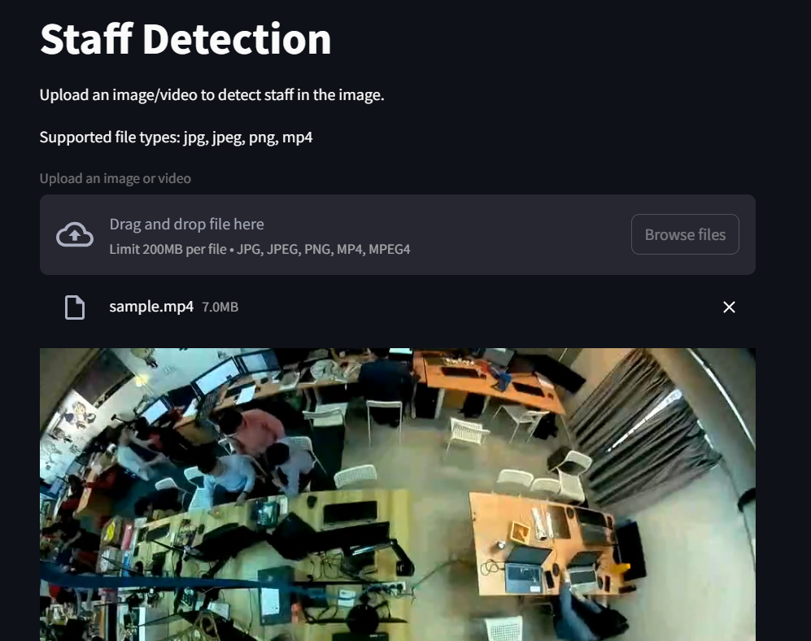

This is the interface of the streamlit app. The use can select browse files to upload the file that need to perform prediction. For image file, the original image and the predicted image will be shown. For Video file, only the processed video will be shown.

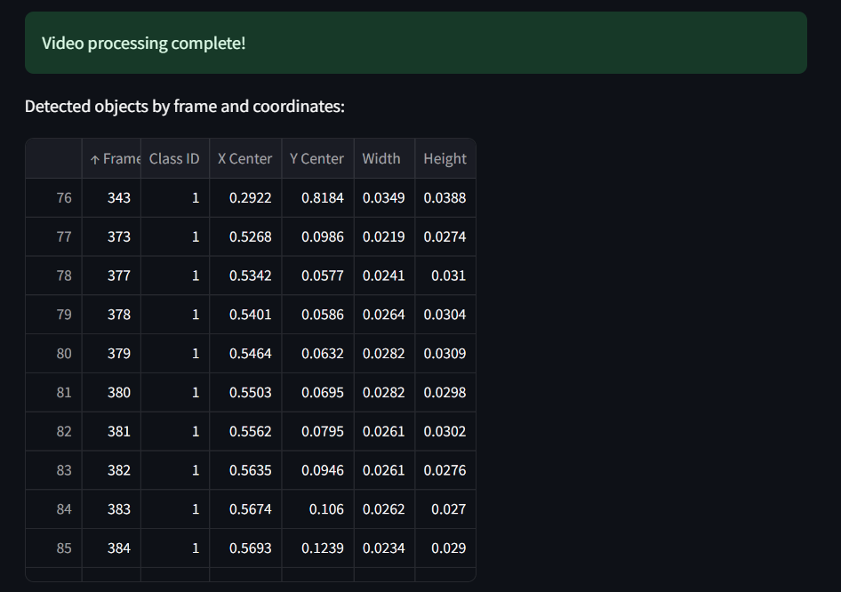  
  
Once the image or video is processed, the details of the bounding box will be shown in a table below the processed video. The information will be listed when there is a frame with staff_tag detected.