**Sales DashBoard**

**Prepared by:** Sagar Singh Meena  
**Registration Number:** 12207321

**Department of Computer Science and Engineering**  
**Lovely Professional University**  
**Bachelor of Technology – Data Science**

**My Dataset**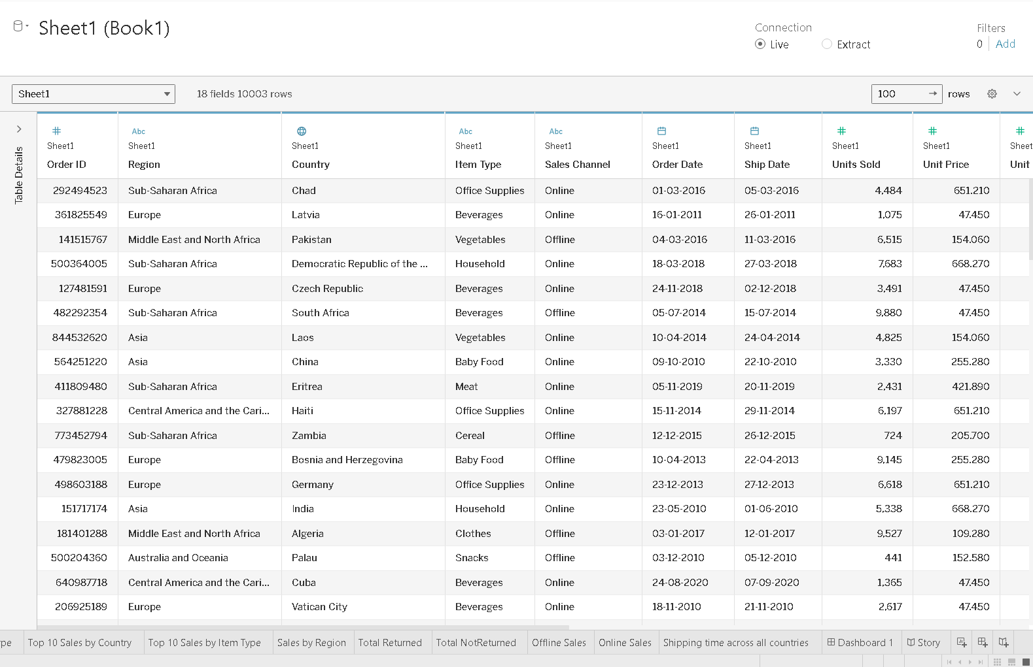

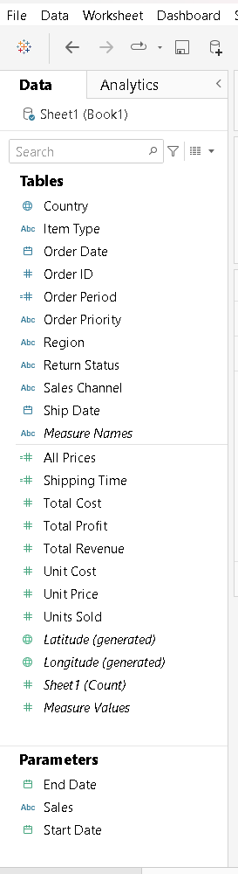

**Various Measeures and Dimensions**

**Sales by years and Item type**

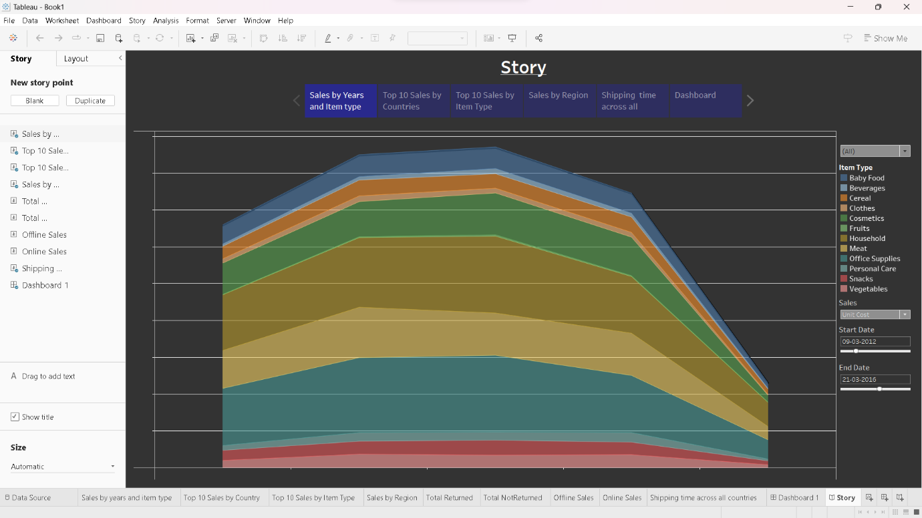

**Top 10 Sales By Countries**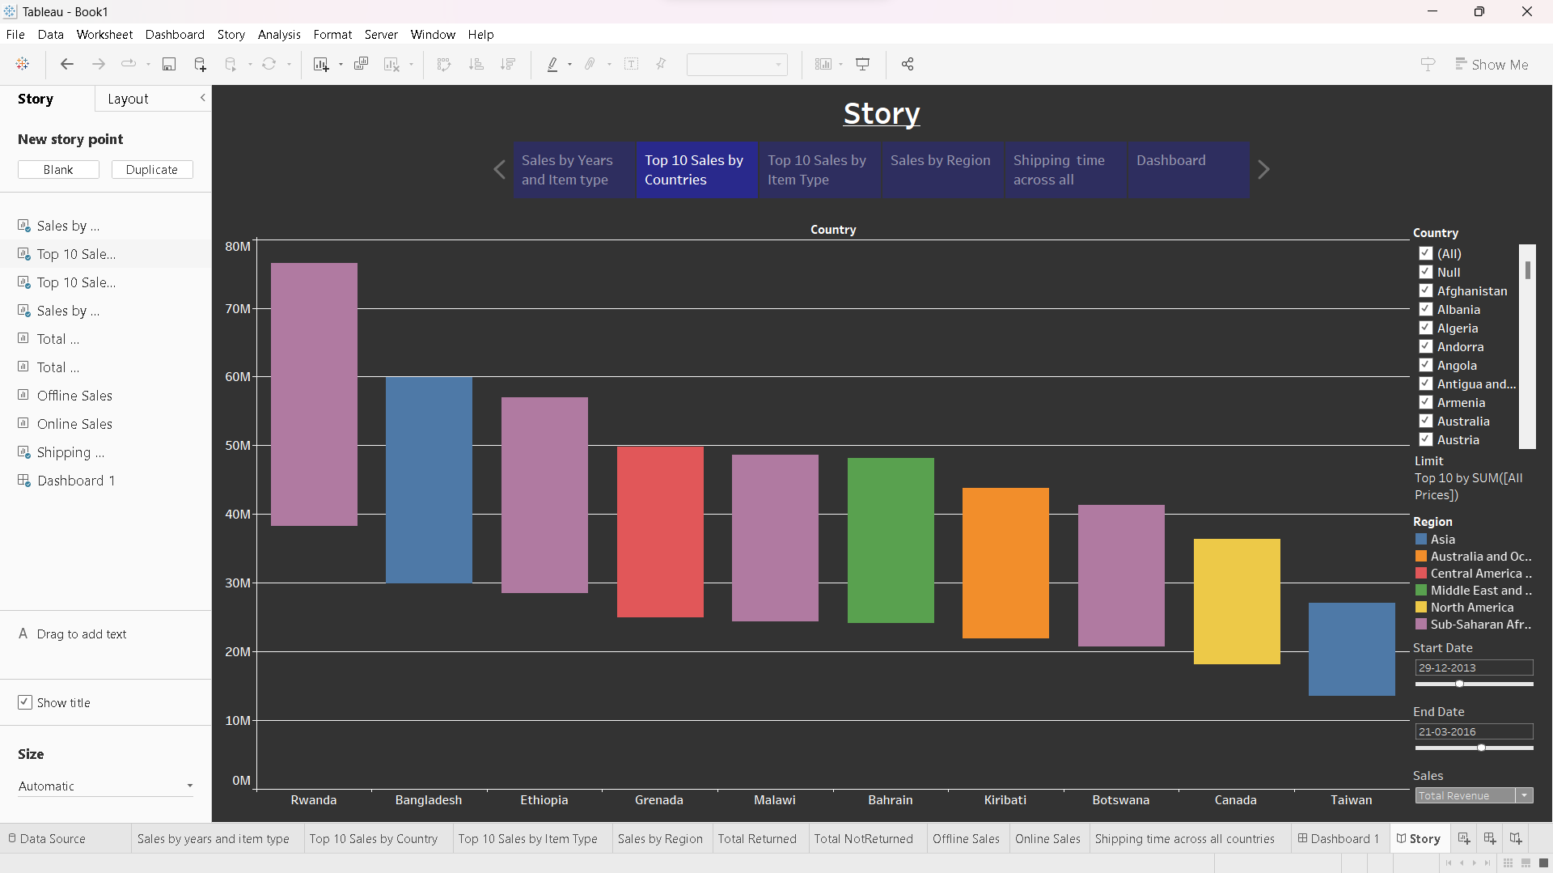

**Top 10 Sales by Item type**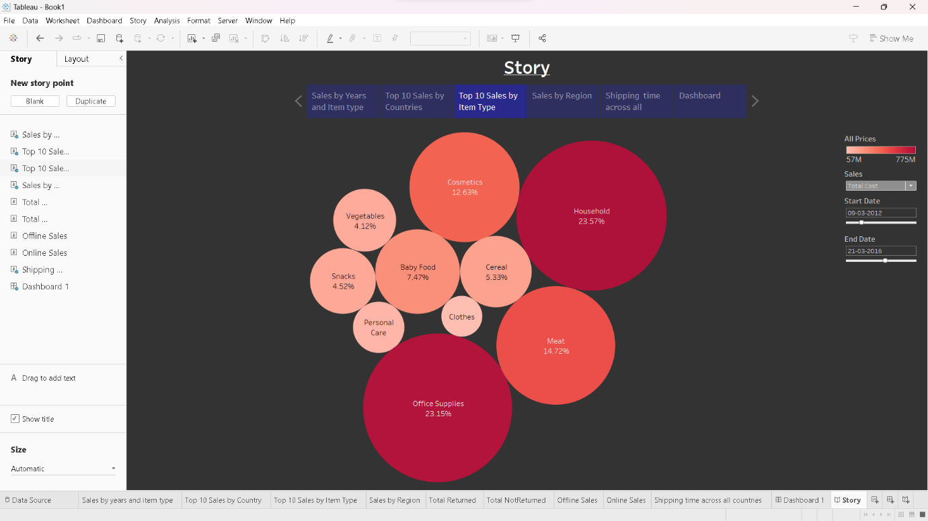

**Sales by Regions**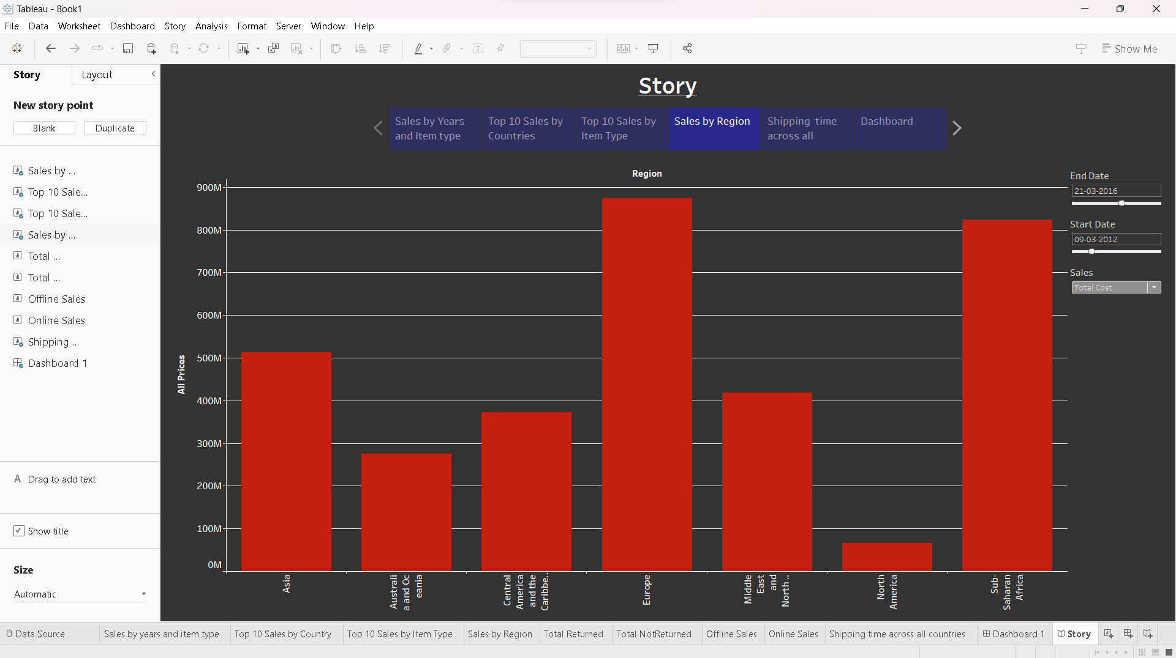

**Shipping time across all Regions**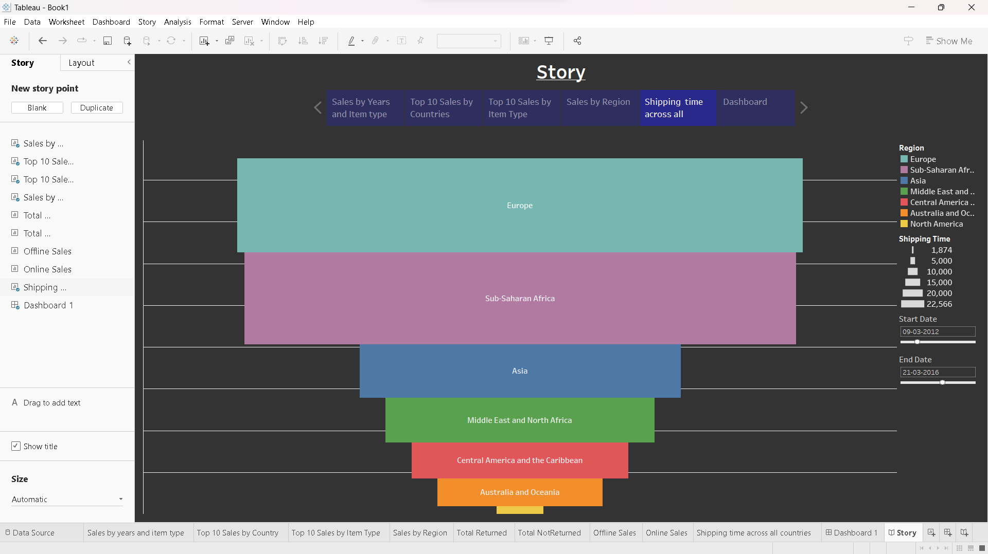

**Dashboard**

